Appendix 1 Recommended GWG for women by prepregnancy BMI*
Pregregnancy BMI IOM Category | BMI, kg/m² | IOM Recommended Total  GWG Range, kg (lbs)†
Underweight | < 18.5 | 12.7 − 18.1 (28 − 40)
Normal weight | 18.5 − 24.9 | 11.3 − 15.9 (25 − 35)
Overweight | 25 − 29.9 | 6.8 − 11.3 (15 − 25)
Obese | ≥ 30.0 | 5.0 − 9.1 (11 − 20)
GWG, gestational weight gain
* Source: Modified from Institute of Medicine (IOM) ⁽⁵⁵⁾
† IOM guidelines do not include the recommended total GWG in kilograms, but these have been added to Appendix 1 for ease of comparison.

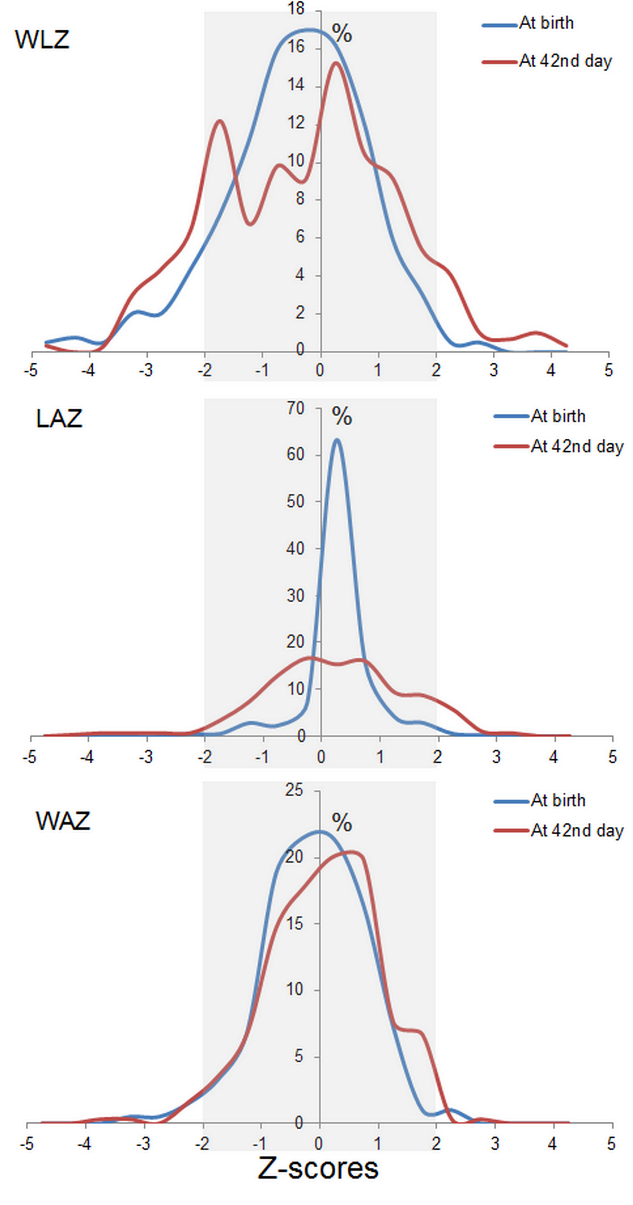
Appendix 2 Z-scores distribution at two different time points (at birth and 42nd day) for infants of all participants (Normal range included in shadow)

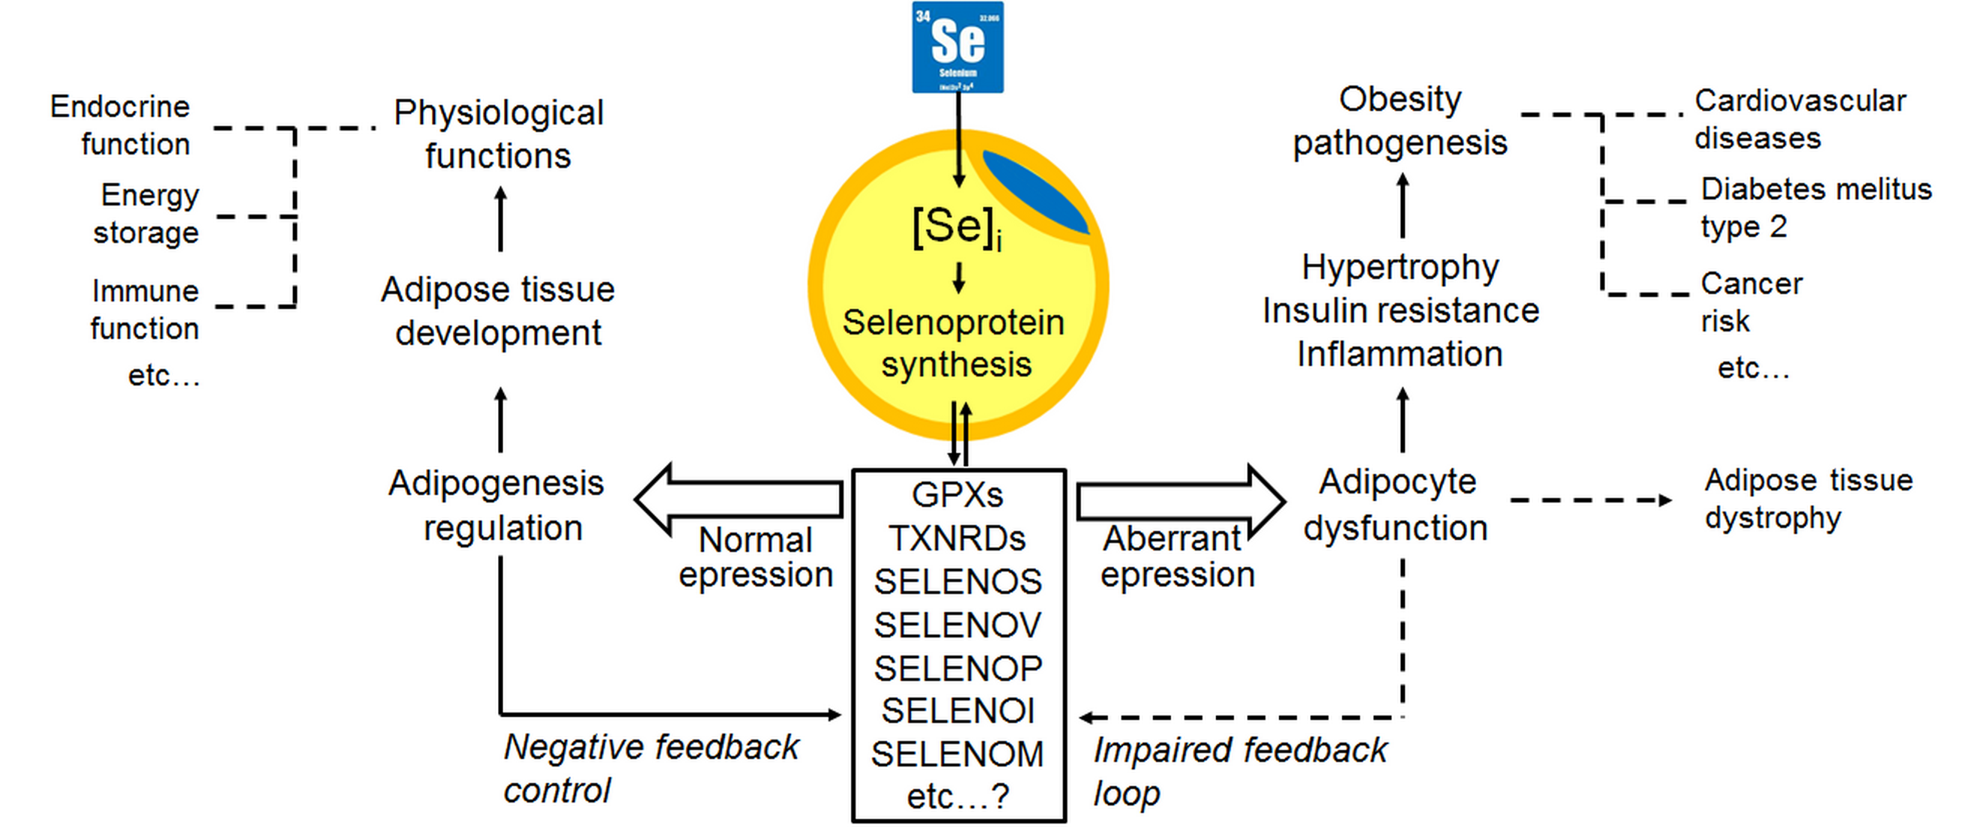
Appendix 3 The proposed role of Se in adipose tissue physiology and obesity pathogenesis (as modified from (80); [Se]_{i}, Adipocyte intracellular Se; GPXs, glutathione peroxidases; Scly, selenocysteine lyase; Se, selenium; SECISBP2, selenocysteine insertion sequence-binding protein 2; SELENOI/-M/-P/-S/-V, selenoprotein I, M, P, S, and V; Sephs2, selenophosphate synthetase 2; TXNRDs, thioredoxin reductases)

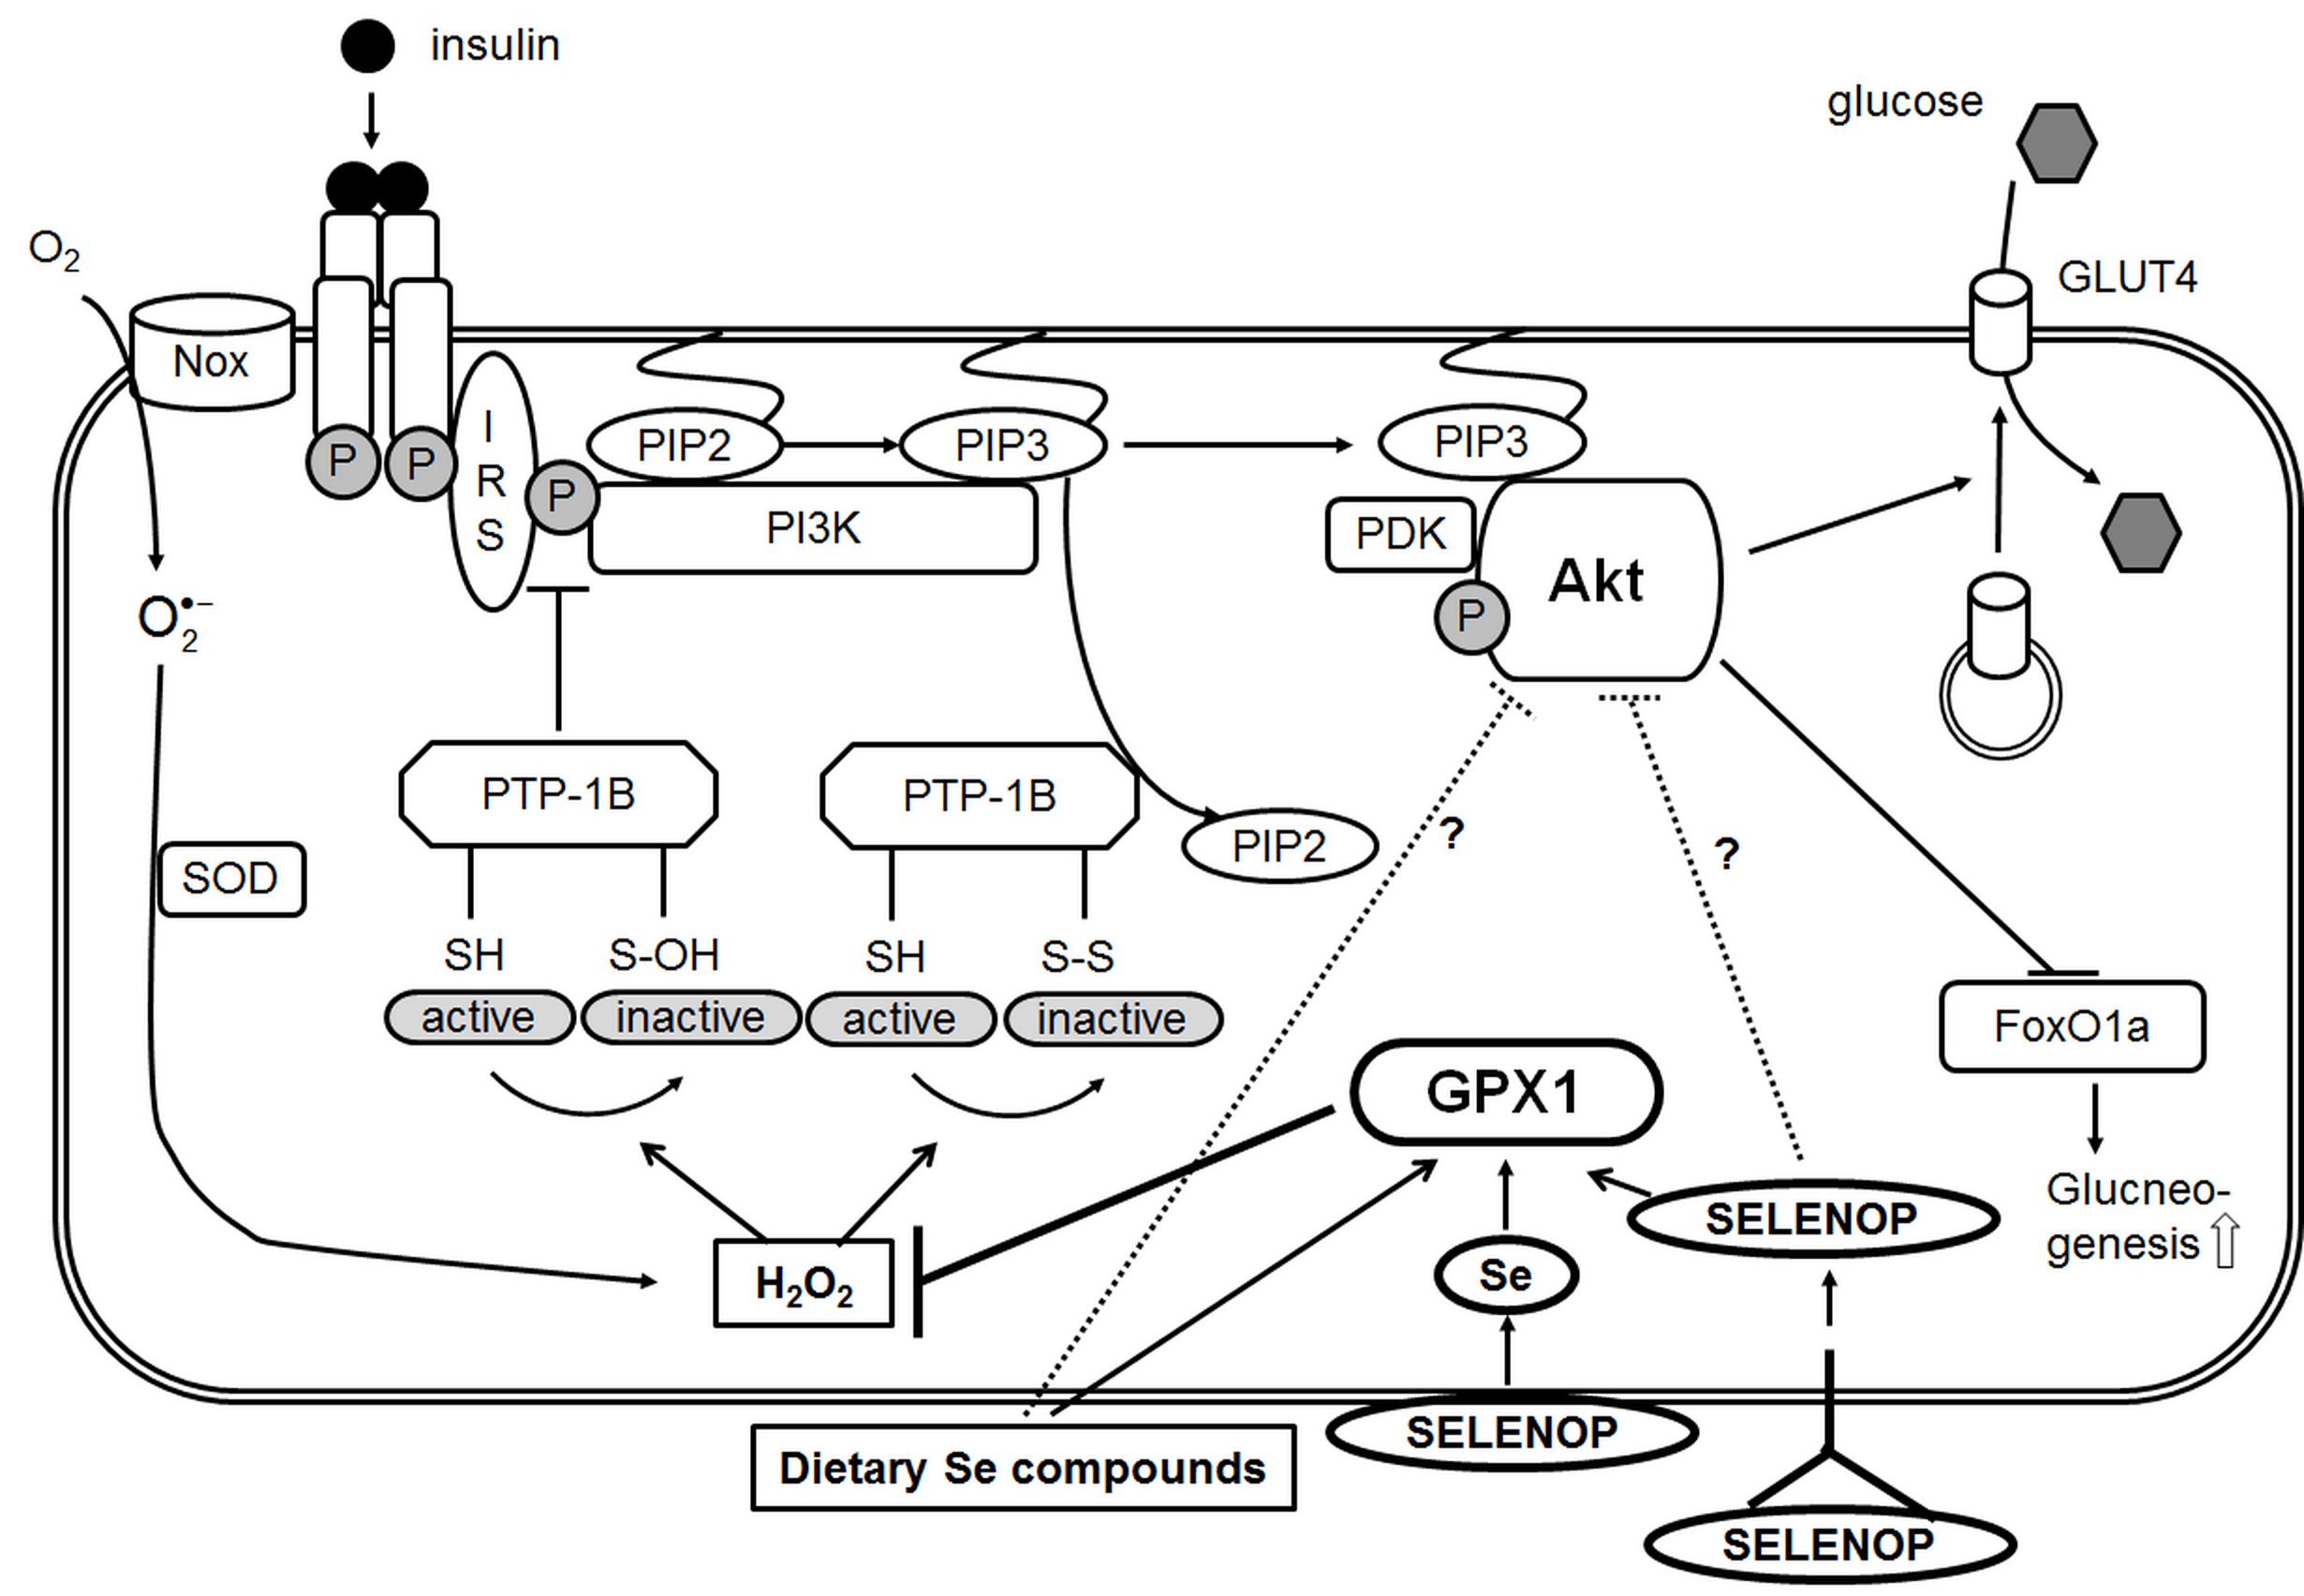
Appendix 4 Impact of selenium on the insulin-regulated carbohydrate metabolism in skeletal muscle and liver (as modified from (85); Akt, protein kinase B; GLUT4, glucose transporter 4; IRS, insulin receptor substrate; P, phosphorylation; PDK, phosphoinositide-dependent protein kinase; PI3K, phosphoinositide 3-kinase; PIP2, phosphatidylinositol 4,5-bisphosphate; PIP3, phosphatidylinositol 3,4,5-trisphosphate)

