Is the Mediterranean Diet associated with healthy habits and physical fitness? A systematic review and meta-analysis including 565,421 youth

Antonio García-Hermoso

Online Supplementary Material

Supplementary material 1.

Search strategy performed in PubMed, Embase and SportDiscus.

 | Searches | Results
PubMed | (("Mediterranean diet" OR "mediterranean adherence" OR "mediterranean") AND (children OR adolescents OR youth OR youths OR adolescent OR child)) AND (active OR "physical activity" OR "exercise" OR "physical inactivity" OR "sitting time" OR "screen time" OR "internet use" OR "computer use" OR "mobile phone use" OR "television watching" OR "video game") AND ("cardiorespiratory fitness" OR "muscular fitness" OR "muscular strength" OR "aerobic fitness" OR "aerobic capacity" OR "exercise capacity") | 37
Embase | ('mediterranean diet' OR adherence OR mediterranean) AND (child OR children OR adolescent OR adolescents OR juvenile OR youth OR youths) AND (active OR 'physical activity' OR 'physical inactivity' OR 'sedentary time' OR 'screen time' OR 'internet use' OR 'computer use' OR 'cell phone use' OR 'television viewing' OR 'video game') AND ('cardiorespiratory fitness' OR 'aerobic capacity' OR exercise OR 'muscle strength' OR 'muscular fitness' OR 'aerobic fitness')c | 760
SportDiscus | mediterranean diet AND ( youth or adolescents or young people or teen or young adults ) AND ( physical activity or exercise or screen time or computer use or television viewing ) AND ( cardiorespiratory fitness or aerobic capacity or exercise capacity or muscle strength or muscle fitness ) | 8
 |  | Total: 725

Supplementary material 2.

References and reasons for exclusion

1 Aguilà Q, Ramon MA, Matesanz S, et al. Estudio de la valoración del estado nutricional y los hábitos alimentarios y de actividad física de la población escolarizada de Centelles, Hostalets de Balenyà y Sant Martí de Centelles (Estudio ALIN 2014). Endocrinol Diabetes Nutr 2017; 64: 138–145.

Reason for exclusion: Inappropriate design

2 Arvaniti F, Priftis KN, Papadimitriou A, et al. Salty-Snack Eating, Television or Video-Game Viewing, and Asthma Symptoms among 10-to 12-Year-Old Children: The PANACEA Study. J Am Diet Assoc 2011; 111: 251–257.

Reason for exclusion: Inappropriate design

3 Giménez-Blasi N, Latorre RJ, Martinez BM, Olea-Serrano F, Mariscal AM. Comparison of diet quality between young children and adolescents in the Mediterranean basin and the influence of life habits. Nutr hosp 2019; 36: 387-393.

Reason for exclusion: Inappropriate exposure

4 Delgado-Floody P, Alvarez C, Caamaño-Navarrete F, Jerez-Mayorga D, Latorre-Román P. Influence of Mediterranean diet adherence, physical activity patterns, and weight status on cardiovascular response to cardiorespiratory fitness test in Chilean school children. Nutrition 2020; 71: 110621. doi:10.1016/j.nut.2019.110621

Reason for exclusion: Inappropriate design

5 Doménech-Asensi G, Sánchez-Martínez Á, Ros-Berruezo G. Cross-sectional study to evaluate the associated factors with differences between city and districts secondary school students of the southeast of Spain (Murcia) for their adherence to the Mediterranean diet. Nutr Hosp 2014; 31: 1359-65.

Reason for exclusion: Inappropriate design

6 Esteban-Cornejo I, Izquierdo-Gomez R, Gómez-Martínez S, et al. Adherence to the Mediterranean diet and academic performance in youth: the UP&DOWN study. Eur J Nutr 2016; 55: 1133–40.

Reason for exclusion: Duplicate study

7 Evaristo OS, Moreira C, Lopes L, et al. Associations between physical fitness and adherence to the Mediterranean diet with health-related quality of life in adolescents: results from the LabMed Physical Activity Study. Eur J Public Health 2018; 28: 631-5.

Reason for exclusion: Inappropriate design

8 Kelishadi R, Ardalan G, Gheiratmand R, et al. Association of Physical Activity and Dietary Behaviours in Relation to the Body Mass Index in a National Sample of Iranian Children and Adolescents: CASPIAN Study. Bull World Health Organ 2007; 85: 19-26.

Reason for exclusion: Inappropriate exposure

9 Galan-Lopez P, Sanchez-Oliver AJ, Pihu M, Gísladóttír T, Domínguez R, Ries F. Association between Adherence to the Mediterranean Diet and Physical Fitness with Body Composition Parameters in 1717 European Adolescents: The AdolesHealth Study. Nutrients 2019; 12: E77. doi:10.3390/nu12010077.

Reason for exclusion: Duplicate study

10 Jennings A, Welch A, van Sluijs EMF, Griffin SJ, Cassidy A. Diet quality is independently associated with weight status in children aged 9-10 years. J Nutr 2011; 141: 453–9.

Reason for exclusion: Inappropriate exposure

11 Knox E, Muros JJ. Association of lifestyle behaviours with self-esteem through health-related quality of life in Spanish adolescents. Eur J Pediatr 2017; 5: 621–8.

Reason for exclusion: Inappropriate design

12 Labayen Goñi I, Arenaza L, Medrano M, García N, Cadenas-Sanchez C, Ortega FB. Associations between the adherence to the Mediterranean diet and cardiorespiratory fitness with total and central obesity in preschool children: the PREFIT project. Eur J Nutr 2018; 57: 2975-83.

Reason for exclusion: Inappropriate design

13 Martino F, Puddu PE, Pannarale G, et al. Metabolic syndrome among children and adolescents from Southern Italy: contribution from the Calabrian Sierras Community Study (CSCS). Int J Cardiol 2014; 177: 455-60.

Reason for exclusion: Inappropriate design

14 McCourt HJ, Draffin CR, Woodside JV, et al. Dietary patterns and cardiovascular risk factors in adolescents and young adults: the Northern Ireland Young Hearts Project. Br J Nutr 2014; 112: 1685–98.

Reason for exclusion: Inappropriate exposure

15 Mistretta A, Marventano S, Antoci M, et al. Mediterranean diet adherence and body composition among Southern Italian adolescents. Obes Res Clin Pract 2017; 11: 215–26.

Reason for exclusion: Inappropriate design

16 Ozen AE, Bibiloni MM, Murcia MA, Pons A, Tur JA. Adherence to the Mediterranean diet and consumption of functional foods among the Balearic Islands’ adolescent population. Public Health Nutr 2015; 18: 659-68.

Reason for exclusion: Duplicate study

17 Pérez-Rodrigo C, Gil Á, González-Gross M, et al. Clustering of Dietary Patterns, Lifestyles, and Overweight among Spanish Children and Adolescents in the ANIBES Study. Nutrients 2015; 8: E11. doi: 10.3390/nu8010011.

Reason for exclusion: Inappropriate design

18 Poeta M, Lamberti R, Di Salvio D, et al. Waist Circumference and Healthy Lifestyle Preferences/Knowledge Monitoring in a Preschool Obesity Prevention Program. Nutrients 2019; 11: E2139. doi: 10.3390/nu11092139.

Reason for exclusion: Inappropriate design

19 Sánchez-Oliva D, Grao-Cruces A, Carbonell-Baeza A, Cabanas-Sánchez V, Veiga OL, Castro-Piñero J. Lifestyle Clusters in School-Aged Youth and Longitudinal Associations with Fatness: The UP&DOWN Study. J Pediatr 2018; 203: 317–24.

Reason for exclusion: Duplicate study

20 Schröder H, Mendez MA, Ribas-Barba L, Covas MI, Serra-Majem L. Mediterranean diet and waist circumference in a representative national sample of young Spaniards. Int J Pediatr Obes 2010; 5: 516–9.

Reason for exclusion: Inappropriate age

21 Shi X, Tubb L, Fingers ST, Chen S, Caffrey JL. Associations of physical activity and dietary behaviors with children’s health and academic problems. J Sch Health 2013; 83: 1-7.

Reason for exclusion: Inappropriate exposure

22 Tambalis KD, Panagiotakos DB, Psarra G, Sidossis LS. Concomitant Associations between Lifestyle Characteristics and Physical Activity Status in Children and Adolescents. J Res Health Sci 2019; 19: 1-7.

Reason for exclusion: Duplicate study

23 Tambalis KD, Panagiotakos DB, Psarra G, Sidossis L. Association of cardiorespiratory fitness levels with dietary habits and lifestyle factors in schoolchildren. Appl Physiol Nutr Metab 2019; 44: 539-45. doi: 10.1139/apnm-2018-0407.

Reason for exclusion: Duplicate study

24 Tonorezos ES, Kent DA, Moskowitz CS, Oeffinger KC. Contribution of diet and physical activity to metabolic parameters among survivors of childhood leukemia. Cancer Causes Control 2013; 24: 313-21.

Reason for exclusion: Inappropriate age

25 Torres-Luque G, Hernández-García R, Ortega-Toro E, Nikolaidis PT. The Effect of Place of Residence on Physical Fitness and Adherence to Mediterranean Diet in 3− 5-Year-Old Girls and Boys: Urban vs. Rural. Nutrients 2018; 10: E1855. doi: 10.3390/nu10121855.

Reason for exclusion: Inappropriate design

26 Wadolowska L, Kowalkowska J, Lonnie M, Czarnocinska J, Jezewska-Zychowicz M, Babicz-Zielinska E. Associations between physical activity patterns and dietary patterns in a representative sample of Polish girls aged 13-21 years: a cross-sectional study (GEBaHealth Project). BMC Public Health 2016; 16: 698. doi: 10.1186/s12889-016-3367-4.

Reason for exclusion: Inappropriate exposure

Supplementary material 3. Items of Quality Assessment Tool for Observational Cohort and Cross-sectional studies
Author | 1 | 2 | 3 | 4 | 5 | 6 | 7 | 8 | 9 | 10 | 11 | 12 | 13 | 14 | Total score
Agostinis-Sobrinho et al. (46) |  |  |  |  |  |  |  |  |  |  |  | NA | NA |  | 9
Arcila-Agudelo et al. (42) |  |  |  |  |  |  |  |  |  |  |  | NA | NA |  | 9
Arnaoutis et al. (20) |  |  |  |  |  |  |  |  |  |  |  | NA | NA |  | 6
Arriscado et al. (31) |  |  | NR |  |  |  |  |  |  |  |  | NA | NA |  | 7
Bawaked et al. (52) |  |  |  |  |  |  |  |  |  |  |  | NA |  |  | 12
Bibiloni et al. (53) |  |  |  |  |  |  |  |  |  |  |  | NA | NA |  | 9
Cabañas-Sánchez et al. (50) |  |  | NR |  | NR |  |  |  |  |  |  | NA | NA |  | 7
Chacón-Cuberos et al. (47) |  |  |  |  |  |  |  |  |  |  |  | NA | NA | NR | 7
Farajian et al. (54) |  |  |  |  |  |  |  |  |  |  |  | NA | NA |  | 8
Fauquet et al. (55) |  |  |  |  | NR |  |  |  |  |  |  | NA | NA |  | 8
Galan-Lopez et al. (56) |  |  |  |  |  |  |  |  |  |  |  | NA | NA |  | 7
Galan-Lopez et al. (57) |  |  |  |  |  |  |  |  |  |  |  | NA | NA |  | 8
Galan-Lopez et al. (21) |  |  |  |  |  |  |  |  |  |  |  | NA | NA |  | 7
García-Hermoso et al. (22) |  |  |  |  |  |  |  |  |  |  |  | NA | NA |  | 8
Grao-Cruces et al. (23) |  |  |  | NR |  |  |  |  |  |  |  | NA | NA | NR | 6
Grao-Cruces et al. (24) |  |  |  | NR |  |  |  |  |  |  |  | NA | NA |  | 7
Grosso et al. (25) |  |  |  | NR | NR |  |  |  |  |  |  | NA | NA |  | 7
Kontogianni et al. (28) |  |  | NR |  |  |  |  |  |  |  |  | NA | NA |  | 8
Lazarou et al. (29) |  |  |  |  |  |  |  |  |  |  |  | NA | NA |  | 9
López-Gil et al. (30) |  |  | NR |  | NR |  |  |  |  |  |  | NA | NA | NR | 6
Magriplis et al. (32) |  |  |  |  |  |  |  |  |  |  |  | NA | NA | NR | 7
Manzano-Carrasco et al. (51) |  |  |  |  |  |  |  |  |  |  |  | NA | NA |  | 9
Martínez et al. (33) |  |  | NR |  | NR |  |  |  |  |  |  | NA | NA |  | 7
Mazaraki et al. (34) |  |  | NR |  | NR |  |  |  |  |  |  | NA | NA |  | 7
Mieziene et al. (35) |  |  |  |  | NR |  |  |  |  |  |  | NA |  |  | 10
Monjardino et al. (36) |  |  | NR |  |  |  |  |  |  |  |  | NA | NA |  | 8
Moral García et al. (37) |  |  | NR |  | NR |  |  |  |  |  |  | NA | NA | NR | 6
Muros et al. (38) |  |  | NR |  |  |  |  |  |  |  |  | NA | NA | NR | 6
Novak et al. (39) |  |  | NR |  | NR |  |  |  |  |  |  | NA | NA |  | 7
Obradovic Salcin et al. (48) |  |  |  |  |  |  |  |  |  |  |  | NA | NA |  | 9
Papadaki et al. (40) |  | NR | NR |  | NR |  |  |  |  |  |  | NA | NA |  | 6
Peng et al. (41) |  |  |  |  |  |  |  |  |  |  |  | NA | NA |  | 9
Pino-Ortega et al. (49) |  |  | NR |  |  |  |  |  |  |  |  | NA | NA | NR | 7
Roccaldo et al. (43) |  |  |  |  |  |  |  |  |  |  |  | NA | NA |  | 8
Rosa Guillamón et al. (26) |  |  | NR |  |  |  |  |  |  |  |  | NA | NA |  | 4
Rosa Guillamón et al. (27) |  |  | NR | NR |  |  |  |  |  |  |  | NA | NA |  | 5
Rosi et al. (10) |  |  |  |  |  |  |  |  |  |  |  | NA | NA | NR | 8
Santomauro et al. (44) |  |  |  |  |  |  |  |  |  |  |  | NA | NA | NR | 7
Tambalis et al. (45) |  |  |  |  |  |  |  |  |  |  |  | NA | NA |  | 6
 indicates “yes”,  indicates “no”, and NR indicates “not reported”.
NA: not applicable due to the cross-sectional design of the studies.

Supplementary material 4.

Funnel Plots Assessing Publication Bias for Studies Analyzing the Association of Mediterranean Diet with A) Physical Activity, B) Sedentary behaviors, C) Cardiorespiratory fitness, D) Muscular fitness; and E) Speed-Agility.

A)
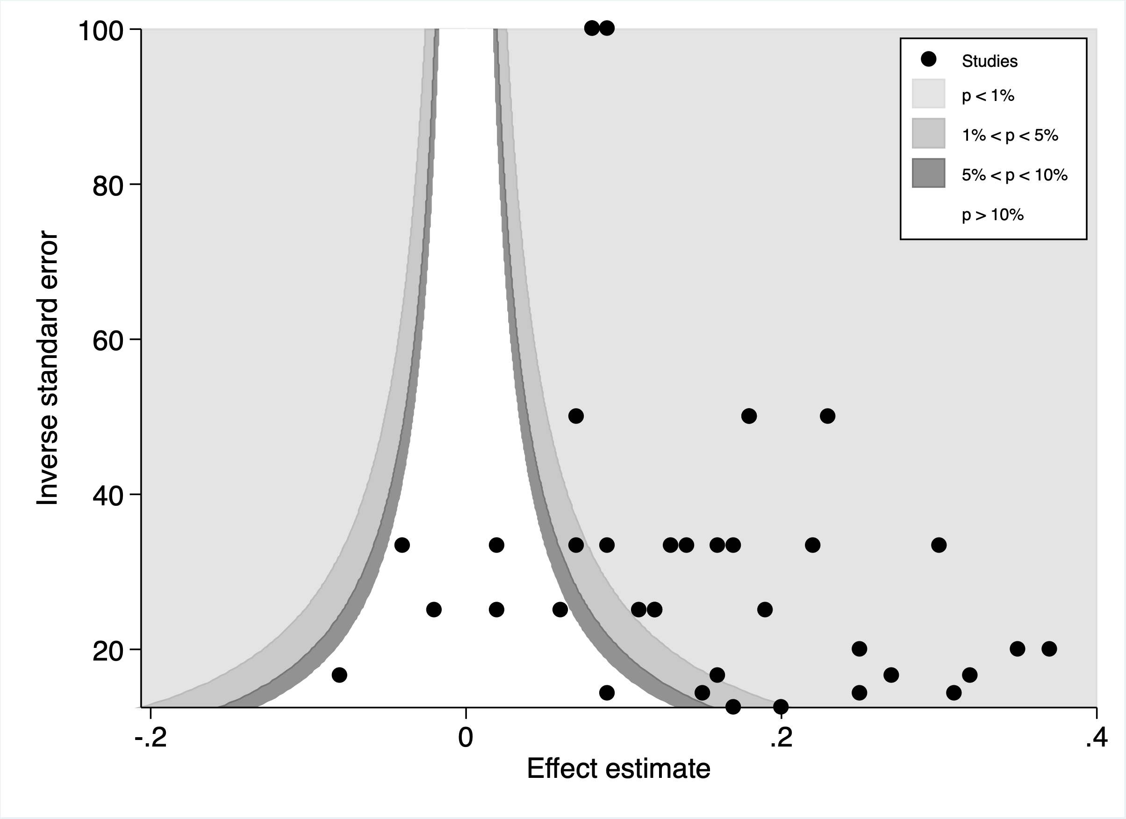

B)

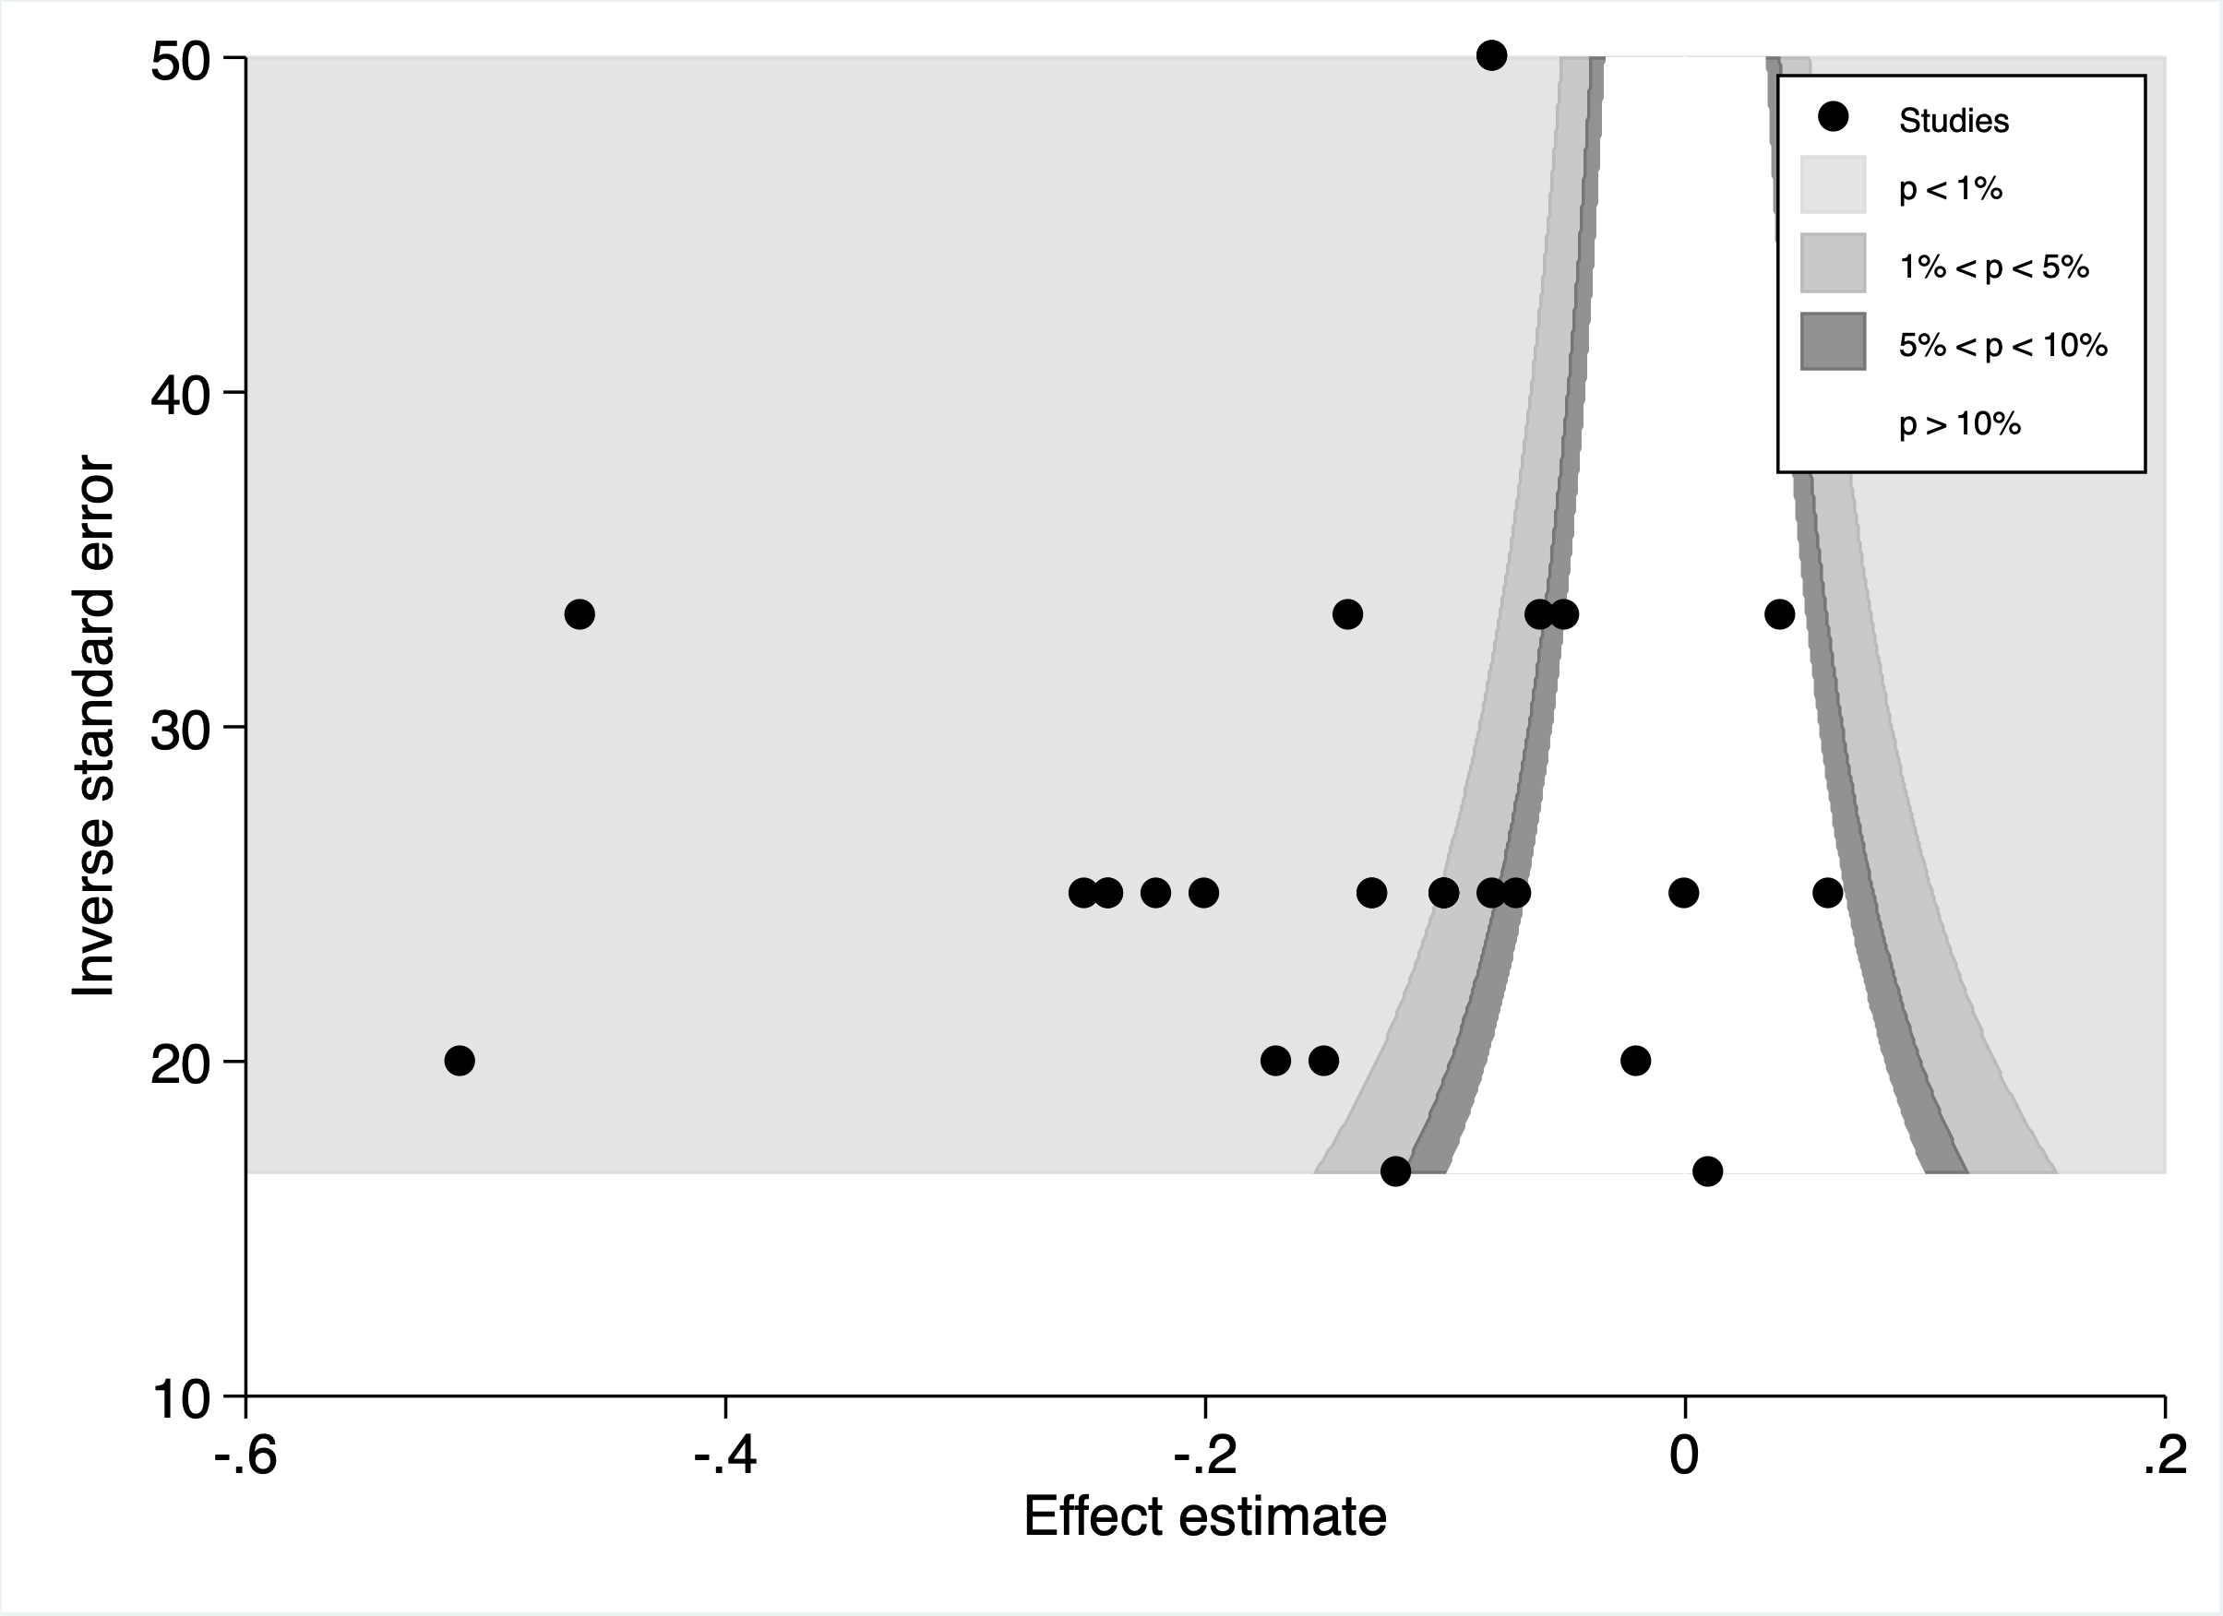

C)

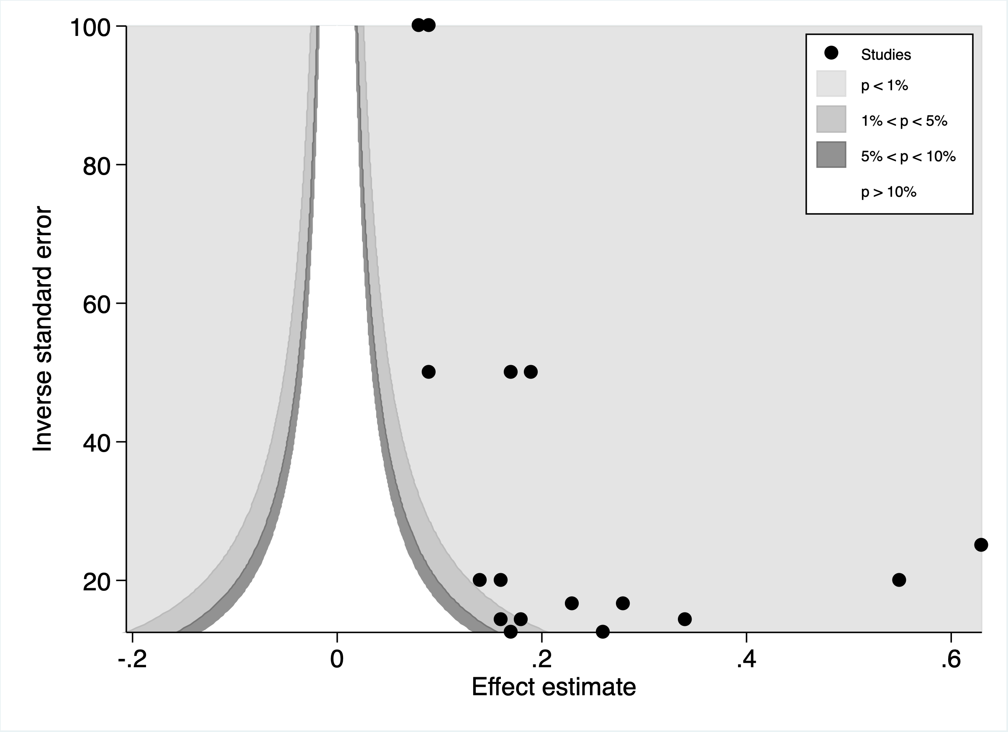

D)

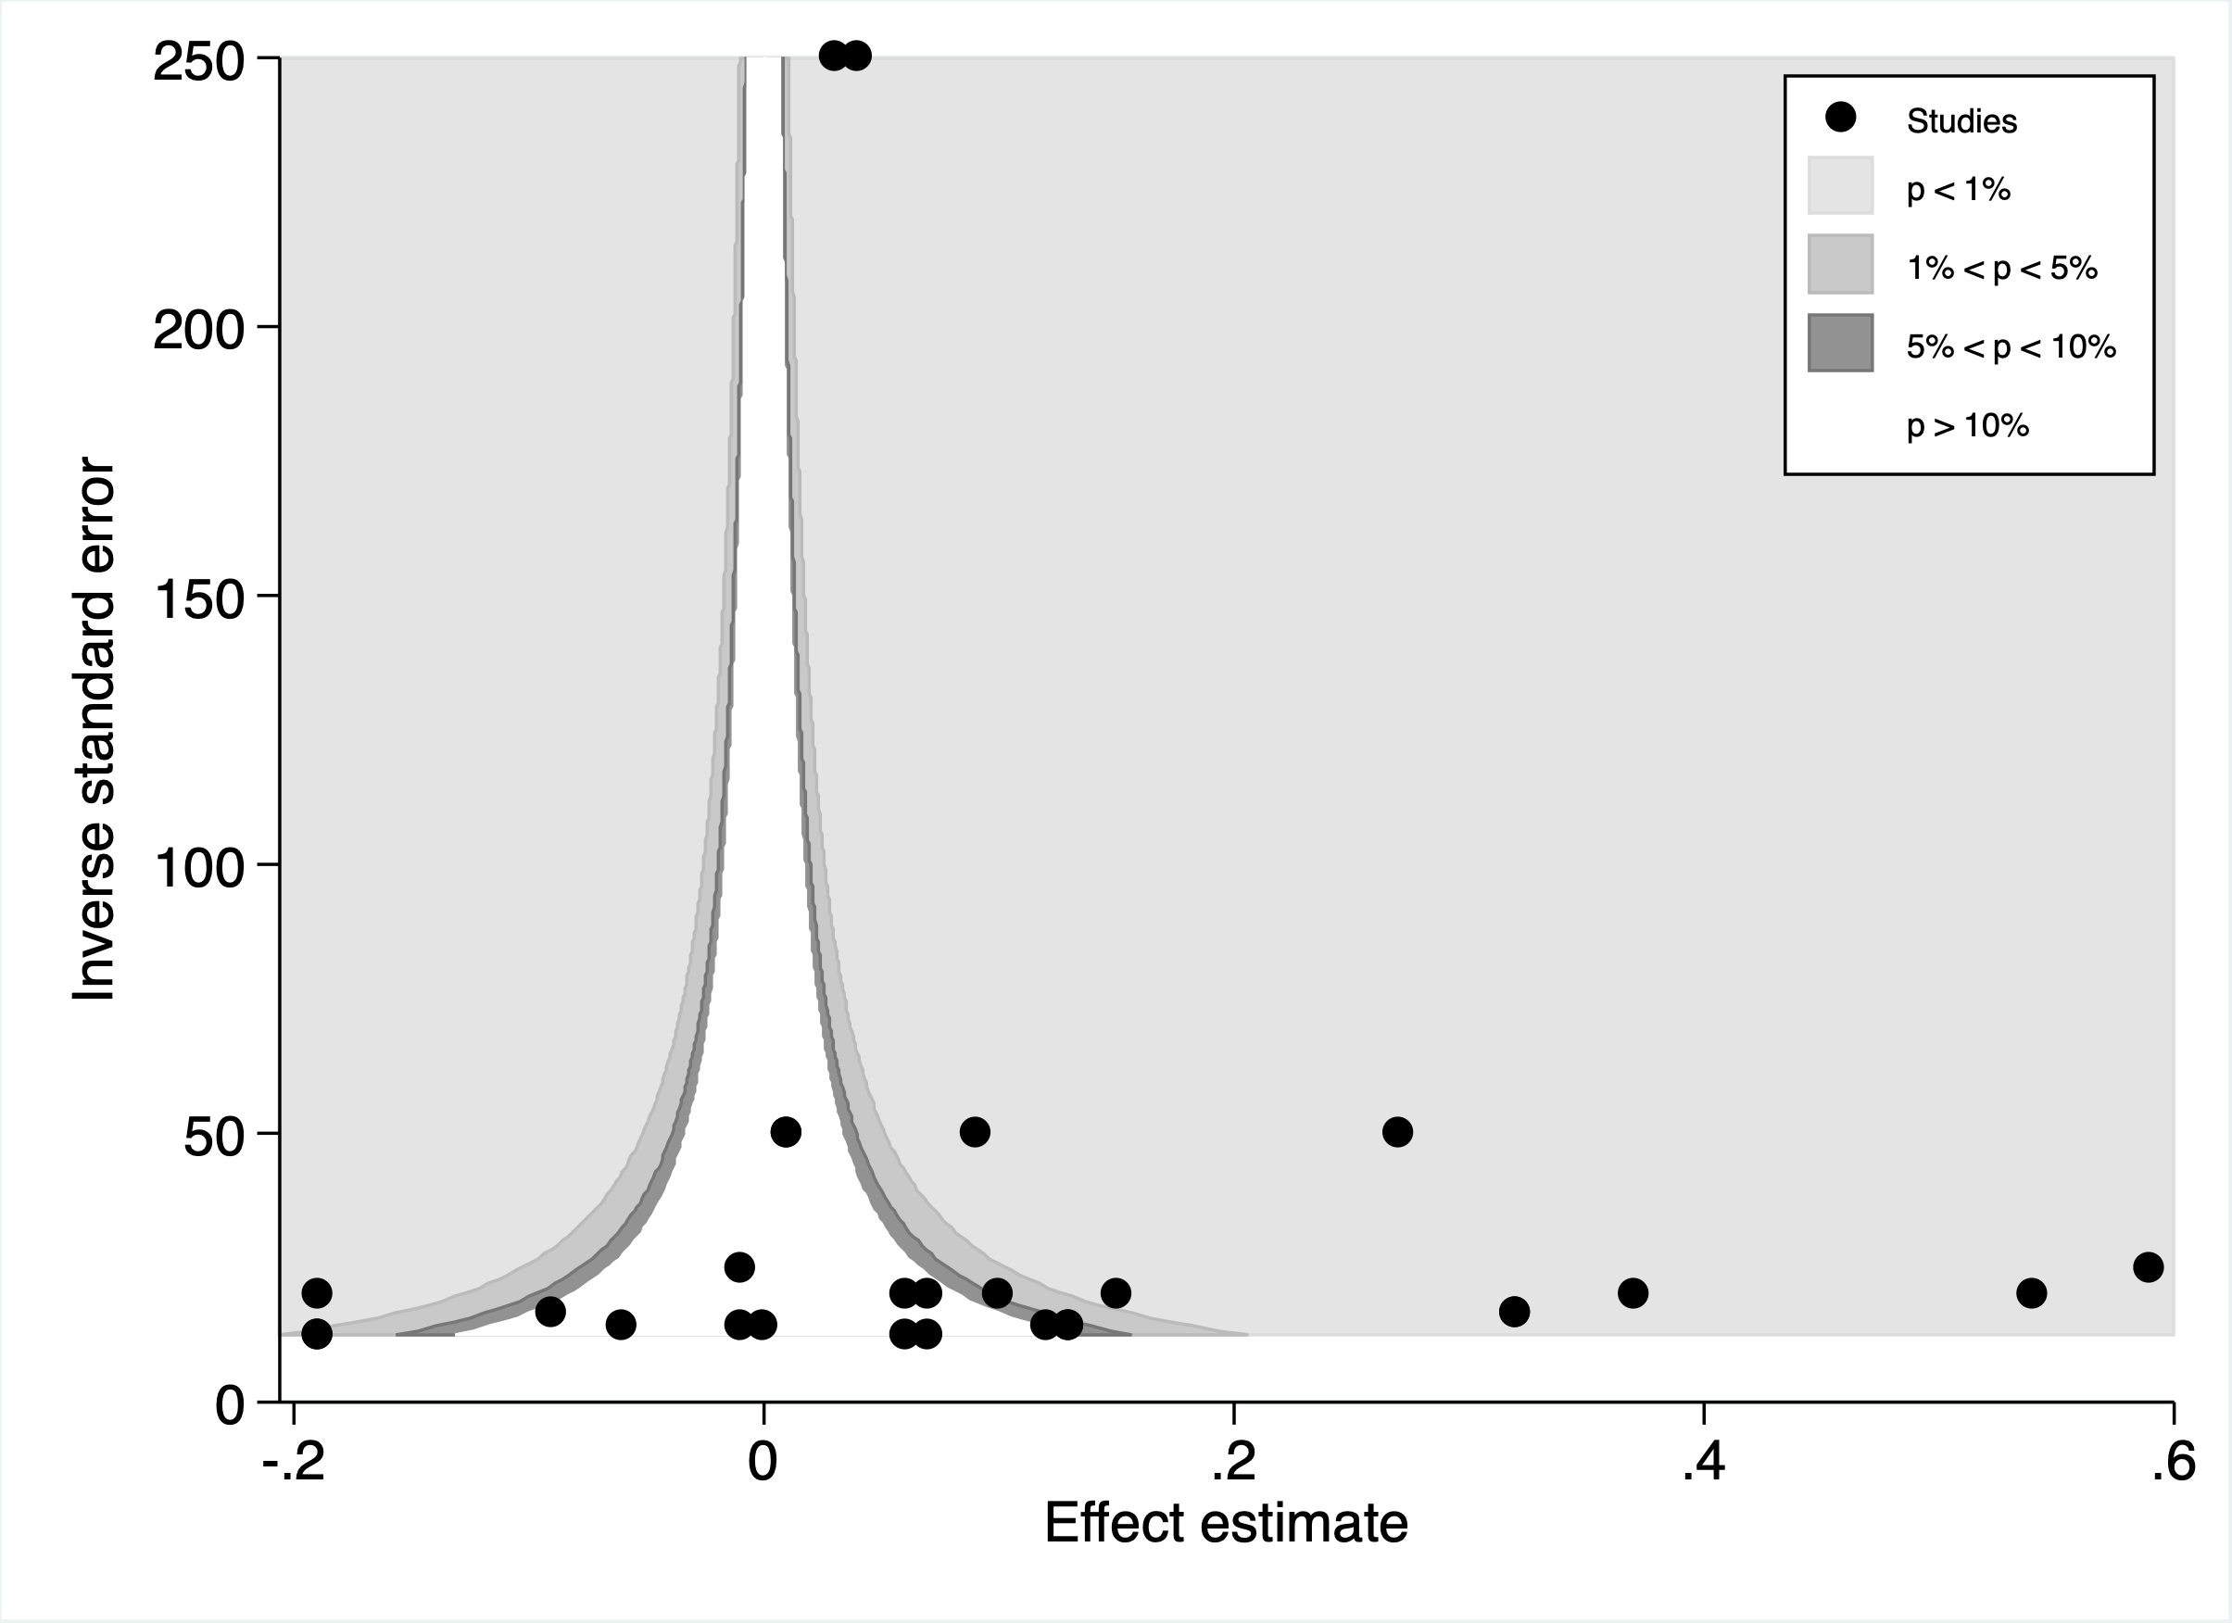

E)

