Deutsche Gesellschaft
für Ernährung e. V.
Godesberger Allee 18
53175 Bonn
Tel.: +49 228 3776-600
Fax: +49 228 3776-800
https://www.dge.de
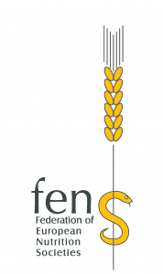

Workshop Program

German Nutrition Society
&
Federation of European Nutrition Societies

Integration of various dimensions of FBDGs via mathematical approaches: Why and how?
Date: September 23rd/24th, 2019
Place: German Nutrition Society, Godesberger Alllee 18, 53175 Bonn
Activity | Speaker
Welcome and introduction to the WS | Angela Bechthold  Heiner Boeing
Trustworthy nutritional recommendations | Malgorzata Bala
Novel FBGD of Belgium and used concepts | Brecht Devleesschauwer
Assessment of health impacts of foodstuffs | Brecht Devleesschauwer
Mathematical optimization of diets: a powerful tool to answer questions in human nutrition and public health | Nicole Darmon
Integrating sustainability into FBDG: The Dutch approach | Corné van Dooren
The French diet optimization approach | Perrine Nadaud
A start-up’s modeling and statistics expertise for nutritional research | Florent Vieux
Modelling techniques for the improvement of FBDG – the example of fish | Sara Monteiro Pires
Assessing sustainability of diets with agri-environmental models | Thomas Heckelei
Outlook/plans for modeling for the German FBDG | Anne Carolin Schäfer  Heiner Boeing
Discussion on feasibility of large scale modeling

