Supplementary Figure 1 – Study flow chart
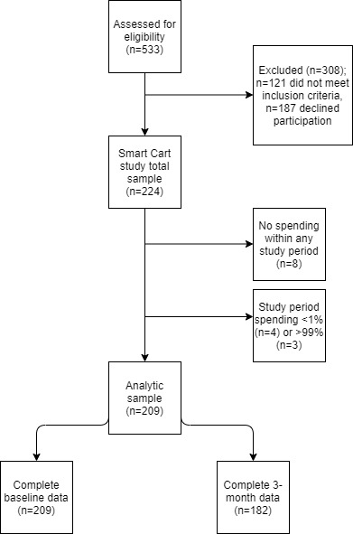

 |  | Midpoint (n=224)
 |  | Included (n=182) |  |  | Excluded (n=42)
Characteristic* |  | Mean or % | SD |  | Mean or % | SD | p-value
Age |  | 56.1 | 13.9 |  | 50.9 | 13.0 | 0.03
BMI |  | 25.5 | 4.6 |  | 25.2 | 4.2 | 0.8
Sex
Female |  | 89% |  |  | 95% |  | 0.2
Education
≤ Bachelor's |  | 51% |  |  | 57% |  | 0.5
Household income
< $100k |  | 52% |  |  | 40% |  | 0.2
Mean household size |  | 2.2 | 1.1 |  | 3.0 | 1.5 | 0.003
Smoking in household
Yes |  | 4% |  |  | 0% |  | 0.2
Children in household
Yes |  | 27% |  |  | 41% |  | 0.08
Percent GPQI score |  | 54.6 | 9.3 |  | 53.7 | 9.8 | 0.6
Percent baseline HEI score |  | 73.3 | 9.2 |  | 70.7 | 9.1 | 0.1
Experimental group
Intervention |  | 50% |  |  | 50% |  | >0.9
Supplementary Table 1 - Descriptive characteristics comparing full and analytic samples at midpoint

GPQI, Grocery Purchase Quality Index; HEI, Healthy Eating Index; BMI, Body Mass Index. P-values reflect t-tests for continuous variables and chi squared for categorical variables.
Supplementary Table 2 – Multivariable-adjusted regression models examining the concordance between Grocery Purchase Quality Index (GPQI) and Healthy Eating Index-2010 (HEI) scores across GPQI tertiles
Model |  | 1 | 1 (mid) | 2 | 2 (mid) | 3 | 3 (mid) | 4 | 4 (mid)
N |  | 209 | 182 | 207 | 180 | 196 | 172 | 151 | 128
Adjustment |  | None |  | Age & sex |  | Age, sex & BMI |  | Age, sex, BMI & income
P for model |  | <0.0001 | <0.0001 | <0.0001 | <0.0001 | <0.0001 | <0.0001 | <0.0001 | <0.0001
R2 |  | 0.2864 | 0.2836 | 0.3051 | 0.2905 | 0.3209 | 0.3150 | 0.4387 | 0.4202
 |  | β (SE)
GPQI T1 (T3=ref) |  | 13.0 (1.0) | 14.0 (1.7) | 12.5 (1.5) | 13.8 (1.7) | 13.4 (1.5) | 14.6 (1.8) | 16.0 (1.7) | 18.0 (2.0)
GPQI T2 (T3=ref) |  | 5.0 (1.4) | 4.7(1.7) | 4.9 (1.4) | 4.9 (1.7) | 5.1 (1.5) | 4.9 (1.7) | 6.7 (1.6) | 7.48 (1.9)
Age |  |  |  | 0.08 (0.04) | 0.04 (0.05) | 0.08 (0.04) | 0.02 (0.05) | 0.1 (0.05) | -0.0 (0.05)
Sex=F (M=ref) |  |  |  | 3.5 (2.0) | 2.8 (2.3) | 3.06 (2.0) | 2.63 (2.3) | 3.0 (2.2) | 2.0 (2.5)
BMI |  |  |  |  |  | -0.27 (0.1) | -0.16 (0.2) | -0.3 (0.2) | -0.3 (0.2)
Income≤100k (>100k=ref) |  |  |  |  |  |  |  | -3.6 (1.3) | -1.6 (1.5)
 |  | Least square means of score differences*
GPQI tertile 1 |  | -25.4±1.0ª | -25.5±1.2ª | -23.6±1.3ª | -24.2±1.5ª | -24.5±1.4ª | -25.0±1.6ª | -26.1±1.5ª | -26.1±1.8ª
GPQI tertile 2 |  | -17.3±1.0^{b} | -16.1±1.2^{b} | -16.0±1.3^{b} | -15.6±1.5^{b} | -16.3±1.3^{b} | -15.3±1.5^{b} | -16.7±1.4^{b} | -15.6±1.5^{b}
GPQI tertile 3 |  | -12.4±1.0^{c} | -11.4±1.2^{c} | -11.1±1.3^{c} | -10.4±1.5^{c} | -11.2±1.3^{c} | -10.5±1.5^{c} | -10.0±1.4^{c} | -8.2±1.7^{c}
* Mean differences between the GPQI and HEI scores adjusted for the designated variables. Different superscripted letters indicate significant differences between groups.

Supplementary Table 3 – Odds of obtaining high or low consumption diet quality scores (HEI) across tertiles of the Grocery Purchase Quality Index (GPQI)
 | Odds of high HEI score (≥80 points) |  | Odds of low HEI score (<60 points)
 | Unadjusted OR (95% CI) | Fully adjusted OR (95% CI) | Unadjusted OR (95% CI) | Fully adjusted OR (95% CI)
Baseline HEI
GPQI Tertile 1 (ref) | - | - | - | -
GPQI Tertile 2 | 1.55 (0.52, 4.61) | 1.84 (0.48, 7.04) | 0.41 (0.13, 1.24) | 0.49 (0.08, 3.05)
GPQI Tertile 3 | 7.42 (2.83, 19.45) | 7.32 (2.04, 26.24) | 0.16 (0.03, 0.73) | 0.39 (0.06, 2.75)
3-months HEI
GPQI Tertile 1 (ref) | - | - | - | -
GPQI Tertile 2 | 1.65 (0.51, 5.32) | 3.07 (0.52, 18.21) | 1.16 (0.52, 2.62) | 0.88 (0.32, 2.41)
GPQI Tertile 3 | 5.48 (1.93, 15.58) | 10.55 (1.92, 57.97) | 0.90 (0.39, 2.08) | 1.17 (0.43, 3.20)
Fully adjusted model includes age, sex, BMI, and income

Supplementary Table 4 – Comparing frequencies of high and low consumed diet quality (HEI) scores across GPQI tertiles
Timepoint | HEI score threshold | Percent of total sample | Percent of GPQI tertile |  |  | P for chi squared test
 |  |  | GPQI T1 | GPQI T2 | GPQI T3
Baseline | High (≥80 points) | 21.1% | 8.7% | 12.9% | 41.4% | <0.0001
 | Low (<60 points) | 8.6% | 15.9% | 7.1% | 2.9% | 0.02
3-months | High (≥80 points) | 18.7% | 8.1% | 13.1% | 35.6% | 0.0002
 | Low (<60 points) | 8.8% | 11.3% | 11.5% | 3.4% | 0.20
Chi squared tests compared percent of sample with high (≥ 80; vs <80) or low HEI (<60; vs ≥60) scores across GPQI tertiles.

