Supplement
Table S1. SES evaluation of each variable assignment criteria
Occupation | Education | Annual income（Yuan） | Household assets | score
unemployed / laid-off / housework | never | ＜10000 | 0~1 | 0
farmer | elementary | 10000~34999 | 2~3 | 1
sales and service staff / workers / other | middle school | ≥34999 | ≥4 | 2
private owners | high school or higher |  |  | 3
professional skill worker / administrative and management personnel |  |  |  | 4

Table S2 Characteristics and biomarkers by quartiles of DP score in participants from the three study sites
 | Quartile of the DP score ( Urunqi) |  |  |  |  | Quartile of the DP score ( Huo Cheng) |  |  |  |  | Quartile of the DP score ( Mo Yu)
 | 1 | 2 | 3 | 4 | P-for trend | 1 | 2 | 3 | 4 | P-for trend | 1 | 2 | 3 | 4 | P-for trend
RRR
Age (years) | 58.00 ±9.41 | 58.85 ± 9.67 | 60.33 ± 9.64 | 62.33 ± 8.39 | ＜0.001 | 51.57±10.06 | 50.55 ± 9.86 | 49.02 ± 9.65 | 49.49 ± 9.31 | ＜0.001 | 50.23±9.79 | 50.44 ± 9.99 | 52.48 ± 10.15 | 55.63 ± 10.18 | ＜0.001
Sex (female) | 776 (72.4) | 654 (62.2) | 639 (59.4) | 566 (53.0) | ＜0.001 | 445 (51.6) | 399 (45.7) | 464 (53.8) | 537 (51.8) | ＜0.001 | 1083 (60.0) | 1133 (62.0) | 1104 (61.1) | 1084 (59.8) | 0.510
Current smoking status, n (%) | 114 (10.6) | 146 (13.9) | 159 (14.8) | 197 (18.5) | ＜0.001 | 157 (18.2) | 237 (27.1) | 238 (27.6) | 229 (26.4) | ＜0.001 | 189 (10.5) | 154 (8.4) | 154 (8.5) | 140 (7.7) | 0.027
Alcohol drinking status, n (%) | 49 (4.6) | 50 (4.8) | 45 (4.2) | 64 (6.0) | 0.437 | 110 (12.7) | 149 (17.1) | 142 (16.5) | 149 (17.1) | 0.015 | 47 (2.6) | 49 (2.7) | 76 (4.2) | 56 (3.1) | 0.049
Physical activity, n (%) | 555 (51.8) | 417 (39.7) | 358 (33.3) | 380 (35.6) | ＜0.001 | 43 (5.0) | 23 (2.6) | 43 (5.0) | 40 (4.6) | 0.001 | 27 (1.5) | 15 (0.8) | 14 (0.8) | 29 (1.6) | 0.026
Very low SES, n (%) | 56 (5.2) | 120 (11.4) | 209 (19.4) | 331 (31.0) | ＜0.001 | 488 (56.5) | 458 (52.5) | 481 (55.8) | 450 (51.8) | 0.116 | 978 (54.2) | 1056 (57.8) | 1180 (65.3) | 1214 (67.0) | ＜0.001
SBP (mmHg) | 126.03 ±18.04 | 129.13 ±17.95 | 131.86 ± 18.89 | 133.38 ± 19.17 | ＜0.001 | 132.20±24.01 | 128.55±22.55 | 125.36±22.40 | 125.03 ± 20.99 | ＜0.001 | 119.63 ±21.49 | 121.07 ± 22.48 | 122.38 ± 22.79 | 126.16 ±25.12 | ＜0.001
DBP (mmHg) | 75.41 ± 10.35 | 77.99 ± 10.82 | 78.95 ± 10.98 | 80.54 ± 11.36 | ＜0.001 | 77.39 ± 12.07 | 76.47 ± 10.66 | 75.14 ± 11.04 | 73.46 ± 11.58 | ＜0.001 | 72.71 ± 13.02 | 73.71 ± 13.24 | 74.91 ± 13.34 | 77.25 ± 13.84 | ＜0.001
WC (cm) | 86.43 ± 9.39 | 88.85 ± 9.68 | 89.18 ± 9.75 | 90.65 ± 10.21 | ＜0.001 | 87.95 ± 10.29 | 87.99 ± 11.11 | 89.45 ± 11.97 | 91.93 ± 11.84 | ＜0.001 | 89.15 ± 11.60 | 90.88 ± 11.51 | 91.68 ± 11.48 | 94.20 ± 11.41 | ＜0.001
FBG (mmol/L) | 5.80 ± 1.62 | 5.87 ± 1.71 | 5.95 ± 1.97 | 5.93 ± 1.89 | 0.049 | 5.50 ± 1.21 | 5.36 ± 1.09 | 5.46 ± 1.36 | 5.60 ± 1.29 | 0.43 | 5.14 ± 1.01 | 5.23 ± 1.08 | 5.23 ± 1.11 | 5.22 ± 1.16 | 0.030
TG (mmol/L) | 1.87 ± 0.43 | 1.78 ± 0.45 | 1.73 ± 0.14 | 1.76 ± 0.78 | 0.043 | 1.58 ± 0.14 | 1.46 ± 0.98 | 1.38 ± 0.94 | 1.41 ± 0.83 | ＜0.001 | 1.23 ± 0.95 | 1.33 ± 0.97 | 1.42 ± 0.15 | 1.51 ±0.29 | ＜0.001
HDL-C (mmol/L) | 1.56 ± 0.59 | 1.51 ± 0.50 | 1.51 ± 0.50 | 1.46 ± 0.48 | ＜0.001 | 1.24 ± 0.77 | 1.21 ± 0.69 | 1.28 ± 0.92 | 1.60 ± 0.53 | ＜0.001 | 1.30 ± 0.48 | 1.31 ± 0.64 | 1.35 ± 0.50 | 1.39 ± 0.48 | ＜0.001
PCA DP1
Age (years) | 58.93± 9.75 | 60.89± 9.48 | 59.86± 9.45 | 59.88± 9.43 | 0.205 | 50.19± 9.72 | 50.75± 9.95 | 50.50± 9.84 | 49.35± 9.54 | 0.081 | 52.55 ± 10.19 | 54.28 ± 10.73 | 51.88 ± 10.03 | 50.06 ± 9.62 | ＜0.001
Sex (female) | 616（23.4） | 635（24.1） | 667（25.3） | 717（27.2） | ＜0.001 | 505(27.4) | 461(25.0) | 431(23.4) | 448(24.3) | 0.002 | 1084(24.6) | 1098(24.9) | 1189(27.0) | 1033(23.5) | 0.574
Current smoking status, n (%) | 182（29.5） | 174（28.2） | 133（21.6） | 127（20.6） | ＜0.001 | 249(28.9) | 240(27.9) | 199(23.1) | 173(20.1) | ＜0.001 | 172(27.0) | 146(22.9) | 120(18.8) | 199(31.2) | 0.296
Alcohol drinking status, n (%) | 207（22.2） | 273（29.2） | 216（23.1） | 238（25.5） | 0.623 | 174(29.1) | 153(25.6) | 151(25.3) | 119(19.9) | 0.005 | 128(30.8) | 113(27.2) | 70(16.9) | 104(25.1) | 0.010
Physical activity, n (%) | 571（22.6） | 613（24.2） | 635（25.1） | 712（28.1） | ＜0.001 | 174(25.9) | 171(25.4) | 172(25.6) | 156(23.2) | 0.684 | 83(26.9) | 62(20.1) | 70(22.7) | 93(30.2) | 0.314
Very low SES, n (%) | 168（23.5） | 235（32.8） | 177（24.7） | 136（19.0） | 0.004 | 488(26.0) | 464(24.7) | 436(23.2) | 489(26.1) | 0.019 | 1140(25.7) | 1200(27.1) | 1111(25.1) | 977(22.1) | ＜0.001
SBP (mmHg) | 129.63± 17.84 | 131.98± 19.51 | 130.33± 18.18 | 128.47± 18.18 | 0.046 | 126.02± 21.15 | 128.20± 23.33 | 129.41±23.47 | 127.48± 22.60 | 0.106 | 121.88± 22.91 | 123.35 ± 23.81 | 122.69 ± 23.41 | 121.33± 22.34 | 0.344
DBP (mmHg) | 78.27± 10.63 | 79.24± 11.20 | 78.51± 11.10 | 76.88± 11.10 | 0.001 | 74.41± 11.37 | 75.53± 11.39 | 75.92± 11.62 | 76.59± 11.29 | ＜0.001 | 75.37 ± 13.13 | 76.00 ± 13.49 | 74.12 ± 13.60 | 73.11 ± 13.47 | ＜0.001
WC (cm) | 89.36± 9.42 | 89.25± 9.90 | 88.8± 9.821 | 87.69± 10.26 | ＜0.001 | 90.78± 11.76 | 89.07± 11.52 | 89.22± 11.03 | 88.27± 11.28 | ＜0.001 | 93.28 ± 11.33 | 93.06 ± 11.47 | 89.83 ± 11.89 | 89.74 ± 11.38 | ＜0.001
FBG (mmol/L) | 5.94± 1.72 | 5.99± 1.96 | 5.89± 1.85 | 5.73± 1.66 | 0.004 | 5.48± 1.15 | 5.49± 1.30 | 5.49± 1.21 | 5.48± 1.24 | 0.729 | 5.20 ± 1.10 | 5.25 ± 1.14 | 5.21 ± 0.99 | 5.17 ± 1.12 | 0.244
TG (mmol/L) | 1.70± 0.12 | 1.77± 0.29 | 1.82± 0.29 | 1.85± 1.48 | 0.005 | 1.36± 0.80 | 1.44± 0.94 | 1.52± 0.12 | 1.51± 0.03 | ＜0.001 | 1.44 ± 0.28 | 1.49 ± 0.15 | 1.28 ± 0.93 | 1.29 ± 0.10 | ＜0.001
HDL-C (mmol/L) | 1.49± 0.49 | 1.51± 0.53 | 1.52± 0.49 | 1.52± 0.56 | 0.005 | 1.47± 0.63 | 1.33± 0.74 | 1.29±0.68 | 1.23± 0.92 | ＜0.001 | 1.35 ± 0.45 | 1.38 ± 0.52 | 1.30± 0.53 | 1.31 ± 0.60 | ＜0.001
PCA DP2
Age (years) | 59.67± 9.40 | 59.97± 9.40 | 60.13± 9.21 | 59.83± 9.63 | 0.597 | 51.10±9.75 | 52.12±10.09 | 50.17±9.82 | 48.90±9.45 | ＜0.001 | 52.89 ± 10.36 | 52.25 ± 10.43 | 52.81 ± 10.35 | 51.19 ± 9.94 | ＜0.001
Sex (female) | 616（23.4） | 747（28.3） | 459（17.4） | 813（30.9） | ＜0.001 | 371(20.1) | 259(14.0) | 514(27.9) | 701(38.0) | 0.844 | 1526(34.7) | 860(19.5) | 618(14.0) | 1400(31.8) | 0.008
Current smoking status, n (%) | 182（29.5） | 182（29.5） | 100（16.2） | 152（24.7） | 0.002 | 189(22.0) | 104(12.1) | 228(26.5) | 340(39.5) | 0.525 | 173(27.2) | 117(18.4) | 96(15.1) | 251(39.4) | ＜0.001
Alcohol drinking status, n (%) | 223（23.9） | 261（27.9） | 166（17.8） | 284（30.4） | 0.102 | 138(23.1) | 77(12.9) | 159(26.6) | 223(37.4) | 0.390 | 107(25.8) | 55(13.3) | 62(14.9) | 191(46.0) | ＜0.001
Physical activity, n (%) | 598（23.6） | 652（25.8） | 458（18.1） | 823（32.5） | ＜0.001 | 120(17.8) | 78(11.6) | 180(26.7) | 295(43.8) | 0.001 | 108(35.1) | 50(16.2) | 31(10.1) | 119(38.6) | 0.379
Very low SES, n (%) | 214（29.9） | 253（35.3） | 108（15.1） | 141（19.7） | ＜0.001 | 366(19.5) | 259(13.8) | 536(28.6) | 716(38.1) | 0.297 | 1631(36.8) | 878(19.8) | 638(14.4) | 1281(28.9) | ＜0.001
SBP (mmHg) | 130.97± 19.24 | 130.55± 18.41 | 130.27± 19.00 | 128.80± 18.38 | 0.006 | 130.87±23.34 | 130.73±23.58 | 127.24±22.21 | 125.39±22.03 | ＜0.001 | 123.88± 23.61 | 123.02 ± 23.61 | 122.10 ± 22.23 | 120.37± 22.23 | ＜0.001
DBP (mmHg) | 79.61± 11.29 | 78.63± 11.21 | 77.73± 10.57 | 76.88± 10.74 | ＜0.001 | 76.38±11.83 | 76.08±11.79 | 76.21±11.13 | 74.58±11.25 | 0.002 | 74.39 ± 13.78 | 74.42 ± 13.74 | 74.35 ± 13.49 | 75.18 ± 12.95 | 0.074
WC (cm) | 89.19± 10.27 | 88.98± 9.91 | 88.12± 9.56 | 88.19± 9.64 | 0.016 | 89.16±10.65 | 89.72±11.62 | 88.87±11.04 | 89.63±12.04 | 0.753 | 90.91 ± 11.80 | 90.01 ± 11.88 | 91.15 ± 11.38 | 93.07 ± 11.26 | ＜0.001
FBG (mmol/L) | 5.59± 1.28 | 5.75± 1.49 | 5.83± 1.69 | 6.31± 2.38 | ＜0.001 | 5.49±1.09 | 5.12±1.22 | 5.47±1.34 | 5.47±1.25 | 0.488 | 5.22 ± 1.03 | 5.20 ± 1.14 | 5.23 ± 1.05 | 5.19 ± 1.14 | 0.498
TG (mmol/L) | 1.86± 0.43 | 1.78± 0.30 | 1.76± 0.21 | 1.73± 0.24 | 0.024 | 1.50±0.92 | 1.50±0.88 | 1.49±0.14 | 1.39±0.92 | 0.025 | 1.33±0.07 | 1.27±0.97 | 1.45±0.88 | 1.45±0.08 | ＜0.001
HDL-C (mmol/L) | 1.51± 0.48 | 1.50± 0.47 | 1.48± 0.49 | 1.54± 0.61 | 0.226 | 1.36±0.66 | 1.33±0.60 | 1.28±0.78 | 1.35±0.84 | 0.438 | 1.31± 0.57 | 1.31 ± 0.52 | 1.34 ± 0.50 | 1.37± 0.51 | ＜0.001
SES, social economic status; WC, waist circumference; SBP, systolic blood pressure; DBP, diastolic blood pressure; FBG, fasting blood glucose; TG, triglyceride; HDL-C, high density lipoprotein.

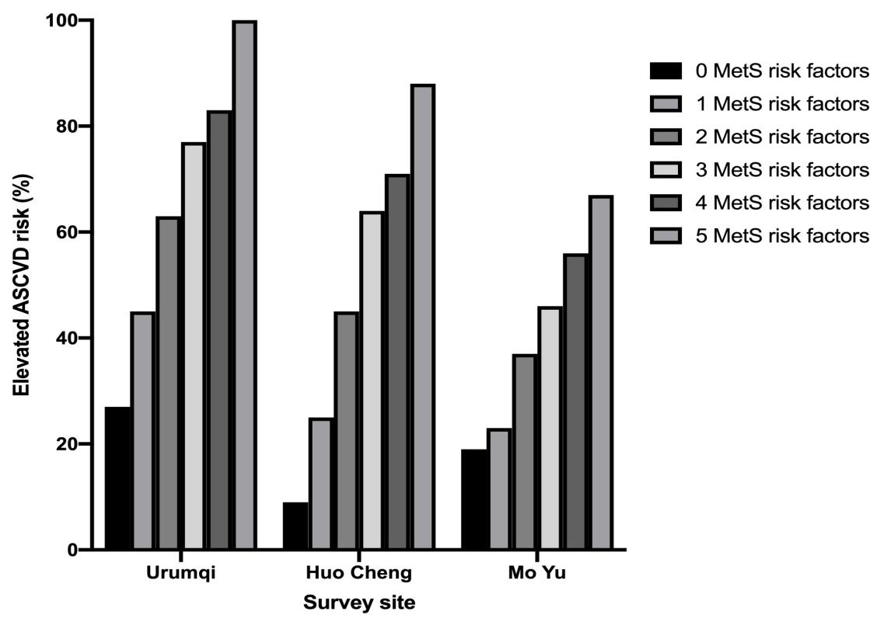
Figure S1 Association between MetS components and increased risk of ASCVD

