**Supplementary**

**Figure 1. Relative expression of *IL6*, *IL33* and *TNFα* in offspring lung.**

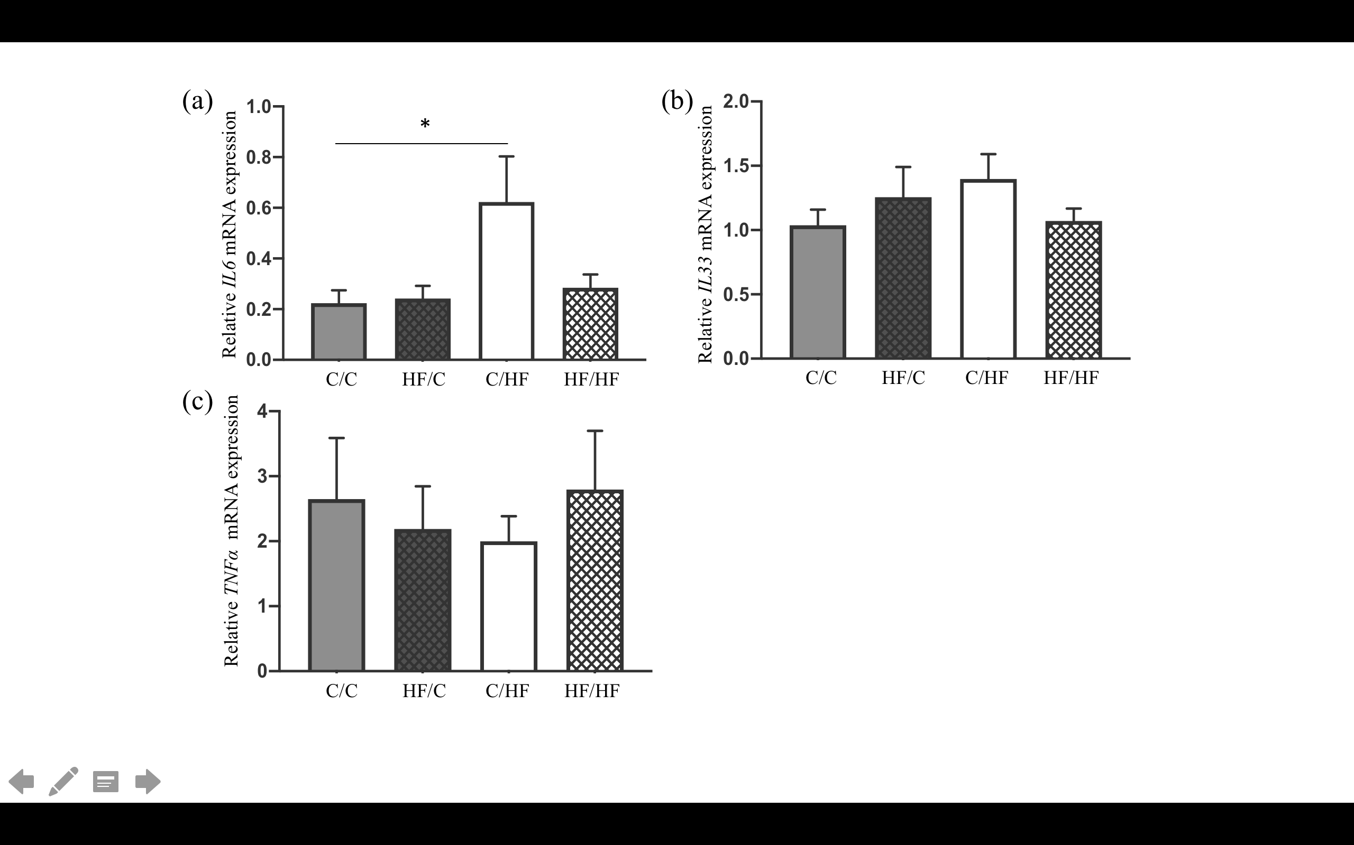

Relative gene expression levels of inflammatory markers for all offspring. Phenotype gene expression compared by Two-way-ANOVA. Significant post-natal difference was identified in *IL6* expression when C/HF compared to C/C group (a, *P*=0.042). Relative expression of *IL33* (b) and *TNFα* (c) did not show any significant difference among study groups.