Table S1. Model fit for models with 2-10 statuses (latent transition analysis)
Log-likelihood | Degrees of freedom | Likelihood-Ratio G² | AIC | BIC | Number of latent statuses
-23697.5 | 1048552 | 12420.92 | 12466.92 | 12599.84 | 2
-23509.1 | 1048537 | 12044.16 | 12120.16 | 12339.76 | 3
-23154 | 1048520 | 11334.02 | 11444.02 | 11761.86 | 4
-22998 | 1048501 | 11021.7 | 11169.7 | 11597.3 | 5
-22924.6 | 1048480 | 10875.13 | 11065.13 | 11614.14 | 6
-22861.3 | 1048457 | 10748.46 | 10984.46 | 11666.39 | 7
-22803 | 1048432 | 10632 | 10918 | 11744.41 | 8
-22738.9 | 1048405 | 10503.79 | 10843.79 | 11826.23 | 9
-22698.8 | 1048376 | 10423.58 | 10821.58 | 11971.61 | 10
Abbreviations: AIC, Akaike Information Criterion; BIC, Bayesian Information Criterion.

Table S2. Test of measurement invariance across time
 | G² | Df | AIC | BIC | Log-likelihood | p-valueª
Model without measurement invariance | 10940,5 | 1048451 | 11188 | 11905 | -22957 | -
Model with measurement invariance | 11021,7 | 1048501 | 11169 | 11597 | -22998 | -
Difference^{b} | 81.2 | 50 | - | - | 41 | 0.003
Abbreviations: AIC, Akaike Information Criterion; BIC, Bayesian Information Criterion; Df, Degree of freedom; G², test for likelihood ratio statistic.
ª p-value of measurement invariance test.
^{b} Difference indicates likelihood-ratio test and difference of degree of freedom between the two models
Table S3. Factors associated with lifestyle behaviour profiles at T0 (baseline): univariable analyses
 | Profile 1  Healthy diet and high PA |  |  | Profile 2  Big eater and moderate to high PA |  |  | Profile 3  Healthy diet and low PA |  | Profile 4  Restrictive diet and moderate PA |  |  | Profile 5  Sugar products, nibbling and moderate PA
 | n= 188 | OR | [95% CI] | n= 570 | OR | [95% CI] | n= 745 | Ref. | n= 493 | OR | [95% CI] | n= 314 | OR | [95% CI]
Gender
Girls | 66 | Ref. | Ref. | 267 | Ref. | Ref. | 484 | . | 302 | Ref. | Ref. | 233 | Ref. | Ref.
Boys | 122 | 3.43 | [2.4;4.8] | 303 | 2.10 | [1.7;2.6] | 261 | . | 191 | 1.17 | [0.9;1.5] | 161 | 1.28 | [1.0;1.6]
Age at entering in grade 10
Classic or advanced | 147 | Ref. | Ref. | 398 | Ref. | Ref. | 633 | . | 348 | Ref. | Ref. | 263 | Ref. | Ref.
Late placement | 41 | 1.58 | [1.1;2.3] | 172 | 2.44 | [1.9;3.2] | 112 | . | 145 | 2.35 | [1.8;3.1] | 131 | 2.81 | [2.1;3.8]
Socio-economic status
Highly advantaged | 16 | Ref. | Ref. | 39 | Ref. | Ref. | 89 | . | 38 | Ref. | Ref. | 24 | Ref. | Ref.
Advantaged | 43 | 1.37 | [0.7;2.6] | 119 | 1.55 | [1.0;2.4] | 175 | . | 95 | 1.27 | [0.8;2.0] | 68 | 1.44 | [0.8;2.4]
Intermediate | 55 | 1.20 | [0.7;2.2] | 177 | 1.59 | [1.0;2.4] | 254 | . | 132 | 1.22 | [0.8;1.9] | 118 | 1.72 | [1.0;2.8]
Less advantaged | 47 | 1.63 | [0.9;3.0] | 145 | 2.07 | [1.3;3.2] | 160 | . | 136 | 1.99 | [1.3;3.1] | 128 | 2.97 | [1.8;4.9]
Highly less advantaged | 27 | 2.24 | [1.1;4.5] | 90 | 3.06 | [1.9;5.0] | 67 | . | 92 | 3.22 | [2.0;5.3] | 56 | 3.10 | [1.7;5.5]
Test for linear trendª |  | 1.18 | [1.0;1.3] |  | 1.26 | [1.1;1.4] |  | . |  | 1.33 | [1.2;1.5] |  | 1.35 | [1.2;1.5]
Overweight/obesity
No | 145 | Ref. | Ref. | 487 | Ref. | Ref. | 596 | . | 366 | Ref. | Ref. | 340 | Ref. | Ref.
Yes | 40 | 1.12 | [0.7;1.7] | 75 | 0.62 | [0.5;0.8] | 147 | . | 118 | 1.31 | [1.0;1.7] | 51 | 0.61 | [0.4;0.9]
Intervention strategies
Educational strategy
No | 79 | Ref. | Ref. | 242 | Ref. | Ref. | 315 | . | 233 | Ref. | Ref. | 191 | Ref. | Ref.
Yes | 109 | 1.01 | [0.7;1.4] | 328 | 0.99 | [0.8;1.2] | 430 | . | 260 | 0.82 | [0.6;1.0] | 203 | 0.78 | [0.6;1.0]
Environmental strategy
No | 99 | Ref. | Ref. | 284 | Ref. | Ref. | 381 | . | 245 | Ref. | Ref. | 201 | Ref. | Ref.
Yes | 89 | 0.94 | [0.7;1.3] | 286 | 1.05 | [0.8;1.3] | 364 | . | 248 | 1.06 | [0.8;1.3] | 193 | 1.00 | [0.8;1.3]
Screening and care strategy
No | 94 | Ref. | Ref. | 312 | Ref. | Ref. | 385 | . | 257 | Ref. | Ref. | 200 | Ref. | Ref.
Yes | 94 | 1.07 | [0.8;1.5] | 258 | 0.88 | [0.7;1.1] | 360 | . | 236 | 0.98 | [0.8;1.2] | 194 | 1.04 | [0.8;1.3]
Abbreviations: OR, odds ratio; CI, confidence interval; Ref, reference.
ª Socioeconomic status (IPSE classes) used as a discrete variable
For all analyses, inactive group was the reference group
OR and 95% CI in bold indicate p-value<0.05.

Table S4. Factors associated with lifestyle behaviours profiles changes using multinomial logistic regression model: univariable analyses
 | Favourable changes¹ |  |  | Mixed changes² |  | Unfavourable changes³
 | n= 671 | OR | [95% CI] | n= 905 | Ref. | n= 814 | OR | [95% CI]
Gender
Girls | 370 | Ref. | Ref. | 577 | . | 405 | Ref. | Ref.
Boys | 301 | 1.43 | [1.2; 1.7] | 328 | . | 409 | 1.78 | [1.5; 2.1]
Age at entering in grade 10
Classic or advanced | 498 | Ref. | Ref. | 737 | . | 554 | Ref. | Ref.
Late placement | 173 | 1.52 | [1.2; 1.9] | 168 | . | 260 | 2.06 | [1.6; 2.6]
Socio-economic status
Highly advantaged | 56 | Ref. | Ref. | 93 | . | 57 | Ref. | Ref.
Advantaged | 132 | 1.03 | [0.7; 1.5] | 212 | . | 156 | 1.20 | [0.8; 1.8]
Intermediate | 202 | 1.13 | [0.8; 1.6] | 297 | . | 237 | 1.30 | [0.9; 1.9]
Less advantaged | 182 | 1.47 | [1.0; 2.2] | 206 | . | 228 | 1.81 | [1.2; 2.6]
Highly less advantaged | 99 | 1.69 | [1.1; 2.6] | 97 | . | 136 | 2.29 | [1.5; 3.5]
Test for linear trend ª |  | 1.16 | [1.1; 1.3] |  | . |  | 1.23 | [1.1; 1.3]
Overweight/obesity
No | 506 | Ref. | Ref. | 721 | . | 707 | Ref. | Ref.
Yes | 157 | 1.25 | [1.0; 1.6] | 179 | . | 95 | 0.54 | [0.4; 0.7]
Intervention strategies
Educational strategy
No | 308 | Ref. | Ref. | 379 | . | 373 | Ref. | Ref.
Yes | 363 | 0.85 | [0.7; 1.0] | 526 | . | 441 | 0.85 | [0.7; 1.0]
Environmental strategy
No | 351 | Ref. | Ref. | 456 | . | 403 | Ref. | Ref.
Yes | 320 | 0.93 | [0.8; 1.1] | 449 | . | 411 | 1.04 | [0.9; 1.2]
Screening and care strategy
No | 358 | Ref. | Ref. | 468 | . | 422 | Ref. | Ref.
Yes | 313 | 0.94 | [0.8; 1.1] | 437 | . | 392 | 0.99 | [0.8; 1.2]
Abbreviations: OR, odds ratio; CI, confidence interval; Ref, reference.
¹Adolescents with improvement in EB and PA, or improvement in PA and no change in EB, or reciprocally from T0 to T2.
²Adolescents with improvement in EB and deterioration in PA from T0 to T2, or reciprocally.
³ Adolescents with deterioration in EB and PA, or improvement in PA and no change in EB, or reciprocally from T0 to T2.
ª Socioeconomic status (IPSE classes) used as a discrete variable.
OR and 95% CI in bold indicate p-value<0.05.

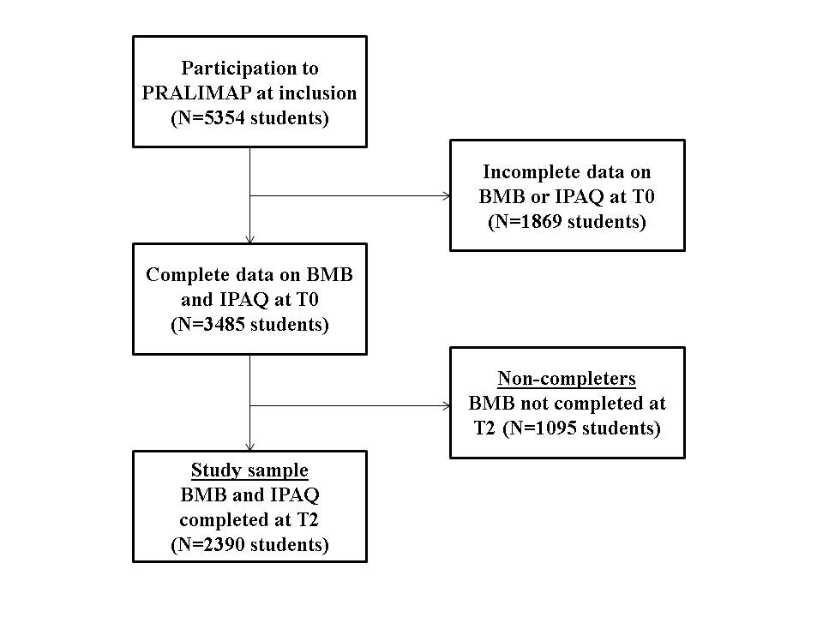
Figure S1. Flow chart of the study sample selection

Figure S2. Lifestyle behaviour profiles identified with latent transition analysis at T0 (baseline) among adolescents (n=2390): 5-statuses model
Abbreviations: PA, physical activity; ST, sedentary time.

