Supplemental data

Supplemental Figure 1. Flowchart of the study design

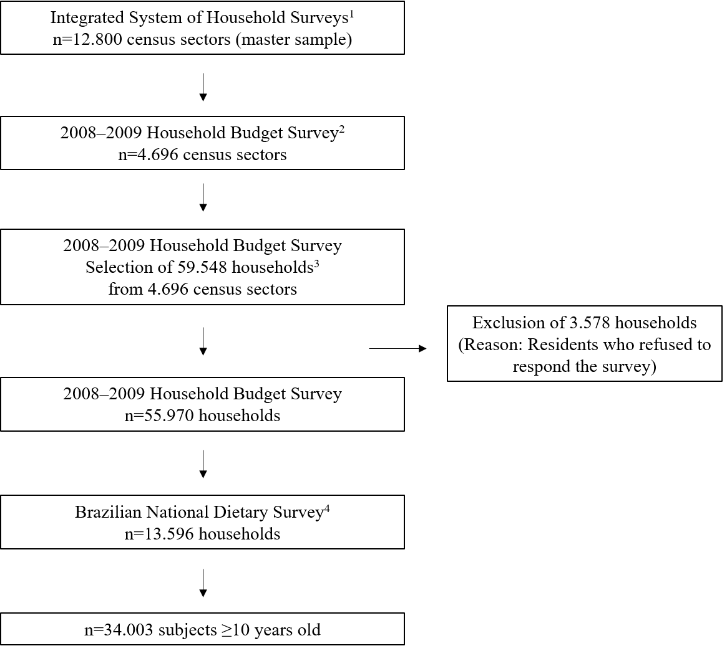
¹Set of census sectors used in the various surveys conducted in the national territory by the Brazilian Institute of Geography and Statistics
²Selection of census sectors carried out using the pre-defined stratification system for the Integrated System of Household Surveys
³ Households selected at random from the pre-defined stratification system. An average loss of 15% was estimated due to possible refusals to answer the survey, and this same proportion was added to the final number of households to minimize possible losses
⁴ Households selected at random from the pre-defined stratification system

Supplemental Table 1. Number of individual polyphenols consumed by Brazilian population
 | Aglycones, glycosides, and esters¹ | Aglycones
Phenolic acids
Hydroxybenzoic acids | 11 | 10
Hydroxycinnamic acids | 57 | 17
Hydroxyphenylacetic acids | 4 | 4
Hydroxyphenylpropanoic acids | 2 | 2
Flavonoids | 0 | 0
Flavan3ols | 19 | 13
Flavones | 14 | 6
Flavonols | 32 | 3
Flavanones | 8 | 3
Anthocyanins | 26 | 6
Isoflavonoids | 13 | 4
Lignans | 13 | 13
Stilbenes | 9 | 6
Furanocoumarins | 4 | 4
Hydroxybenzaldehydes | 4 | 4
Tyrosols | 13 | 5
Alkylphenols | 6 | 6
Alkylmethoxyphenols | 3 | 3
Hydroxycoumarins | 3 | 3
Phenolic terpenes | 3 | 3
Others polyphenols | 9 | 9
Total | 253 | 124
¹Number of aglycone consumed as such or as the conversion of ester and glycoside forms into aglycone equivalents.

Supplemental table 2. Total and polyphenol classes intake (as aglycone equivalents) by socio-demographic characteristics^{1,2}
 | N | Total polyphenols |  | Phenolic acids |  | Flavonoids |  | Lignans |  | Stilbenes |  | Other polyphenols³
 |  | Median | 25-75th percentile | Median | 25-75th percentile | Median | 25-75th percentile | Median | 25-75th percentile | Median | 25-75th percentile | Median | 25-75th percentile
Sex
Male | 15,700 | 378 | 208-1035 | 163 | 78-280 | 116 | 28-823 | 1.3 | 0.7-1.9 | 0.001 | 0.0-0.002 | 1.9 | 1.1-3.0
Female | 18,303 | 350 | 196-982 | 147 | 76-255 | 123 | 31-816 | 1.0 | 0.5-1.5 | 0.001 | 0.0-0.002 | 1.8 | 1.1-2.7
P |  | 0.0001 |  | 0.0001 |  | 0.0707 |  | 0.0001 |  | 0.9124 |  | 0.0001
Race
White | 13,705 | 369 | 206-1090 | 146 | 73-251 | 139 | 35-870 | 1.0 | 0.6-1.8 | 0.001 | 0.0-0.002 | 2.0 | 1.2-3.0
Other | 20,298 | 360 | 195-944 | 162 | 81-287 | 100 | 26-746 | 1.1 | 0.6-1.7 | 0.0004 | 0.0-0.001 | 1.7 | 1.0-2.7
P |  | 0.0001 |  | 0.0001 |  | 0.0001 |  | 0.0001 |  | 0.0002 |  | 0.0001
Age (years)
10-13 | 3,084 | 325 | 178-924 | 100 | 40-209 | 137 | 38-814 | 0.9 | 0.4-1.4 | 0.001 | 0.0-0.002 | 1.8 | 1.1-2.8
14-18 | 3,855 | 355 | 192-1042 | 115 | 42-242 | 153 | 41-839 | 1.0 | 0.6-1.6 | 0.001 | 0.0-0.002 | 1.9 | 1.2-2.9
19-59 | 22,742 | 373 | 204-1024 | 159 | 83-274 | 120 | 29-821 | 1.1 | 0.7-1.8 | 0.001 | 0.0-0.002 | 1.9 | 1.1-2.9
≥60 | 4,322 | 357 | 208-931 | 181 | 96-286 | 90 | 25-702 | 1.1 | 0.6-1.7 | 0.0004 | 0.0-0.001 | 1.6 | 0.9-2.5
P |  | 0.0001 |  | 0.0001 |  | 0.0001 |  | 0.0001 |  | 0.0011 |  | 0.0001
Brazilian region
North | 5,274 | 367 | 190-1045 | 137 | 72-226 | 145 | 32-848 | 0.8 | 0.4-1.4 | 0.001 | 0.0-0.002 | 1.6 | 0.8-2.5
Northeast | 12,615 | 350 | 183-842 | 169 | 88-301 | 79 | 24-591 | 1.0 | 0.6-1.6 | 0.001 | 0.0-0.002 | 1.6 | 0.8-2.7
Midwest | 4,645 | 298 | 163-990 | 116 | 59-210 | 111 | 26-816 | 1.1 | 0.7-1.8 | 0.0004 | 0.0-0.001 | 1.6 | 1.0-2.5
Southeast | 7,302 | 373 | 215-1057 | 160 | 77-264 | 137 | 32-852 | 1.2 | 0.8-1.8 | 0.0004 | 0.0-0.001 | 1.9 | 1.2-2.9
South | 4,167 | 408 | 211-1179 | 143 | 73-257 | 155 | 42-999 | 1.0 | 0.5-2.1 | 0.001 | 0.0-0.002 | 2.3 | 1.5-3.3
P |  | 0.0001 |  | 0.0001 |  | 0.0001 |  | 0.0001 |  | 0.0001 |  | 0.0001
Area
Urban | 25,753 | 362 | 201-1029 | 150 | 75-258 | 127 | 31-826 | 1.0 | 0.6-1.7 | 0.001 | 0.0-0.002 | 2.0 | 1.2-3.0
Rural | 8,250 | 374 | 198-911 | 182 | 96-311 | 87 | 23-679 | 1.3 | 0.7-2.0 | 0.0004 | 0.0-0.001 | 1.2 | 0.6-2.2
P |  | 0.1038 |  | 0.0001 |  | 0.0001 |  | 0.0001 |  | 0.0001 |  | 0.0001
Table 2. (continued)
 | N | Total polyphenols |  | Phenolic acids |  | Flavonoids |  | Lignans |  | Stilbenes |  | Other polyphenols³
 |  | Median | 25-75th percentile | Median | 25-75th percentile | Median | 25-75th percentile | Median | 25-75th percentile | Median | 25-75th percentile | Median | 25-75th percentile
Educational level
Elementary school | 13,935 | 363 | 205-972 | 180 | 97-283 | 95 | 26-731 | 1.1 | 0.7-1.8 | 0.0004 | 0.0-0.001 | 1.9 | 1.1-2.9
Secondary school | 6,387 | 389 | 208-1141 | 148 | 74-248 | 155 | 38-969 | 1.0 | 0.6-1.7 | 0.001 | 0.0-0.002 | 2.1 | 1.3-3.1
University | 2,028 | 417 | 223-1392 | 127 | 69-215 | 200 | 79-1227 | 0.9 | 0.5-1.8 | 0.001 | 0.0-0.002 | 2.3 | 1.5-3.4
P |  | 0.0001 |  | 0.0001 |  | 0.0001 |  | 0.0001 |  | 0.0001 |  | 0.0001
Personal income
Low | 11,335 | 345.8 | 189.5-875.7 | 169.7 | 86.6-287.2 | 82.9 | 23.1-683.3 | 1.1 | 0.7-1.2 | 0.0004 | 0.0001-0.001 | 1.6 | 0.9-2.5
Middle | 11,335 | 362.9 | 200.7-973.7 | 155.2 | 74.9-267.1 | 116.8 | 30.0-810.5 | 1.1 | 0.7-1.7 | 0.001 | 0.0001-0.002 | 1.9 | 1.2-2.9
High | 11,333 | 392.7 | 216.0-1212.5 | 136.5 | 67.8-238.5 | 170.5 | 46.7-1010.8 | 1.0 | 0.5-1.8 | 0.001 | 0.0002-0.002 | 2.1 | 1.4-3.2
P |  | 0.0001 |  | 0.0001 |  | 0.0001 |  | 0.0001 |  | 0.0001 |  | 0.0001
¹Estimates were performed using sample weights to allow population representativeness.
²Comparisons across categories were performed by using Kruskal-Wallis test.
³Other polyphenols as the sum of alkylphenols, alkylmethoxyphenols, furanocoumarins, hydroxybenzaldehydes, hydroxycoumarins, phenolic terpenes, tyrosols, catechols, pyrogallols and phlorins.

