Supplementary data
Supplementary Table 1. Description of studies
Country | Democratic Republic of Congo | Ecuador | Kenya | Sri Lanka | Vietnam
Location | Oriental Province† | Cotopaxi Province | Vihiga County | Ratnapura District | Mai Son District
Data collection period | July-September 2009 | March 2011 | September 2014-2015 | July-September 2013 | August-December 2014
WRA per season | Wet: n=375, mean ± SD age: 32.4 ± 8.7 years | Wet: n=201, mean ± SD age: 34.3 ± 8.9 years | Wet: n=361, mean ± SD age: 28.8 ± 7.3 years  Dry: n=362, mean ± SD age: 28.2 ± 6.8 years | Wet: n=20, mean ± SD age: 35.3 ± 9.1 years | Wet: n=262, mean ± SD age: 24.0 ± 4.4 years  Dry: n=369, mean ± SD age: 24.1 ± 4.5 years
Primary FCT used | Democratic Republic of Congo ⁽¹⁾ and Tanzania ⁽²⁾ | Ecuador ⁽³⁾, Peru ⁽⁴⁾, and Central America ⁽⁵⁾ | Tanzania ⁽²⁾, Kenya ⁽⁶⁾, and West Africa ⁽⁷⁾ | Sri Lanka ⁽⁸⁾ and India ⁽⁹⁾ | Vietnam ⁽¹⁰⁾ and ASEAN ⁽¹¹⁾
WRA, women of reproductive age; FCT, food composition table.†74% formally classified as urban (Kisangani City), however, the province was relying on local food supply due to post-war conflict and was essentially considered a rural food system during data collection ⁽¹²⁾.
Supplementary data
Supplementary Table 2. Proportion of 1,950 women of reproductive age adhering to the EAT-Lancet diet score recommendations without minimum intake values by country and season
Country | Democratic Republic of Congo  (n=375) | Ecuador  (n=201) | Kenya  (n=723) | Sri Lanka  (n=20) | Vietnam  (n=631) | All^{ǂ}  (n=1,950)
Dietary components† | n (%) | n (%) | n (%) | n (%) | n (%) | n (%)
Whole grains
Wet season | 308 (82.1) | 141 (70.2) | 155 (42.9) | 0 (0) | 37 (14.1) | 641 (52.6)
Dry season | NA | NA | 170 (47) | NA | 31 (8.4) | 201 (27.5)
Tubers and starchy vegetables
Wet season | 59 (15.7) | 118 (58.7) | 325 (90) | 13 (65) | 253 (96.6) | 768 (63)
Dry season | NA | NA | 295 (81.5) | NA | 356 (96.5) | 651 (89.1)
Vegetables
Wet season | 44 (11.7) | 45 (22.4) | 55 (15.2) | 4 (20) | 134 (51.2) | 282 (23.1)
Dry season | NA | NA | 166 (45.9) | NA | 113 (30.6) | 279 (38.2)
Fruits
Wet season | 37 (9.9) | 73 (36.3) | 43 (11.9) | 3 (15) | 69 (26.3) | 225 (18.5)
Dry season | NA | NA | 34 (9.4) | NA | 62 (16.8) | 96 (13.1)
Dairy foods
Wet season | 375 (100) | 194 (96.5) | 353 (97.8) | 20 (100) | 262 (100) | 1,204 (98.8)
Dry season | NA | NA | 350 (96.7) | NA | 369 (100) | 719 (98.4)
Protein sources
Beef, lamb, and pork
Wet season | 339 (90.4) | 84 (41.8) | 340 (94.2) | 18 (90) | 117 (44.7) | 898 (73.7)
Dry season | NA | NA | 345 (95.3) | NA | 178 (48.2) | 523 (71.6)
Chicken and other poultry
Wet season | 370 (98.7) | 167 (83.1) | 358 (99.2) | 100 (20) | 209 (79.8) | 1,124 (92.2)
Dry season | NA | NA | 359 (99.2) | NA | 251 (68) | 610 (83.5)
Eggs
Wet season | 368 (98.1) | 141 (70.2) | 354 (98.1) | 19 (95) | 196 (74.8) | 1,078 (88.4)
Dry season | NA | NA | 355 (98.1) | NA | 291 (78.9) | 646 (88.4)
Fish
Wet season | 360 (96) | 188 (93.5) | 356 (98.6) | 17 (85) | 203 (77.5) | 1,124 (92.2)
Dry season | NA | NA | 360 (99.5) | NA | 289 (78.3) | 649 (88.8)
Dry beans, lentils, and peas
Wet season | 336 (89.6) | 193 (96) | 346 (95.8) | 9 (45) | 235 (89.7) | 1,119 (91.8)
Dry season | NA | NA | 316 (87.3) | NA | 326 (88.4) | 642 (87.8)
Soy foods
Wet season | 373 (99.5) | 100 (49.8) | 361 (100) | 20 (100) | 100 (262) | 1,217 (99.8)
Dry season | NA | NA | 362 (100) | NA | 100 (369) | 731 (100)
Peanuts and tree nuts
Wet season | 46 (12.3) | 1 (0.5) | 0 (0) | 0 (0) | 3 (1.2) | 50 (4)
Dry season | NA | NA | 5 (1.4) | NA | 9 (2.5) | 14 (1.9)
Added fats
Wet season | 223 (59.5) | 11 (5.5) | 69 (19.1) | 0 (0) | 11 (4.2) | 314 (25.7)
Dry season | NA | NA | 80 (22.1) | NA | 13 (3.5) | 93 (12.7)
Added sugars
Wet season | 267 (71.2) | 156 (77.6) | 97 (26.9) | 13 (65) | 249 (95) | 782 (64.2)
Dry season | NA | NA | 92 (25.4) | NA | 360 (97.6) | 452 (61.8)
†Recommendations described in Table 1. ^{ǂ}Wet season: Democratic Republic of Congo, Ecuador, Kenya, Sri Lanka, and Vietnam; Dry season: Kenya and Vietnam.
Supplementary data
Supplementary Table 3. Probability of Adequacy of calcium, folate, iron, vitamin A, vitamin C, and zinc in women of reproductive age by country and season
Country | EAR ± SD† | Democratic Republic of Congo  (n=375) | Ecuador  (n=201) | Kenya  (n=723) | Sri Lanka  (n=20) | Vietnam  (n=631) | All^{ǂ}  (n=1,950)
Micronutrient |  | Mean ± SD | Mean ± SD | Mean ± SD | Mean ± SD | Mean ± SD | Mean ± SD
Calcium§ | 800 ± 100 mg/day
Wet season |  | 0.198 ± 0.361 | 0.096 ± 0.259 | 0.120 ± 0.287 | 0.107 ± 0.307 | 0.059 ± 0.212 | 0.127 ± 0.298
Dry season |  | NA | NA | 0.208 ± 0.367 | NA | 0.025 ± 0.128 | 0.116 ± 0.288
Folate | 320 ± 32 μg/day
Wet season |  | 0.245 ± 0.384 | NA | 0.125 ± 0.291 | 0.340 ± 0.467 | 0.295 ± 0.428 | 0.217 ± 0.375¶¶
Dry season |  | NA | NA | 0.545 ± 0.466 | NA | 0.345 ± 0.450 | 0.444 ± 0.468
Iron¶ | †† mg/day
Wet season |  | 0.642 ± 0.446 | 0.422 ± 0.427 | 0.893 ± 0.279 | 0.911 ± 0.272 | 0.964 ± 0.160 | 0.754 ± 0.398
Dry season |  | NA | NA | 0.891 ± 0.290 | NA | 0.945 ± 0.205 | 0.918 ± 0.252
Vitamin A^{ǂǂ} | 270 ± 54 μg/day RE
Wet season |  | 0.962 ± 0.185 | 0.680 ± 0.400 | 0.502 ± 0.445 | 0.327 ± 0.453 | 0.816 ± 0.364 | 0.738 ± 0.404
Dry season |  | NA | NA | 0.759 ± 0.408 | NA | 0.846 ± 0.340 | 0.803 ± 0.378
Vitamin C | 38 ± 3.8 mg/day
Wet season |  | 0.861 ± 0.335 | 0.861 ± 0.316 | 0.629 ± 0.459 | 0.239 ± 0.427 | 0.755 ± 0.413 | 0.759 ± 0.408
Dry season |  | NA | NA | 0.767 ± 0.411 | NA | 0.687 ± 0.444 | 0.727 ± 0.429
Zinc§§ | 34%: 6.0 ± 0.75 mg/d  25%: 7 ± 0.88 mg/day
Wet season |  | 0.315 ± 0.419 | 0.377 ± 0.417 | 0.763 ± 0.377 | 0.763 ± 0.391 | 0.997 ± 0.042 | 0.612 ± 0.450
Dry season |  | NA | NA | 0.810 ± 0.348 | NA | 0.980 ± 0.131 | 0.896 ± 0.275
NA, data not available. †Estimated Average Requirements (EAR) are given for non-pregnant non-lactating (NPNL) women aged 19-65 years from the Food and Agriculture Organization of the United Nations (FAO) & World Health Organization (WHO) (2004) unless otherwise stated ⁽¹³⁾. Values for EAR are adjusted for an assumed bioavailability and thus refer to intake of the nutrient, not the physiological need for the absorbed nutrient. All SD were calculated based on EAR and coefficients of variation (CV; SD=CV*EAR/100). CV is assumed to be 10% for all micronutrients except 20% for vitamin A and 12.5% for zinc ⁽¹⁴⁾ and calcium ⁽¹⁵⁾. ^{ǂ}Wet season: Democratic Republic of Congo, Ecuador, Kenya, Sri Lanka, and Vietnam; Dry season: Kenya and Vietnam. §EAR taken from the Institute of Medicine (IOM) (2001) ⁽¹⁴⁾. ¶According to FAO & WHO (2004), either a very low (5%) or low (10%) absorption level can be assumed in a low- and middle-income country. ††Tables I-6 and I-7 in IOM (2001) report the Probability of Adequacy for various levels of iron intakes, using a bioavailability of 18% for adult women. Calculations have been adjusted for a bioavailability of 10% for the present study. ^{ǂǂ}As retinol equivalents (RE). 1 RE = 1 μg retinol, 6 μg β-carotene, 12 μg α-carotene, or 12 μg β-cryptoxanthin ⁽¹³⁾. The RAE for dietary provitamin A carotenoids is two-fold greater than retinol equivalents (RE), whereas the RAE for preformed vitamin A is the same as RE. §§As suggested by requirements for NPNL women: 34% for mixed diets or refined vegetarian diets; 25% for unrefined cereal-based diets ⁽¹⁶⁾. ¶¶Total sample-size for folate in the wet season (n=1,018), due to the absence of data from Ecuador (n=201).
Supplementary data
Supplementary Table 4. Proportion of 1,950 women of reproductive age adhering to the EAT-Lancet diet score recommendations with minimum intake values by country and season
Country | Democratic Republic of Congo  (n=375) | Ecuador  (n=201) | Kenya  (n=723) | Sri Lanka  (n=20) | Vietnam  (n=631) | All^{ǂ}  (n=1,950)
Dietary components† | n (%) | n (%) | n (%) | n (%) | n (%) | n (%)
Whole grains
Wet season | 78 (20.8) | 95 (47.3) | 119 (33) | 0 (0) | 34 (13) | 326 (26.7)
Dry season | NA | NA | 105 (29) | NA | 25 (6.8) | 130 (17.8)
Tubers and starchy vegetables
Wet season | 29 (7.7) | 22 (11) | 2 (0.6) | 3 (15) | 2 (0.8) | 58 (4.8)
Dry season | NA | NA | 7 (1.9) | NA | 11 (3) | 18 (2.5)
Vegetables
Wet season | 44 (11.7) | 45 (22.4) | 55 (15.2) | 4 (20) | 134 (51.2) | 282 (23.1)
Dry season | NA | NA | 166 (45.9) | NA | 113 (30.6) | 279 (38.2)
Fruits
Wet season | 37 (9.9) | 73 (36.3) | 43 (11.9) | 3 (15) | 69 (26.3) | 225 (18.5)
Dry season | NA | NA | 34 (9.4) | NA | 62 (16.8) | 96 (13.1)
Dairy foods
Wet season | 0 (0) | 36 (17.9) | 36 (10) | 0 (0) | 0.0 (0) | 72 (5.9)
Dry season | NA | NA | 62 (17.1) | NA | 1 (0.3) | 63 (8.6)
Protein sources
Beef, lamb, and pork
Wet season | 20 (5.3) | 4 (2) | 1 (0.3) | 1 (5) | 9 (3.4) | 35 (2.9)
Dry season | NA | NA | 2 (0.6) | NA | 10 (2.7) | 12 (1.6)
Chicken and other poultry
Wet season | 3 (0.8) | 19 (9.5) | 1 (0.3) | 0 (0) | 12 (4.6) | 35 (2.9)
Dry season | NA | NA | 0 (0) | NA | 10 (2.7) | 10 (1.4)
Eggs
Wet season | 1 (0.3) | 7 (3.5) | 0 (0) | 0 (0) | 8 (3.1) | 16 (1.3)
Dry season | NA | NA | 0 (0) | NA | 14 (3.8) | 14 (1.9)
Fish
Wet season | 58 (15.5) | 33 (16.4) | 37 (10.3) | 8 (40) | 52 (19.9) | 188 (15.4)
Dry season | NA | NA | 49 (13.5) | NA | 67 (18.2) | 116 (15.9)
Dry beans, lentils, and peas
Wet season | 20 (5.3) | 11 (5.5) | 8 (2.2) | 3 (15) | 13 (5) | 55 (4.5)
Dry season | NA | NA | 21 (5.8) | NA | 14 (3.8) | 35 (4.8)
Soy foods
Wet season | 10 (2.7) | 0 (0) | 0 (0) | 0 (0) | 0 (0) | 10 (0.8)
Dry season | NA | NA | 0 (0) | NA | 0 (0) | 0 (0)
Peanuts and tree nuts
Wet season | 46 (12.3) | 1 (0.5) | 0 (0) | 0 (0) | 3 (1.2) | 50 (4)
Dry season | NA | NA | 5 (1.4) | NA | 9 (2.5) | 14 (1.9)
Added fats
Wet season | 223 (59.5) | 11 (5.5) | 69 (19.1) | 0 (0) | 11 (4.2) | 314 (25.7)
Dry season | NA | NA | 80 (22.1) | NA | 13 (3.5) | 93 (12.7)
Added sugars
Wet season | 267 (71.2) | 156 (77.6) | 97 (26.9) | 13 (65) | 249 (95) | 782 (64.2)
Dry season | NA | NA | 92 (25.4) | NA | 360 (97.6) | 452 (61.8)
†Recommendations described in Table 1. ^{ǂ}Wet season: Democratic Republic of Congo, Ecuador, Kenya, Sri Lanka, and Vietnam; Dry season: Kenya and Vietnam.

Supplementary data
Mean Probability of Adequacy (0-1)
β (SE)
Country | Democratic Republic of Congo |  | Ecuador |  | Kenya |  | Sri Lanka |  | Vietnam |  | All†
Total energy intake (kcal/day) | < 2500  (n=267) | ≥ 2500  (n=108) | < 2500  (n=195) | ≥ 2500  (n=6) | < 2500  (n=361) | ≥ 2500  (n=362) | < 2500  (n=16) | ≥ 2500  (n=4) | < 2500  (n=192) | ≥ 2500  (n=439) | < 2500  (n=1,031) | ≥ 2500  (n=919)
EAT-Lancet diet score, without minimum intake values (per 1-point increase) | 0.010  (0.011) | -0.036  (0.012)** | -0.025  (0.012)* | 0.054  (0.083) | 0.027  (0.012)* | 0.045  (0.009)*** | -0.041  (0.038) | -0.033  (0.031) | -0.018  (0.012) | 0.009  (0.006) | -0.001  (0.006) | 0.006  (0.015)
EAT-Lancet diet score, with minimum intake values (per 1-point increase) | 0.023  (0.010) | -0.035  (0.015)** | 0.025  (0.013) | 0.011  (0.087) | 0.077  (0.010)*** | 0.075  (0.009)*** | 0.001  (0.042) | -0.059  (0.056) | 0.056  (0.015)*** | 0.038  (0.008)*** | 0.043  (0.013)** | 0.024  (0.023)
Supplementary Table 5. Association between EAT-Lancet diet scores, without or with minimum intake values, and Mean Probability of Adequacy in women of reproductive age, by total energy intake
†Mixed effects linear regression model with random intercept: country; random slope: association between EAT-Lancet diet score and MPA by country. *Significant at the 5% level. **Significant at the 1% level. ***Significant at the 0.1% level.

Supplementary data
Supplementary Table 6. Associations between EAT-Lancet diet scores, with or without minimum intake values and adjusted for each individual recommendation, and Mean Probability of Adequacy in women of reproductive age
Mean Probability of Adequacy (0-1)
β (SE)
 | Without minimum intake values  (n=1,950) | With minimum intake values  (n=1,950)
EAT-Lancet diet score (per 1-point increase) | -0.026 ± 0.007*** | 0.024 ± 0.013
EAT-Lancet diet score, minus rice, wheat, corn, and other (per 1-point increase) | 0.130 ± 0.012***† | 0.092 ± 0.012***
EAT-Lancet diet score, minus potatoes and cassava (per 1-point increase) | 0.058 ± 0.014*** | 0.030 ± 0.012**
EAT-Lancet diet score, minus all vegetables (per 1-point increase) | -0.195 ± 0.011***† | -0.134 ± 0.012***†
EAT-Lancet diet score, minus all fruits (per 1-point increase) | -0.054 ± 0.010*** | 0.005 ± 0.011
EAT-Lancet diet score, minus whole milk or derivative equivalents (per 1-point increase) | -0.018 ± 0.008* | -0.041 ± 0.017*
EAT-Lancet diet score, minus beef, lamb, and pork (per 1-point increase) | 0.014 ± 0.012† | 0.029 ± 0.012*
EAT-Lancet diet score, minus chicken and other poultry (per 1-point increase) | -0.022 ± 0.007** | 0.032 ± 0.012**
EAT-Lancet diet score, minus eggs (per 1-point increase) | 0.031 ± 0.015* | 0.018 ± 0.013
EAT-Lancet diet score, minus fish (per 1-point increase) | 0.024 ± 0.015 | 0.002 ± 0.012†
EAT-Lancet diet score, minus dry beans, lentils, and peas (per 1-point increase) | 0.104 ± 0.017*** | 0.019 ± 0.012
EAT-Lancet diet score, minus soy foods (per 1-point increase) | -0.026 ± 0.008** | 0.011 ± 0.015†
EAT-Lancet diet score, minus peanuts and tree nuts (per 1-point increase) | -0.038 ± 0.010*** | -0.038 ± 0.010***
EAT-Lancet diet score, minus palm oil, unsaturated oils, dairy fats (included in milk), lard or tallow (per 1-point increase) | -0.044 ± 0.009*** | 0.013 ± 0.011
EAT-Lancet diet score, minus all sweeteners (per 1-point increase) | -0.004 ± 0.010 | 0.074 ± 0.012***
Mixed effects linear regression model with random intercept: country; random slope: association between EAT-Lancet diet score and MPA by country. *Significant at the 5% level. **Significant at the 1% level. ***Significant at the 0.1% level. †Interaction term between dietary recommendation and EAT-Lancet diet score significant at the 5% level.
Supplementary data
Standardised energy-adjusted Mean Probability of Adequacy (SD)
β (SE)
Country | Democratic Republic of Congo  (n=375) | Ecuador  (n=201) | Kenya  (n=723) | Sri Lanka  (n=20) | Vietnam  (n=631) | All†  (n=1,950)
EAT-Lancet diet score, without minimum intake values (per 1-point increase) | 0.17 ± 0.04*** | 0.19 ± 0.07*** | 0.29 ± 0.03*** | -0.11 ± 0.15 | 0.14 ± 0.03*** | 0.20 ± 0.03***
EAT-Lancet diet score, with minimum intake values (per 1-point increase) | -0.02 ± 0.05 | 0.19 ± 0.05* | 0.26 ± 0.03*** | -0.04 ± 0.18 | 0.21 ± 0.03*** | 0.16 ± 0.06*
Supplementary Table 7. Association between EAT-Lancet diet score, without or with minimum intake values, and standardised energy-adjusted Mean Probability of Adequacy in women of reproductive age, by country
†Mixed effects linear regression model with random intercept: country; random slope: association between EAT-Lancet diet score and MPA by country. *Significant at the 5% level. **Significant at the 1% level. ***Significant at the 0.1% level.
Supplementary data
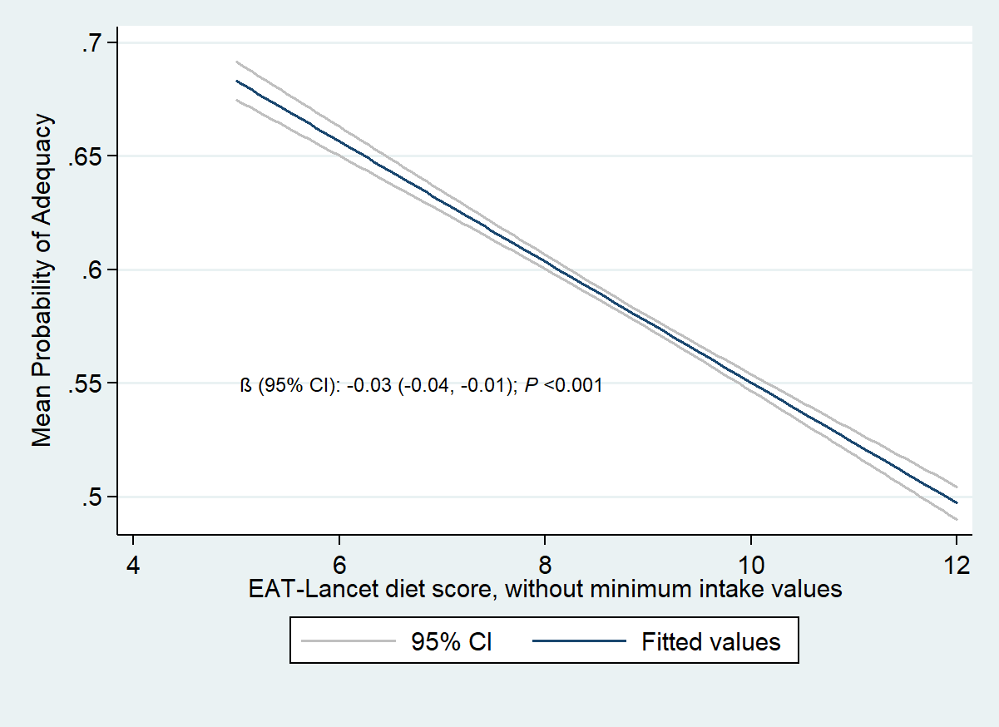
Supplementary Figure 1. Association between EAT-Lancet diet score, without minimum intake values, and Mean Probability of Adequacy of diets in 1,950 women of reproductive age in five low- and middle-income countries (wet and dry season combined). Linear prediction plot with CI was fitted from our linear mixed-effects model.
Supplementary data
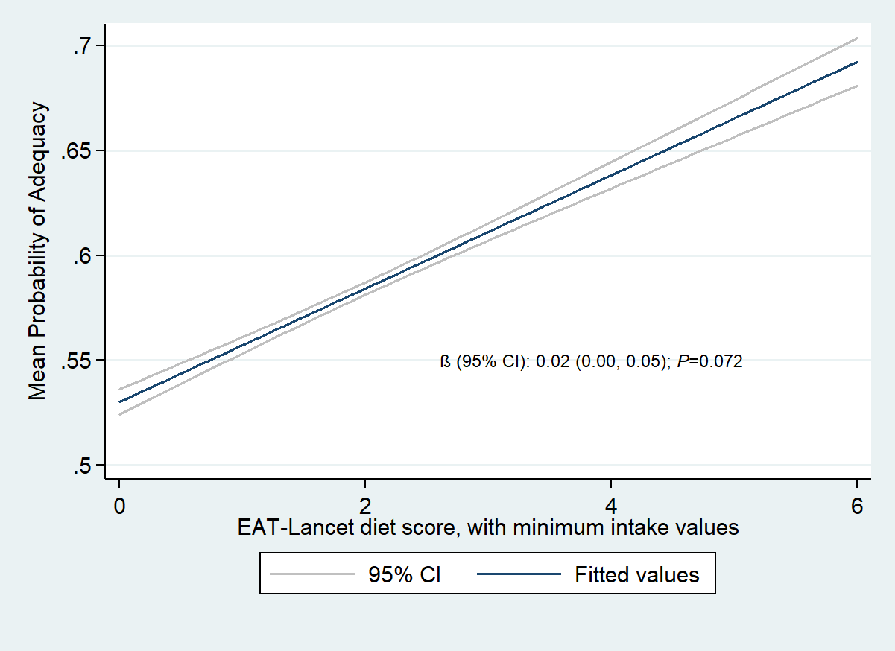
Supplementary Figure 2. Association between EAT-Lancet diet score, with minimum intake values, and Mean Probability of Adequacy of diets in 1,950 women of reproductive age in five low- and middle-income countries (wet and dry season combined). Linear prediction plot with CI was fitted from our linear mixed-effects model.

Supplementary data
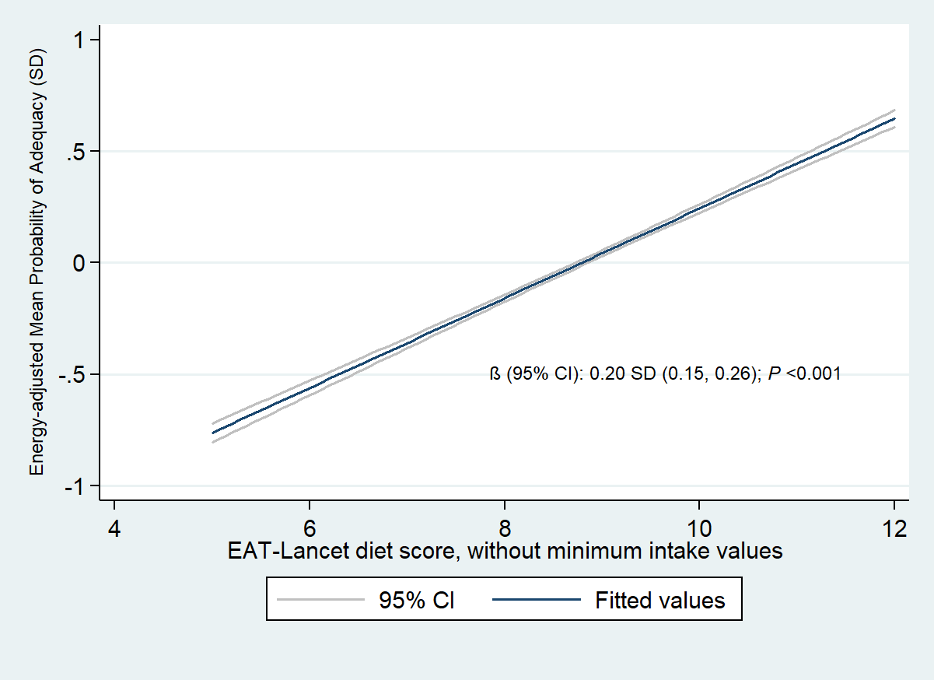
Supplementary Figure 3. Association between EAT-Lancet diet score, without minimum intake values, and standardised energy-adjusted Mean Probability of Adequacy of diets in 1,950 women of reproductive age in five low- and middle-income countries (wet and dry season combined). Linear prediction plot with CI was fitted from our linear mixed-effects model.

Supplementary data
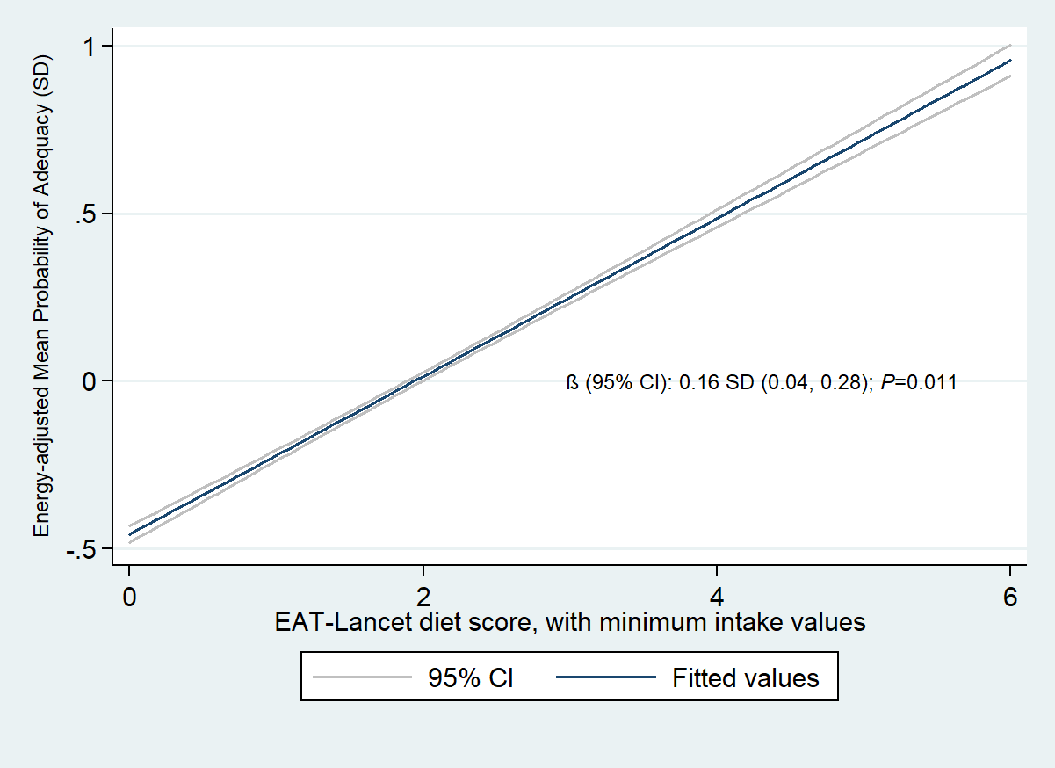Supplementary Figure 4. Association between EAT-Lancet diet score, with minimum intake values, and standardised energy-adjusted Mean Probability of Adequacy of diets in 1,950 women of reproductive age in five low- and middle-income countries (wet and dry season combined). Linear prediction plot with CI was fitted from our linear mixed-effects model.

Supplementary data
Supplementary Text 1. STROBE-nut: An extension of the STROBE statement for nutritional epidemiology (17)
Item | Item nr | STROBE recommendations | Extension for Nutritional Epidemiology studies (STROBE-nut) | Reported on page #
Title and  abstract | 1 | (a) Indicate the study’s design with a commonly used term in the title or the abstract.  (b) Provide in the abstract an informative and balanced summary of what was done and what was found. | nut-1 State the dietary/nutritional assessment method(s) used in the title, abstract, or keywords. | 3, 4
Introduction
Background rationale | 2 | Explain the scientific background and rationale for the investigation being reported. |  | 5-7
Objectives | 3 | State specific objectives, including any pre-specified hypotheses. |  | 6, 7
Methods
Study design | 4 | Present key elements of study design early in the paper. |  | 8
Settings | 5 | Describe the setting, locations, and relevant dates, including periods of recruitment, exposure, follow-up, and data collection. | nut-5 Describe any characteristics of the study settings that might affect the dietary intake or nutritional status of the participants, if applicable. | 8, S1
Participants | 6 | a) Cohort study—Give the eligibility criteria, and the sources and methods of selection of participants. Describe methods of follow-up.  Case-control study—Give the eligibility criteria, and the sources and methods of case ascertainment and control selection. Give the rationale for the choice of cases and controls.  Cross-sectional study—Give the eligibility criteria, and the sources and methods of selection of participants.  (b) Cohort study—For matched studies, give matching criteria and number of exposed and unexposed.  Case-control study—For matched studies, give matching criteria and the number of controls per case. | nut-6 Report particular dietary, physiological or nutritional characteristics that were considered when selecting the target population. | 8
Variables | 7 | Clearly define all outcomes, exposures, predictors, potential confounders, and effect modifiers. Give diagnostic criteria, if applicable. | nut-7.1 Clearly define foods, food groups, nutrients, or other food components.  nut-7.2 When using dietary patterns or indices, describe the methods to obtain them and their nutritional properties. | 9, 10, 26  8-10
Data sources - measurements | 8 | For each variable of interest, give sources of data and details of methods of assessment (measurement).Describe comparability of assessment methods if there is more than one group. | nut-8.1 Describe the dietary assessment method(s), e.g., portion size estimation, number of days and items recorded, how it was developed and administered, and how quality was assured. Report if and how supplement intake was assessed.  nut-8.2 Describe and justify food composition data used. Explain the procedure to match food composition with consumption data. Describe the use of conversion factors, if applicable.  nut-8.3 Describe the nutrient requirements, recommendations, or dietary guidelines and the evaluation approach used to compare intake with the dietary reference values, if applicable.  nut-8.4 When using nutritional biomarkers, additionally use the STROBE Extension for Molecular Epidemiology (STROBE-ME). Report the type of biomarkers used and their usefulness as dietary exposure markers.  nut-8.5 Describe the assessment of nondietary data (e.g., nutritional status and influencing factors) and timing of the assessment of these variables in relation to dietary assessment.  nut-8.6 Report on the validity of the dietary or nutritional assessment methods and any internal or external validation used in the study, if applicable. | 8-11  8, S1  8-10, S3  NA  NA  8-10
Bias | 9 | Describe any efforts to address potential sources of bias. | nut-9 Report how bias in dietary or nutritional assessment was addressed, e.g., misreporting, changes in habits as a result of being measured, or data imputation from other sources | 8, S1
Study Size | 10 | Explain how the study size was arrived at. |  | 8
Quantitative variables | 11 | Explain how quantitative variables were handled in the analyses. If applicable, describe which groupings were chosen and why. | nut-11 Explain categorization of dietary/nutritional data (e.g., use of N-tiles and handling of nonconsumers) and the choice of reference category, if applicable. | 9, 10
Statistical  Methods | 12 | (a) Describe all statistical methods, including those used to control for confounding  (b) Describe any methods used to examine subgroups and interactions.  (c) Explain how missing data were addressed.  (d) Cohort study—If applicable, explain how loss to follow-up was addressed.  Case-control study—If applicable, explain how matching of cases and controls was addressed.  Cross-sectional study—If applicable, describe analytical methods taking account of sampling strategy.  (e) Describe any sensitivity analyses. | nut-12.1 Describe any statistical method used to combine dietary or nutritional data, if applicable.  nut-12.2 Describe and justify the method for energy adjustments, intake modeling, and use of weighting factors, if applicable.  nut-12.3 Report any adjustments for measurement error, i.e,. from a validity or calibration study. | 10, 11  10, 11  NA
Results
Participants | 13 | (a) Report the numbers of individuals at each stage of the study—e.g., numbers potentially eligible, examined for eligibility, confirmed eligible, included in the study, completing follow-up, and analyzed.  (b) Give reasons for non-participation at each stage.  (c) Consider use of a flow diagram. | nut-13 Report the number of individuals excluded based on missing, incomplete or implausible dietary/nutritional data. | 12
Descriptive data | 14 | (a) Give characteristics of study participants (e.g., demographic, clinical, social) and information on exposures and potential confounders  (b) Indicate the number of participants with missing data for each variable of interest  (c) Cohort study—Summarize follow-up time (e.g., average and total amount) | nut-14 Give the distribution of participant characteristics across the exposure variables if applicable. Specify if food consumption of total population or consumers only were used to obtain results. | 12
Outcome data | 15 | Cohort study—Report numbers of outcome events or summary measures over time.  Case-control study—Report numbers in each exposure category, or summary measures of exposure.  Cross-sectional study—Report numbers of outcome events or summary measures. |  | 12
Main results | 16 | (a) Give unadjusted estimates and, if applicable, confounder-adjusted estimates and their precision (e.g., 95% confidence interval).  Make clear which confounders were adjusted for and why they were included.  (b) Report category boundaries when continuous variables were categorized.  (c) If relevant, consider translating estimates of relative risk into absolute risk for a meaningful time period. | nut-16 Specify if nutrient intakes are reported with or without inclusion of dietary supplement intake, if applicable. | 8, 12-14
Other analyses | 17 | Report other analyses done—e.g., analyses of subgroups and interactions and sensitivity analyses. | nut-17 Report any sensitivity analysis (e.g., exclusion of misreporters or outliers) and data imputation, if applicable. | 12-14
Discussion
Key results | 18 | Summarize key results with reference to study objectives. |  | 15
Limitation | 19 | Discuss limitations of the study, taking into account sources of potential bias or imprecision. Discuss both direction and magnitude of any potential bias. | nut-19 Describe the main limitations of the data sources and assessment methods used and implications for the interpretation of the findings. | 17-18
Interpretation | 20 | Give a cautious overall interpretation of results considering objectives, limitations, multiplicity of analyses, results from similar studies, and other relevant evidence. | nut-20 Report the nutritional relevance of the findings, given the complexity of diet or nutrition as an exposure. | 15-18
Generalizability | 21 | Discuss the generalizability (external validity) of the study results. |  | 18
Other information
Funding | 22 | Give the source of funding and the role of the funders for the present study and, if applicable, for the original study on which the present article is based. |  | 1, 2
Ethics |  |  | nut-22.1 Describe the procedure for consent and study approval from ethics committee(s). | 2, 8
Supplementary material |  |  | nut-22.2 Provide data collection tools and data as online material or explain how they can be accessed. | 2, 8

Supplementary references
1. Degroote V. Tables de Composition Alimentaire pour la République Démocratique du Congo. Kinshasa: Concordia; 1965. 32 p.
2. Lukmanji Z, Hertzmark E, Mlingi N, Assey V, Fawzi WW. Tanzania Food Composition Tables. 1st ed. Dar es Salaam: MUHAS, TFNC, and HSPH; 2008. 259 p.
3. Instituto Nacional de la Nutrición. Tabla de Composición de Alimentos Ecuatorianos. Quito: Ministero de Prevision Social y Sanidad; 1965.
4. Centro Nacional de Alimentación y Nutrición. Tablas Peruanas De Compsición de Alimentos. Lima: Instituto Nacional de Salud; 2009.
5. Instituto de Nutrición de Centro América y Panamá. Tabla de Composición de Alimentos de Centroamérica. 2nd ed. Organización Panamericana de la Salud; 2012. 128 p.
6. Sehmi JK. National Food Composition Tables and the Planning of Satisfactory Diets in Kenya. Nairobi: Government Printer; 1993. 200 p.
7. Stadlmayr B, Charrondiere UR, Enujiugha VN, Bayili RG, Fagbohoun EG, Samb B, et al. West African Food Composition Table. Rome: FAO; 2012.
8. Thamilini J, Silva K, Sirasa M, Samarasinghe W. Food Composition Data in Sri Lanka: Past, Present, and Future. In: International Food Data Conference. Hyderabad, India; 2015. p. S1-33.
9. Gopalang C, Rama Sastri B V., Balasubramanian SC. Nutritive Value of Indian Foods. Hyderabad: National Institute of Nutrition; 1989. p. 58.
10. National Institute of Nutrition. Food Products in Vietnam, Composition and Nutritive Value. Hanoi: Ministry of Health, Medicine Publisher; 1995. 555 p.
11. Institute of Nutrition, Mahidol University. ASEAN Food Composition Database [Internet]. Bangkok: ASEANFOODS Regional Centre and INFOODS Regional Database Centre; 2014. 87 p. Available from: http://www.inmu.mahidol.ac.th/aseanfoods/doc/ASEAN_FCD_V1_2014.pdf
12. Termote C, Bwama Meyi M, Dhed’a Djailo B, Huybregts L, Lachat C, Kolsteren P, et al. A biodiverse rich environment does not contribute to a better diet: a case study from DR Congo. PLoS One. 2012 Jan;7(1):e30533.
13. Food and Agriculture Organization of the United Nations (FAO), World Health Organization (WHO). Vitamin and mineral requirements in human nutrition [Internet]. 2nd ed. Geneva: FAO and WHO; 2004. 1–20 p. Available from: www.who.org
14. Institute of Medicine (IOM). Dietary Reference Intakes for Vitamin A, Vitamin K, Arsenic, Boron, Chromium, Copper, Iodine, Iron, Manganese, Molybdenum, Nickel, Silicon, Vanadium, and Zinc [Internet]. Washington, D.C.: National Academies Press; 2001. 773 p. Available from: http://www.nap.edu/catalog/10026.html
15. Institute of Medicine (IOM). Dietary Reference Intakes for Calcium and Vitamin D [Internet]. Washington, D.C.: National Academy Press; 2011. 1115 p. Available from: https://www.nap.edu/catalog/13050.html
16. Brown KH, Rivera JA, Bhutta Z, Gibson RS, King JC, Lönnerdal B, et al. International Zinc Nutrition Consultative Group (IZiNCG) technical document #1. Assessment of the risk of zinc deficiency in populations and options for its control. Food Nutr Bull Bull. 2004;25(Suppl 2):S99-203.
17. Lachat C, Hawwash D, Ocké MC, Berg C, Forsum E, Hörnell A, et al. Strengthening the Reporting of Observational Studies in Epidemiology – Nutritional Epidemiology (STROBE-nut): An extension of the STROBE statement. PLoS Med. 2016;13(6):e1002036.

