Online Supplement Material

Supplementary Table 1 Components and scoring criteria for the Alternative Healthy Eating Index (AHEI) as previously published by the InterAct consortium(1)
Component of dietary pattern | Range of points | Criterion for lowest points | Criterion for highest points
Vegetables | 0-10 | 0 servings/day* | ≥ 5 servings/day*
Fruits | 0-10 | 0 servings/day* | ≥ 4 servings/day*
Nuts | 0-10 | 0 servings/day* | ≥ 1 serving/day*
Ratio of white to red meat | 0-10 | 0 | ≥ 4
Cereal fibre | 0-10 | 0 g/day | ≥ 15 g/day
Ratio of PUFA to SFA | 0-10 | ≤ 0.1 | ≥ 1
Alcohol
Men | 0-10 | 0 to > 3.5 drinks/day* | 1.5 - 2.5 drinks/day*
Women | 0-10 | 0 to >2.5 drinks/day* | 0.5-1.5 drinks/day*
*Serving sizes are defined as follows: vegetables, fruits, 125 g; nuts, seeds, 30 g; meat, poultry, 30 g; fats, oils, 10 g; alcoholic drink, drink containing 5 g pure ethanol

Supplementary Table 2 Components of the Mediterranean diet score and their respective scoring points by Galbete et al.(2)
Food groups | Food items considered in each group | Scoring criteria
Cereals | Whole-grain bread, other bread, grain flakes, grains, muesli, cornflakes, crisps, pasta, rice | Sex-specific tertiles  T1 = 0, T2 = 1, T3 = 2
Fruits and nuts | Fresh fruits, nuts | Sex-specific tertiles  T1 = 0, T2 = 1, T3 = 2
Vegetables | Raw vegetables, green salad, cruciferous vegetables, cooked vegetables, garlic, mushrooms | Sex-specific tertiles  T1 = 0, T2 = 1, T3 = 2
Fish | Fish (preserved and smoked is also considered) | Sex-specific tertiles  T1 = 0, T2 = 1, T3 = 2
Legumes | Legumes (green peas, green beans, lentil, peas, bean stew) | Sex-specific tertiles  T1 = 0, T2 = 1, T3 = 2
Meat | Poultry, meat, meat products | Sex-specific tertiles  T1 = 2, T2 = 1, T3 = 0
Dairy products* | Low-fat dairy products, high-fat dairy products, low-fat cheese, high-fat cheese | Sex-specific tertiles  T1 = 2, T2 = 1, T3 = 0
Alcohol | Beer, wine, spirits, other alcoholic beverages | 5 to 25g/day for women =2  10-50g/day for men = 2  Outside of the range = 0
Olive oil | Olive oil for salad dressing, preparation of vegetables, and preparation of meat | Non-consumers = 0  < sex-specific median = 1  ≥ sex-specific median = 2
*contrarily to previous publication, Butter is no longer included

Supplementary Table 3 Components and scoring criteria of the MedPyramid as published by Galbete et al.(2)
Component | Recommended intake | Score of 0 | Score of 1
Vegetables | ≥ 6/d | 0/d | ≥ 6/d
Legumes | ≥ 2/wk | 0/wk | ≥ 2/wk
Fruits | 3-6/d | 0/d | 3-6/d
Nuts | 1-2/d | 0/d | 1-2/d
Cereals | 3-6/d | 0/d | 3-6/d
Dairy | 2/d | 0/d | 1.5-2.5/d
Fish | ≥ 2/wk | 0/wk | ≥ 2/wk
Red meat | < 2/wk | ≥ 4/wk | < 2/wk
Processed Meat | ≤ 1/wk | ≥ 2/wk | ≤ 1/wk
White Meat | 2/wk | 0/wk | 1.5-2.5/wk
Egg | 2-4/wk | 0/wk | 2-4/wk
Potatoes | ≤ 3/wk | ≥ 6/wk | ≤ 3/wk
Sweets | ≤ 2/wk | ≥ 4/wk | ≤ 2/wk
Alcohol | 10-50g/d for men  5-25g/d for women | >50g/d for men  >25g/d for women | 10-50g/d for men  5.25g/d for women
Olive Oil | Principal source of dietary lipids | Non-consumers | Consumers

Supplementary Table 4 Overview of the 39 food groups and their respective food items
 | Food group | Food items
1 | Potatoes | Potatoes, Potato products
2 | Leafy vegetables | All sorts of leafy vegetables (raw or cooked)
3 | Fruiting vegetables | All sorts of fruiting vegetables (raw or cooked)
4 | Root vegetables | All sorts of root vegetables (raw or cooked)
5 | Cabbages | All cabbages (raw or cooked)
6 | Other vegetables | Mushrooms, onions, garlic, mixed salad, mixed vegetables
7 | Legumes | All legumes
8 | Fruits | Fruits (raw or cooked)
9 | Nuts | Nuts, seeds
10 | Other fruits | Mixed fruits, olives
11 | Milk and dairy products | Milk and all dairy except for cheese
12 | Cheese | All sorts of cheese
13 | Pasta, rice | Pasta, Rice, Groats
14 | Bread | Bread, Crispbread, Rusk, rice waffle
15 | Other cereals | Flour, Flakes, Semolina, breakfast cereals, savoury biscuits, doughs
16 | Red meat | Beef, Veal, Pork, Lamb, Game
17 | Poultry | All sorts of poultry
18 | Processed meat | Sausages, Meatballs, Ham, all sorts pf processed meat
19 | Offals | Offals
20 | Fish | Fish, fish products, shellfish, mussels
21 | Eggs | Eggs
22 | Vegetable oils | All sorts of vegetable oils
23 | Margarines | Margarine
24 | Butter | Butter
25 | Other fats | Frying fat, lard, fat non-specified
26 | Sugar | Sugar, Honey, Marmalade, chocolate, sweets with/without chocolate, syrup, ice cream
27 | Cakes, cookies | Cake, pastry, cookies, waffles
28 | Fruit and vegetables juices | Fruit and vegetable juices
29 | Soft drinks | Lemonade, Coca cola, Tonic
30 | Coffee | Coffee, Cappuccino, Espresso (with or without caffeine)
31 | Tea | All sorts of tea
32 | Other non-alcoholic drinks | Water, coffee substitute, alcohol-free beer, alcohol-free wine/sparkling wine
33 | Wine | Red, white or rosé wine
34 | Beer | All sorts of beer
35 | Spirits | All sorts of spirits
36 | Other alcoholic beverages | Dessert wine, Liqueur, cocktails, anis drinks
37 | Sauces | All sorts of sauces (incl. dressings, dessert sauces)
38 | Soups | Bouillons, cream soups
39 | Miscellaneous | Soy products, diet products, brawlings, snacks, condiments

Supplementary Table 5 Dietary patterns and the respective factor loadings of all 39 food groups compared to energy-adjusted* food groups
Food groups | FFQ_{b} |  |  |  | FFQ₁ |  |  |  | mHDR
 | DP score 1 | DP score 1_e* | DP score 2 | DP score 2_e* | DP score 1 | DP score 1_e* | DP score 2 | DP score 2_e* | DP score 1 | DP score 1_e*
Explained variance | 10.42% | 9.74% | 8.96% | 8.02% | 10.15% | 9.75% | 8.69% | 9.00% | 10.21% | 8.51%
Potatoes | - | - | 59 | 44 | 45 | 57 | 46 | 27 | 50 | -
Leafy vegetables | 64 | 65 | - | - | 49 | -30 | -45 | 57 | - | -37
Fruiting vegetables | 59 | 62 | - | - | - | -36 | -37 | 24 | - | -
Root vegetables | 65 | 59 | - | -24 | 52 | -28 | -43 | 57 | - | -
Cabbages | 37 | 28 | - | - | 53 | - | - | 51 | - | -
Other vegetables | 54 | 50 | 36 | 21 | 71 | 27 | - | 62 | 48 | 27
Legumes | - | - | 37 | 35 | 47 | 30 | - | 39 | - | -
Fruits | 49 | 40 | - | -35 | - | -43 | -45 | 27 | - | -39
Nuts | - | - | - | - | - | -27 | - | - | - | -37
Other fruits | 31 | - | 37 | -34 | - | -27 | - | - | - | -
Milk and dairy products | 36 | - | - | -39 | - | -45 | -40 | - | -47 | -64
Cheeses | - | -21 | - | - | - | - | - | -25 | - | -
Pasta, rice | 37 | 38 | - | - | 39 | - | - | 48 | - | -
Bread | - | -20 | 34 | 25 | - | - | - | -42 | 42 | -
other cereals | 45 | 36 | - | -33 | - | -46 | -52 | 29 | - | -48
Red meat | - | - | 70 | 64 | 58 | 64 | 49 | 38 | 59 | 40
Poultry | - | 35 | - | 27 | 30 | - | - | 26 | - | -
Processed meat | - | - | 42 | 34 | - | 23 | 31 | -21 | 64 | 54
Offals | - | - | 56 | 45 | - | 26 | - | - | - | -
Fish | - | - | - | - | 41 | - | - | 43 | 39 | 28
Eggs | - | - | - | - | - | - | - | - | - | 22
Vegetable oils | 66 | 66 | - | - | 49 | 61 | 49 | 27 | - | -26
Margarines | - | - | - | - | - | - | - | - | 46 | 31
Butter | - | -20 | 40 | - | - | - | - | -34 | - | -
Other fats | - | - | - | - | - | 33 | 32 | - | 51 | 30
Sugar | - | - | - | -25 | - | 21 | 32 | -21 | - | -30
Cakes, cookies | - | -37 | - | -46 | - | -26 | - | - | - | -
Fruit and vegetable juices | 32 | 21 | - | -35 | - | -24 | - | - | - | -27
Soft drinks | - | - | 31 | - | - | - | - | - | - | -
Coffee | - | - | - | - | - | 23 | 34 | -27 | 34 | 35
Tea | - | 25 | - | 24 | - | - | - | - | - | -
Other non-alcoholic drinks | - | 32 | -29 | - | - | -29 | -32 | - | - | -
Wine | - | 25 | -26 | - | - | - | - | - | - | -
Beer | - | -21 | 40 | 56 | - | 55 | 50 | - | 66 | 68
Spirits | - | - | 33 | 52 | - | 42 | 42 | - | 51 | 52
Other alcoholic beverages | - | - | - | - | - | - | - | - | - | -
Sauces | - | - | 66 | 43 | 36 | 60 | 54 | - | 31 | -
Soups | 37 | 31 | 39 | 24 | 65 | 21 | - | 58 | 30 | -
Miscellaneous | 52 | 56 | - | - | - | - | - | 27 | - | -
FFQ_{b} = FFQ at baseline; FFQ₁ = FFQ after 1 year; mHDR = mean of 12 24-hour dietary recalls
*PCA was applied on the 39 food groups, which were adjusted for total energy intake by the residual method

Supplementary Table 6 Comparisons of intake between baseline FFQ_{b}, FFQ₁ and the mHDR (n=134)
 | Median food intake (g/d) |  |  | Median difference |  | MAD†
Food groups | FFQ_{b} | FFQ₁ | mHDR | FFQ_{b} vs FFQ₁ | mHDR vs FFQ₁ | FFQ_{b} vs FFQ₁ | mHDR vs FFQ₁
Potatoes | 106.3 | 100.5 | 95.6 | 9.87* | 1.21 | 58.66 | 46.04
Leafy vegetables | 6.93 | 7.48 | 7.20 | -0.79 | -1.46 | 7.02 | 1.72
Fruiting vegetables | 53.22 | 57.22 | 55.39 | -0.24 | 2.94 | 11.79 | 7.11
Root vegetables | 11.54 | 13.09 | 11.29 | -1.50 | -1.83 | 7.29 | 2.39
Cabbages | 15.43 | 17.10 | 21.71 | 0.60 | 4.07* | 2.89 | 22.34
Other vegetables | 24.58 | 21.73 | 30.85 | 1.69* | 8.26* | 16.63 | 11.65
Legumes | 1.87 | 2.80 | 0.00 | 0.00 | -0.84 | 7.11 | 25.04
Fruits | 141.4 | 155.9 | 235.4 | -5.46 | 51.79* | 238.1 | 29.97
Nuts | 0.95 | 0.73 | 0.00 | 0.03* | -0.38* | 0.03 | 0.37
Other fruits | 2.67 | 2.30 | 0.03 | 0.27* | -1.09 | 4.00 | 2.23
Milk and dairy products | 183.1 | 162.1 | 146.6 | 5.28 | -7.31 | 35.30 | 103.4
Cheeses | 31.61 | 31.75 | 26.58 | -0.17 | -3.80 | 26.12 | 7.41
Pasta, rice | 15.70 | 15.33 | 14.21 | 0.38 | -0.29 | 8.80 | 32.50
Bread | 187.9 | 184.8 | 130.7 | 3.97 | -40.9* | 94.50 | 99.11
other cereals | 5.47 | 4.45 | 3.76 | 0.49* | -0.86 | 1.20 | 0.99
Red meat | 26.81 | 28.03 | 32.10 | -1.52 | 4.13* | 13.80 | 14.06
Poultry | 10.65 | 9.76 | 13.23 | -0.30 | 0.92* | 6.92 | 11.60
Processed meat | 58.03 | 53.19 | 58.94 | 4.80 | 2.05 | 22.14 | 33.91
Offals | 1.22 | 1.14 | 0.00 | 0.00 | 0.00 | 0 | 0
Fish | 22.19 | 21.64 | 19.17 | 0.82* | -0.46 | 1.59 | 10.67
Eggs | 14.10 | 13.12 | 13.75 | 0.36* | 0.48 | 0.43 | 1.68
Vegetable oils | 3.31 | 0.86 | 1.84 | 2.27* | 1.03* | 2.36 | 1.86
Margarines | 12.23 | 11.79 | 12.77 | 0.65 | 0.15 | 62.48 | 15.32
Butter | 5.32 | 1.83 | 5.38 | 0.93* | -1.75* | 0.91 | 0.98
Other fats | 0.29 | 0.11 | 1.34 | 0.12* | 1.23* | 0.12 | 0.01
Sugar | 29.04 | 23.50 | 27.72 | 4.99* | 2.07* | 173.2 | 32.00
Cakes, cookies | 55.55 | 48.91 | 55.76 | 7.73* | 4.15 | 82.26 | 62.24
Fruit and vegetable juices | 122.3 | 109.2 | 101.7 | 6.27 | -9.51* | 14.53 | 55.90
Soft drinks | 0.00 | 0.00 | 0.00 | 0.00 | 0.00 | 0 | 0
Coffee | 450.0 | 435.2 | 512.9 | 0.00 | 93.55* | 0 | 25.23
Tea | 25.68 | 24.66 | 17.71 | 0.00 | 0.00 | 0 | 0
Other non-alcoholic drinks | 431.4 | 480.1 | 481.4 | 4.16 | 12.36 | 4.50 | 127.1
Wine | 37.26 | 25.48 | 19.76 | 1.44* | -4.95* | 18.70 | 12.31
Beer | 71.23 | 45.21 | 79.06 | 0.00* | 0.00* | 0 | 94.75
Spirits | 0.62 | 0.31 | 0.00 | 0.00 | 0.00 | 3.70 | 4.62
Other alcoholic beverages | 0.43 | 0.46 | 0.00 | 0.00* | 0.00* | 0.25 | 0.31
Sauces | 11.22 | 11.63 | 19.02 | -0.19 | 7.02* | 9.03 | 41.77
Soups | 33.72 | 33.14 | 52.25 | 1.18 | 15.95* | 21.07 | 10.58
Miscellaneous | 0.75 | 0.53 | 1.67 | 0.08* | 0.95* | 0.17 | 0.78
FFQ_{b} = FFQ at baseline; FFQ₁ = FFQ after 1 year; mHDR = mean of 12 24-hour dietary recalls;
*Wilcoxon signed rank test to test, if median difference is significantly different from 0; †MAD = mean absolute deviation from median of individual differences;

Supplementary Table 7 Spearman rank correlation coefficients for 39 food groups between the two FFQs and mHDR
Food group | FFQ_{b} vs FFQ₁  r | FFQ₁ vs mHDR  r | FFQ₁ vs mHDR  r deatt†
Potatoes | 0.67* | 0.65* | 0.68
Leafy vegetables | 0.44* | 0.30* | 0.31
Fruiting vegetables | 0.47* | 0.27 | 0.28
Root vegetables | 0.40* | 0.35* | 0.36
Cabbages | 0.37* | 0.20 | 0.21
Other vegetables | 0.51* | 0.31* | 0.32
Legumes | 0.63* | 0.36* | 0.38
Fruits | 0.55* | 0.58* | 0.61
Nuts | 0.65* | 0.37* | 0.38
Other fruits | 0.72* | -0.04 | -0.04
Milk and dairy products | 0.73* | 0.69* | 0.74
Cheeses | 0.24 | 0.48* | 0.51
Pasta, rice | 0.57* | 0.34* | 0.38
Bread | 0.63* | 0.52* | 0.54
Other cereals | 0.66* | 0.58* | 0.65
Red meat | 0.61* | 0.40* | 0.42
Poultry | 0.54* | 0.40* | 0.42
Processed meat | 0.59* | 0.60* | 0.62
Offals | 0.67* | 0.37* | 0.39
Fish | 0.63* | 0.39* | 0.41
Eggs | 0.62* | 0.31* | 0.32
Vegetable oils | 0.22 | -0.01 | -0.01
Margarine | 0.72* | 0.79* | 0.81
Butter | 0.70* | 0.74* | 0.75
Other fats | 0.30* | 0.16 | 0.18
Sugar | 0.65* | 0.52* | 0.55
Cakes, cookies | 0.65* | 0.57* | 0.60
Fruit and veg. juices | 0.58* | 0.67* | 0.70
Soft drinks | 0.74* | 0.50* | 0.53
Coffee | 0.73* | 0.83* | 0.98
Tea | 0.81* | 0.70* | 0.77
Other non-alc. drinks | 0.73* | 0.82* | 0.87
Wine | 0.76* | 0.66* | 0.70
Beer | 0.93* | 0.90* | 0.99
Spirits | 0.77* | 0.62* | 0.65
Other alcoholic beverages | 0.66* | 0.26 | 0.27
Sauces | 0.62* | 0.40* | 0.41
Soups | 0.56* | 0.42* | 0.44
Miscellaneous | 0.48* | 0.51* | 0.53
FFQ_{b} = FFQ at baseline; FFQ₁ = FFQ after 1 year; mHDR = mean of 12 24-hour dietary recall
*P<0.001; †corrected for the intra-individual variation in the 12 24HDRs;

Supplementary Table 8 Sensitivity analysis: Reliability and validity of a confirmatory tMDS score
Dietary index | FFQ_{b} |  | FFQ₁ |  | mHDR |  | FFQ_{b} vs  FFQ₁ |  | mHDR vs  FFQ₁ |  | FFQ_{b} vs FFQ₁ | mHDR vs  FFQ₁
 | Mean | Std | Mean | Std | Mean | Std | Mean difference | Std | Mean difference | Std | r | r | r_{deatt}
tMDS*
(Max 18P)
All | 9.09 | 2.55 | 9.30 | 2.70 | 8.43 | 2.50 | -0.21 | 2.54 | -0.87 | 2.79 | 0.53 | 0.43 | 0.46
Men | 9.21 | 2.40 | 9.24 | 2.30 | 8.17 | 2.53 | -0.03 | 2.41 | -1.07 | 2.91 | 0.47 | 0.28 | 0.30
women | 8.93 | 2.74 | 9.37 | 3.15 | 8.76 | 2.44 | -0.44 | 2.70 | -0.61 | 2.64 | 0.59 | 0.58 | 0.63
FFQ_{b} = FFQ at baseline; FFQ₁ = FFQ after 1 year; mHDR = mean of 12 24-hour dietary recalls
*For all tMDS scores, the sex-specific tertiles of the respective components from FFQ_{b} were applied to FFQ₁ data.

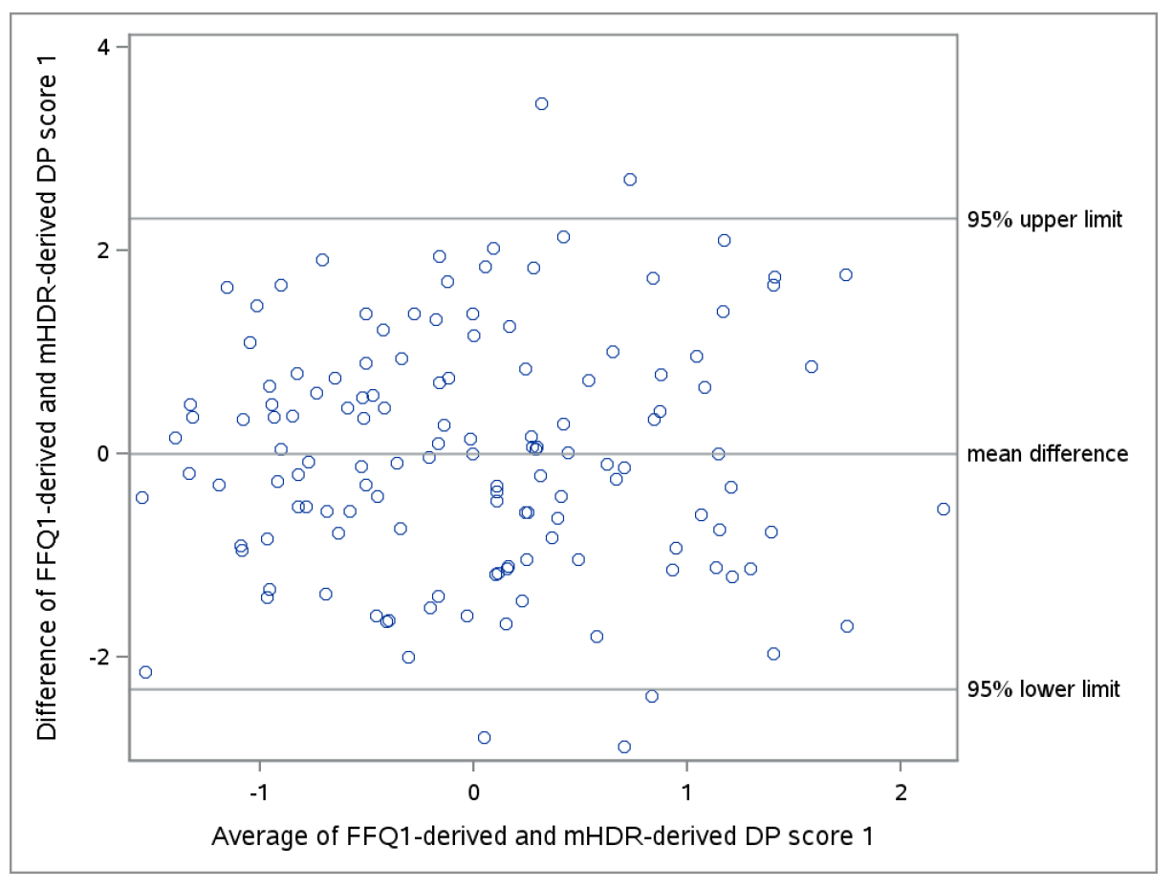
Supplemental Figure 1 Bland-Altman Plot of the FFQ₁-derived DP score 1 vs mHDR-derived DP score 1
FFQ₁ = FFQ applied after 1 year; mHDR = mean of 12 24-hour dietary recalls

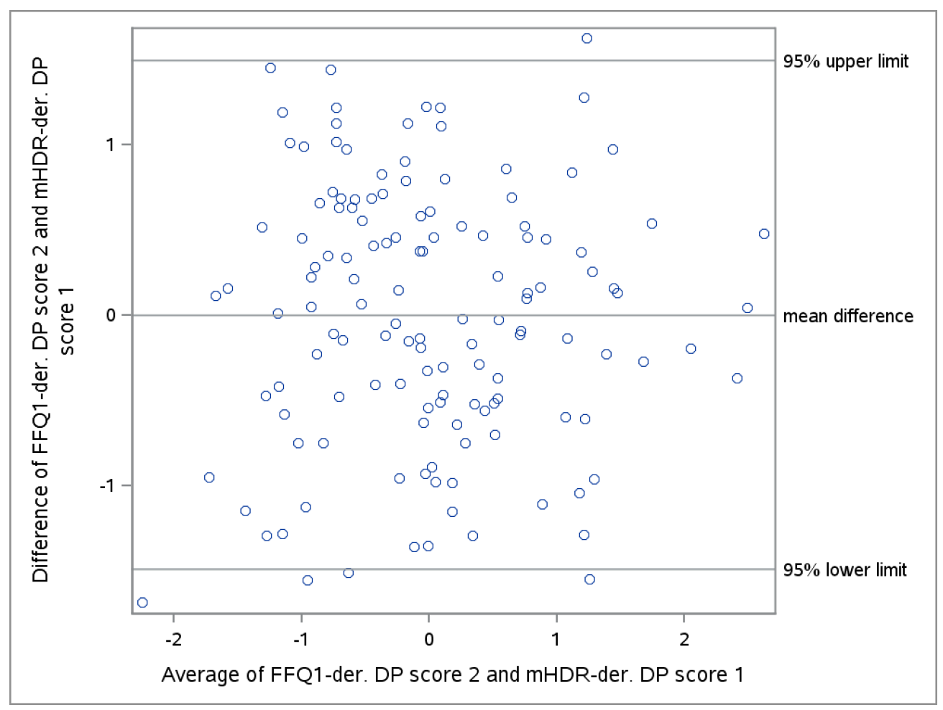
Supplemental Figure 2 Bland-Altman Plot of the FFQ₁-derived DP score 2 vs mHDR-derived DP score 1
FFQ₁ = FFQ applied after 1 year; mHDR = mean of 12 24-hour dietary recalls

References
1. InterAct C. Adherence to predefined dietary patterns and incident type 2 diabetes in European populations: EPIC-InterAct Study. Diabetologia. 2014;57(2):321-33.
2. Galbete C, Kroger J, Jannasch F, et al. Nordic diet, Mediterranean diet, and the risk of chronic diseases: the EPIC-Potsdam study. BMC Med. 2018;16(1):99.

