Supplementary Table 1. Sequences of the primers used in the present study
Genes | Functions | Nucleotide sequence (5′-3′) | Size (bp) | Accession no.
ELOVL4* | LC-PUFA biosynthesis | F: GAAGGGGAGCAAGAATGG  R: GAGGGAAAGAAAGGAAGACA | 183 | KX454537.1
Δ6 FAD † | LC-PUFA biosynthesis | F: TAATCCTGACTGGGGACTGT  R: AAGACTGGGTAGAGGCTGTT | 159 | KU975033.1
SREBP-1‡ | Transcription factor | F: AGTGACACGGCAACTCCTG  R: ACAAACATTCCCTCGTACATC | 113 | MH910503.1
FAS§ | Lipogenesis | F: CATTCTGGGCATCAAGGA  R: TGTTGGAGTCAGGGAGCA | 263 | HM217807.1
G6PD|| | Lipogenesis | F: AATGAGAGGAAGGCTGAGGT | 194 | PRJNA634782
 |  | R: CGGTCGCCATAAGTCAAGTC
6PGD¶ | Lipogenesis | F: TCAATCGCACCACGGAGA | 124 | PRJNA634782
 |  | R: AGCATAACACGCCTCGGT
CPTⅠ** | Fatty acid β-oxidation | F: CTTTTCCGTCGCCTTGTAGA | 222 | PRJNA634782
 |  | R: ATTGAGCAGCCGACCCTTAT
CPTⅡ** | Fatty acid β-oxidation | F: GCACAACTCCCAAGTCATTC | 164 | PRJNA634782
 |  | R: AAAATGTCTGGCATAGGGGA
ACO†† | Fatty acid β-oxidation | F: TGAGGACAGATACGCTAACG | 156 | PRJNA634782
 |  | R: GGGTTGCCATCTTTTGTCAG
HSL‡‡ | lipolysis | F: TTTGTCAGTGGCAGTGTTGG | 151 | PRJNA634782
 |  | R: CCTCAGTCTGTCCATGGTGT
EF-1α§§ | House-keeping gene | F: CTACAAGATTGGCGGCAT  R: GGGGGCAAAGTTCACGAC | 108 | JQ824130.1
* ELOVL4, elongase of very long-chain fatty acids 4; † Δ6 FAD, delta-6 fatty acyl desaturase; ‡ SREBP-1, sterol regulatory element binding protein-1; § FAS, fatty acid synthase; || G6PD, glucose-6-phosphate dehydrogenase; ¶ 6PGD, 6-phosphogluconate dehydrogenase; ** CPT, carnitine palmitoyltransferase I and II; †† ACO, acyl-CoA oxidase; ‡‡ HSL, hormone-sensitive triglyceride lipase; §§ EF-1α, elongation factor 1-α.

Supplementary Table 2. Fatty acid compositions of muscle in mud crab fed the experimental diets (mg g⁻¹ dry matter)
FAs | Initial | 7 % Lipid |  |  |  |  |  |  |  |  |  | 12 % Lipid
 |  | n-3 LC PUFA (mg g⁻¹)
 |  | 0.15 |  | 7.4 |  | 14.8 |  | 19.8 |  | 24.9 |  | 0.1 |  | 6.8 |  | 13.2 |  | 19.0 |  | 25.6
14:00 | 0.12 | 0.13ª | 0.01 | 0.12ª | 0.01 | 0.11^{ab} | 0.01 | 0.09^{bcd} | 0.00 | 0.09^{bcd} | 0.00 | 0.10^{abc} | 0.00 | 0.10^{abc} | 0.00 | 0.09^{bcd} | 0.00 | 0.07^{d} | 0.00 | 0.08^{cd} | 0.00
16:00 | 2.39 | 5.08ª | 0.13 | 4.87^{ab} | 0.09 | 4.80^{ab} | 0.18 | 4.49^{bc} | 0.05 | 3.96^{c} | 0.08 | 4.93^{ab} | 0.12 | 5.25ª | 0.02 | 5.11ª | 0.19 | 5.16ª | 0.11 | 5.20ª | 0.06
18:00 | 2.32 | 3.11^{abc} | 0.07 | 3.16ª | 0.06 | 3.14^{ab} | 0.14 | 3.25ª | 0.07 | 3.11^{abc} | 0.06 | 2.78^{bcd} | 0.01 | 2.69^{d} | 0.01 | 2.75^{cd} | 0.10 | 2.93^{abcd} | 0.08 | 3.01^{abcd} | 0.04
20:00 | 0.11 | 0.11ª | 0.00 | 0.12^{abc} | 0.00 | 0.11^{bc} | 0.00 | 0.14^{ab} | 0.00 | 0.14ª | 0.01 | 0.12^{abc} | 0.01 | 0.11^{bc} | 0.01 | 0.11^{bc} | 0.00 | 0.10ª | 0.00 | 0.12^{abc} | 0.00
16:1n | 0.63 | 0.59ª | 0.04 | 0.36^{bc} | 0.01 | 0.26^{cd} | 0.00 | 0.19de | 0.00 | 0.13e | 0.01 | 0.57ª | 0.03 | 0.59ª | 0.02 | 0.38^{b} | 0.03 | 0.32^{bc} | 0.01 | 0.31^{bc} | 0.02
18:1n-9 | 2.64 | 3.88ª | 0.12 | 3.40^{b} | 0.07 | 3.04^{c} | 0.03 | 3.14^{ab} | 0.05 | 3.12^{ab} | 0.05 | 3.38^{b} | 0.05 | 3.38^{b} | 0.01 | 2.85^{c} | 0.09 | 2.84^{c} | 0.06 | 3.03^{c} | 0.06
20:1n-9 | 0.13 | 0.13^{abc} | 0.01 | 0.11^{bc} | 0.00 | 0.13^{abc} | 0.00 | 0.14^{ab} | 0.01 | 0.15ª | 0.00 | 0.08^{d} | 0.00 | 0.12^{bc} | 0.01 | 0.11^{c} | 0.00 | 0.13^{bc} | 0.00 | 0.13^{abc} | 0.00
18:2n-6 | 0.63 | 3.54ª | 0.11 | 2.89^{bc} | 0.09 | 2.53^{cd} | 0.13 | 2.49^{cd} | 0.07 | 2.29^{d} | 0.04 | 3.14^{ab} | 0.15 | 2.95^{bc} | 0.03 | 2.18^{d} | 0.12 | 2.14^{d} | 0.08 | 2.06^{d} | 0.03
20:2n-6 | 0.25 | 0.34^{cd} | 0.01 | 0.39^{bc} | 0.01 | 0.39^{bc} | 0.02 | 0.44^{ab} | 0.02 | 0.50ª | 0.01 | 0.30^{d} | 0.01 | 0.35^{cd} | 0.01 | 0.31^{d} | 0.01 | 0.34^{cd} | 0.01 | 0.34^{cd} | 0.01
20:4n-6 | 1.56 | 3.97ª | 0.02 | 3.33^{b} | 0.09 | 2.85^{c} | 0.09 | 2.60^{cde} | 0.06 | 2.44de | 0.05 | 3.67^{ab} | 0.15 | 2.81^{cd} | 0.56 | 2.58^{cde} | 0.07 | 2.51^{cde} | 0.05 | 2.42e | 0.04
22:4n-6 | 0.21 | 0.22ª | 0.02 | 0.12^{b}c | 0.00 | 0.09^{bcd} | 0.00 | 0.09^{cd} | 0.00 | 0.10^{bcd} | 0.01 | 0.12^{b} | 0.00 | 0.08^{d} | 0.00 | 0.09^{bcd} | 0.00 | 0.09^{bcd} | 0.00 | 0.07^{d} | 0.01
18:3n-3 | 0.11 | 0.36ª | 0.02 | 0.26^{b} | 0.00 | 0.19^{c} | 0.00 | 0.21^{c} | 0.01 | 0.18^{c} | 0.01 | 0.30^{b} | 0.02 | 0.27^{b} | 0.00 | 0.19^{c} | 0.01 | 0.16^{c} | 0.00 | 0.18^{c} | 0.01
EPA | 4.20 | 3.80^{d} | 0.05 | 4.96^{c} | 0.15 | 5.26^{bc} | 0.16 | 5.77^{ab} | 0.09 | 5.38^{abc} | 0.19 | 3.83^{d} | 0.04 | 5.25^{bc} | 0.05 | 5.32^{bc} | 0.05 | 5.54^{ab} | 0.13 | 5.90ª | 0.05
22:5n-3 | 0.30 | 0.15^{abc} | 0.00 | 0.14^{abc} | 0.00 | 0.13^{d} | 0.00 | 0.14^{cd} | 0.00 | 0.12^{d} | 0.00 | 0.14^{cd} | 0.00 | 0.15^{abc} | 0.01 | 0.14^{bcd} | 0.00 | 0.15^{ab} | 0.00 | 0.16ª | 0.00
DHA | 2.67 | 2.21e | 0.04 | 3.28^{d} | 0.13 | 4.52^{bc} | 0.04 | 5.20ª | 0.1 | 5.04^{ab} | 0.06 | 2.07e | 0.12 | 3.92^{c} | 0.04 | 4.49^{bc} | 0.23 | 4.95^{ab} | 0.2 | 5.33ª | 0.02
EPA, C20:5n-3; DHA, 22:6n-3.
FAs | P (two-way ANOVA)
 | Lipid | n-3 LC-PUFA | Interaction
14:0 | 0.000 | 0.000 | 0.926
16:0 | 0.000 | 0.004 | 0.000
18:0 | 0.000 | 0.122 | 0.219
20:0 | 0.004 | 0.037 | 0.004
16:1n-7 | 0.000 | 0.000 | 0.000
18:1n-9 | 0.000 | 0.000 | 0.015
20:1n-9 | 0.000 | 0.000 | 0.000
18:2n-6 | 0.000 | 0.000 | 0.135
20:2n-6 | 0.000 | 0.000 | 0.000
20:4n-6 | 0.000 | 0.000 | 0.029
22:4n-6 | 0.000 | 0.000 | 0.000
18:3n-3 | 0.003 | 0.000 | 0.006
EPA | 0.066 | 0.000 | 0.030
22:5n-3 | 0.000 | 0.003 | 0.000
DHA | 0.200 | 0.000 | 0.010

FAs | Initial | 7 % Lipid |  |  |  |  |  |  |  |  |  | 12 % Lipid
 |  | n-3 LC PUFA (mg g⁻¹)
 |  | 0.15 |  | 7.4 |  | 14.8 |  | 19.8 |  | 24.9 |  | 0.1 |  | 6.8 |  | 13.2 |  | 19.0 |  | 25.6
14:00 | 2.94 | 0.69^{b} | 0.09 | 1.59ª | 0.05 | 1.48ª | 0.23 | 1.35ª | 0.17 | 1.42ª | 0.14 | 1.12^{ab} | 0.03 | 1.07^{ab} | 0.04 | 1.21^{ab} | 0.09 | 1.49ª | 0.2 | 1.51ª | 0.11
16:00 | 18.12 | 63.21ª | 1.73 | 56.11ª | 0.28 | 44.80^{b} | 0.58 | 43.70^{b} | 3.12 | 31.47^{c} | 3.57 | 58.57ª | 1.49 | 56.99ª | 0.07 | 56.55ª | 3.02 | 63.59ª | 0.55 | 65.45ª | 2.49
18:00 | 10.67 | 9.00^{c} | 0.06 | 12.58ª | 0.23 | 12.23ª | 0.74 | 11.10^{abc} | 0.48 | 9.95^{bc} | 0.64 | 8.99^{c} | 0.32 | 9.21^{c} | 0.11 | 11.12^{abc} | 0.08 | 11.59^{ab} | 0.3 | 10.80^{abc} | 0.67
20:00 | 1.79 | 0.74^{c} | 0.01 | 1.23ª | 0.04 | 1.13^{ab} | 0.01 | 1.12^{ab} | 0.04 | 1.00^{b} | 0.03 | 0.69^{c} | 0.04 | 0.64^{c} | 0.04 | 1.11^{ab} | 0.01 | 1.02^{b} | 0.03 | 1.01^{b} | 0.01
16:1n-7 | 7.59 | 3.12^{cd} | 0.33 | 5.26^{bc} | 0.25 | 5.09^{bc} | 0.24 | 3.40^{cd} | 0.22 | 2.23^{d} | 0.41 | 7.64ª | 0.96 | 6.53^{ab} | 0.11 | 7.30^{ab} | 0.75 | 6.43^{ab} | 0.09 | 6.97^{ab} | 0.06
18:1n-9 | 16.01 | 21.26^{f} | 1.29 | 30.77^{ab} | 0.07 | 31.03ª | 0.37 | 30.00^{ab} | 0.19 | 24.89^{cdef} | 0.41 | 23.04^{ef} | 1.44 | 24.40^{def} | 0.17 | 26.88^{bcde} | 0.48 | 28.18^{abcd} | 1.34 | 28.71^{abc} | 0.08
20:1n-9 | 1.91 | 0.61^{d} | 0.02 | 1.19^{bc} | 0.05 | 1.35^{ab} | 0.06 | 1.51ª | 0.01 | 1.35^{ab} | 0.01 | 0.63^{d} | 0.03 | 0.90^{cd} | 0.02 | 1.33^{ab} | 0.10 | 1.33^{ab} | 0.04 | 1.46^{ab} | 0.13
22:1n-11 | 0.39 | 0.11^{f} | 0.00 | 0.20e | 0.00 | 0.39^{c} | 0.00 | 0.49^{b} | 0.01 | 0.55ª | 0.01 | 0.04^{g} | 0.00 | 0.18e | 0.00 | 0.42^{c} | 0.01 | 0.32^{d} | 0.01 | 0.49^{ab} | 0.03
18:2n-6 | 6.64 | 22.38^{ef} | 0.14 | 37.14ª | 0.47 | 34.32^{ab} | 0.76 | 33.23^{abc} | 1.59 | 31.08^{bcd} | 0.25 | 21.95^{f} | 1.15 | 26.22^{def} | 0.22 | 27.35de | 1.48 | 31.35^{bcd} | 1.53 | 28.11^{cd} | 1.42
18:3n-6 | 0.16 | 0.38^{c} | 0.00 | 0.67^{abc} | 0.27 | 0.84^{ab} | 0.08 | 0.92^{ab} | 0.04 | 0.95ª | 0.00 | 0.49^{bc} | 0.02 | 0.35^{c} | 0.01 | 0.35^{c} | 0.00 | 0.69^{abc} | 0.00 | 0.56^{abc} | 0.00
20:2n-6 | 2.07 | 2.01^{abc} | 0.05 | 2.44ª | 0.02 | 2.46ª | 0.15 | 2.26^{ab} | 0.04 | 2.12^{abc} | 0.10 | 1.65^{cd} | 0.11 | 1.79^{bcd} | 0.06 | 1.52^{d} | 0.11 | 1.94^{bcd} | 0.02 | 1.52^{d} | 0.15
20:4n-6 | 6.96 | 15.26 | 1.06 | 16.91 | 0.29 | 16.43 | 0.96 | 16.58 | 0.51 | 16.5 | 0.02 | 15.09 | 0.81 | 16.12 | 1.18 | 14.41 | 0.10 | 14.93 | 0.5 | 13.68 | 1.15
22:4n-6 | 2.27 | 0.15^{c} | 0.00 | 0.26^{ab} | 0.01 | 0.28ª | 0.02 | 0.29ª | 0.02 | 0.29ª | 0.02 | 0.16^{c} | 0.00 | 0.09^{d} | 0.00 | 0.21^{bc} | 0.01 | 0.25^{ab} | 0.01 | 0.26^{ab} | 0.01
18:3n-3 | 1.2 | 1.68de | 0.03 | 3.48ª | 0.05 | 2.67^{b} | 0.13 | 3.33ª | 0.04 | 3.13ª | 0.00 | 2.39^{bc} | 0.17 | 1.91^{d} | 0.02 | 1.49e | 0.12 | 2.50^{b} | 0.01 | 2.07^{cd} | 0.04
18:4n-3 | 0.51 | 0.02^{g} | 0.00 | 0.24^{d} | 0.01 | 0.37^{c} | 0.02 | 0.79^{b} | 0.02 | 0.93ª | 0.01 | 0.02^{g} | 0.00 | 0.09^{f} | 0.01 | 0.16e | 0.01 | 0.27^{d} | 0.01 | 0.28^{d} | 0.01
20:4n-3 | 1.07 | 0.09^{f} | 0.01 | 0.39de | 0.02 | 0.67^{c} | 0.07 | 0.97^{ab} | 0.05 | 1.03ª | 0.11 | 0.04^{f} | 0.00 | 0.26^{ef} | 0.02 | 0.42de | 0.04 | 0.55^{cd} | 0.00 | 0.75^{bc} | 0.01
EPA | 11.01 | 1.93^{d} | 0.03 | 10.28^{c} | 0.32 | 16.54^{b} | 1.26 | 24.17ª | 0.35 | 26.44ª | 0.03 | 1.85^{d} | 0.03 | 9.90^{c} | 0.57 | 11.27^{c} | 0.09 | 16.13^{b} | 0.75 | 17.78^{b} | 0.00
22:5n-3 | 2.42 | 0.29e | 0.01 | 0.73^{d} | 0.01 | 1.27^{b} | 0.01 | 1.38^{b} | 0.02 | 1.64ª | 0.03 | 0.09^{f} | 0.01 | 0.40e | 0.01 | 0.70^{d} | 0.05 | 0.96^{c} | 0.05 | 1.26^{b} | 0.07
DHA | 11.81 | 1.13e | 0.07 | 10.25^{d} | 0.19 | 18.76^{bc} | 0.25 | 25.46ª | 0.38 | 27.20ª | 0.06 | 1.43e | 0.12 | 10.42^{d} | 0.71 | 12.13^{d} | 0.43 | 17.25^{c} | 0.75 | 19.85^{b} | 0.43
Supplementary Table 3. Fatty acid compositions of hepatopancreas of mud crabs fed the experimental diets (mg g⁻¹ dry matter)
EPA, C20:5n-3; DHA, 22:6n-3.

FAs | P (two-way ANOVA)
 | Lipid | n-3 LC-PUFA | Interaction
14:0 | 0.786 | 0.002 | 0.025
16:0 | 0.000 | 0.000 | 0.000
18:0 | 0.034 | 0.000 | 0.001
20:0 | 0.000 | 0.000 | 0.000
16:1n-7 | 0.000 | 0.067 | 0.001
18:1n-9 | 0.013 | 0.000 | 0.000
20:1n-9 | 0.073 | 0.000 | 0.023
22:1n-11 | 0.000 | 0.000 | 0.362
18:2n-6 | 0.000 | 0.000 | 0.001
18:3n-6 | 0.000 | 0.005 | 0.015
20:2n-6 | 0.000 | 0.001 | 0.345
20:4n-6 | 0.006 | 0.392 | 0.467
22:4n-6 | 0.000 | 0.000 | 0.014
18:3n-3 | 0.000 | 0.000 | 0.000
18:4n-3 | 0.000 | 0.000 | 0.000
20:4n-3 | 0.000 | 0.000 | 0.000
EPA | 0.000 | 0.000 | 0.000
22:5n-3 | 0.000 | 0.000 | 0.000
DHA | 0.000 | 0.000 | 0.000

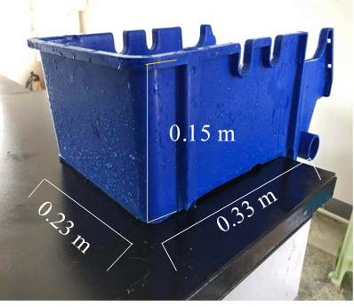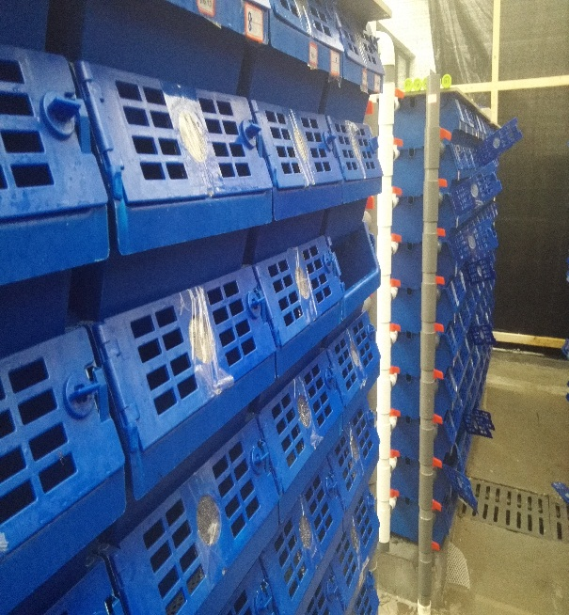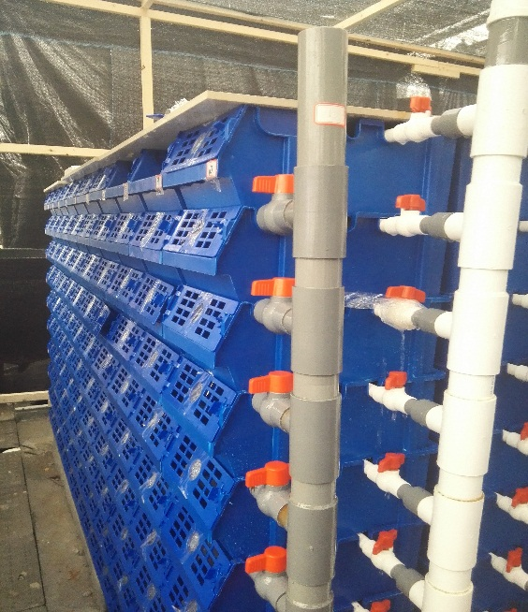
C
B
A
Supplementary Figure 1. A: single crab cell; B, C: cellular system.
In cellular systems, crabs are held individually in cells to mitigate the risk of cannibalism and to provide optimal conditions for growth. The systems have been built with a variety of technological systems incorporated to minimize labour and maximize automation, making it possible to manage up to 450 crabs at one time for a feeding trial.
Generally, the system includes a sophisticated water recirculation system. In the present study, all the cells were in the same room, with each cell mutually independent (all cells isolated from each other), with separate water inlet and drainage pipes. The system was half filled with a continuous flow of (300 mL min⁻¹).

