Foods, nutrient intakes, and Mediterranean dietary pattern in midlife are not associated with reaction times: a longitudinal analysis of the UK Women’s Cohort Study
Huifeng Zhang¹, Laura Hardie², Janet Cade³
1 Nutritional Epidemiology Group, School of Food Science and Nutrition, University of Leeds, Leeds LS2 9JT, UK. ORCID: 0000-0002-9818-7904
2 Division of Clinical and Population Sciences, Leeds Institute of Cardiovascular and Metabolic Medicine, School of Medicine, University of Leeds, Leeds LS2 9JT, UK. ORCID: 0000-0001-5039-2100
3 Nutrition Epidemiology Group, School of Food Science and Nutrition, University of Leeds, Leeds LS2 9JT, UK. ORCID: 0000-0003-3421-0121
Corresponding author: Huifeng Zhang fshz@leeds.ac.uk

Supplementary Table 1 Derivation of the Mediterranean diet score
 | Indicator value
MDS component | 1 | 0
Vegetables (g/day) | ≥279.98 | <279.98
Legumes (g/day) | ≥31.90 | <31.90
Fruit & nuts (g/day) | ≥273.64 | <273.64
Cereals (g/day) | ≥241.66 | <241.66
Fish (g/day) | ≥20.64 | <20.64
MUFA + PUFA: SFAª | ≥1.96 | <1.96
Meat (g/day) | <27.50 | ≥27.50
Poultry (g/day) | <10.83 | ≥10.83
Dairy (g/day) | <95.15 | ≥95.15
Alcohol (g/day) | 5–25 | <5 or >25
ª Fatty acid ratio of monounsaturated plus polyunsaturated fatty acids to saturated fatty acids

Supplementary Figure 1 Directed acyclic graph (DAG) showing the relationships among the exposure (Diet; represented by the green oval with the triangle), outcome (Reaction time; represented by the blue oval with the line), and related factors.
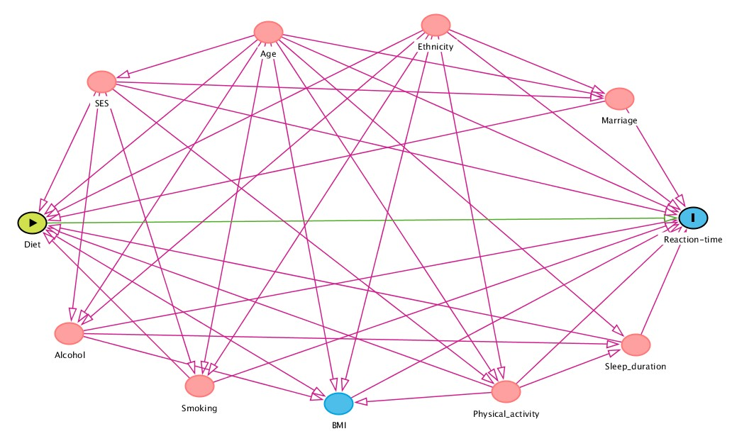

Variables represented as pink ovals are ancestors of exposure and outcome while variables represented as blue ovals (BMI) are ancestors only of the outcome. Pink lines are biasing paths and the green line between the exposure and outcome is the causal path of interest. SES, social economic status; BMI, body mass index.

