Supplementary Table S1. Baseline (1992 in the NHS and 1993 in the NHSII) characteristics of participants according to the first 4-year changes in healthful plant-based diet index (hPDI) and unhealthful plant-based diet index (uPDI)*
 | Decrease ≥ 10 pt | Decrease 3 to 9 pt | Relatively stable (± 2 pt) | Increase 3 to 9 pt | Increase ≥ 10 pt
Healthful plant-based diet index (hPDI)
Nurses’ Health Study
n | 4,365 | 16,053 | 15,645 | 11,826 | 2,401
hPDI score
Baseline | 61.8 (6.4) | 58.0 (6.9) | 55.2 (6.9) | 52.7 (6.8) | 49.6 (6.6)
Change | -12.4 (2.4) | -5.5 (1.9) | -0.1 (1.4) | 5.3 (1.9) | 12.2 (2.0)
Age (year)† | 59 (7) | 59 (7) | 58 (7) | 57 (7) | 57 (7)
Body-mass index | 26.7 (5.1) | 26.0 (4.9) | 25.8 (4.8) | 25.8 (4.9) | 26.0 (5.1)
Physical activity (Met-hours/week) | 19.2 (23.2) | 19.9 (22.7) | 19.8 (22.4) | 19.8 (23.8) | 19.8 (22.2)
Alcohol intake (g/day) | 4.7 (9.4) | 5.1 (9.3) | 5.2 (9.3) | 5.4 (9.9) | 5.4 (9.8)
Margarine Intake (servings/day) | 0.9 (1.0) | 0.9 (1.0) | 0.9 (1.0) | 0.9 (1.0) | 0.9 (1.0)
Energy Intake (kcal/day) | 1647 (474) | 1723 (503) | 1758 (507) | 1805 (512) | 1865 (499)
White race (%) | 98 | 98 | 98 | 98 | 98
Current Smoker (%) | 12 | 12 | 13 | 12 | 13
Premenopausal (%) | 21 | 21 | 21 | 22 | 23
Postmenopausal hormone use (%) | 34 | 32 | 32 | 31 | 29
Comorbidities (%)
Cardiovascular disease | 9 | 8 | 8 | 8 | 8
Cancer | 9 | 9 | 9 | 9 | 8
Diabetes | 4 | 4 | 4 | 5 | 6
Hypertension | 36 | 32 | 32 | 32 | 32
Hypercholesterolemia | 51 | 47 | 45 | 45 | 46
Respiratory diseases | 12 | 11 | 11 | 11 | 12
NSAIDs use (%) | 48 | 50 | 49 | 49 | 48
Multivitamin use (%) | 44 | 43 | 43 | 42 | 44
Social status (%)
Currently married | 82 | 83 | 84 | 83 | 80
Currently working | 90 | 91 | 90 | 90 | 89
Education (more than Bachelor) | 30 | 31 | 31 | 31 | 31
Husband Education (more than college) | 46 | 46 | 48 | 47 | 45
Baseline SF-36 scores
Physical component score | 49.6 (9.1) | 50.2 (8.8) | 50.3 (8.7) | 50.3 (8.8) | 50.3 (8.8)
Mental component score | 52.0 (8.6) | 52.1 (8.5) | 52.4 (8.3) | 52.1 (8.4) | 51.9 (8.6)
Physical functioning | 85.1 (17.8) | 86.3 (17.1) | 86.4 (17.1) | 86.5 (17.0) | 86.4 (17.1)
Physical role limitations | 74.9 (35.8) | 76.3 (35.0) | 76.7 (34.8) | 76.5 (35.1) | 76.4 (35.1)
Bodily pain | 73.0 (20.5) | 74.3 (20.2) | 74.8 (19.8) | 74.6 (20.1) | 74.4 (20.3)
General health | 79.0 (18.4) | 80.2 (17.3) | 80.4 (17.3) | 80.3 (17.6) | 80.3 (17.6)
Vitality | 63.6 (18.5) | 64.3 (18.0) | 64.9 (17.9) | 64.5 (18.1) | 64.3 (18.4)
Social functioning | 88.7 (18.7) | 89.6 (18.0) | 90.1 (17.7) | 89.8 (17.9) | 89.1 (18.5)
Mental role limitations | 83.8 (29.3) | 84.2 (28.9) | 85.0 (28.1) | 84.6 (28.6) | 84.1 (28.6)
Mental health | 76.8 (14.3) | 77.1 (14.1) | 77.5 (13.9) | 77.2 (14.1) | 77.0 (14.3)
Nurses’ Health Study II
n | 4,194 | 15,307 | 15,906 | 13,141 | 3,236
hPDI score
Baseline | 61.6 (6.6) | 57.4 (6.9) | 54.7 (7.0) | 52.3 (6.8) | 49.3 (6.5)
Change | -12.5 (2.3) | -5.5 (1.9) | -0.1 (1.4) | 5.3 (1.9) | 12.5 (2.3)
Age (year)† | 39 (4) | 39 (5) | 39 (5) | 39 (5) | 38 (5)
Body-mass index | 26.0 (6.0) | 25.3 (5.7) | 24.9 (5.5) | 24.7 (5.4) | 25.1 (5.7)
Physical activity (Met-hours/week) | 21.4 (26.7) | 20.5 (26.4) | 20.2 (26.1) | 20.1 (25.7) | 20.0 (26.7)
Alcohol intake (g/day) | 2.9 (6.0) | 3.1 (6.0) | 3.2 (6.3) | 3.3 (6.4) | 3.1 (5.9)
Margarine Intake (servings/day) | 0.6 (0.8) | 0.7 (0.8) | 0.7 (0.8) | 0.7 (0.8) | 0.7 (0.8)
Energy Intake (kcal/day) | 1625 (490) | 1737 (528) | 1796 (538) | 1864 (545) | 1935 (523)
White race (%) | 97 | 97 | 97 | 97 | 97
Current Smoker (%) | 10 | 9 | 10 | 11 | 10
Premenopausal (%) | 93 | 94 | 94 | 94 | 94
Postmenopausal hormone use (%) | 5 | 4 | 4 | 4 | 4
Comorbidities (%)
Cardiovascular disease | 4 | 3 | 3 | 4 | 3
Cancer | 2 | 2 | 2 | 2 | 2
Diabetes | 1 | 1 | 1 | 1 | 2
Hypertension | 8 | 8 | 7 | 7 | 8
Hypercholesterolemia | 20 | 19 | 18 | 18 | 18
Respiratory diseases | 10 | 10 | 10 | 10 | 9
NSAIDs use (%) | 11 | 10 | 10 | 10 | 10
Multivitamin use (%) | 43 | 43 | 43 | 43 | 43
Social status (%)
Currently married | 82 | 85 | 85 | 84 | 81
Currently working | 95 | 96 | 95 | 96 | 95
Husband Education (college) | 70 | 71 | 71 | 71 | 69
Income status (%)
less than $50,000 | 15 | 14 | 13 | 13 | 13
$50,000 to less than $75,000 | 24 | 24 | 23 | 23 | 25
$75,000 to less than $100,000 | 18 | 18 | 18 | 19 | 17
$100,000 or more | 31 | 29 | 30 | 31 | 31
Baseline SF-36 scores
Physical component score | 52.6 (8.3) | 53.1 (7.6) | 53.3 (7.6) | 53.3 (7.7) | 53.4 (7.7)
Mental component score | 47.6 (9.6) | 48.0 (9.3) | 48.2 (9.1) | 48.1 (9.4) | 48.0 (9.3)
Physical functioning | 90.9 (14.9) | 91.9 (13.6) | 92.1 (13.5) | 92.2 (13.4) | 91.8 (14.0)
Physical role limitations | 81.9 (31.4) | 83.3 (30.2) | 83.9 (29.7) | 83.8 (29.9) | 84.3 (29.6)
Bodily pain | 76.3 (19.5) | 77.2 (18.5) | 77.8 (18.4) | 77.8 (18.8) | 78.0 (18.7)
General health | 79.5 (17.9) | 80.5 (17.0) | 80.7 (16.8) | 80.6 (17.1) | 80.9 (17.3)
Vitality | 54.3 (19.3) | 55.4 (19.1) | 56.0 (18.9) | 56.2 (19.2) | 56.2 (20.0)
Social functioning | 85.0 (20.6) | 86.6 (19.2) | 87.1 (18.8) | 86.6 (19.4) | 86.6 (19.0)
Mental role limitations | 81.1 (30.9) | 81.8 (30.1) | 81.9 (30.2) | 81.8 (30.5) | 81.7 (30.5)
Mental health | 71.2 (15.4) | 71.7 (15.0) | 72.1 (14.7) | 72.0 (15.1) | 71.9 (14.9)
Unhealthful plant-based diet index (uPDI)
Nurses’ Health Study
n | 2,871 | 12,792 | 15,411 | 14,951 | 4,265
uPDI score
Baseline | 60.2 (6.3) | 57.0 (6.8) | 54.6 (6.9) | 52.0 (6.8) | 48.1 (6.5)
Change | -12.2 (2.0) | -5.4 (1.9) | 0.0 (1.4) | 5.5 (1.9) | 12.6 (2.5)
Age (year)† | 58 (7) | 58 (7) | 58 (7) | 58 (7) | 58 (7)
Body-mass index | 26.2 (5.1) | 25.8 (4.9) | 25.8 (4.9) | 26.0 (4.8) | 26.6 (5.1)
Physical activity (Met-hours/week) | 20.1 (25.0) | 20.0 (23.4) | 19.8 (22.9) | 19.7 (22.8) | 19.4 (21.1)
Alcohol intake (g/day) | 5.4 (9.6) | 5.6 (9.7) | 5.4 (9.8) | 4.9 (9.2) | 4.1 (8.2)
Margarine Intake (servings/day) | 0.9 (1.0) | 0.9 (1.0) | 0.9 (1.0) | 0.9 (1.0) | 0.9 (1.0)
Energy Intake (kcal/day) | 1622 (479) | 1704 (495) | 1750 (511) | 1799 (508) | 1844 (500)
White race (%) | 98 | 98 | 98 | 98 | 98
Current Smoker (%) | 13 | 13 | 13 | 12 | 11
Premenopausal (%) | 22 | 22 | 22 | 22 | 21
Postmenopausal hormone use (%) | 32 | 32 | 31 | 32 | 32
Comorbidities (%)
Cardiovascular disease | 9 | 8 | 8 | 8 | 9
Cancer | 9 | 9 | 9 | 10 | 9
Diabetes | 6 | 5 | 4 | 4 | 4
Hypertension | 34 | 32 | 32 | 33 | 34
Hypercholesterolemia | 48 | 46 | 45 | 46 | 48
Respiratory diseases | 12 | 12 | 11 | 11 | 11
NSAIDs use (%) | 49 | 50 | 50 | 49 | 48
Multivitamin use (%) | 44 | 43 | 42 | 43 | 44
Social status (%)
Currently married | 82 | 83 | 84 | 83 | 82
Currently working | 90 | 90 | 90 | 90 | 89
Education (more than Bachelor) | 31 | 31 | 31 | 30 | 30
Husband Education (more than college) | 45 | 48 | 47 | 46 | 45
Baseline SF-36 scores
Physical component score | 49.9 (9.2) | 50.2 (8.9) | 50.3 (8.6) | 50.2 (8.8) | 49.8 (9.0)
Mental component score | 51.9 (8.6) | 52.2 (8.4) | 52.2 (8.4) | 52.2 (8.4) | 51.9 (8.7)
Physical functioning | 85.4 (18.2) | 86.2 (17.3) | 86.7 (16.7) | 86.4 (17.2) | 85.3 (17.8)
Physical role limitations | 75.7 (35.6) | 76.5 (35.0) | 76.6 (35.0) | 76.5 (34.9) | 75.6 (35.4)
Bodily pain | 74.1 (20.6) | 74.6 (20.1) | 74.7 (19.9) | 74.4 (20.0) | 73.4 (20.5)
General health | 79.4 (18.3) | 80.0 (17.6) | 80.4 (17.2) | 80.4 (17.4) | 80.0 (17.5)
Vitality | 64.2 (18.1) | 64.7 (18.0) | 64.7 (18.0) | 64.4 (18.0) | 63.3 (18.7)
Social functioning | 89.1 (18.4) | 89.7 (17.9) | 89.9 (17.9) | 90.0 (17.8) | 89.0 (18.7)
Mental role limitations | 83.6 (29.7) | 84.6 (28.5) | 84.8 (28.3) | 84.7 (28.5) | 83.5 (29.5)
Mental health | 76.7 (14.3) | 77.2 (14.0) | 77.3 (14.1) | 77.4 (13.9) | 76.9 (14.4)
Nurses’ Health Study II
n | 3,013 | 12,392 | 15,244 | 15,833 | 5,302
uPDI score
Baseline | 60.9 (6.4) | 57.9 (7.1) | 55.5 (7.2) | 52.6 (7.1) | 48.9 (6.5)
Change | -12.4 (2.3) | -5.4 (1.9) | 0.0 (1.4) | 5.5 (1.9) | 12.9 (2.7)
Age (year)† | 38 (5) | 38 (5) | 39 (5) | 39 (4) | 39 (4)
Body-mass index | 25.0 (5.6) | 24.9 (5.5) | 24.9 (5.6) | 25.1 (5.5) | 25.9 (5.9)
Physical activity (Met-hours/week) | 18.4 (21.8) | 19.9 (26.7) | 19.9 (24.7) | 21.0 (27.0) | 22.3 (28.7)
Alcohol intake (g/day) | 3.3 (6.6) | 3.3 (6.3) | 3.2 (6.2) | 3.1 (6.0) | 2.9 (6.0)
Margarine Intake (servings/day) | 0.7 (0.8) | 0.7 (0.8) | 0.7 (0.8) | 0.7 (0.8) | 0.7 (0.8)
Energy Intake (kcal/day) | 1651 (501) | 1739 (530) | 1781 (542) | 1833 (540) | 1893 (530)
White race (%) | 96 | 97 | 97 | 97 | 97
Current Smoker (%) | 10 | 11 | 10 | 10 | 8
Premenopausal (%) | 93 | 94 | 94 | 94 | 94
Postmenopausal hormone use (%) | 5 | 4 | 4 | 4 | 4
Comorbidities (%)
Cardiovascular disease | 4 | 3 | 3 | 3 | 4
Cancer | 2 | 2 | 2 | 2 | 1
Diabetes | 1 | 1 | 1 | 1 | 1
Hypertension | 8 | 8 | 7 | 8 | 8
Hypercholesterolemia | 20 | 19 | 18 | 18 | 19
Respiratory diseases | 11 | 10 | 9 | 9 | 10
NSAIDs use (%) | 11 | 11 | 10 | 10 | 9
Multivitamin use (%) | 45 | 44 | 42 | 43 | 41
Social status (%)
Currently married | 81 | 84 | 85 | 85 | 85
Currently working | 95 | 95 | 96 | 95 | 96
Husband Education (more than college) | 71 | 71 | 71 | 71 | 70
Income status (%)
less than $50,000 | 14 | 13 | 14 | 13 | 14
$50,000 to less than $75,000 | 23 | 23 | 23 | 23 | 24
$75,000 to less than $100,000 | 18 | 18 | 18 | 18 | 18
$100,000 or more | 30 | 30 | 30 | 30 | 30
Baseline SF-36 scores
Physical component score | 52.8 (8.1) | 53.1 (7.8) | 53.2 (7.5) | 53.2 (7.7) | 53.2 (7.9)
Mental component score | 47.7 (9.6) | 48.1 (9.2) | 48.2 (9.2) | 48.0 (9.3) | 47.7 (9.6)
Physical functioning | 91.0 (15.2) | 91.9 (13.7) | 92.2 (13.2) | 92.0 (13.6) | 91.6 (13.9)
Physical role limitations | 82.1 (31.1) | 83.6 (30.1) | 83.7 (29.9) | 83.7 (29.9) | 83.5 (30.0)
Bodily pain | 76.9 (19.0) | 77.4 (18.8) | 77.7 (18.5) | 77.6 (18.5) | 77.4 (18.7)
General health | 79.8 (17.7) | 80.3 (17.3) | 80.7 (16.9) | 80.6 (16.9) | 80.8 (17.2)
Vitality | 55.4 (19.3) | 55.9 (19.2) | 55.9 (19.1) | 55.6 (19.1) | 55.2 (19.2)
Social functioning | 85.6 (20.1) | 86.7 (19.2) | 86.9 (19.0) | 86.7 (19.2) | 86.1 (19.5)
Mental role limitations | 79.7 (31.9) | 81.9 (30.2) | 82.2 (30.2) | 81.9 (30.1) | 81.2 (30.8)
Mental health | 71.6 (15.3) | 72.0 (14.8) | 72.1 (14.9) | 71.8 (15.0) | 71.4 (15.3)
NHS, Nurses’ Health Study; NHS II, Nurses’ Health Study II; hPDI, healthful plant-based diet index; SF-36, 36-Item Short Form Health Survey; uPDI, unhealthful plant-based index.
* Values were means (SDs) or percentages and were standardized to the age distribution of the study population. † Value was not age-adjusted.
Supplementary Table S2. 4-year changes in physical component scores (1992-2000 in NHS and 1993-2001 in NHSII) according to 4-year changes in plant-based diet indices (1990-1998 in NHS and 1991-1999 in NHSII) adjusted for age, baseline corresponding plant-based diet indices, and baseline corresponding HRQoL scores*
 | Decrease ≥ 10 pt | Decrease 3 to 9 pt | Relatively stable (± 2 pt) | Increase 3 to 9 pt | Increase ≥ 10 pt | Changes/10-point increase in indices (95% CIs) | p
Overall Plant-Based Diet Index (PDI)
Nurses’ Health study
Basic model | -0.45 (-0.65, -0.25) | -0.22 (-0.34, -0.10) | 0.00 | 0.08 (-0.04, 0.20) | 0.23 (0.02, 0.44) | 0.29 (0.20, 0.37) | <0.001
Nurses’ Health study II
Basic model | -0.22 (-0.39, -0.04) | -0.09 (-0.20, 0.02) | 0.00 | 0.01 (-0.10, 0.12) | -0.06 (-0.24, 0.12) | 0.09 (0.02, 0.16) | 0.02
Pooled Results
Basic model | -0.32 (-0.45, -0.19) | -0.15 (-0.23, -0.07) | 0.00 | 0.04 (-0.04, 0.12) | 0.06 (-0.08, 0.20) | 0.17 (0.12, 0.23) | <0.001
Healthful Plant-Based Diet Index (hPDI)
Nurses’ Health study
Basic model | -0.72 (-0.91, -0.53) | -0.24 (-0.36, -0.13) | 0.00 | 0.12 (0.00, 0.25) | 0.23 (0.02, 0.44) | 0.39 (0.30, 0.47) | <0.001
Nurses’ Health study II
Basic model | -0.63 (-0.81, -0.46) | -0.21 (-0.31, -0.10) | 0.00 | 0.09 (-0.02, 0.20) | 0.01 (-0.16, 0.19) | 0.29 (0.22, 0.37) | <0.001
Pooled Results
Basic model | -0.67 (-0.80, -0.55) | -0.22 (-0.30, -0.15) | 0.00 | 0.11 (0.03, 0.19) | 0.10 (-0.03, 0.24) | 0.33 (0.28, 0.39) | <0.001
Unhealthful Plant-Based Diet Index (uPDI)
Nurses’ Health study
Basic model | 0.19 (0.00, 0.38) | 0.03 (-0.09, 0.15) | 0.00 | -0.33 (-0.45, -0.21) | -0.73 (-0.92, -0.55) | -0.36 (-0.44, -0.29) | <0.001
Nurses’ Health study II
Basic model | -0.24 (-0.41, -0.08) | -0.08 (-0.19, 0.03) | 0.00 | -0.03 (-0.14, 0.08) | -0.22 (-0.39, -0.06) | 0.01 (-0.06, 0.08) | 0.78
Pooled Results
Basic model | -0.06 (-0.19, 0.06) | -0.03 (-0.11, 0.05) | 0.00 | -0.17 (-0.25, -0.09) | -0.45 (-0.57, -0.33) | -0.15 (-0.20, -0.10) | <0.001
NHS, Nurses’ Health Study; NHS II, Nurses’ Health Study II.
* Values were beta coefficients (95% CIs) in physical component scores. Pooled results were calculated with a fixed effects model.
† The P value for Q-statistic for heterogeneity <0.05, indicating statistically significant heterogeneity between the NHS and the NHSII.

Supplementary Table S3. 4-year changes in mental component scores (1992-2000 in NHS and 1993-2001 in NHSII) according to 4-year changes in plant-based diet indices (1990-1998 in NHS and 1991-1999 in NHSII) adjusted for age, baseline corresponding plant-based diet indices, and baseline corresponding HRQoL scores*
 | Decrease ≥ 10 pt | Decrease 3 to 9 pt | Relatively stable (± 2 pt) | Increase 3 to 9 pt | Increase ≥ 10 pt | Changes/10-point increase in indices (95% CIs) | p
Overall Plant-Based Diet Index (PDI)
Nurses’ Health study
Basic model | -0.10 (-0.28, 0.07) | 0.02 (-0.09, 0.12) | 0.00 | 0.16 (0.06, 0.26) | -0.01 (-0.20, 0.17) | 0.06 (-0.01, 0.14) | 0.10
Nurses’ Health study II
Basic model | -0.36 (-0.57, -0.16) | -0.10 (-0.22, 0.03) | 0.00 | 0.09 (-0.04, 0.21) | 0.16 (-0.04, 0.37) | 0.21 (0.12, 0.29) | <0.001
Pooled Results
Basic model | -0.21 (-0.35, -0.08) | -0.03 (-0.11, 0.05) | 0.00 | 0.13 (0.05, 0.21) | 0.06 (-0.07, 0.20) | 0.12 (0.07, 0.18) | <0.001
Healthful Plant-Based Diet Index (hPDI)
Nurses’ Health study
Basic model | -0.15 (-0.32, 0.01) | 0.02 (-0.09, 0.12) | 0.00 | 0.15 (0.05, 0.26) | 0.15 (-0.04, 0.33) | 0.10 (0.03, 0.17) | 0.007
Nurses’ Health study II
Basic model | -0.49 (-0.69, -0.29) | -0.08 (-0.20, 0.05) | 0.00 | 0.17 (0.04, 0.29) | 0.23 (0.03, 0.43) | 0.27 (0.18, 0.35) | <0.001
Pooled Results
Basic model | -0.29 (-0.42, -0.16) | -0.02 (-0.10, 0.06) | 0.00 | 0.16 (0.08, 0.24) | 0.19 (0.05, 0.32) | 0.17 (0.11, 0.22) | <0.001
Unhealthful Plant-Based Diet Index (uPDI)
Nurses’ Health study
Basic model | 0.17 (0.00, 0.34) | 0.12 (0.02, 0.23) | 0.00 | 0.03 (-0.07, 0.14) | -0.21 (-0.37, -0.05) | -0.13 (-0.20, -0.07) | <0.001
Nurses’ Health study II
Basic model | 0.28 (0.09, 0.47) | 0.19 (0.06, 0.32) | 0.00 | 0.06 (-0.07, 0.18) | -0.15 (-0.34, 0.04) | -0.16 (-0.23, -0.08) | <0.001
Pooled Results
Basic model | 0.22 (0.09, 0.34) | 0.15 (0.07, 0.23) | 0.00 | 0.04 (-0.04, 0.12) | -0.19 (-0.31, -0.07) | -0.14 (-0.19, -0.09) | <0.001
NHS, Nurses’ Health Study; NHS II, Nurses’ Health Study II.
* Values were beta coefficients (95% CIs) in mental component scores. Pooled results were calculated with a fixed effects model.
† The P value for Q-statistic for heterogeneity <0.05, indicating statistically significant heterogeneity between the NHS and the NHSII.

Supplementary Table S4. Changes in physical and mental component scores per 10-point increase in hPDI, 5-lbs increase in weight, and 5-Met-hours/week increase in physical activity
 | PCS | P | MCS | P
NHS
hPDI increase (10 pt)
Multivariable-adjusted model | 0.22 (0.14, 0.30) | <0.001 | 0.04 (-0.04, 0.11) | 0.34
Weight increase (5 lbs)
Multivariable-adjusted model | -0.29 (-0.31, -0.26) | <0.001 | 0.09 (0.07, 0.11) | <0.001
Physical activity increase (5 Met-h/week)
Multivariable-adjusted model | 0.19 (0.18, 0.20) | <0.001 | 0.10 (0.08, 0.11) | <0.001
NHSII
hPDI increase (10 pt)
Multivariable-adjusted model | 0.07 (-0.01, 0.14) | 0.08 | 0.16 (0.07, 0.25) | <0.001
Weight increase (5 lbs)
Multivariable-adjusted model | -0.35 (-0.37, -0.34) | <0.001 | -0.03 (-0.05, -0.01) | 0.001
Physical activity increase (5 Met-h/week)
Multivariable-adjusted model | 0.06 (0.05,0.07) | <0.001 | 0.08 (0.07, 0.09) | <0.001
hPDI, healthful plant-based diet index; PCS, physical component scores; MCS, mental component scores; NHS, Nurses’ Health Study; NHS II, Nurses’ Health Study II. Values were multivariable-adjusted beta coefficients (95% CIs) in PCS and MCS. Results were calculated in each cohort and pooled with a fixed effects model.

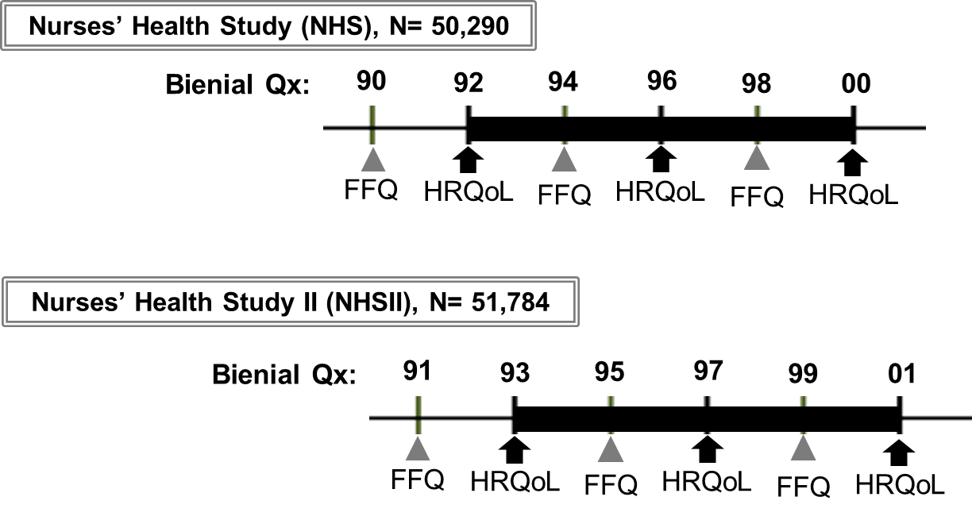

Supplementary Figure S1: Assessments of dietary information and HRQoL during the follow-up periods. The black bold lines show the follow-up periods. Qx, questionnaire; FFQ, food frequency questionnaire; HRQoL, health-related quality of life.

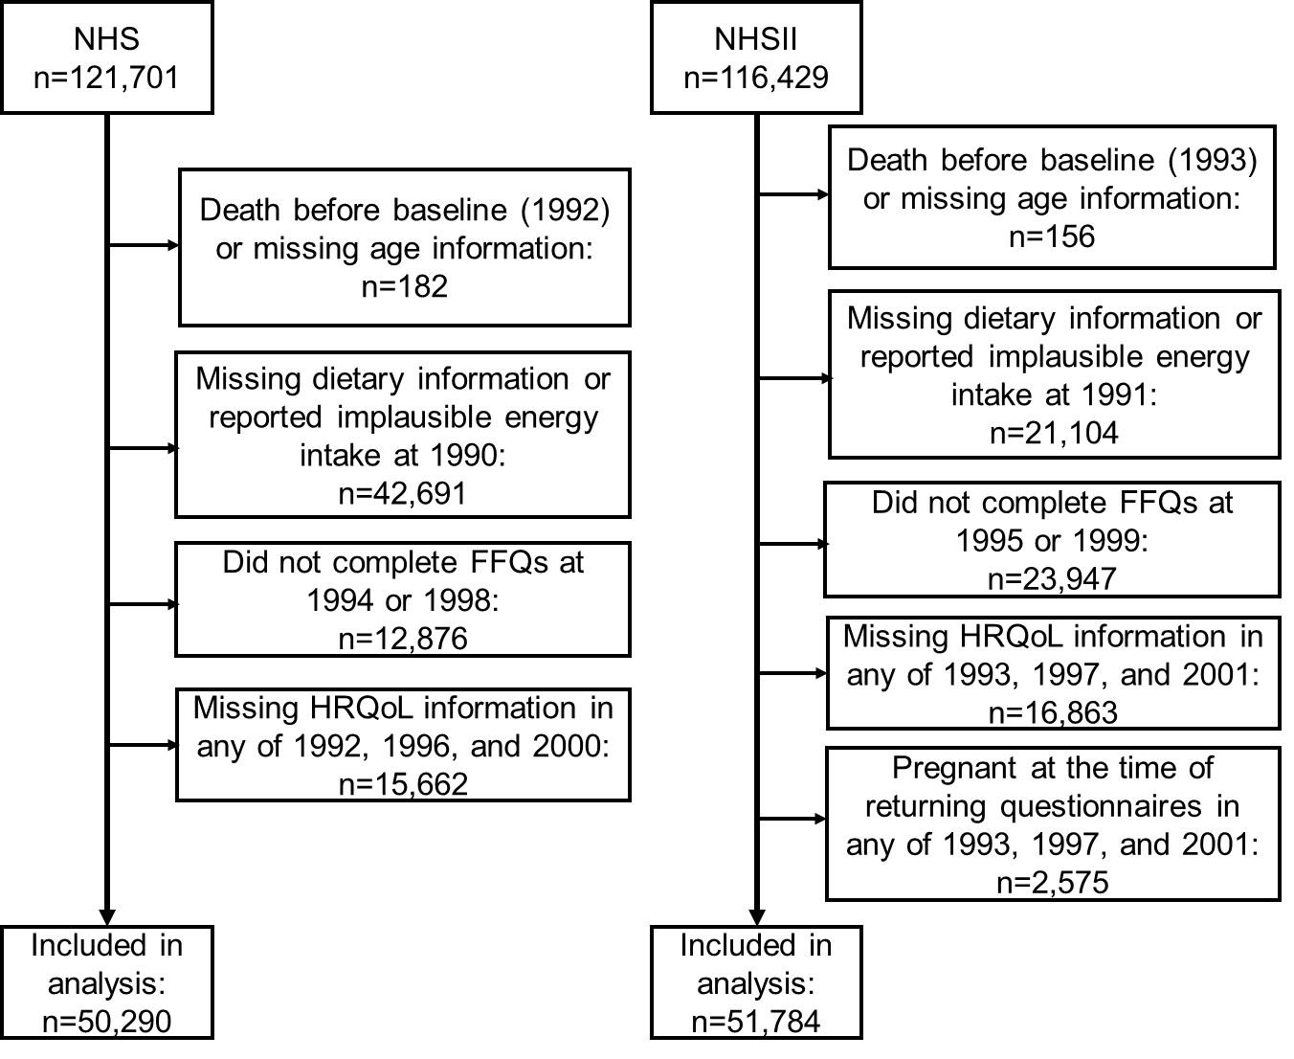

Supplementary Figure S2: Flow chart of participants. NHS, Nurses’ Health Study; NHS II, Nurses’ Health Study II; FFQ, food frequency questionnaire; HRQoL, health-related quality of life.

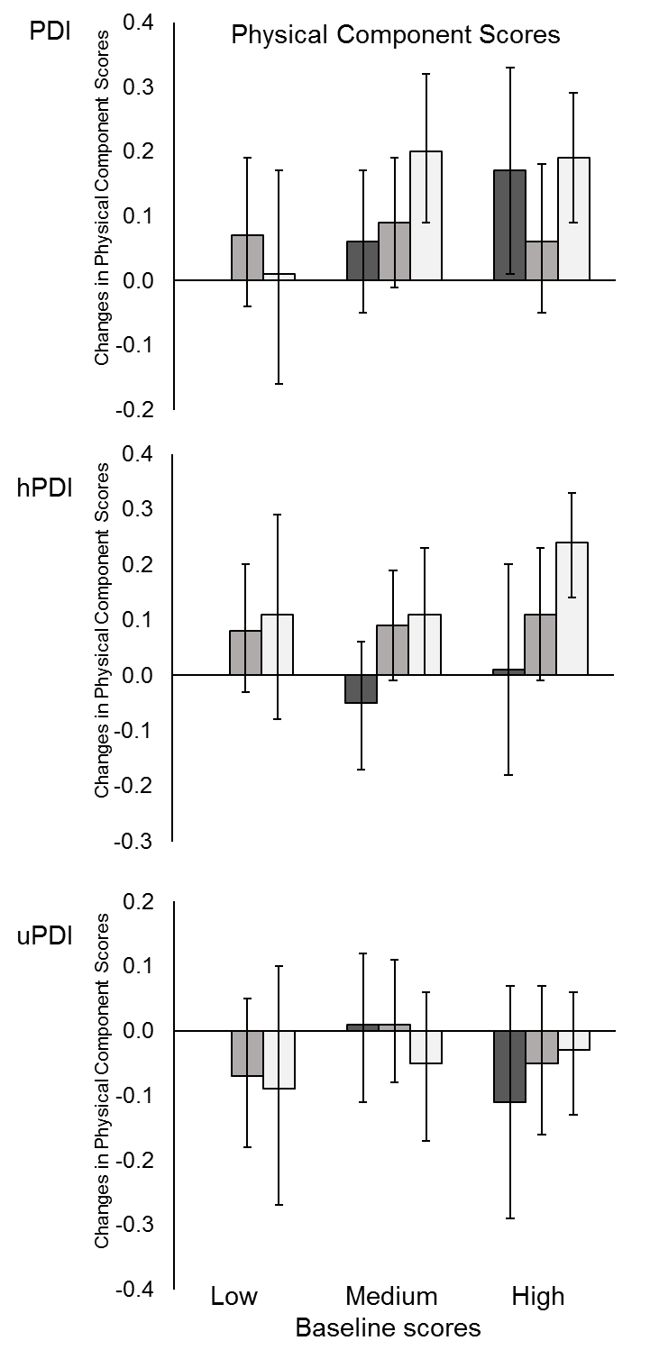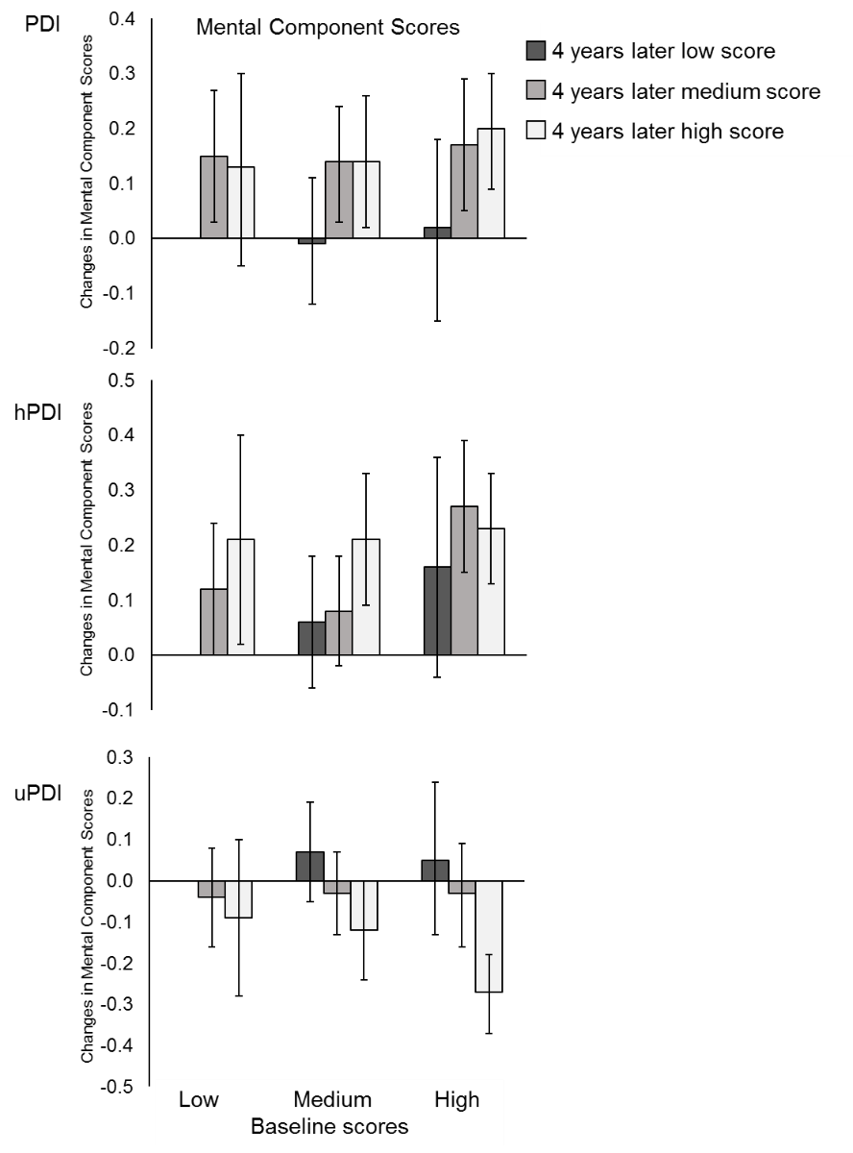

Supplementary Figure S3. Changes in physical and mental component scores according to baseline and 4-years later plant-based diet index scores. hPDI, healthful plant-based diet index; PDI, overall plant-based diet index; uPDI, unhealthful plant-based index.
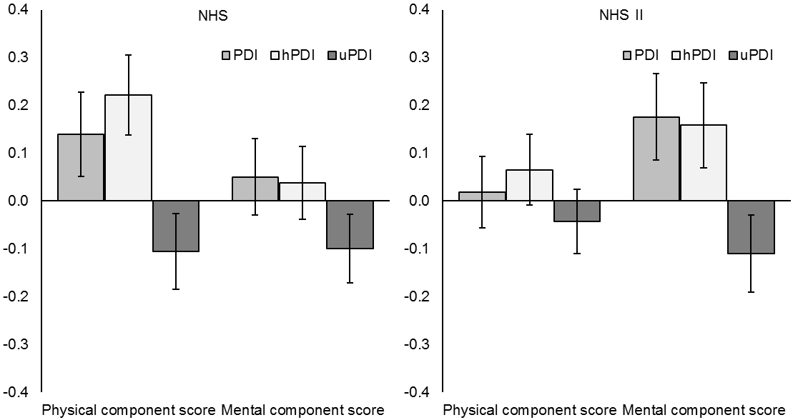
Supplementary Figure S4. Changes in physical and mental component scores per 10-point increase in plant-based diet index scores in the NHS and the NHSII. The bar graph indicate the multivariable-adjusted differences of PCS and MCS scores. Error bars indicate 95% confidence intervals. hPDI, healthful plant-based diet index; MCS, mental component score; NHS, Nurses’ Health Study; NHSII, Nurses’ Health Study II; PCS, physical component score; PDI, overall plant-based diet index; uPDI, unhealthful plant-based index.

