Street food in Eastern Europe: a perspective from an urban environment in Moldova
Supplementary Material

Supplementary Table S1. Characteristics of participants and non-participants (n=439)
 | Total (n=439) | Participation
 |  | No  (n=111) |  | Yes  (n=328)
 | n | n | % | n | % | p
Location within the buffer |  |  |  |  |  | <0.001ª
Inside the market | 237 | 79 | 71.2 | 158 | 48.2
Surroundings | 202 | 32 | 28.8 | 170 | 51.8
Type of vending site |  |  |  |  |  | 1.000
Stationary | 421 | 107 | 96.4 | 314 | 95.7
Mobile | 18 | 4 | 3.6 | 14 | 4.3
Physical setup (stationary) |  |  |  |  |  | <0.001^{b}
Stand | 170 | 37 | 34.6 | 133 | 42.4
Kiosk | 99 | 30 | 28.0 | 69 | 22.0
Freezer or soft ice cream machine | 46 | 14 | 13.1 | 32 | 10.2
Dukoni | 43 | 6 | 5.6 | 37 | 11.8
Bench with table | 23 | 14 | 13.1 | 9 | 2.9
Kvass barrel | 29 | 4 | 3.7 | 25 | 8.0
Truck | 8 | 0 | 0.0 | 8 | 2.6
Pushcart | 1 | 1 | 0.9 | 0 | 0.0
Table with chairs | 2 | 1 | 0.9 | 1 | 0.3
ª Statistically significant differences according to Pearson’s Chi-square test, for a confidence level of 95% (p-value<0.05)
ª Statistically significant differences according to Fisher’s exact test, for a confidence level of 95% (p-value<0.05)

Supplementary Table S2. Characteristics of the stationary street food vending sites by physical setups in Chișinău, Moldova (n=314)
 | Total |  | Physical Setupsª
Characteristics |  |  | Informal  (n=41) |  | Formal (n=273) |  | p
Food vendor | n | % | n | % | n | %
Food vendor sex (women) | 280 | 89.2 | 37 | 90.2 | 243 | 89.0 | 0.813
Food vendor ownership (owner) | 24 | 7.6 | 2 | 4.9 | 22 | 8.1 | 0.752
Business
Operating the whole week | 274 | 87.3 | 38 | 92.7 | 236 | 86.5 | 0.264
Operating the whole year | 251 | 79.9 | 12 | 29.3 | 239 | 87.6 | <0.001^{b}
Operating under every type of weather | 255 | 81.2 | 20 | 48.8 | 235 | 86.1 | <0.001^{b}
Infrastructure
Access to electricity | 279 | 88.9 | 38 | 92.7 | 241 | 88.3 | 0.595
Access to drinking water | 303 | 96.5 | 39 | 95.1 | 264 | 96.7 | 0.642
Access to toilet facility | 306 | 97.5 | 40 | 97.6 | 266 | 97.4 | 1.000
ª Informal physical setups: freezer or ice machine (n=32); bench with table (n= 9). Formal physical setups: stand, stall or booth (n= 133); kiosk (n=69); dukoni (n=37); kvass barrel (n=25); truck (n=8) and tables with chairs for customers (n=1)
^{b} Statistically significant differences according to Pearson’s Chi-square test, for a confidence level of 95% (p-value<0.05)

Supplementary Table S3. Examples of street food vending sites in Chișinău, Moldova
Type of vending site | Example
Mobile
Street vendor carrying a bag with foods or beverages. | 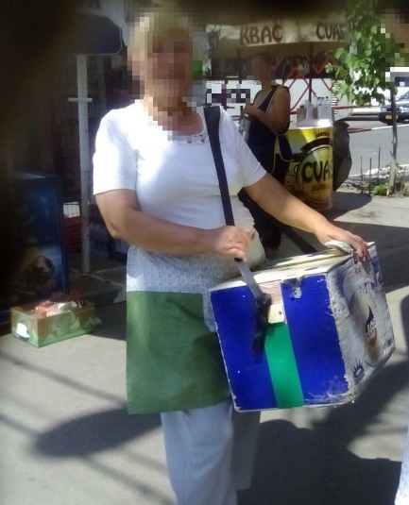
Stationary
Stand  Upright structure where street food is prepared and/or displayed. | 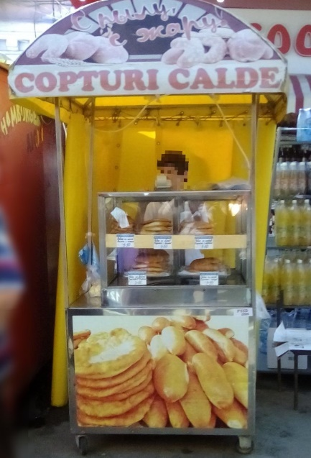
Kiosk  Small open-fronted hut or cubicle where typically newspapers are sold, as well as a sort of foods and beverages. | 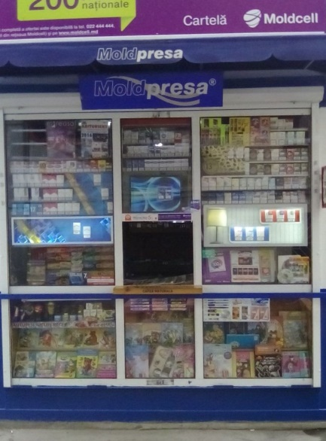
Vending site consisting of freezer and refrigeration machines selling ice-creams and beverages. | 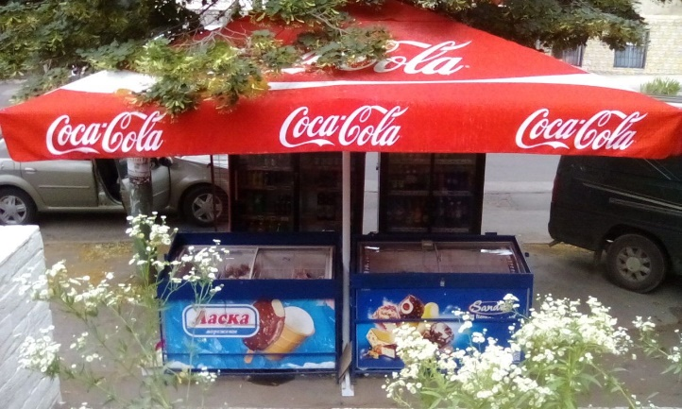
Dukoni  Restaurant serving traditional fast food selling directly on the street through an open window. | 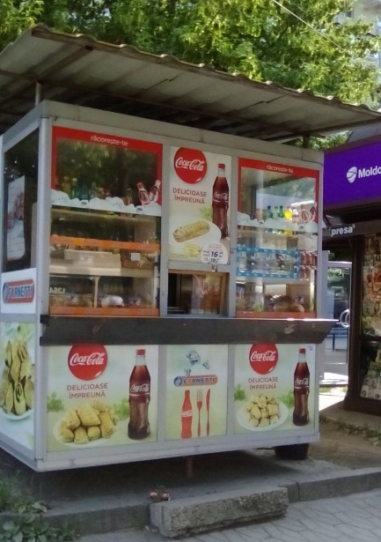
Kvass barrel  Vending site consisting of a portable metal barrel containing kvass (a traditional fermented beverage made from rye bread), supported by an upright structure. | 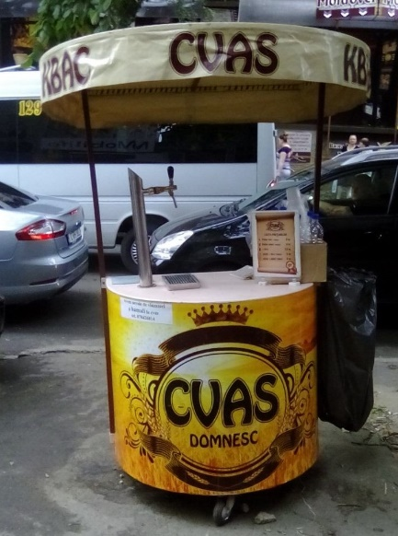
Truck  Large motorized vehicle, such as a van or trailer, equipped to cook, prepare, serve, and/or sell food. | 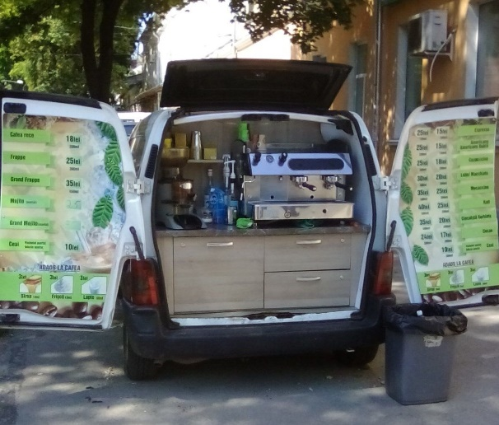
No quality photos of “tables with chairs for customers” or “bench with tableboard” were registered.

Supplementary Table S4. Examples of street foods collected in Chișinău, Moldova
Street Food | Example
Industrial
Chocolate | 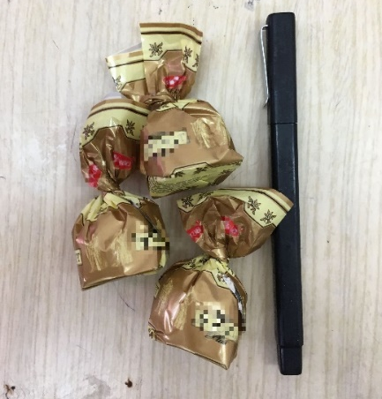
Biscuits

Ice-cream | 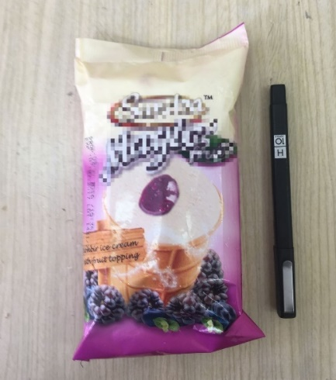
Kvass:
traditional fermented beverage made from rye bread.

Pretzels | 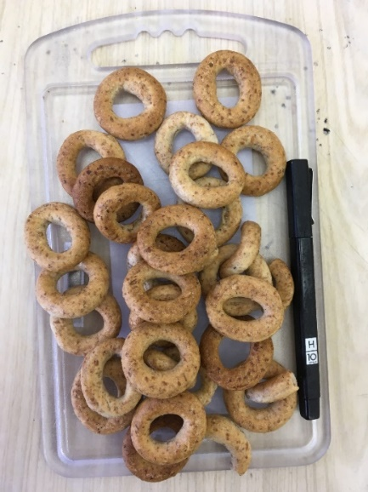
Wafers | 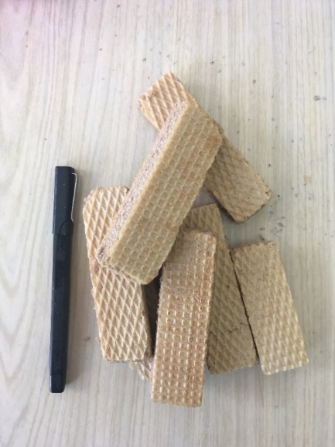
Homemade
Cheburec  Traditional fried savoury pastry generally filled with meat (e.g. chicken, beef). | 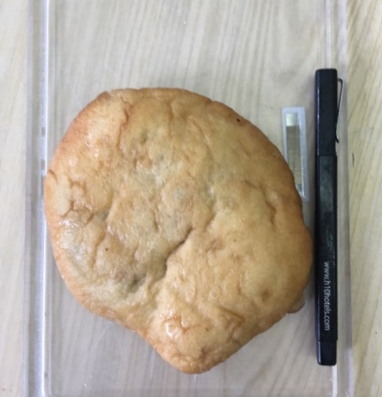
Sweet roll (chiflă)  Sweet bun made of leavened dough (either flaky or brioche type), usually filled with a sweet filling such as chocolate, vanilla or cherry cream. | 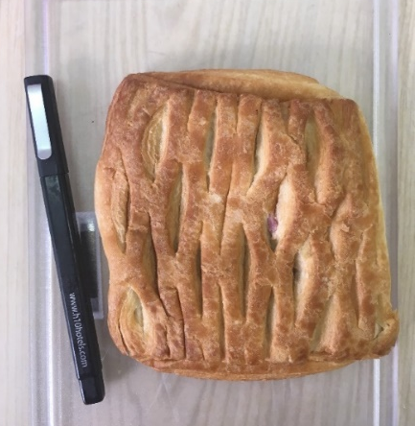
Sausage roll or hot dog

Pateuri or pateu  Traditional fried pastry made from leavened dough filled with cheese, vegetables or meat, usually an oval shape and served in individual portions. | 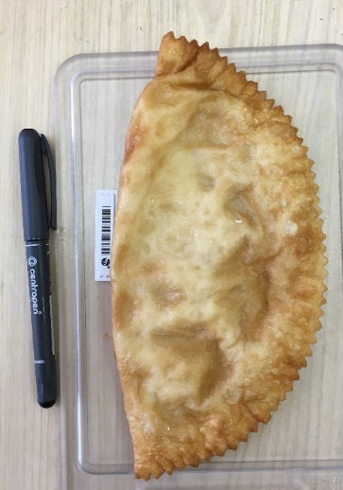
Plăcintă (savoury)  Fried pastry, usually made from dough made of flour, water and sunflower oil, filled with cheese, vegetables, meat or potatoes or sweet fillings, usually served in a pie shape, but may have various shapes. | 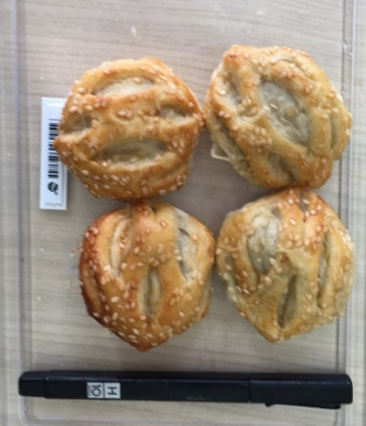
Plăcintă (sweet):  Fried pastry, usually made from flour, water and sunflower oil, filled with a sweet filling as chocolate, vanilla or cherry cream. | 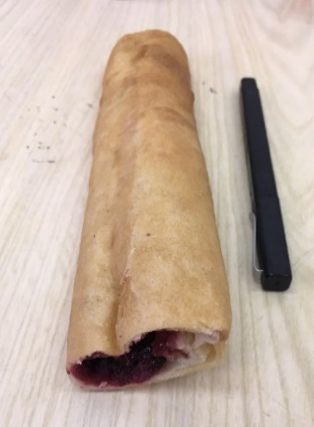
Sweet doughnut | 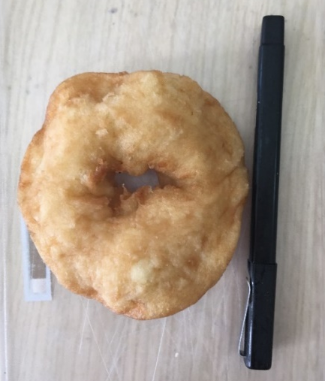

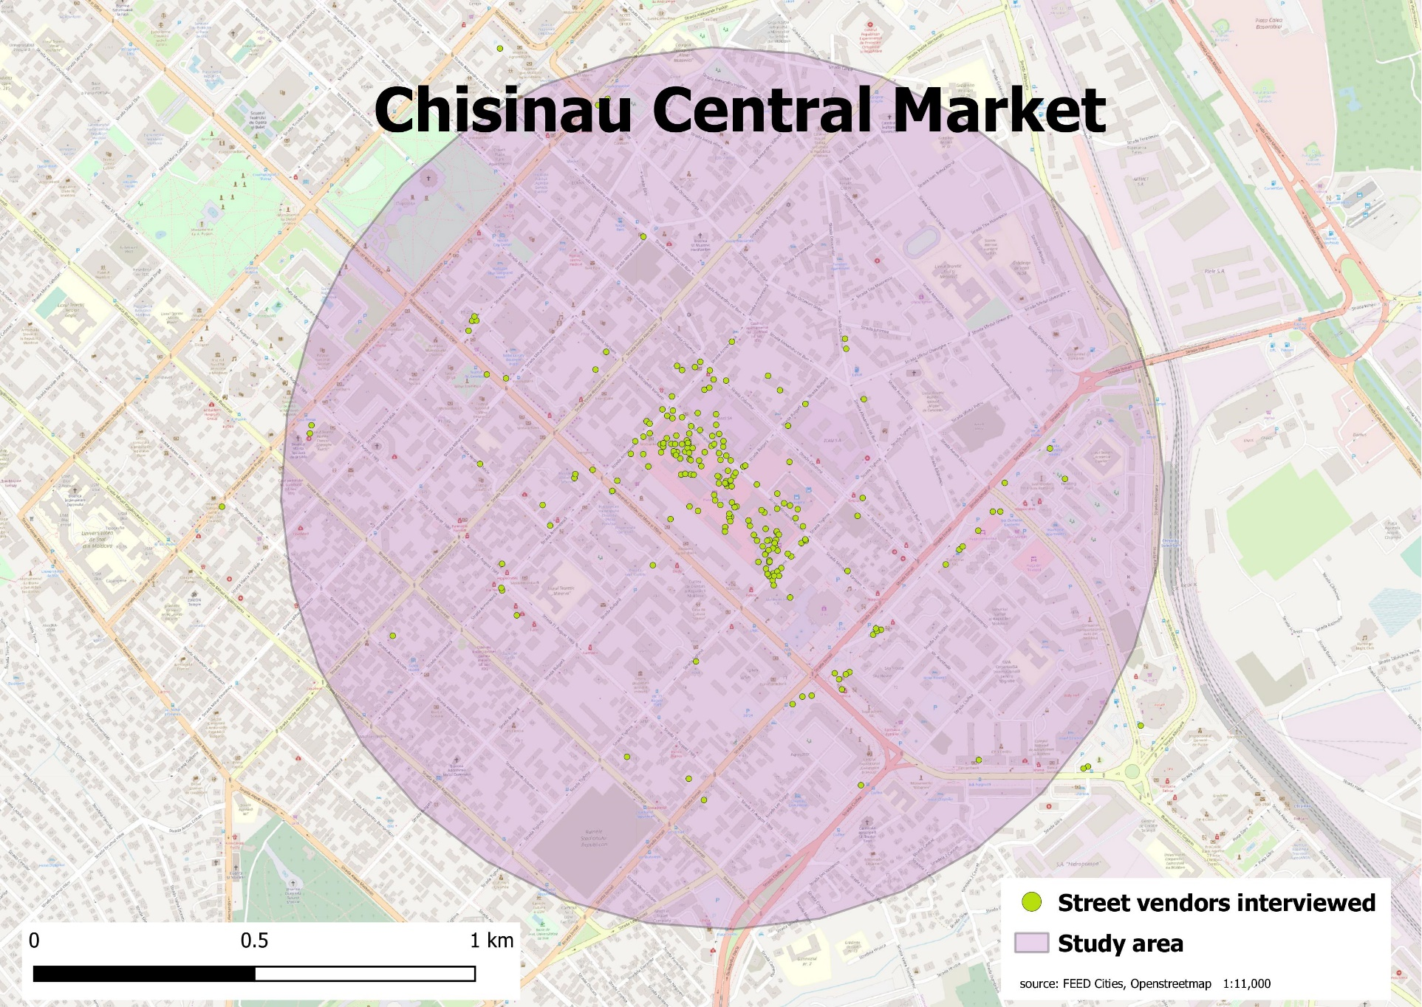
Supplementary Figure 1. Geographical distribution of the street food vending sites in Chișinău, Moldova

