Initial total subjects
N = 581

Exclusion from study with reasons as follows (n=381)
- Did not respond to staff (n=71) or declined (n=39)
- Antibiotic use in past month or treatment of exclusionary GI or autoimmune disorder (e.g., inflammatory bowel disease) in past year (n=77)
- History of cancer (n=7)
- Current smoker (n=16)
- Major intestinal surgery or other condition that restricts dietary intake (n=10)
- Age or BMI criteria not met (n=142)
- Did not return stool collection kit or dietary assessment (n=10)
Exclusion from study with reasons as follows (n=93)
- Did not respond to study staff (n=35)
- Antibiotic use in the past month or treatment of exclusionary GI or autoimmune disorder (e.g., inflammatory bowel disease) in past year (n=25)
- History of cancer (n=2)
- Current smoker (n=2)
- Major intestinal surgery or other condition that restricts dietary intake (n=5)
- Did not return stool collection kit or dietary assessment (n=24)

Cancer free-patient volunteers identified in the colonoscopy clinic (n=132)
Healthy volunteers from the medical center community (n=449

Eligible subjects recruited to study (n=39)

Eligible subjects recruited to study (n=68)

Exclusion in the analysis
- Did not pass the microbiome data quality filtering criteria (n=3)

Exclusion in the analysis
- Did not pass the microbiome data quality filtering criteria (n=3)

Subjects included in analysis
N = 36
Subjects included in analysis
N = 65

Total subjects included in the analysis
N = 101

Supplemental Figure 1. Flow Chart for study participant inclusion

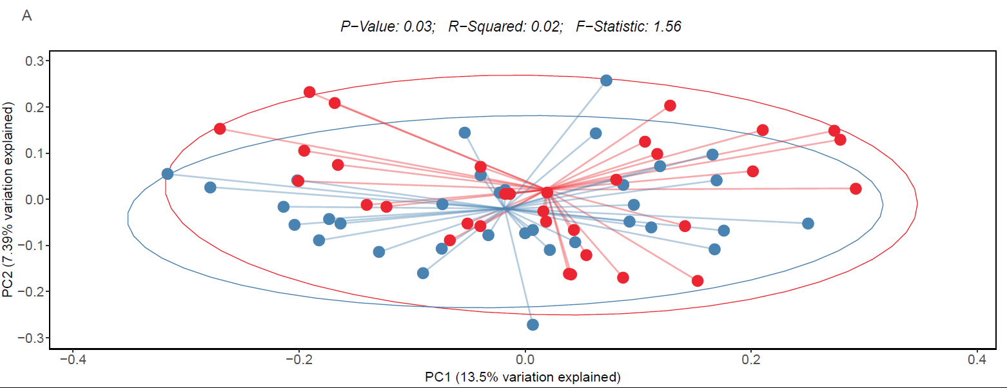

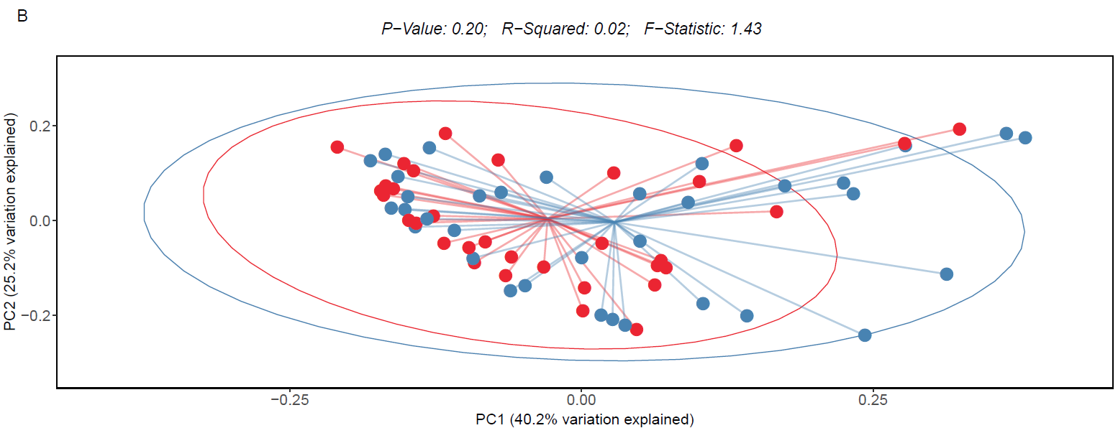

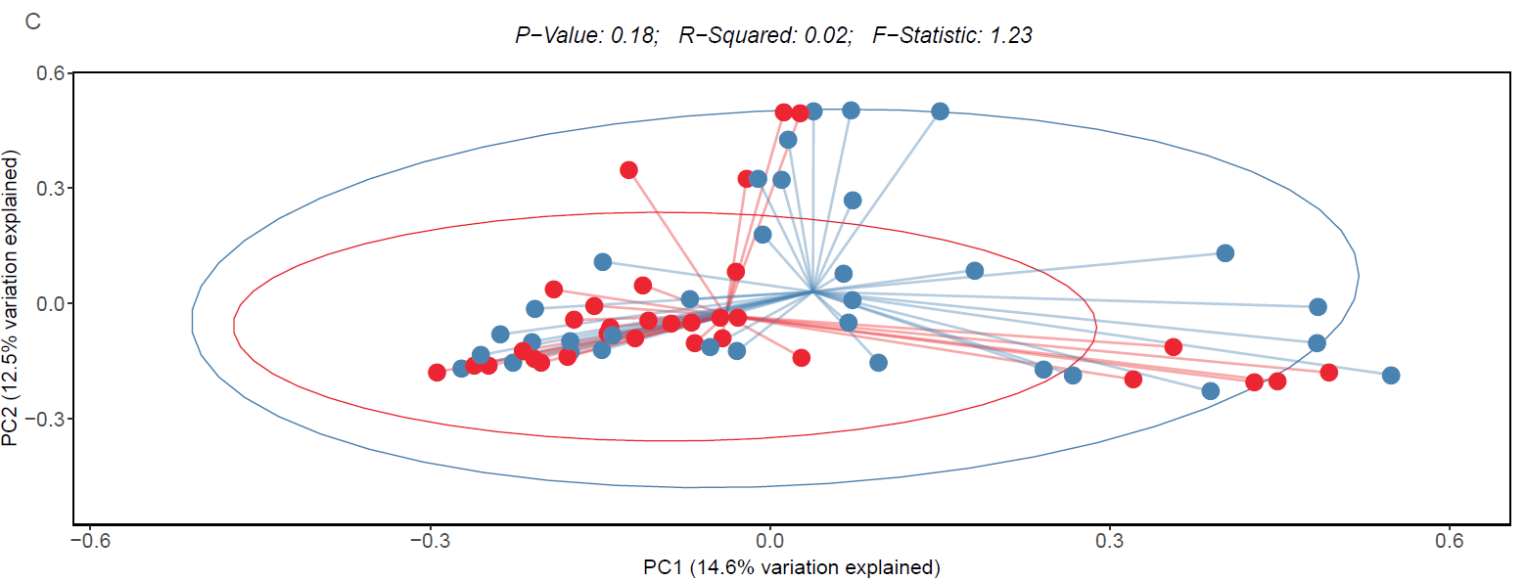

most anti-inflammatory diet
E-DII group
most pro-inflammatory diet

Supplemental Figure 2. Bacterial community level differences by E-DII, as assessed by the following beta-diversity metrics (A) Unweighted Unifrac, (B) Weighted Unifrac and (C) Jaccard

