Supplementary materials

Maternal intake of one-carbon metabolism-related B vitamins and
anorectal malformations in the Japan Environment and Children’s Study

Takehiro Michikawa^{1,2}*, Hiroshi Nitta², Makiko Sekiyama², Tatsuo Kuroda³, Shoji F. Nakayama², Tomohiko Isobe², Yayoi Kobayashi², Miyuki Iwai-Shimada², Eiko Suda², Yu Taniguchi², Toshihiro Kawamoto², Shin Yamazaki² and the Japan Environment and Children’s Study Group⁴

¹Department of Environmental and Occupational Health, School of Medicine, Toho University, 5-21-16 Omori-nishi, Ota-ku, Tokyo 143-8540, Japan.
²Centre for Health and Environmental Risk Research, National Institute for Environmental Studies, 16-2 Onogawa, Tsukuba, Ibaraki 305-8506, Japan.
³Department of Paediatric Surgery, Keio University School of Medicine, 35 Shinanomachi, Shinjuku-ku, Tokyo 160-8582, Japan.
⁴The Study Group members are listed in the Appendix

Correspondence to:
Takehiro Michikawa, MD, PhD
Department of Environmental and Occupational Health,
School of Medicine, Toho University,
5-21-16 Omori-nishi, Ota-ku, Tokyo 143-8540, Japan.
TEL: +81-3-3762-4151
E-mail: takehiro.michikawa@med.toho-u.ac.jp

Table of contents:
Table S1………………………………………………………………………………………………2
Table S2………………………………………………………………………………………………4
Fig. S1.…………….…………………………………………………………………………………5

Table S1. Baseline characteristics of mothers who delivered infants with anorectal malformation (ARM), Japan Environment and Children's Study (2011-2014)

 |  | No. of women* | Frequency (%) |  | ARM (n = 43)
 |  |  |  |  | No. of cases | /10,000 live births
No. of women |  | 89,235 | 100 |  | 43 | 4·8
Dietary and supplemental intake of folate in early pregnancy (μg/day)
 | Low (< 400 μg/day) | 59,573 | 66·8 |  | 29 | 4·9
 | High (≥ 400 μg/day) | 29,662 | 33·2 |  | 14 | 4·7
Dietary intake of vitamin B₆ in early pregnancy (mg/day)
 | Low | 44,617 | 50·0 |  | 27 | 6·1
 | High | 44,618 | 50·0 |  | 16 | 3·6
Dietary intake of vitamin B₁₂ in early pregnancy (μg/day)
 | Low | 44,615 | 50·0 |  | 25 | 5·6
 | High | 44,620 | 50·0 |  | 18 | 4·0
Age at delivery (years)
 | < 25 | 8,603 | 9·6 |  | 4 | 4·6
 | 25-29 | 24,537 | 27·5 |  | 10 | 4·1
 | 30-34 | 31,680 | 35·5 |  | 16 | 5·1
 | ≥ 35 | 24,415 | 27·4 |  | 13 | 5·3
Smoking habits
 | Never smoked | 51,999 | 58·3 |  | 30 | 5·8
 | Ex-smokers/smokers | 37,113 | 41·7 |  | 13 | 3·5
Alcohol consumption
 | Never drank | 30,713 | 34·4 |  | 17 | 5·5
 | Ex-drinkers/drinkers | 58,505 | 65·6 |  | 26 | 4·4
Pre-pregnancy body mass index
 | < 18·5 kg/m² | 14,406 | 16·2 |  | 9 | 6·2
 | 18·5-24·9 kg/m² | 65,370 | 73·3 |  | 32 | 4·9
 | ≥ 25·0 kg/m² | 9,421 | 10·5 |  | 2 | 2·1
Current history of diabetes or gestational diabetes
 | No | 86,429 | 96·9 |  | 41 | 4·7
 | Yes | 2,806 | 3·1 |  | 2 | 7·1
Infertility treatment
 | No | 83,193 | 93·3 |  | 36 | 4·3
 | Yes | 6,015 | 6·7 |  | 7 | 11·6
Educational background (years)
 | < 13 | 31,496 | 35·8 |  | 11 | 3·5
 | ≥ 13 | 56,490 | 64·2 |  | 32 | 5·7
Household income (million Japanese-yen/year)
 | < 6 | 60,086 | 73·0 |  | 30 | 5·0
 | ≥ 6 | 22,192 | 27·0 |  | 10 | 4·5
Occupation in early pregnancy
 | Administrative, managerial, professional, and engineering | 20,568 | 23·2 |  | 9 | 4·4
 | Clerical | 15,224 | 17·2 |  | 10 | 6·6
 | Sales and service | 19,438 | 21·9 |  | 12 | 6·2
 | Homemaker | 24,686 | 27·9 |  | 7 | 2·8
 | Other | 8,657 | 9·8 |  | 5 | 5·8
Use of multi-vitamin supplements
 | No | 82,059 | 92·4 |  | 41 | 5·0
 | Yes | 6,797 | 7·6 |  | 2 | 2·9
Week of pregnancy at delivery
 | < 37 weeks (preterm) | 4,143 | 4·6 |  | 6 | 14·5
 | ≥ 37 weeks | 85,092 | 95·4 |  | 37 | 4·3
Parity
 | 0 | 38,938 | 43·8 |  | 24 | 6·2
 | ≥ 1 | 49,995 | 56·2 |  | 19 | 3·8
Infant sex
 | Boys | 45,808 | 51·3 |  | 25 | 5·5
 | Girls | 43,419 | 48·7 |  | 18 | 4·1
* Subgroup totals do not equal the overall number because of missing data.

Table S2. Spearman’s correlation coefficients between dietary B vitamin intake in early pregnancy and that in mid-late pregnancy

 |  | Early pregnancy |  |  | Mid-late pregnancy
 |  | Folate | Vitamin B₆ | Vitamin B₁₂ | Folate | Vitamin B₆ | Vitamin B₁₂
Early pregnancy
 | Folate | 1
 | Vitamin B₆ | 0·70* | 1
 | Vitamin B₁₂ | 0·28* | 0·53* | 1
Mid-late pregnancy
 | Folate | 0·57* | 0·46* | 0·19* | 1
 | Vitamin B₆ | 0·45* | 0·58* | 0·29* | 0·70* | 1
 | Vitamin B₁₂ | 0·19* | 0·32* | 0·48* | 0·31* | 0·54* | 1
* P-value < 0.01

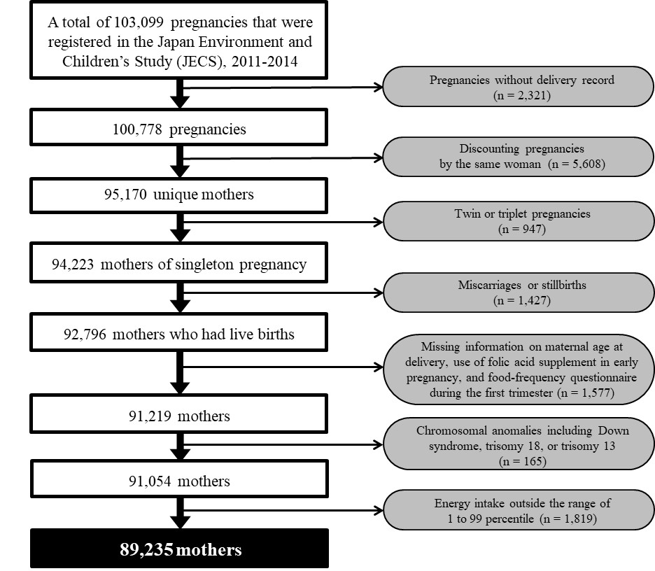

Fig. S1. Flow of Study Population

