Supplementary materials
Table S1 Ingredients and nutrient composition of the rations
Item | Dietary energy level, MJ/kg DM¹
 | 8.21 | 9.33 | 10.45 | 11.57
Ingredient, g/kg dry matter (DM)
Corn | 92.2 | 127.5 | 160.0 | 208.5
Corn starch | 23.5 | 70.0 | 124.0 | 161.5
Sucrose | 5.5 | 16.5 | 22.0 | 30.0
Molasses | 5.5 | 16.5 | 21.5 | 30.0
Wheat bran | 25.0 | 14.6 | 12.8 | 8.0
Soybean meal | 12.0 | 16.5 | 15.4 | 13.2
Cotton seed meal | 15.6 | 13.6 | 13.4 | 12.5
Soybean oil | 0.60 | 4.20 | 10.0 | 15.0
Calcium hydrophosphate | 6.3 | 6.6 | 6.0 | 5.3
Calcium carbonate | 1.8 | 2.0 | 2.9 | 4.0
Sodium chloride | 6.0 | 6.0 | 6.0 | 6.0
Commercial premix² | 6.0 | 6.0 | 6.0 | 6.0
Highland barley straw | 800 | 700 | 600 | 500
Chemical composition³, g/kg DM
DE, MJ/kg | 8.21 | 9.33 | 10.45 | 11.57
CP | 69.7 | 69.6 | 69.1 | 70.2
NDF | 684.1 | 601.5 | 519.7 | 443.7
ADF | 370.2 | 324.9 | 280.9 | 237.6
Ca | 5.21 | 5.13 | 5.20 | 4.92
P | 2.71 | 2.71 | 2.62 | 2.54
¹ Digestible energy on a dry matter basis.
² The premix provided the following per kg of diets: VA 1700 IU; VD 190 IU; VE 18 IU; Co 0.30mg; Cu 17 mg; I 1.5mg; Fe 70 mg; Mn 38 mg; Se 0.28 mg; Zn 40 mg.
³ The DE was calculated according to the Feeding Standard of Meat-producing Sheep and Goats of China, NY/T 816-2004 (Ministry of Agriculture, MOA, PRC, 2004). Others were the measured values. DM, dry matter; DE, digestible energy; CP, crude protein; NDF, neutral detergent fibre; ADF, acid detergent fibre.

Table S2. Sequences of oligonucleotide primers used for real-time quantitative reverse transcription PCR (Real-Time qRT-PCR)
Target gene¹ | Gene bank ID | Primer sequences²（5'→3'） | Tm³ (ºC)
INSR | AY157728 | F: CGTGGCCTGTCGCAACTTCTAC  R: GGACGCACTTGTTGTTGTGAATGAC | 60
GLUT4 | AY949177 | F: GTCAACACAGTCTTCACCTTAGTCTCG  R: GCAGAAGCAGAGCCACAGTC | 58
FABP4 | EU301804 | F: ACTTAGATGAAGGTGCTCTGGTACAAG  R: CTCTGGTAGCAGTGACACCGTTC | 57
LPL | NM_001009394 | F: CGCCGCCGACAGGATTACAAG  R: CAGTTAGCCACAGATTCCGTCACTC | 58
PPARγ | AY137204 | F: TGCCGATTCCAGAAGTGCCTTG  R: GTTGGTCGATGTCGCTGGAGATC | 57
mTOR | NM_001145455 | F: GGCAGCAACAGCGAGAGTGAG  R: GTGACAAGGAGATGGAACGGAAGAAG | 58
AMPKα | EU131097 | F: ATGATGAGGTGGTGGAGCAGAGG  R: CCAGGCGAGGTGAGACAGAGG | 58
β-actin | U39357.1 | F: AGCCTTCCTTCCTGGGCATGGA  R: GGACAGCACCGTGTTGGCGTAGA | 58

¹ INSR, insulin receptor; GLUT4, glucose transporter 4; FABP4, fatty acid binding protein 4; LPL, lipoprotein lipase; PPARγ, peroxisome proliferator-activated receptor-gamma; mTOR, the mammalian target of rapamycin; AMPKα, adenosine monophosphate-activated protein kinase-alpha.
² F, forward; R, reverse.
³ Tm, optimal PCR annealing temperature.

Table S3. The nutrient intake of Tibetan (T) and Small-tailed Han (H) sheep offered diets of different energy levels¹
Items² | Breed | Dietary energy level, MJ/kg³ |  |  |  | SEM | P-value⁴
 |  | 8.21 | 9.33 | 10.45 | 11.57 |  | Breed | E-L | E-Q | E-C
DM, g/d | T | 725 | 732 | 739 | 756 | 41.1 | 0.834 | 0.539 | 0.902 | 0.938
 | H | 721 | 744 | 748 | 751 |  |  | 0.957^{x} | 0.911^{x} | 0.976^{x}
DE, MJ BW^{-0.75} d⁻¹ | T | 0.412 | 0.474 | 0.514 | 0.544 | 0.0129 | 0.275 | <0.001 | 0.127 | 0.938
 | H | 0.406 | 0.463 | 0.509 | 0.532 |  |  | 0.873^{x} | 0.772^{x} | 0.859^{x}
CP, g/d | T | 54.3 | 55.5 | 53.8 | 55.2 | 2.26 | 0.485 | 0.653 | 0.592 | 0.412
 | H | 53.3 | 53.3 | 52.2 | 55.5 |  |  | 0.739^{x} | 0.621^{x} | 0.966^{x}
NDF, g/d | T | 510 | 471 | 392 | 351 | 28.1 | 0.400 | <0.001 | 0.580 | 0.561
 | H | 495 | 429 | 374 | 356 |  |  | 0.642^{x} | 0.538^{x} | 0.764^{x}
ADF, g/d | T | 275 | 254 | 211 | 187 | 8.0 | 0.551 | <0.001 | 0.866 | 0.393
 | H | 280 | 251 | 220 | 190 |  |  | 0.891^{x} | 0.948^{x} | 0.451^{x}

¹ Values are means ± pooled SEM.
² DM, dry matter; DE, digestible energy; CP, crude protein; NDF, neutral detergent fibre; ADF, acid detergent fibre.
³ Digestible energy on a dry matter basis
⁴ E-L = Linear effect of dietary energy level; E-Q = Quadratic effect of dietary energy level; E-C = Cubic effect of dietary energy level.
^{x} P-value for the interaction of dietary energy level with breeds.

Figure S1.
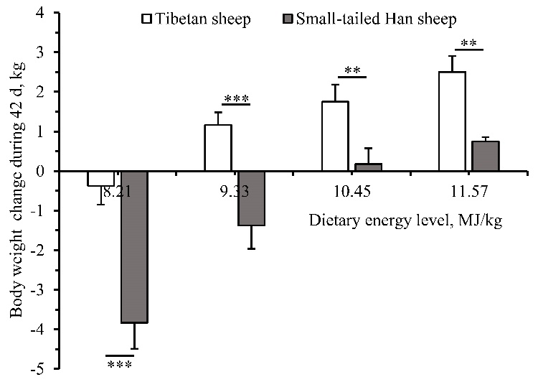
Figure S1. The body weight change of Tibetan and Small-tailed Han sheep offered different energy level diets during the 42 d experiment period. The dietary energy levels are digestible energy on a dry matter basis. Breed P < 0.001, Linear effect of dietary energy level P < 0.001, Quadratic effect of dietary energy level P = 0.003, Cubic effect of dietary energy level P = 0.582, P-value for interaction of dietary energy level effect with species of linear, quadratic and cubic were 0.003, 0.208 and 0.527, respectively. ** P < 0.01, *** P < 0.001

