Supplementary Materials to “A Data Mining Approach to Investigate Food Groups related to Incidence of Bladder Cancer in the BLadder cancer Epidemiology and Nutritional Determinants International Study”

Supplementary Table 1 Included individual food items in the BLEND Dataset

Supplementary Figure 1 Receiver Operating Characteristic Curves for Each Cross-validation Run

Supplementary Figure 2 Importance Values of Input Variables after C5.0 in the BLEND Dataset

Supplementary Table 1 Included individual food items in the BLEND Dataset

Food Items | Food Items | Food Items
Milk and milk products | Eggs and egg products | Meat and meat products
Milk in miscellaneous | Eggs in miscellaneous | Meat in miscellaneous
Liquid milk | Egg dishes | Beef
Liquid milk in miscellaneous | Omelette | Beef in miscellaneous
Milk >4% fat |  | Beef tenderloin
Milk 3-4% fat |  | Beef Striploin
Milk 1-3% fat |  | Veal
Milk < 1% fat |  | Pork
Processed milk |  | Pork in miscellaneous
Chocolate-flavoured milk |  | Pork chump
Acidophilus milk |  | Pork Loin
Cream |  | Mutton/Lamb
Yoghurt |  | Mammals
Yoghurt in miscellaneous |  | Horse
Yoghurt >3% |  | Poultry
Yoghurt <1% |  | Chicken
Cheese |  | Duck
Cheese in miscellaneous |  | Liver
Soft cheese |  | Kidney
Processed cheese |  | Other Offal
Whey cheese |  | Preserved meat
Imitation milk |  | Preserved meat in miscellaneous
Imitation milk in miscellaneous |  | Ham
Non-dairy coffee creamer |  | Bacon
Milk beverage powder
Drinking chocolate powder
Ices
Dairy ice
Sorbet

Supplementary Table 1_continued Included individual food items in the BLEND Dataset

Food Items | Food Items | Food Items
Fish and fish Products | Fats and oils | Grain and grain products
Fish in miscellaneous | Fats and oils in miscellaneous | Grain in miscellaneous
Clupeiformes | Butter | Wheat basic products
Herring | Margarine | Oats basic products
Salmon and trout | Animal fat | Oatmeal
Whitefish | Marine Oil | Barley basic products
Perciformes | Vegetable fats and oil | Barley meal
Tuna | Vegetable fats and oil in miscellaneous | Rice basic products
 | Olive oil | Brown rice
 | Sunflower oil | Polished rice
 | Compound fats and oils | Basic products of other cereals
 |  | Pasta and noodles
 |  | Pasta and noodles in miscellaneous
 |  | Leavened bread
 |  | Leavened bread in miscellaneous
 |  | Rye bread
 |  | Wheat bread
 |  | Unleavened bread and crispbreads
 |  | Crispbread
 |  | Bread products
 |  | Fine bakery wares
 |  | Savoury biscuits
 |  | Sweet biscuits and cookies
 |  | Currant bun
 |  | Dough cakes
 |  | Doughnut
 |  | Danish pastry
 |  | Mince pie
 |  | Baked cake

Supplementary Table 1_continued Included individual food items in the BLEND Dataset

Food Items | Food Items | Food Items
Savoury cereal dishes | Pulses, seeds, kernels, and nut products | Vegetable and vegetable products
Savoury pancake | Pulses, seeds, kernels, and nut products in miscellaneous | Vegetable in miscellaneous
Risotto | Pulses | Leaf vegetable
Savoury pie | Dried broad bean | Endive
Breakfast cereals | Lentil | Lettuce
 | Mung bean | Spinach
 | Soya bean | Brassicas
 | Underground pulses | Cauliflower
 | Peanut | Broccoli
 | Seeds and kernels | Red cabbage
 | Sunflower seed | Chinese cabbage
 | Pine nut | Cabbage
 | Nuts | Turnip tops
 | Walnut | Brussels sprout
 | Hazelnut | Kohlrabi
 | Hickory nut | Curly kale
 | Cashew nut | Stalk vegetables
 | Sweet chestnut | Rhubarb
 | Pulse products | Celery
 | Unfermented soya paste (tofu) | Fennel
 | Peanut butter | Shoot vegetable
 | Nut and seed products | Asparagus
 |  | Chicory
 |  | Globe artichoke
 |  | Bamboo shoot
 |  | Onion family Vegetable
 |  | Garlic
 |  | Onion
 |  | Leek

Supplementary Table 1_continued Included individual food items in the BLEND Dataset

Food Items | Food Items | Food Items
Garlic | Runner bean | Berries
Chives | Sweet corn | White grapes
Tubers | Okra | Strawberries
Tubers in miscellaneous | Avocado | Blueberries
New potato | Olive | Citrus fruit
Main crop | Edible Fungi | Orange
Sweet potato | Cultivated mushrooms | Grapefruit
Yam | Truffle | Miscellaneous
Root vegetable | Morel | Banana
Carrot | Seaweed | Pineapple
Parsnip | Vegetable mixes | Kiwi
Swede | Vegetable mixes in miscellaneous | Melon
Beetroot | Mustard and cress | Watermelon
Radish | Pot herb | Fruit mixture
Parsley | Vegetable products | Fruit products
Fruit vegetable | Tomato puree | Fruit products in miscellaneous
Fruit vegetable in miscellaneous | Pickled gherkins | Dried mixed fruit
Tomato | Pickled onion
Aubergine | Sauerkraut
Sweet pepper | Fruit and fruit products
Chilli pepper | Fruit in miscellaneous
Cucumber | Malaceious fruit
Courgette | Apple
Cucurbita squash | Prunus species fruit
Pod and seed vegetable | Apricot
Pea | Peach
Wax beans | Plum
Broad bean | Sweet cherry
French bean | Other stone fruit

Supplementary Table 1_continued Included individual food items in the BLEND Dataset

Food Items | Food Items | Food Items
Sugar and sugar products | Beverages (non-milk) | Tea in miscellaneous
Sugar in miscellaneous | Beverage in miscellaneous | Herbal tea
Sugar | Beers in malt | Decaffeinated coffee
Other sugar | Beer - alcohol >5% | Caffeinated coffee
Fructose | Beer - alcohol 3-5% | Instant coffee
Sugar substitutes | Beer - alcohol 1-3% | Coffee in miscellaneous
Nutritive sweeteners | Beer - alcohol <1% | Water
Honey | Wine | Fruit juice
Syrup | Wine - alcohol >9% | Fruit juice in miscellaneous
Fruit syrup | Wine - alcohol 5-9% | Orange juice
Jams, marmalades and spreads | Fortified and liqueur | Grapefruit juice
Chocolate and chocolate products | Liqueurs | Apple juice
Chocolate in miscellaneous | Spirits | Grape juice
Milk chocolate bar | Whisky | Vegetable juice
Chocolate-coated confectionery bars | Gin | Tomato juice
Non-chocolate confectionery | Vodka | Other juice
Boiled sweet | Alcoholic mixed drinks
 | Punch - alcohol >1%
 | Carbonated soft drinks
 | Carbonated soft drinks in miscellaneous
 | Soda water
 | Cola
 | Lucozade
 | Non-dilution still drinks
 | Still lemonade
 | Infusion drinks
 | Infusion drinks in miscellaneous
 | Black tea
 | Green tea

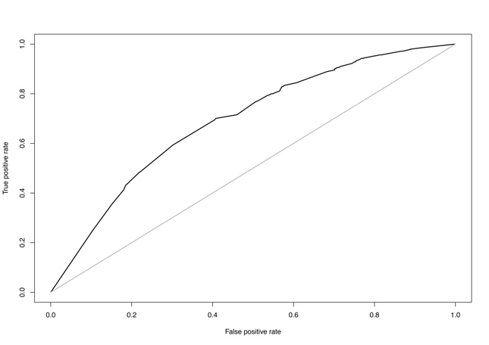
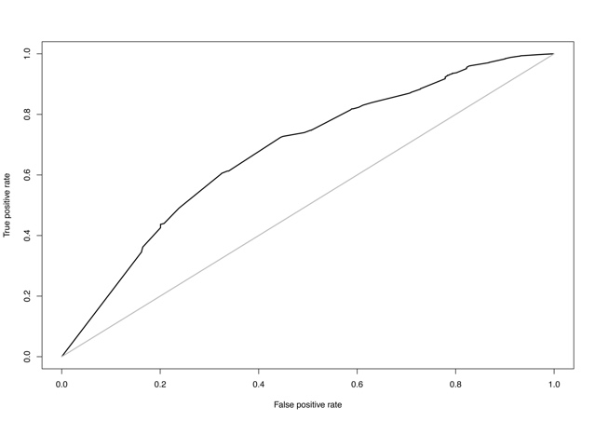
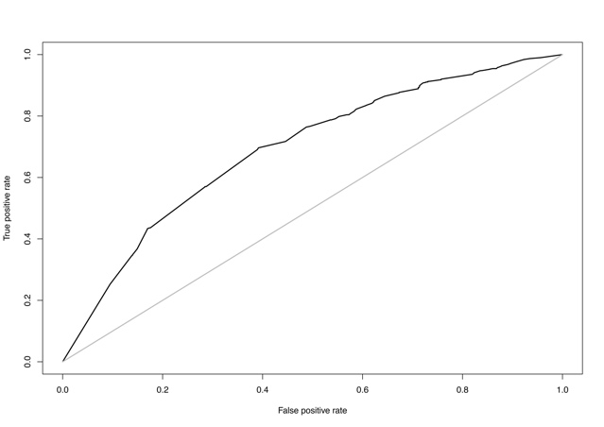
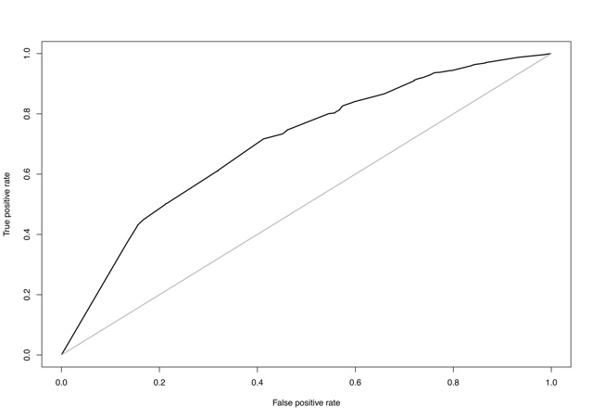
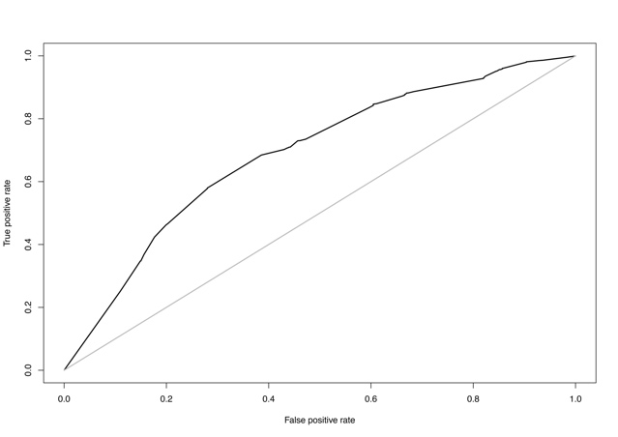
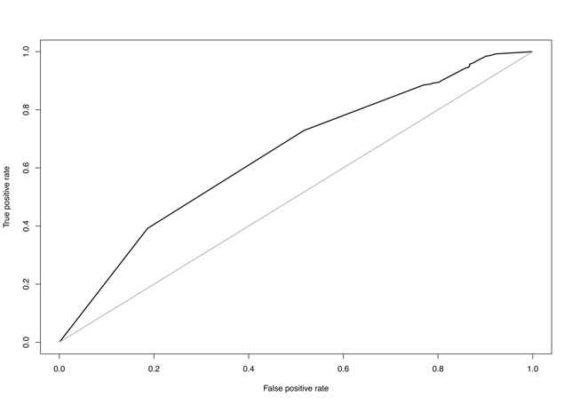
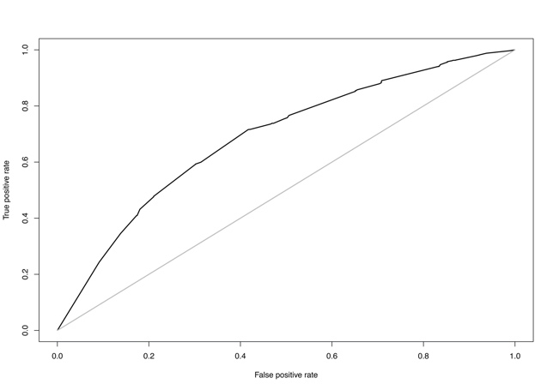
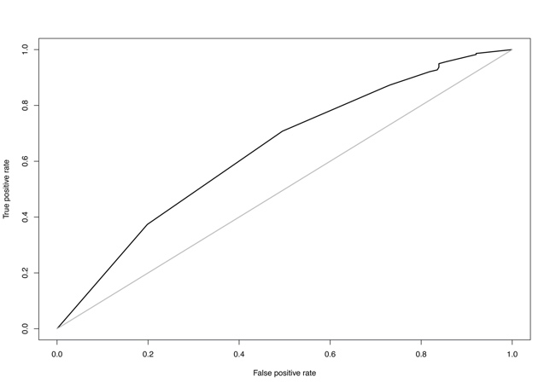
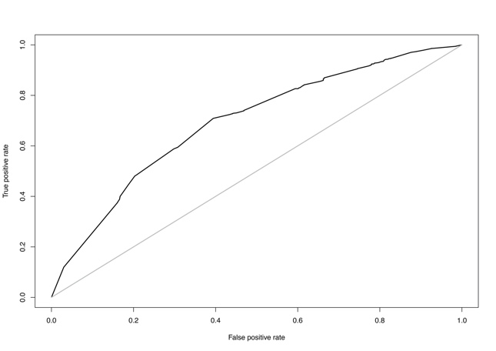
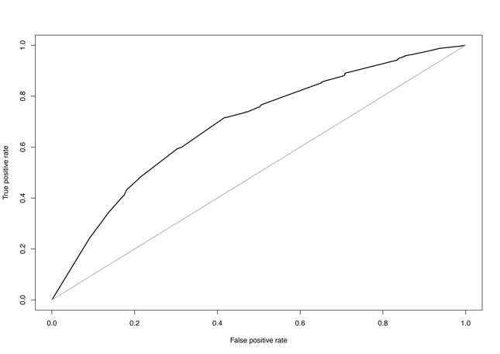

AUC=0.690
AUC=0.692
AUC=0.695
AUC=0.691

AUC=0.698
AUC=0.699
AUC=0.681
AUC=0.685

Supplementary Figure 1 Receiver Operating Characteristic Curves for Each Cross-validation Run

AUC=Area Under the Curve

AUC=0.694
AUC=0.701

2.35%
26.11%
27.89%
39.11%
56.05%
78.64 %
100%
2.47%
Importance values
Input variables
Supplementary Figure 2 Importance Values of Input Variables after C5.0 in the BLEND Dataset

A: milk and dairy products; B: eggs and egg products; C: meats and meat products; D: fishes and fish products; E: fats, oils and their products; F: grains and grain products; G: pulses, seeds, kernels, nuts and their products; H: vegetables and vegetable products; I: fruits and fruit products; J: sugar and sugar products; K: beverages (non-milk)

The importance values range from 0% to 100%, where 0% indicates ‘unimportant’ and 100% indicates ‘extremely important’.

