Supplementary Material
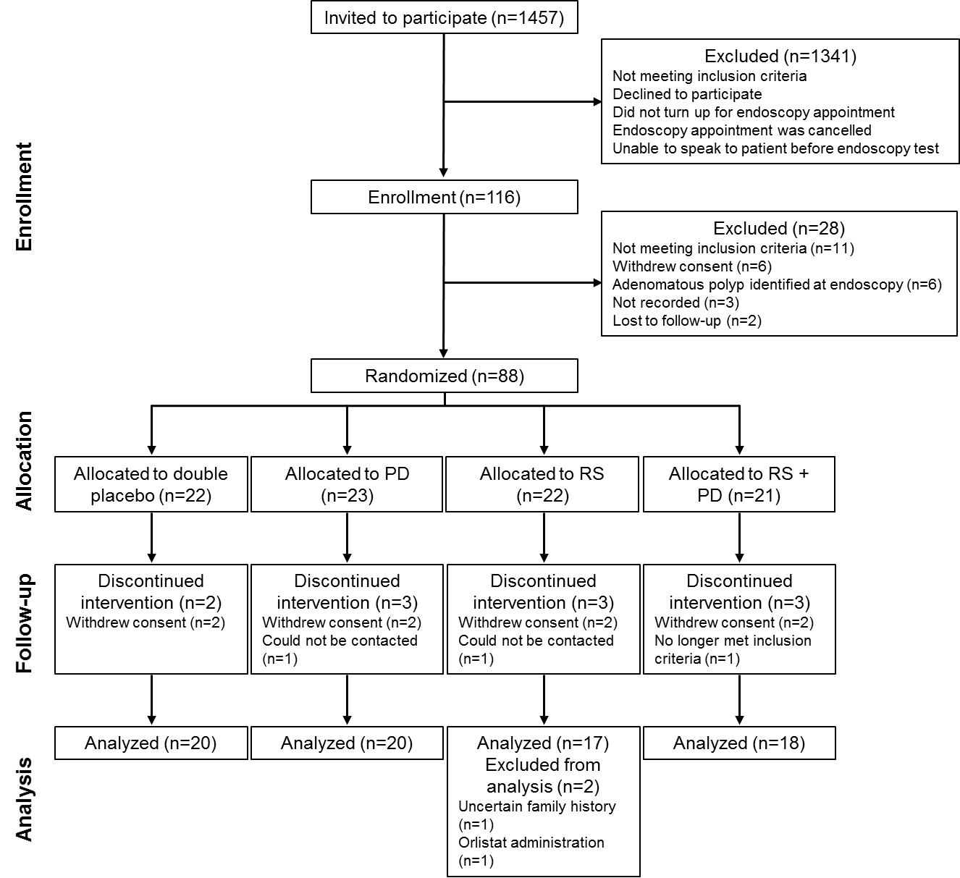

Supplementary Figure 1: Consolidated Standards of Reporting Trials Diagram: flow of participants through the Dietary Intervention, Stem cells and Colorectal cancer Study randomized controlled trial. PD, polydextrose; RS, resistant starch.

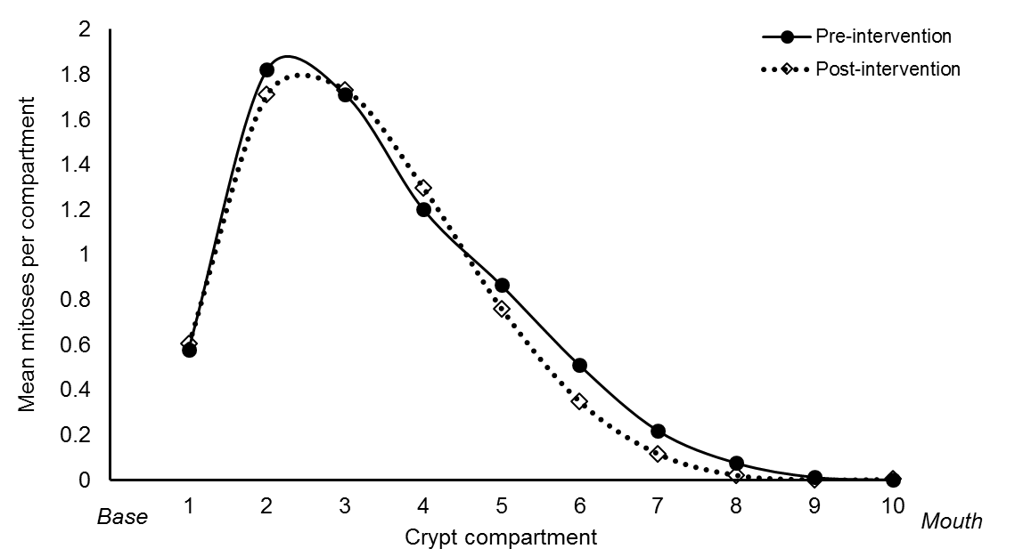

Supplementary Figure 2: Mean number of mitoses per crypt compartment pre- and post-intervention for all DISC Study participants

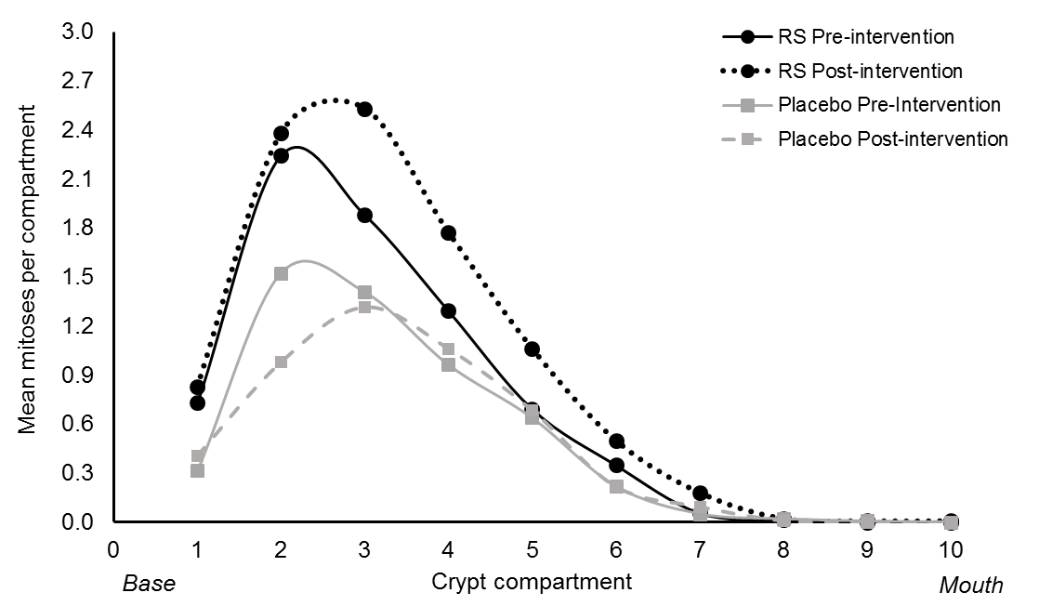
Supplementary Figure 3: Mean number of mitoses per crypt compartment pre- and post-intervention for all older (>50 years old) DISC Study participants given RS or placebo

Supplementary Methods:

Supplementary Table 1: Primer sequences for quantification of CCND1, c-MYC and SFRP1 by qPCR
Gene | Forward primer sequence | Reverse primer sequence
18S | GGCTCATTAAATCAGTTATGGTTCCT | GTATTAGCTCTAGAATTACCACAGTTATCC
B2M | AAAGATGAGTATGCCTGCCGT | ACTTAACTATCTTGGGCTGTGACAA
CCND1 | TTGTACCTGTAGGACTCTCATTCG | ACAGCACTGTGAGCTGGCT
c-MYC | AGATCCGGAGCGAATAGGG | GTCCTTGCTCGGGTGTTGTA
SFRP1 | TGGTGTGGATCTATTGGCTG | TCACTTTCTGGGCTTGACCT

