**Table S1. Sequence of primers used for RT-PCR**

|  |  |  |
| --- | --- | --- |
| Primers |  | sequence |
| Acc1 | forward | GGGCACAGACCGTGGTAGTT |
|  | reverse | CAGGATCAGCTGGGATACTGAGT |
| Atgl | forward | TGACTCGAGTTTCGGATGGAGA |
|  | reverse | GAAATGCCGCCATCCACATAG |
| Cpt1a | forward | TTTGAATCGGCTCCTAATGG |
|  | reverse | CCCAAGTATCCACAGGGTCA |
| Cpt1c | forward | CCCCAATACCCCTACATCCT |
|  | reverse | ATCCCCGATACCCCTGTCT |
| Cpt2 | forward | ACCACAACATCCTGTCCACC |
|  | reverse | GTGGAGAAACTCTCGGGCAT |
| Dnmt3a | forward | CCGCCTCTTCTTTGAGTTCTAC |
|  | reverse | AGATGTCCCTCTTGTCACTAACG |
| Dnmt3b | forward | CCCAAGTTGTACCCAGCAATTC |
|  | reverse | TGCAATTCCATCAAACAGAGACA |
| Fas | forward | GGAGGTGGTGATAGCCGGTAT |
|  | reverse | TGGGTAATCCATAGAGCCCAG |
| Hsl | forward | ATGCCACTCACCTCTGATCC |
|  | reverse | CTGTCCTGTCCTTCCCGTAG |
| Leptin | forward | TGGCTTTGGTCCTATCTGTC |
|  | reverse | TCCTGGTGACAATGGTCTTG |
| Lep-R | forward | CCAGGTGAGGAGCAAGAGAC |
|  | reverse | CTGCACAGTGCTTCCCACTA |
| Npy | forward | ATGCTAGGTAACAAGCGAATGG |
|  | reverse | TGTCGCAGAGCGGAGTAGTAT |
| Pgc-1α | forward | AGCCGTGACCACTGACAACGAG |
|  | reverse | GCTGCATGGTTCTGAGTGCTAAG |
| Ppar-α | forward | ACGGCAATGGCTTTATCA |
|  | reverse | CGCTGCGTCGGACTCGGT |
| Pomc | forward | ATGCCGAGATTCTGCTACAGT |
|  | reverse | TCCAGCGAGAGGTCGAGTTT |
| Socs3 | forward | ATGGTCACCCACAGCAAGTTT |
|  | reverse | TCCAGTAGAATCCGCTCTCCT |
| Srebp-1c | forward | ATGCCATGGGCAAGTACACA |
|  | reverse | GAGGCTGGTTTTGACCCTCA |
| Acss2 | forward | AAACACGCTCAGGGAAAATCA |
|  | reverse | ACCGTAGATGTATCCCCCAGG |
| Aacs | forward | GGGAGCCTGACAGCAAGAAG |
|  | reverse | CGGACAGACCAGTGGTATAAGTC |
| β-actin | forward | GGCCAACCGTGAAAAGATGA |
|  | reverse | CAGCCTGGATGGCTACGTACA |
| Gapdh | forward | GGTGAAGGTCGGTGTGAACG |
|  | reverse | CTCGCTCCTGGAAGATGGTG |



**Figure S1. Differences in body weight change between GF and CV mice.** Four- to five-week-old male C57 BL/6J germ-free (GF) and conventional (CV) mice were fed either a normal-fat diet (NFD) or a high-fat diet (HFD) for 16 weeks. Mouse body weight was measured weekly. n = 6 in each GF group, and n=10 in each CV group. Data are the means ± SEM. * Compared to CV mice with the same diet feeding, P < 0.05; **#** Compared to NFD with the same mouse type, P<0.05.

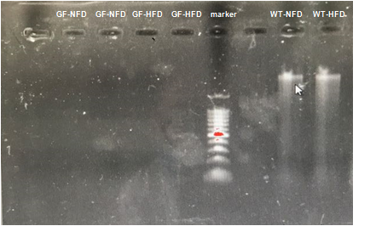

**Figure S2. Test in gut microbiota in GF mice.** Fecal genome DNA was extracted and examined by gel electrophoresis with a 2000 bp DNA ladder as maker. GF: germ-free mice; WT: wild type mice; NFD: normal-fat diet feeding; HFD: high-fat diet feeding. No DNA bands were observed in GF mouse feces.

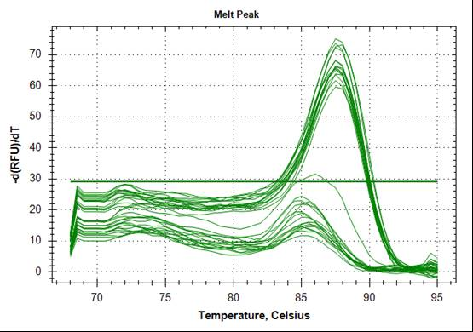

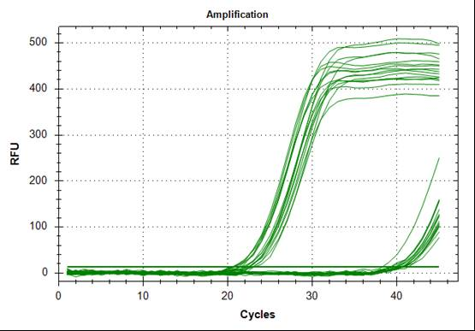

**Figure S3. Test in gut microbiota in GF mice by quantitative PCR for genome DNA extract from faeces.** The universal primer (F: 5’-ACTCCTACGGGAGGCAGCAG-3’; R: 5’-ATTACCGCGGCTGCTGG-3’) was used. No melt peak was shown in GF-NFD and GF-HFD mice, whereas higher melt peak was shown in CV-NFD and CV-HFD mice (the upper figure). The averaged CT value for GF mice was 39.82±0.80, whereas that for CV mice was 22.95±0.91 (the lower figure).