Supplementary data
Effects of dairy products, calcium, and vitamin D on ovarian cancer risk:
a meta-analysis of 29 epidemiological studies

Min-qi Liao^{1, *}, Xu-ping Gao^{1, *}, Xiao-xuan Yu¹, Yu-fei Zeng², Shu-na Li¹, Nalen Naicker ³, Tanya Joseph ³, Wen-ting Cao⁴, Yan-hua Liu⁵, Sui Zhu⁶, Qing-shan Chen¹, Zhi-cong Yang^{7, #}, Fang-fang Zeng^{1, #}

Initial Search Strategies
Search 1: PubMed, search through July 07,2018 (n=1199)
(((((Dairy* or dairy product* or milk* or milk product* or lait or creamery OR Dairy Products[MESH])) OR (Calcium*or calcidiol or calcitriol or Calcium[MESH])) OR (Vitamin D* or VD* OR 25(OH)D OR 1,25(OH)2D or Irradiated ergosterol or ergocalciferol* or calciferol* OR Vitamin D[MESH]))) AND (((Ovary or ovarian) and (cancer or cancers or carcinoma* or tumor or tumour)) or Ovarian cancer or ovarian carcinoma* or carcinoma of ovary* or oophoroma* or Ovarian Neoplasms[MeSH])

Search 2: Embase, search through July 07,2018 (n=3314)
(dairy* OR 'dairy product' OR milk* OR 'milk product' OR lait OR creamery OR 'dairy products' OR calcium* OR calcidiol OR calcitriol OR 'calcium'/exp OR 'vitamin d' OR vd OR '25(oh)d' OR '1,25(oh)2d' OR 'irradiated ergosterol' OR ergocalciferol* OR calciferol* OR 'vitamin-d'/exp) AND ((ovary OR ovarian) AND (cancer OR cancers OR carcinoma* OR tumor OR tumour) OR 'ovarian cancer' OR 'ovarian carcinoma*' OR 'carcinoma of ovary*' OR oophoroma* OR 'ovarian neoplasms'/exp)

Search 3: Web of science, search through July 07,2018 (n=943)
((Dairy* or dairy product* or milk* or milk product* or lait or creamery) OR (Calcium*or calcidiol or calcitriol) OR (Vitamin-D* or VD OR 25(OH)D OR 1,25(OH)2D or Irradiated ergosterol or ergocalciferol* or calciferol*)) AND (((Ovary or ovarian) and (cancer or cancers or carcinoma* or tumor or tumour)) or Ovarian cancer or ovarian carcinoma* or carcinoma of ovary* or oophoroma* or Ovarian Neoplasms)

Search 4: Cochrane Library, search through July 07,2018 (n=66)
((Dairy* or dairy product* or milk* or milk product* or lait or creamery or Dairy Products) AND (Calcium*or calcidiol or calcitriol or Calcium) AND (Vitamin D* or VD* or 25(OH)D or 1,25(OH)2D or Irradiated ergosterol or ergocalciferol* or calciferol* or Vitamin D)) AND (((Ovary or ovarian) or (cancer or cancers or carcinoma* or tumor or tumour)) or Ovarian cancer or ovarian carcinoma* or carcinoma of ovary* or oophoroma* or Ovarian Neoplasms) in Title Abstract Keyword - in Trials (Word variations have been searched)

Search 5: ClinicalTrial.gov, search through July 07,2018 (n=21)
((dairy OR milk) OR vitamin D OR calcium) | Ovarian Cancer AND (Neoplasm OR (Ovarian Neoplasm) OR (Ovarian epithelial cancer))

Note: 329 articles identified with updated search of the PubMed (n=85), Embase (n=92), Web of Science (n=147), Cochrane Library (n=3) and ClinicalTrial.gov (n=2) used initially, but no eligible study was added up to December 24, 2019.
Supplemental Table 1. Estimating dairy products intakes for several studies using USDA MPED database.
Supplemental Table 2. Certain reasons for the exclusion of several studies.
Supplemental Table 3. Further details of the eligible studies included in the meta-analysis.
Supplemental Table 4. Quality of case-control studies included in meta-analysis according to the Newcastle-Ottawa Scale.
Supplemental Table 5. Quality of cohort studies included in meta-analysis according to the Newcastle-Ottawa Scale.
Supplemental Table 6. Stratified analysis on the association between intake of total dairy products and the risk of ovarian cancer.
Supplemental Table 7. Stratified analysis on the association between intake of whole milk and the risk of ovarian cancer.
Supplemental Table 8. Stratified analysis on the association between intake of low-fat milk and the risk of ovarian cancer.
Supplemental Table 9. Stratified analysis on the association between intake of skim milk and the risk of ovarian cancer.
Supplemental Table 10. Stratified analysis on the association between intake of yogurt and the risk of ovarian cancer.
Supplemental Table 11. Stratified analysis on the association between intake of cheese and the risk of ovarian cancer.
Supplemental Table 12. Stratified analysis on the association between intake of lactose and the risk of ovarian cancer.
Supplemental Table 13. Stratified analyses on the association between dietary calcium and the risk of ovarian cancer.
Supplemental Table 14. Stratified analyses on the association between total calcium intake and the risk of ovarian cancer.
Supplemental Table 15. Stratified analysis on the association between intake of dietary vitamin D and the risk of ovarian cancer.
Supplemental Table 16. Stratified analysis on the association between intake of total vitamin D and the risk of ovarian cancer.
Supplemental Table 17. The meta-regression analysis between different intakes of exposures and the risk of ovarian cancer.
Supplemental Table 18. Influence analysis on the association between intakes of each kind of dairy products and the risk of ovarian cancer.
Supplemental Table 19. Publication bias of eligible studies under different exposures models.
Supplemental Figure 1. Forest plots of associations between whole milk intake and the risk of ovarian cancer; Error bars indicate 95% confidence intervals. Abbreviations: RR, relative risk; 95%CI, 95% confidence intervals.
Supplemental Figure 2. Forest plots of associations between low-fat milk intake and the risk of ovarian cancer; Error bars indicate 95% confidence intervals. Abbreviations: RR, relative risk; 95%CI, 95% confidence intervals.
Supplemental Figure 3. Forest plots of associations between cheese intake and the risk of ovarian cancer; Error bars indicate 95% confidence intervals. Abbreviations: RR, relative risk; 95%CI, 95% confidence intervals.
Supplemental Figure 4. Forest plots of associations between dietary calcium intake and the risk of ovarian cancer; Error bars indicate 95% confidence intervals. Abbreviations: RR, relative risk; 95%CI, 95% confidence intervals.
Supplemental Figure 5. Forest plots of associations between dietary vitamin D intake and the risk of ovarian cancers. Error bars indicate 95% confidence intervals. Abbreviations: RR, relative risk; 95%CI, 95% confidence intervals.
Supplemental Figure 6. Funnel plots of studies evaluating RRs of ovarian cancer among participants with intake of total dairy products. Abbreviation: RR, relative risk.
Supplemental Figure 7. Funnel plots of studies evaluating RRs of ovarian cancer among participants with intake of whole milk. Abbreviation: RR, relative risk.
Supplemental Figure 8. Funnel plots of studies evaluating RRs of ovarian cancer among participants with intake of cheese. Abbreviation: RR, relative risk.
Supplemental Figure 9. Funnel plots of studies evaluating RRs of ovarian cancer among participants with intake of lactose. Abbreviation: RR, relative risk.

Supplemental Table 1. Estimating dairy products intakes for several studies using USDA MPED database
Author (Ref) | Food group | Units before translated  (/d) | Unit per serving in MPED(/d) | Unit after translated, (gram/d)
Mettlin CJ ⁽³⁰⁾ | Total dairy products, whole milk, low-fat milk, skim milk | glass | 200 (ml) | 206.00
Qin B ⁽⁴⁶⁾ | Total dairy products, whole milk, low-fat milk, skim milk | ml | 237 (ml) | 244.11
 | Yogurt | serving | 8oz(g) | 226.79
 | Cheese | serving | 1oz (g) | 28.35
Park Y ⁽⁴²⁾ | Total dairy products | cup | 8oz(g) | 226.79
Bertone ER ⁽³⁴⁾ | Whole milk, skim milk | serving | 245(g) | 245.00
 | Yogurt | serving | 8oz(g) | 226.79
 | Cheese | serving | 1oz (g) | 28.35
Kiani F ⁽⁴¹⁾ | Whole milk, low-fat milk, skim milk | cup | 8oz (g) | 226.79
 | Cheese | serving | 1oz (g) | 28.35
Merritt MA ⁽⁴⁴⁾ | Total dairy products, whole milk, low-fat milk, skim milk | 8oz | 8oz (g) | 226.79
 | Yogurt | cup | 8oz (g) | 226.79
 | Cheese | cup | 2oz (g) | 56.70
Webb PM ⁽³³⁾ | Total dairy products, whole milk, low-fat milk, skim milk | glass | 200 (ml) | 206.00
 | Yogurt | carton | 8oz (g) | 226.79
 | Cheese | serving | 1oz (g) | 28.35
Faber MT ⁽⁴³⁾ | Total dairy products, whole milk, low-fat milk, skim milk | ml | 237 (ml) | 244.11
 | Yogurt | portion | 9oz (g) | 257.50
 | Cheese | portion | 100 (ml) | 106.00
Larsson SC ⁽⁴⁸⁾ | Total dairy products, whole milk | serving | 245(g) | 245.00
 | Yogurt | cup | 8oz (g) | 226.79
 | Cheese | serving | 1oz (g) | 28.35
Koralek DO ⁽⁴⁹⁾ | Total dairy products, whole milk, low-fat milk, skim milk | serving | 245 (g) | 245.00
 | Cheese | serving | 1oz (g) | 28.35
Kushi LH ⁽⁴⁷⁾ | Total dairy products, skim milk | serving | 245 (g) | 245.00
 | Cheese | serving | 1oz (g) | 28.35

Supplemental Table 2. Certain reasons for the exclusion of several studies
First author | Title | Exclusion reasons
Reinhold U | Circulating 25-hydroxyvitamin D concentration in German cancer patients | Cross-sectional study, insufficient sample
Cramer DW | Commentary: re: "A case-control study of milk drinking and ovarian cancer risk | Commentary
Kelly MG | Does high normocalcemia predict ovarian cancer in patients with a pelvic mass? | Abstract
Schildkraut J | Risk factors and ovarian cancer in African American women: Contributors to disparities | Abstract
Schulz M | No association of consumption of animal foods with risk of ovarian cancer | Meta-analysis
Dimitrakopoulou VI | Circulating vitamin D concentration and risk of seven cancers: Mendelian randomisation study | Mendelian randomisation study
Webb PM | Circulating 25-hydroxyvitamin D and survival in women with ovarian cancer | Survival analysis
Nagle CM | Dietary influences on survival after ovarian cancer | Survival analysis
Schwartz GG | Prospective studies of total and ionized serum calcium in relation to incident and fatal ovarian cancer | Survival analysis
Grant WB | The likely role of vitamin D from solar ultraviolet-B irradiance in increasing cancer survival | Survival analysis
Meloni GF | Lactose absorption in patients with ovarian cancer | Unrelated study factors
Bodelon C | Sun exposure and risk of epithelial ovarian cancer | Unrelated study factors

Supplemental Table 3. Further details of the eligible studies included in the meta-analysis
Author (Ref) | Name of studies | Diagnosis method | Pathological type | Dietary assessment method | Adjusted factors
Case-control study
La Vecchia C ⁽²⁹⁾ | NA | Histologically confirmed | EOC: serous carcinomas, endometrioid, mucinous, clear cell, poorly differentiated | Standard questionnaire | Age
Mettlin CJ ⁽³⁰⁾ | The Roswell Park Memorial Institute case-control study | NA | EOC | FFQ  (66 items) | Education, annual household income, the percentage of having been pregnant, marital status
Engle A ⁽³¹⁾ | The American Health Foundation's large case-control study of tobacco-related diseases | NA | EOC | FFQ | Body mass, smoking, β-carotene intake
Risch HA ⁽³²⁾ | NA | Pathology confirmed | Primary, malignant or borderline malignant, EOC | Interview | Age at diagnosis/interview, continuous variables, number of full-term pregnancies, total duration of oral-contraceptive usage, total calories/day, the nutrient variables, saturated fat/total fat, vegetable fiber
Webb PM ⁽³³⁾ | NA | Blood analysis | Primary EOC | FFQ | Age group, education level, BMI, smoking, parity, oral contraceptive use, total energy intake
Bertone ER ⁽³⁴⁾ | NA | Diagnosed by state tumor registry | OC | FFQ | Age, state, parity, tubal ligation, and family history of ovarian cancer in a first-degree relative
Bosetti C ⁽³⁵⁾ | NA | NA | EOC | FFQ  (78 items) | Age, study center, education, year of interview, parity, oral contraceptive use, energy intake
Bidoli E ⁽⁵²⁾ | NA | Major teaching and general hospitals | Common EOC (borderline ovarian tumor excluded) | FFQ  (78 items) | Age, study center, year of interview, education, BMI, parity, oral contraceptive use, occupational physical activity, and energy intake
Cramer DW ⁽⁵⁵⁾ | Study of ovarian cancer in Massachusetts or New Hampshire | NA | EOC including tumors of borderline malignancy | FFQ | Total caloric intake, age, site, parity, BMI, oral contraceptive use, family history of breast, ovarian or prostate cancer in a first-degree relative, tubal ligation, education and marital status
Goodman MT ⁽³⁶⁾ | NA | Cancer registries | All types of OC | Diet questionnaire | Education, family incomes, history of being pregnant, oral contraceptives history of tubal ligation and family history of breast or ovarian cancer.
Salazar-Martinez E ⁽³⁷⁾ | The case-control study of OVC in the south of Mexico City | NA | EOC and endometrium cancer | FFQ  (116 items) | Age, total energy intake, number of live births, recent changes in weight, physical activity, diabetes
Zhang M ⁽³⁸⁾ | NA | Medical records and laboratory pathology reports | EOC | FFQ  (120 items) | Age at interview, education, living area, BMI, smoking, alcohol drinking, tea drinking, family income, marital and menopause status, parity, tubal ligation, oral contraceptive use, physical activity, family history of ovarian cancer, total energy intake
McCann SE ⁽³⁹⁾ | The case-control studies of diet and cancer of the breast, endometrium, ovary and prostate in western New York (1986-1991) | NA | EOC | FFQ | Age, education, total months menstruating, difﬁculty becoming pregnant, oral contraceptive use, menopausal status and total energy
Pan SY ⁽⁴⁰⁾ | The Canadian National Enhanced Cancer Surveillance System (NECSS) | Pathology reports | EOC | The national cancer institute’s block questionnaire | Age, province of residence, education, alcohol consumption, cigarette pack-years, BMI, total caloric intake, recreational physical activity, number of live births, menstruation years, and menopause status
Gallus S ⁽⁴⁵⁾ | An integrated network of hospital-based case-control studies in Italy of ovary | Histologically confirmed | EOC | FFQ | Age, sex, study center, education, smoking, alcohol, BMI, physical activity and total energy intake
Faber MT ⁽⁴³⁾ | The Danish MALOVA (Malignant Ovarian cancer) study | Explorative laparotomy or laparoscopy | EOC: serous, mucinous, endometrioid, other types | Open-ended questions | Age, pregnancy, number of pregnancies oral contraceptive use, duration of oral contraceptive use, hormone replacement therapy use and family history of breast and/or ovarian cancer
Merritt MA ⁽⁴⁴⁾ | The New England case–control (NECC) study | Hospital tumor boards and statewide cancer registries | EOC: serous borderline or invasive, mucinous, endometrioid and clear cell tumors | FFQ | Skim/low-fat milk, yogurt: age, number of pregnancies, oral contraceptive pill use, tubal ligation, family history of ovarian cancer in a first-degree relative, study center, study phase and total calories; whole milk, hard cheeses, cottage or ricotta cheese, ice cream, cream cheese, lactose: all the factors mentioned above plus total calcium, total vitamin D and lactose.
Qin B ⁽⁴⁶⁾ | The African American Cancer Epidemiology Study | State cancer registries, SEER registries or hospitals’ gynecologic oncology departments. | Invasive EOC | FFQ  (110 items) | Age, region, and total energy intake, education, parity, oral contraceptive use, menopausal status, tubal ligation, family history of breast/ovarian cancer, daylight hours spent outdoors in summer
Cohort study
Kushi LH ⁽⁴⁷⁾ | The Iowa Women's Health Study | Ascertained through the State Health Registry | EOC | FFQ  (126 items) | Age, total energy intake, number of livebirths, age at menopause, family history of ovarian, hysterectomy/unilateral oophorectomy status, waist-to-hip ratio, level of physical activity, cigarette smoking, and educational level
Larsson SC ⁽⁴⁸⁾ | The Swedish Mammography Cohort | The national Swedish  Cancer Registry and the Regional Cancer Registry | Invasive EOC | FFQ  (67 items) | Age, BMI, education level, parity, oral contraceptive use, quartiles of fruit, vegetable, total energy intakes.
Kiani F ⁽⁴¹⁾ | The AHSMOG Study (Adventist Health and Smog Study) | Annual hospital history forms | EOC | Lifestyle questionnaire  (55 items) | Age, parity and BMI, and for age at menopause and hormone replacement therapy in postmenopausal analyses
Koralek DO ⁽⁴⁹⁾ | The Breast Cancer Detection Demonstration Project (BCDDP) | Medical records | OC | FFQ  (62 items) | Total calcium, total vitamin D, lactose, age, menopause type, parity, age at menarche, oral contraceptive use, and postmenopausal hormone use at baseline.
Mommers M ⁽⁵⁰⁾ | The Netherlands Cohort Study on Diet and Cancer | The regional cancer registries, the nationwide network and registry of histo-and cytopathology | Invasive EOC | FFQ  (151 items) | Age, height, current cigarette smoker, duration of cigarette smoking, number of cigarettes smoked daily, duration of oral contraceptive use and parity, and fermented dairy products and nonfermented dairy products for each other.
Chang ET ⁽⁵¹⁾ | The California Teachers Study cohort | NA | Invasive or borderline OC | FFQ | Race, total energy intake, parity, oral contraceptive use, strenuous exercise, wine consumption, and menopausal status/hormone therapy use; stratified by age at baseline use of dietary supplements; excluded short-term supplement users.
Park Y ⁽⁴²⁾ | The National Institutes of Health (NIH)-AARP | Cancer registry database | EOC | FFQ  (124 items) | Race/ethnicity; education; marital status; BMI; family history of cancer; vigorous physical activity; alcohol consumption; intakes of red meat and total energy; smoking, parity, oral contraceptive use, and duration of menopausal hormone therapy
Merritt MA ⁽⁵⁴⁾ | The Nurses’ Health Study (NHS); the Nurses’ Health Study II(NHSII) | Medical records | OC | FFQ  (61 items)  (126 items) | Total caloric intake, number of pregnancies, parity, oral contraceptive pill  use, menopausal status, tubal ligation and family history of ovarian cancer.
Nest case-control study
Tworoger SS ⁽⁵⁶⁾ | The Nurses’ Health Study (NHS); the Nurses’ Health Study II (NHSII); the Women's Health Study (WHS) | Blood samples, medical record review | EOC or peritoneal cancer | 25-OH D radioimmunoassay  (RIA) | Ever use of postmenopausal hormones, BMI at blood draw, parity, lactose intake, duration of oral contraceptive use, season of blood draw, and the interaction between study with both duration of oral contraceptive use and BMI at blood draw
Toriola AT ⁽⁵³⁾ | The Finnish Maternity Cohort (FMC) | Population-based Finnish Cancer Registry (FCR) | EOC: serous, mucinous and endometroid cancers | 25-OHD radioimmunoassay  (RIA) | Age at first full-term pregnancy and region of residence
Zheng W ⁽²⁰⁾ | The Cohort Consortium Vitamin D Pooling Project of Rarer Cancers (VDPP); the CLUE Study (CLUE); the Cancer Prevention Study II Nutrition Cohort (CPS-II); the Multiethnic Cohort Study (MEC); the Nurses’ Health Study (NHS); the New York University Women’s Health Study (NYUWHS); the Prostate, Lung, Colorectal, and Ovarian Cancer Screening Trial (PLCO); the Shanghai Women's Health Study (SWHS); the case-control study of ovarian cancer in Northern Italy(the Ospedale Maggiore of Milan) | Blood analysis, histological subtype classiﬁcation | EOC: serous, endometrioid, mucinous, clear cell, other types | Dia sarin liaison vitamin D total assay | Duration of oral contraceptive use and number of pregnancies
OC, ovarian cancer; EOC, epithelial ovarian cancer; BMI, body mass index; NA, not available; FFQ, food frequency questionnaire.

Supplemental Table 4. Quality of case-control studies included in meta-analysis according to the Newcastle-Ottawa Scale
Author, year | Overall score | Selection |  |  |  | Comparability | Exposure
 |  | Definition adequate | Representativeness of the cases | Selection of controls | Definition of controls | Comparability of cases and controls | Ascertain-ment of exposure | Same method of ascertainment for cases and controls | Non-Response rate
La Vecchia C, 1987 | 8 | * | * | 0 | * | ** | * | * | 0
Mettlin CJ, 1990 | 6 | * | * | 0 | * | * | * | * | 0
Engle A, 1991 | 5 | * | 0 | 0 | 0 | ** | * | * | 0
Risch HA, 1994 | 6 | * | * | * | 0 | ** | 0 | * | 0
Webb PM, 1998 | 8 | * | * | * | * | ** | * | * | 0
Cramer DW, 2001 | 6 | * | 0 | * | 0 | ** | * | * | 0
Bertone ER, 2001 | 8 | * | 0 | * | * | ** | * | * | 0
Bosetti C, 2001 | 7 | * | * | 0 | * | ** | * | * | 0
Bidoli E, 2001 | 8 | * | * | 0 | * | ** | * | * | *
Goodman MT, 2002 | 8 | * | 0 | * | * | ** | * | * | 0
Zhang M, 2002 | 6 | * | * | 0 | 0 | ** | * | * | 0
Salazar-Martinez E, 2002 | 6 | * | 0 | 0 | 0 | ** | * | * | 0
McCann SE, 2003 | 5 | 0 | 0 | * | 0 | ** | * | * | 0
Pan SY, 2004 | 8 | * | * | * | 0 | ** | * | * | 0
Gallus S, 2006 | 8 | * | * | 0 | 0 | ** | * | * | *
Faber MT, 2012 | 7 | * | * | * | 0 | ** | * | * | 0
Merritt MA, 2013 | 7 | * | * | * | 0 | ** | * | * | 0
Qin B, 2016 | 8 | * | * | * | * | ** | * | * | 0
Notes: The Newcastle-Ottawa Scale (NOS) was used to assess the quality of case-control study. There are the three main quality parameters: selection (4 items), comparability (1 items), and exposure (3 items). Each item in the “selection” and “exposure” parameters can obtain 0 or 1 star, whereas those in the “comparability” parameter can receive 0 to 2 stars, and one star equals 1 point. The total score ranges from 0 to 9, with a higher score indicating higher methodological quality.

Supplemental Table 5. Quality of cohort studies included in meta-analysis according to the Newcastle-Ottawa Scale
Author, year | Overall score | Selection |  |  |  | Comparability | Outcome
 |  | Representativeness of the exposed cohort | Selection of the non-exposed cohort | Ascertainment of exposure | Demonstr-ation that outcome of interest was not present at start of study | Comparability of cohorts on the basic of the design or analysis | Assessment of outcome | Was follow-up long enough for outcomes to occur | Adequacy of follow up of cohorts
Kushi LH,1999 | 7 | * | * | * | * | ** | * | 0 | 0
Larsson SC,2004 | 8 | * | * | * | * | ** | * | * | 0
Kiani F,2006 | 7 | * | * | * | 0 | ** | * | 0 | *
Koralek DO,2006 | 8 | * | * | * | * | ** | * | * | 0
Mommers M,2006 | 9 | * | * | * | * | ** | * | * | *
Chang ET,2007 | 8 | * | * | * | * | ** | * | * | 0
Park Y,2007 | 8 | * | * | * | * | * | * | * | *
Merritt MA,2014 | 7 | 0 | 0 | * | * | ** | * | * | *
Nest case-control study
Tworoger SS, 2007 | 7 | 0 | * | * | * | * | * | * | *
Zheng W, 2010 | 7 | * | 0 | * | * | ** | * | * | 0
Toriola AT, 2010 | 8 | * | * | * | * | * | * | * | *
Notes: The Newcastle-Ottawa Scale (NOS) was used to assess the quality of cohort study. There are the three main quality parameters: selection (4 items), comparability (1 items), and outcome (3 items). Each item in the “selection” and “outcome” parameters can obtain 0 or 1 star, whereas those in the “comparability” parameter can receive 0 to 2 stars, and one star equals 1 point. The total score ranges from 0 to 9, with a higher score indicating higher methodological quality.

Supplemental Table 6. Stratified analysis on the association between intake of total dairy products and the risk of ovarian cancer
 | No.* | RR (95% CIs) † | P ‡ | Heterogeneity |  | P for interaction
 |  |  |  | I² (%) | P §
Publication year |  |  |  |  |  | 0.457
<2009 | 14 | 1.06 (0.92, 1.21) | 0.437 | 29.6 | 0.141
≥2009 | 3 | 1.31 (0.76, 2.24) | 0.336 | 84.0 | 0.002
Study design |  |  |  |  |  | 0.566
Case-control study | 11 | 1.14 (0.96, 1.35) | 0.130 | 42.7 | 0.065
Cohort study | 6 | 1.03 (0.76, 1.39) | 0.846 | 67.6 | 0.009
Age |  |  |  |  |  | 0.242
<55 | 5 | 0.98 (0.80, 1.21) | 0.866 | 18.9 | 0.417
≥55 | 12 | 1.16 (0.96, 1.41) | 0.125 | 59.3 | 0.125
NOS score |  |  |  |  |  | 0.650
<7 | 4 | 1.19 (0.85, 1.66) | 0.302 | 0.0 | 0.976
≥7 | 13 | 1.09 (0.91, 1.30) | 0.350 | 63.7 | 0.001
The results of stratified analyses were generated from the analyses comparing highest vs. lowest group.
NOS, Newcastle-Ottawa Scale.
* Number of studies.
† RRs and 95%CIs.
‡ P-value of Z-test for the significance of the pool RRs and 95%CIs.
§ P-value of Q-test for between-study heterogeneity test.

Supplemental Table 7. Stratified analysis on the association between intake of whole milk and the risk of ovarian cancer
 | No.* | RR (95% CIs) † | P ‡ | Heterogeneity |  | P for interaction
 |  |  |  | I² (%) | P §
Publication year |  |  |  |  |  | 0.930
<2009 | 7 | 1.36 (1.05, 1.77) | 0.019 | 50.5 | 0.059
≥2009 | 3 | 1.38 (1.14, 1.67) | 0.001 | 0.0 | 0.862
Study design |  |  |  |  |  | 0.451
Case-control study | 6 | 1.41 (1.23, 1.75) | 0.002 | 50.2 | 0.074
Cohort study | 4 | 1.24 (0.93, 1.64) | 0.139 | 0.0 | 0.584
Age |  |  |  |  |  | 0.743
<55 | 6 | 1.33 (1.34, 1.55) | <0.001 | 0.0 | 0.889
≥55 | 4 | 1.44 (0.90, 2.30) | 0.128 | 71.5 | 0.015
NOS score |  |  |  |  |  | 0.003
<7 | 1 | 3.10 (1.77, 5.42) | <0.001 | - | -
≥7 | 9 | 1.29 (1.15, 1.59) | <0.001 | 0.0 | 0.895
The results of stratified analyses were generated from the analyses comparing highest vs. lowest group.
NOS, Newcastle-Ottawa Scale.
* Number of studies.
† RRs and 95%CIs.
‡ P-value of Z-test for the significance of the pool RRs and 95%CIs.
§ P-value of Q-test for between-study heterogeneity test.

Supplemental Table 8. Stratified analysis on the association between intake of low-fat milk and the risk of ovarian cancer
 | No.* | RR (95% CIs) † | P ‡ | Heterogeneity |  | P for interaction
 |  |  |  | I² (%) | P §
Publication year |  |  |  |  |  | 0.616
<2009 | 4 | 0.80 (0.64, 1.01) | 0.061 | 0.0 | 0.457
≥2009 | 3 | 0.86 (0.73, 1.02) | 0.092 | 0.0 | 0.528
Study design |  |  |  |  |  | 0.146
Case-control study | 4 | 0.91 (0.77, 1.07) | 0.252 | 0.0 | 0.904
Cohort study | 3 | 0.72 (0.56, 0.96) | 0.007 | 0.0 | 0.587
Age |  |  |  |  |  | 0.498
<55 | 3 | 0.89 (0.74, 1.06) | 0.025 | 0.0 | 0.956
≥55 | 1 | 1.06 (0.66, 1.70) | 0.407 | - | -
The results of stratified analyses were generated from the analyses comparing highest vs. lowest group.
NOS, Newcastle-Ottawa Scale.
* Number of studies.
† RRs and 95%CIs.
‡ P-value of Z-test for the significance of the pool RRs and 95%CIs.
§ P-value of Q-test for between-study heterogeneity test.

Supplemental Table 9. Stratified analysis on the association between intake of skim milk and the risk of ovarian cancer
 | No.* | RR (95% CIs) † | P ‡ | Heterogeneity |  | P for interaction
 |  |  |  | I² (%) | P §
Publication year |  |  |  |  |  | 0.952
<2009 | 7 | 0.91 (0.67, 1.23) | 0.532 | 63.2 | 0.012
≥2009 | 2 | 0.90 (0.74, 1.10) | 0.311 | 0.0 | 0.459
Study design |  |  |  |  |  | 0.242
Case-control study | 6 | 0.85 (0.69, 1.05) | 0.139 | 43.3 | 0.117
Cohort study | 3 | 1.16 (0.72, 1.87) | 0.532 | 52.8 | 0.120
Age |  |  |  |  |  | 0.512
<50 | 3 | 0.78 (0.44, 1.38) | 0.395 | 70.1 | 0.035
≥50 | 6 | 0.96 (0.76, 1.23) | 0.765 | 51.6 | 0.066
NOS score |  |  |  |  |  | 0.428
<7 | 1 | 0.70 (0.35, 1.40) | 0.313 | - | -
≥7 | 8 | 0.94 (0.75, 1.18) | 0.602 | 57.2 | 0.022
The results of stratified analyses were generated from the analyses comparing highest vs. lowest group.
NOS, Newcastle-Ottawa Scale.
* Number of studies.
† RRs and 95%CIs.
‡ P-value of Z-test for the significance of the pool RRs and 95%CIs.
§ P-value of Q-test for between-study heterogeneity test.

Supplemental Table 10. Stratified analysis on the association between intake of yogurt and the risk of ovarian cancer
 | No.* | RR (95% CIs) † | P ‡ | Heterogeneity |  | P for interaction
 |  |  |  | I² (%) | P §
Publication year |  |  |  |  |  | 0.897
<2009 | 6 | 1.11 (0.96, 1.30) | 0.170 | 0.0 | 0.816
≥2009 | 3 | 1.06 (0.54, 2.10) | 0.862 | 95.0 | <0.001
Study design |  |  |  |  |  | 0.599
Case-control study | 7 | 1.12 (0.79, 1.58) | 0.539 | 87.5 | <0.001
Cohort study | 2 | 1.00 (0.79, 1.28) | 0.986 | 0.0 | 0.357
Age |  |  |  |  |  | 0.603
<55 | 4 | 1.01 (0.68, 1.50) | 0.835 | 85.7 | <0.001
≥55 | 4 | 1.17 (0.79, 1.72) | 0.288 | 81.7 | 0.001
NOS score |  |  |  |  |  | 0.857
<7 | 1 | 1.00 (0.41, 2.45) | 1.000 | - | -
≥7 | 8 | 1.09 (0.82, 1.45) | 0.563 | 85.7 | <0.001
The results of stratified analyses were generated from the analyses comparing highest vs. lowest group.
NOS, Newcastle-Ottawa Scale.
* Number of studies.
† RRs and 95%CIs.
‡ P-value of Z-test for the significance of the pool RRs and 95%CIs.
§ P-value of Q-test for between-study heterogeneity test.

Supplemental Table 11. Stratified analysis on the association between intake of cheese and the risk of ovarian cancer
 | No.* | RR (95% CIs) † | P ‡ | Heterogeneity |  | P for interaction
 |  |  |  | I² (%) | P §
Publication year |  |  |  |  |  | 0.694
<2009 | 9 | 0.96 (0.83, 1.04) | 0.539 | 24.9 | 0.222
≥2009 | 3 | 1.06 (0.65, 1.70) | 0.827 | 87.7 | <0.001
Study design |  |  |  |  |  | 0.221
Case-control study | 8 | 0.96 (0.79, 1.16) | 0.662 | 69.1 | 0.002
Cohort study | 4 | 1.16 (0.92, 1.47) | 0.213 | 0.0 | 0.563
Age |  |  |  |  |  | 0.284
<55 | 4 | 1.12 (0.86, 1.46) | 0.407 | 54.4 | 0.086
≥55 | 8 | 0.94 (0.78, 1.12) | 0.468 | 52.6 | 0.039
The results of stratified analyses were generated from the analyses comparing highest vs. lowest group.
NOS, Newcastle-Ottawa Scale.
* Number of studies.
† RRs and 95%CIs.
‡ P-value of Z-test for the significance of the pool RRs and 95%CIs.
§ P-value of Q-test for between-study heterogeneity test.

Supplemental Table 12. Stratified analysis on the association between intake of lactose and the risk of ovarian cancer
 | No.* | RR (95% CIs) † | P ‡ | Heterogeneity |  | P for interaction
 |  |  |  | I² (%) | P §
Publication year |  |  |  |  |  | 0.066
<2009 | 8 | 0.88 (0.70, 1.10) | 0.255 | 45.7 | 0.075
≥2009 | 4 | 1.28 (0.92, 1.78) | 0.144 | 80.0 | 0.002
Study design |  |  |  |  |  | 0.642
Case-control study | 8 | 1.04 (0.79, 1.37) | 0.770 | 74.0 | <0.001
Cohort study | 4 | 0.95 (0.73, 1.24) | 0.720 | 43.9 | 0.148
Age |  |  |  |  |  | 0.040
<55 | 5 | 0.84 (0.67, 1.07) | 0.162 | 62.0 | 0.032
≥55 | 6 | 1.25 (0.93, 1.69) | 0.136 | 64.8 | 0.014
NOS score |  |  |  |  |  | 0.334
<7 | 3 | 0.84 (0.54, 1.29) | 0.418 | 40.6 | 0.186
≥7 | 9 | 1.07 (0.85, 1.34) | 0.566 | 73.1 | <0.001
The results of stratified analyses were generated from the analyses comparing highest vs. lowest group.
NOS, Newcastle-Ottawa Scale.
* Number of studies.
† RRs and 95%CIs.
‡ P-value of Z-test for the significance of the pool RRs and 95%CIs.
§ P-value of Q-test for between-study heterogeneity test.

Supplemental Table 13. Stratified analyses on the association between dietary calcium and the risk of ovarian cancer
 | No.* | RR (95% CIs) † | P ‡ | Heterogeneity |  | P for interaction
 |  |  |  | I² (%) | P §
Publication year |  |  |  |  |  | 0.234
<2009 | 4 | 0.64 (0.53, 0.78) | <0.001 | 0.0 | 0.550
≥2009 | 3 | 0.79 (0.59, 1.05) | 0.108 | 59.8 | 0.083
Study design |  |  |  |  |  | 0.402
Case-control study | 5 | 0.69 (0.60, 0.79) | <0.001 | 0.0 | 0.410
Cohort study | 2 | 0.84 (0.54, 1.30) | 0.432 | 63.4 | 0.099
Age |  |  |  |  |  | 0.431
<55 | 2 | 0.64 (0.48, 0.86) | 0.003 | 37.0 | 0.204
≥55 | 5 | 0.75 (0.57, 0.97) | 0.027 | 49.6 | 0.114
NOS score |  |  |  |  |  | 0.571
<7 | 1 | 0.59 (0.32, 1.09) | 0.094 | - | -
≥7 | 6 | 0.71 (0.59, 0.86) | <0.001 | 46.3 | 0.097
The results of stratified analyses were generated from the analyses comparing highest vs. lowest group.
NOS, Newcastle-Ottawa Scale.
* Number of studies.
† RRs and 95%CIs.
‡ P-value of Z-test for the significance of the pool RRs and 95%CIs.
§ P-value of Q-test for between-study heterogeneity test.

Supplemental Table 14. Stratified analyses on the association between total calcium intake and the risk of ovarian cancer
 | No.* | RR (95% CIs) † | P ‡ | Heterogeneity |  | P for interaction
 |  |  |  | I² (%) | P §
Publication year |  |  |  |  |  | 0.583
<2009 | 3 | 0.95 (0.55, 1.65) | 0.861 | 73.4 | 0.023
≥2009 | 4 | 0.79 (0.55, 1.14) | 0.212 | 78.8 | 0.003
Study design |  |  |  |  |  | 0.155
Case-control study | 3 | 0.69 (0.48, 0.99) | 0.042 | 63.6 | 0.064
Cohort study | 4 | 1.00 (0.70, 1.44) | 0.995 | 65.5 | 0.034
Age |  |  |  |  |  | 0.329
<55 | 2 | 0.71 (0.50, 1.00) | 0.053 | 49.7 | 0.159
≥55 | 5 | 0.91 (0.64, 1.31) | 0.599 | 72.4 | 0.006
The results of stratified analyses were generated from the analyses comparing highest vs. lowest group.
NOS, Newcastle-Ottawa Scale.
* Number of studies.
† RRs and 95%CIs.
‡ P-value of Z-test for the significance of the pool RRs and 95%CIs.
§ P-value of Q-test for between-study heterogeneity test.

Supplemental Table 15. Stratified analysis on the association between intake of dietary vitamin D and the risk of ovarian cancer
 | No.* | RR (95% CIs) † | P ‡ | Heterogeneity |  | P for interaction
 |  |  |  | I² (%) | P §
Publication year |  |  |  |  |  | 0.565
<2009 | 4 | 0.76 (0.57, 1.02) | 0.065 | 49.9 | 0.112
≥2009 | 2 | 0.84 (0.70, 1.00) | 0.052 | 0.0 | 0.471
Study design |  |  |  |  |  | 0.441
Case-control study | 5 | 0.78 (0.64, 0.95) | 0.015 | 38.8 | 0.162
Cohort study | 1 | 0.95 (0.60, 1.51) | 0.828 | - | -
Age |  |  |  |  |  | 0.510
<55 | 2 | 0.64 (0.34, 1.18) | 0.153 | 73.5 | 0.052
≥55 | 3 | 0.80 (0.63, 1.00) | 0.054 | 11.5 | 0.323
NOS score |  |  |  |  |  | 0.809
<7 | 3 | 0.76 (0.54, 1.08) | 0.127 | 58.6 | 0.089
≥7 | 3 | 0.80 (0.63, 1.00) | 0.054 | 11.5 | 0.323
The results of stratified analyses were generated from the analyses comparing highest vs. lowest group.
NOS, Newcastle-Ottawa Scale.
* Number of studies.
† RRs and 95%CIs.
‡ P-value of Z-test for the significance of the pool RRs and 95%CIs.
§ P-value of Q-test for between-study heterogeneity test.

Supplemental Table 16. Stratified analysis on the association between intake of total vitamin D and the risk of ovarian cancer
 | No.* | RR (95% CIs) † | P ‡ | Heterogeneity |  | P for interaction
 |  |  |  | I² (%) | P §
Publication year |  |  |  |  |  | 0.807
<2009 | 3 | 0.99 (0.74, 1.34) | 0.963 | 15.9 | 0.304
≥2009 | 3 | 0.94 (0.70, 1.25) | 0.526 | 69.9 | 0.036
Study design |  |  |  |  |  | 0.807
Case-control study | 3 | 0.94 (0.70, 1.25) | 0.526 | 69.9 | 0.036
Cohort study | 3 | 0.99 (0.74, 1.34) | 0.963 | 15.9 | 0.304
Age |  |  |  |  |  | 0.837
<55 | 2 | 1.02 (0.53, 1.96) | 0.989 | 83.3 | 0.014
≥55 | 4 | 0.95 (0.80, 1.13) | 0.586 | 0.0 | 0.477
The results of stratified analyses were generated from the analyses comparing highest vs. lowest group.
NOS, Newcastle-Ottawa Scale.
* Number of studies.
† RRs and 95%CIs.
‡ P-value of Z-test for the significance of the pool RRs and 95%CIs.
§ P-value of Q-test for between-study heterogeneity test.

Supplemental Table 17. The meta-regression analysis between different intakes of exposures and the risk of ovarian cancer
 | Coefficient | Standard error | t | P value | 95% CI of intercept
Total dairy products
Publication year | 0.0046728 | 0.0127408 | 0.37 | 0.719 | (-0.0224836, 0.0318293)
Study design | -0.0967211 | 0.1705846 | -0.57 | 0.579 | (-0.4603137, 0.2668715)
Age | 0.0133711 | 0.0117905 | 1.13 | 0.275 | (-0.0117597, 0.0385018)
NOS score | -0.0637159 | 0.0850563 | -0.75 | 0.465 | (-0.245009, 0.1175773)
Whole milk
Publication year | -0.0142708 | 0.0117076 | -1.22 | 0.258 | （-0.0412686, 0.01272）
Study design | -0.114898 | 0.2008983 | -0.57 | 0.583 | (-0.5781705, 0.3483743)
Age | -0.0074194 | 0.0141572 | -0.52 | 0.614 | (-0.0400658, 0.0252271)
NOS score | -0.3011594 | 0.1099009 | -2.74 | 0.025 | (-0.5545914, -0.0477274)
Low-fat milk
Publication year | 0.0022488 | 0.0127547 | 0.18 | 0.867 | (-0.030538, 0.0350359)
Study design | -0.2359826 | 0.1500286 | -1.57 | 0.177 | (-0.6216433, 0.1496781)
Age | 0.0095875 | 0.0098867 | 0.97 | 0.377 | (-0.015827, 0.0350021)
NOS score | 0.0854542 | 0.1422592 | 0.60 | 0.574 | (-0.2802345, 0.451143)
Skim milk
Publication year | 0.0068452 | 0.0177158 | 0.39 | 0.713 | (-0.0365037, 0.0501942)
Study design | 0.2877099 | 0.2524787 | 1.14 | 0.298 | (-0.3300833, 0.9055031)
Age | 0.0233413 | 0.0132642 | 1.76 | 0.129 | (-0.009115, 0.0557976)
NOS score | 0.0363487 | 0.1990432 | 0.18 | 0.860 | (-0.4343137, 0.507011)
Yogurt
Publication year | -0.0081728 | 0.018336 | -0.45 | 0.669 | (-0.0515305, 0.0351848)
Study design | -0.1218466 | 0.2981539 | -0.41 | 0.695 | (-0.8268686, 0.5831754)
Age | 0.0312757 | 0.0244756 | 1.28 | 0.249 | (-0.0286139, 0.0911654)
NOS score | -0.0235073 | 0.1456179 | -0.16 | 0.876 | (-0.3678388, 0.3208242)
Cheese
Publication year | 0.0009376 | 0.0163997 | 0.06 | 0.956 | (-0.0356031, 0.0374783)
Study design | 0.1887771 | 0.1886192 | 1.00 | 0.341 | (-0.2314927, 0.6090468)
Age | -0.0170665 | 0.015711 | -1.09 | 0.303 | (-0.0520728, 0.0179398)
NOS score | -0.0028154 | 0.1480368 | -0.02 | 0.985 | (-0.332662, 0.3270312)
Lactose
Publication year | 0.014343 | 0.0145608 | 0.99 | 0.348 | (-0.0181005, 0.0467866)
Study design | -0.0722236 | 0.2428462 | -0.30 | 0.772 | (-0.6133186, 0.4688715)
Age | 0.0198498 | 0.0175346 | 1.13 | 0.287 | (-0.0198162, 0.0595159)
NOS score | -0.0494253 | 0.1215236 | -0.41 | 0.693 | (-0.3201967, 0.2213461)
Total calcium
Publication year | -0.0528503 | 0.024988 | -2.12 | 0.088 | (-0.1170841, 0.0113835)
Study design | 0.3725164 | 0.282676 | 1.32 | 0.245 | (-0.3541253,1.099158)
Age | 0.0152867 | 0.0221396 | 0.69 | 0.521 | (-0.041625, 0.0721985)
NOS score | -0.2084812 | 0.3226895 | -0.65 | 0.547 | (-1.037981, 0.6210185)
Dietary calcium
Publication year | 0.0109453 | 0.0191499 | 0.57 | 0.592 | (-0.0382811, 0.0601716)
Study design | 0.2726972 | 0.1808814 | 1.51 | 0.192 | (-0.1922732, 0.7376675)
Age | 0.0282249 | 0.0309086 | 0.91 | 0.403 | (-0.0512281, 0.107678)
NOS score | 0.0271742 | 0.1639117 | 0.17 | 0.875 | (-0.3941742, 0.4485225)
Total vitamin D
Publication year | -0.0256493 | 0.0158707 | -1.62 | 0.181 | (-0.0697136, 0.0184149)
Study design | 0.0917978 | 0.2302638 | 0.40 | 0.711 | (-0.547517, 0.7311126)
Age | 0.0348294 | 0.0258236 | 1.35 | 0.249 | (-0.0368684, 0.1065271)
NOS score | 0.0818029 | 0.2310952 | 0.35 | 0.741 | (-0.5598202, 0.723426)
Dietary vitamin D
Publication year | 0.0126634 | 0.0158864 | 0.80 | 0.470 | (-0.0314443, 0.0567711)
Study design | 0.1905784 | 0.3138143 | 0.61 | 0.576 | (-0.6807097, 1.061866)
Age | -0.0005414 | 0.0150565 | -0.04 | 0.974 | (-0.048458, 0.0473753)
NOS score | 0.0045225 | 0.0672644 | 0.07 | 0.950 | (-0.1822335, 0.1912785)
NOS, Newcastle-Ottawa Scale.
Supplemental Table 18. Influence analyses on the association between each kind of exposures and the risk of ovarian cancer
 | No.* | RR (95% CIs) † | P ‡ | Heterogeneity |  | P for interaction
 |  |  |  | I² (%) | P §
Total dairy products || |  |  |  |  |  | 0.467
Minimal | 16 | 1.13 (0.97, 1.30) | 0.079 | 44.7 | 0.079
Maximal | 16 | 1.05 (0.92, 1.20) | 0.440 | 35.4 | 0.440
Whole milk¶ |  |  |  |  |  | 0.525
Minimal | 9 | 1.38 (1.18, 1.62) | <0.001 | 22.5 | 0.243
Maximal | 9 | 1.29 (1.13, 1.48) | <0.001 | 0.0 | 0.895
Low-fat milk ** |  |  |  |  |  | 0.644
Minimal | 6 | 0.86 (0.74, 0.98) | 0.029 | 0.0 | 0.828
Maximal | 6 | 0.82 (0.71, 0.95) | 0.008 | 0.0 | 0.685
Skim milk †† |  |  |  |  |  | 0.402
Minimal | 7 | 1.04 (0.85, 1.27) | 0.731 | 36.9 | 0.147
Maximal | 7 | 0.92 (0.75, 1.13) | 0.424 | 37.0 | 0.146
Yogurt‡‡ |  |  |  |  |  | 0.260
Minimal | 8 | 1.18 (0.94, 1.45) | 0.107 | 57.70 | 0.021
Maximal | 8 | 0.98 (0.78, 1.26) | 0.886 | 70.5 | 0.001
Cheese§§ |  |  |  |  |  | 0.608
Minimal | 11 | 1.04 (0.89, 1.22) | 0.603 | 49.2 | 0.032
Maximal | 11 | 0.98 (0.83, 1.15) | 0.770 | 60.2 | 0.005
Lactose|||| |  |  |  |  |  | 0.525
Minimal | 12 | 1.06 (0.87, 1.29) | 0.563 | 66.5 | 0.001
Maximal | 12 | 0.97 (0.80, 1.17) | 0.719 | 61.2 | 0.004
Dietary calcium¶¶ |  |  |  |  |  | 0.402
Minimal | 6 | 0.74 (0.64, 0.86) | <0.001 | 24.2 | 0.253
Maximal | 6 | 0.68 (0.60, 0.78) | <0.001 | 0.0 | 0.546
Total calcium*** |  |  |  |  |  | 0.450
Minimal | 6 | 0.91 (0.67, 1.22) | 0.522 | 73.8 | 0.002
Maximal | 6 | 0.78 (0.60, 1.02) | 0.067 | 68.0 | 0.008
Dietary vitamin D††† |  |  |  |  |  | 0.750
Minimal | 5 | 0.82 (0.72, 0.94) | 0.003 | 0.0 | 0.525
Maximal | 5 | 0.78 (0.54, 0.94) | 0.011 | 37.2 | 0.173
Total vitamin D‡‡‡ |  |  |  |  |  | 0.269
Minimal | 5 | 1.02 (0.83, 1.25) | 0.987 | 22.8 | 0.269
Maximal | 5 | 0.88 (0.75, 1.04) | 0.126 | 26.9 | 0.242
The results of sensitivity analyses were generated from the analyses comparing highest vs. lowest group.
* Number of studies.
† RRs and 95%CIs.
‡ P-value of Z-test for the significance of the pool RRs and 95%CIs.
§ P-value of Q-test for between-study heterogeneity test.
|| Influence analysis was conducted by eliminating one study at time and excluded the study by Koralek DO et al⁴³ for minimal pool RRs, and Faber MT et al³⁷ for maximal pool RRs,
¶ Influence analysis was conducted by eliminating one study at time and excluded the study by Koralek DO et al⁴³ for minimal pool RRs, and Mettlin CJ et al²⁴ for maximal pool RRs.
** Influence analysis was conducted by eliminating one study at time and excluded the study by Kiani F et al³⁵ for minimal pool RRs, and Kushi LH et al⁴¹ for maximal pool RRs.
†† Influence analysis was conducted by eliminating one study at time and excluded the study by Webb PM et al²⁷ for minimal pool RRs, and Kushi LH et al⁴¹ for maximal pool RRs.
‡‡ Influence analysis was conducted by eliminating one study at time and excluded the study by Merritt MA et al³⁸ for minimal pool RRs, and Faber MT et al³⁷ for maximal pool RRs.
§§Influence analysis was conducted by eliminating one study at time and excluded the study by Faber MT et al³⁷ for minimal pool RRs, and Kushi LH et al⁴¹ for maximal pool RRs.
|||| Influence analysis was conducted by eliminating one study at time and excluded the study by Salazar-Martinez E et al³¹ for minimal pool RRs, and Qin B et al⁴⁰ for maximal pool RRs.
¶¶ Influence analysis was conducted by eliminating one study at time and excluded the study by Goodman MT et al³⁰ for minimal pool RRs, and Koralek DO et al⁴³ for maximal pool RRs.
*** Influence analysis was conducted by eliminating one study at time and excluded the study by Qin B et al⁴⁰ for minimal pool RRs, and Kushi LH et al⁴¹ for maximal pool RRs.
††† Influence analysis was conducted by eliminating one study at time and excluded the study by Salazar-Martinez E et al³¹ for minimal pool RRs, and Qin B et al⁴⁰ for maximal pool RRs.
‡‡‡ Influence analysis was conducted by eliminating one study at time and excluded the study by Merritt MA et al³⁸ for minimal pool RRs, and Goodman MT et al³⁰ for maximal pool RRs.
Supplemental Table 19. Publication bias of eligible studies under different exposures models
Exposure models | No. | Begg’s test P value | Egger’s test P value
Total dairy products | 17 | 0.711 | 0.995
Whole milk | 10 | 0.858 | 0.974
Cheese | 12 | 0.193 | 0.266
Lactose | 12 | 0.732 | 0.878
No., Number of studies.

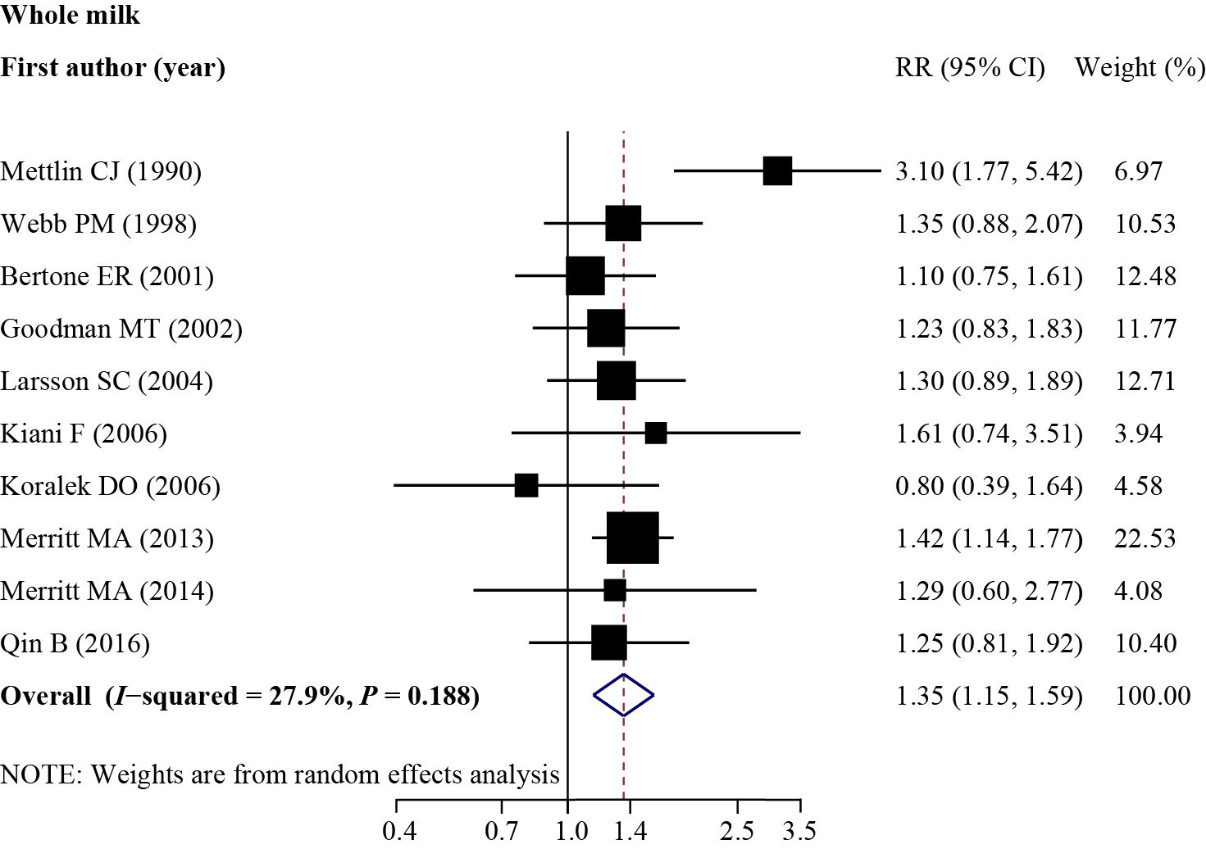
Supplemental Figure 1. Forest plots of associations between whole milk intake and the risk of ovarian cancers. Error bars indicate 95% confidence intervals. Abbreviations: RR, relative risk; 95%CI, 95% confidence intervals.
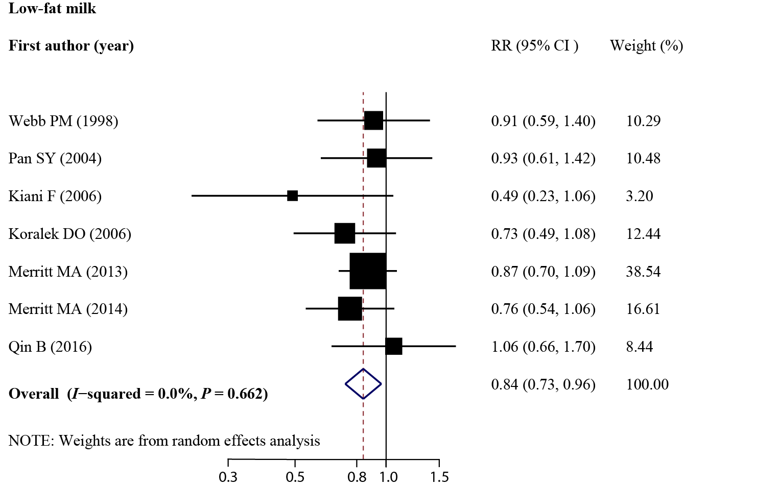
Supplemental Figure 2. Forest plots of associations between low-fat milk intake and the risk of ovarian cancers. Error bars indicate 95% confidence intervals. Abbreviations: RR, relative risk; 95%CI, 95% confidence intervals.
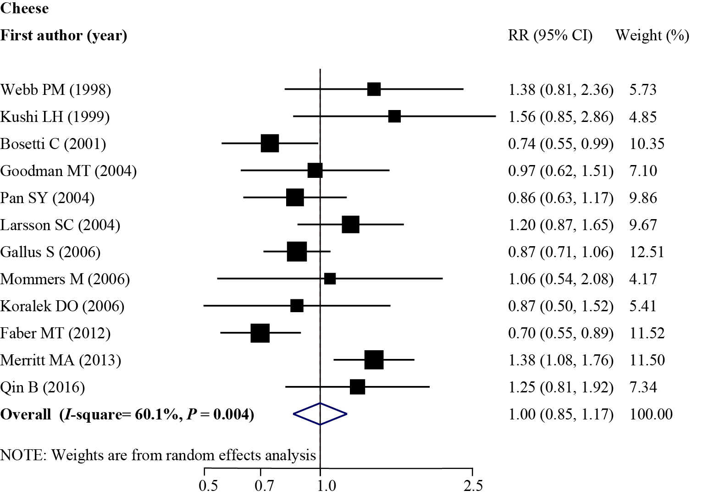
Supplemental Figure 3. Forest plots of associations between cheese intake and the risk of ovarian cancers. Error bars indicate 95% confidence intervals. Abbreviations: RR, relative risk; 95%CI, 95% confidence intervals.
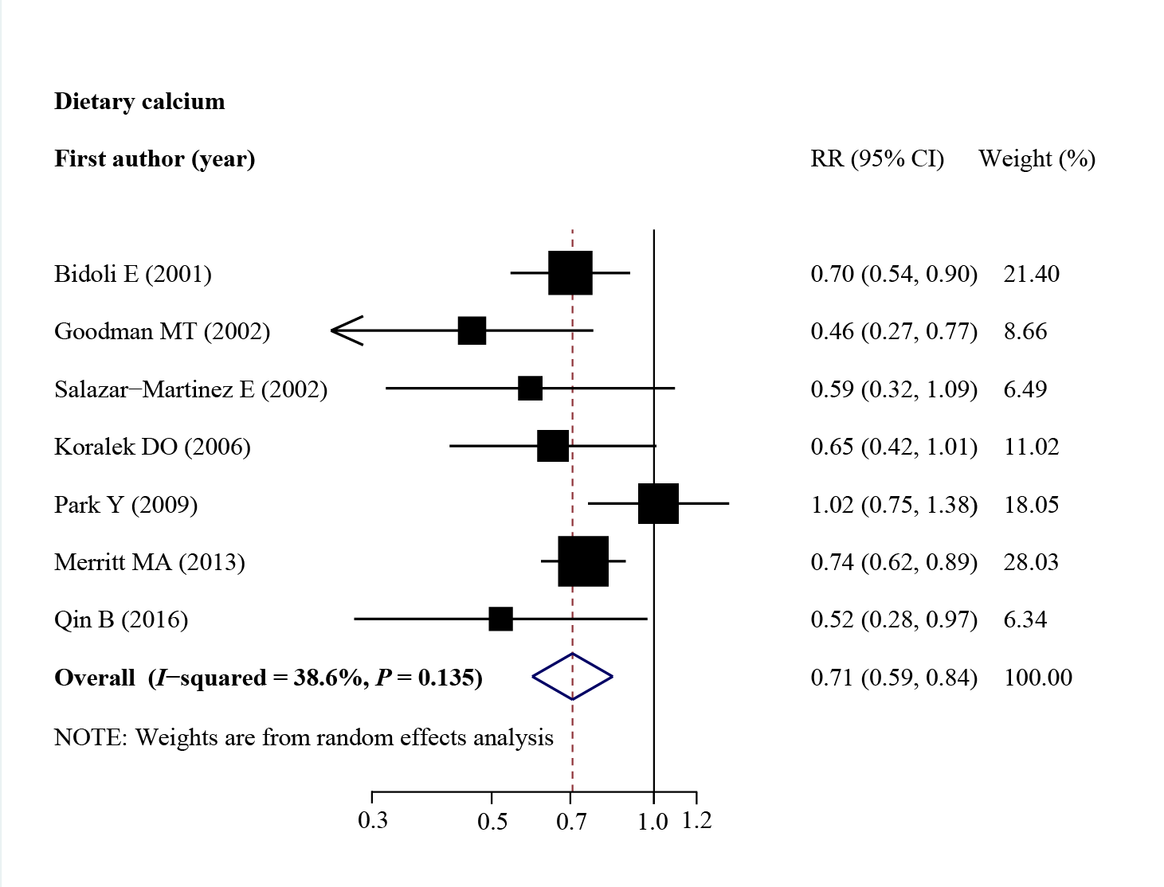
Supplemental Figure 4. Forest plots of associations between dietary calcium intake and the risk of ovarian cancers. Error bars indicate 95% confidence intervals. Abbreviations: RR, relative risk; 95%CI, 95% confidence intervals.
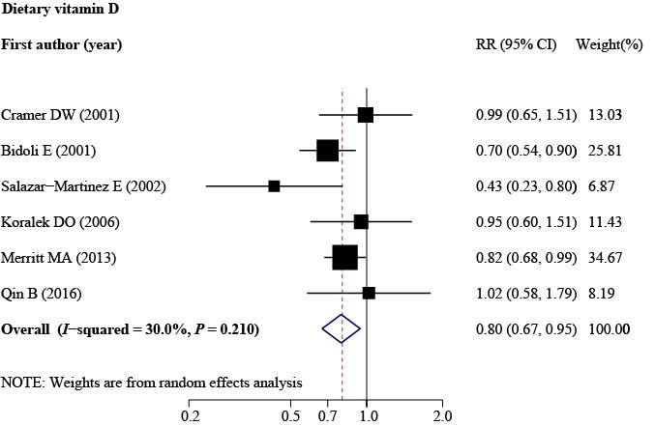
Supplemental Figure 5. Forest plots of associations between dietary vitamin D intake and the risk of ovarian cancers. Error bars indicate 95% confidence intervals. Abbreviations: RR, relative risk; 95%CI, 95% confidence intervals.
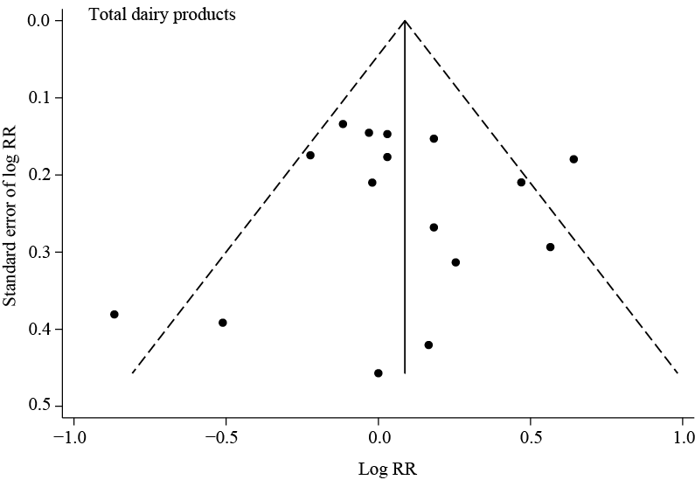
Supplemental Figure 6. Funnel plots of studies evaluating RRs of ovarian cancer among participant with intake of total dairy products. Abbreviation: RR, relative risk.
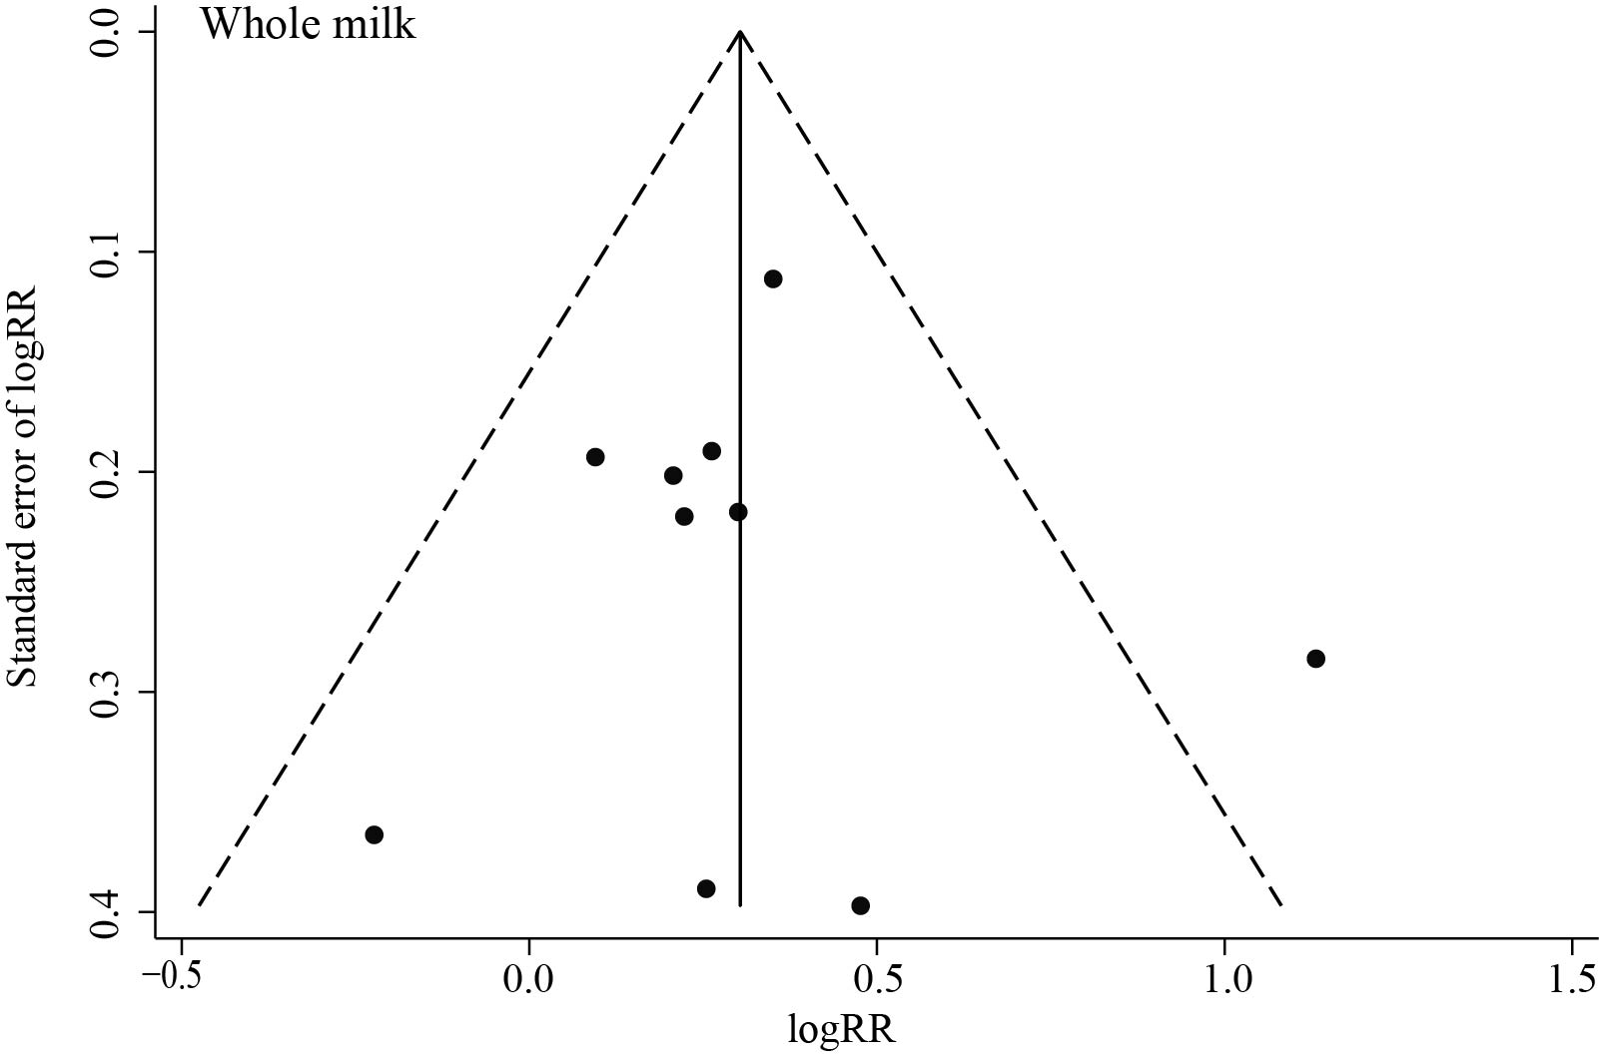
Supplemental Figure 7. Funnel plots of studies evaluating RRs of ovarian cancer among participant with intake of whole milk. Abbreviation: RR, relative risk.

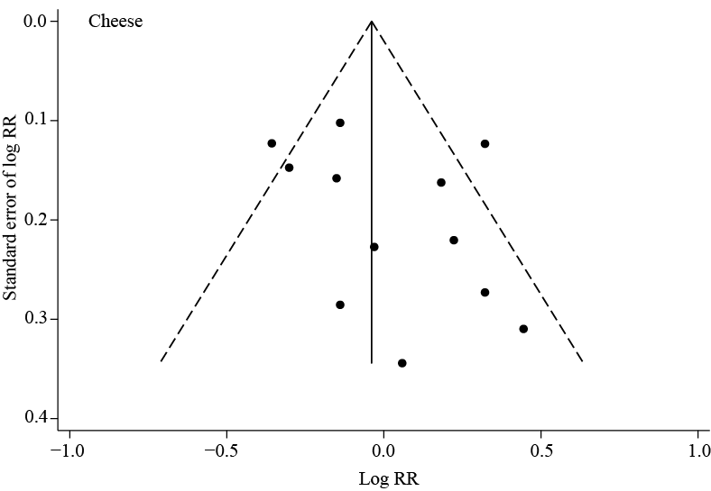
Supplemental Figure 8. Funnel plots of studies evaluating RRs of ovarian cancer among participant with intake of cheese. Abbreviation: RR, relative risk.

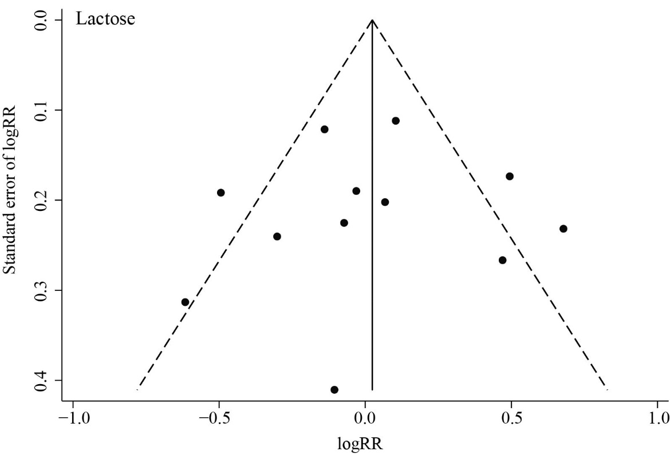
Supplemental Figure 9. Funnel plots of studies evaluating RRs of ovarian cancer among participant with intake of lactose. Abbreviation: RR, relative risk.

