Supplementary Figure 1.
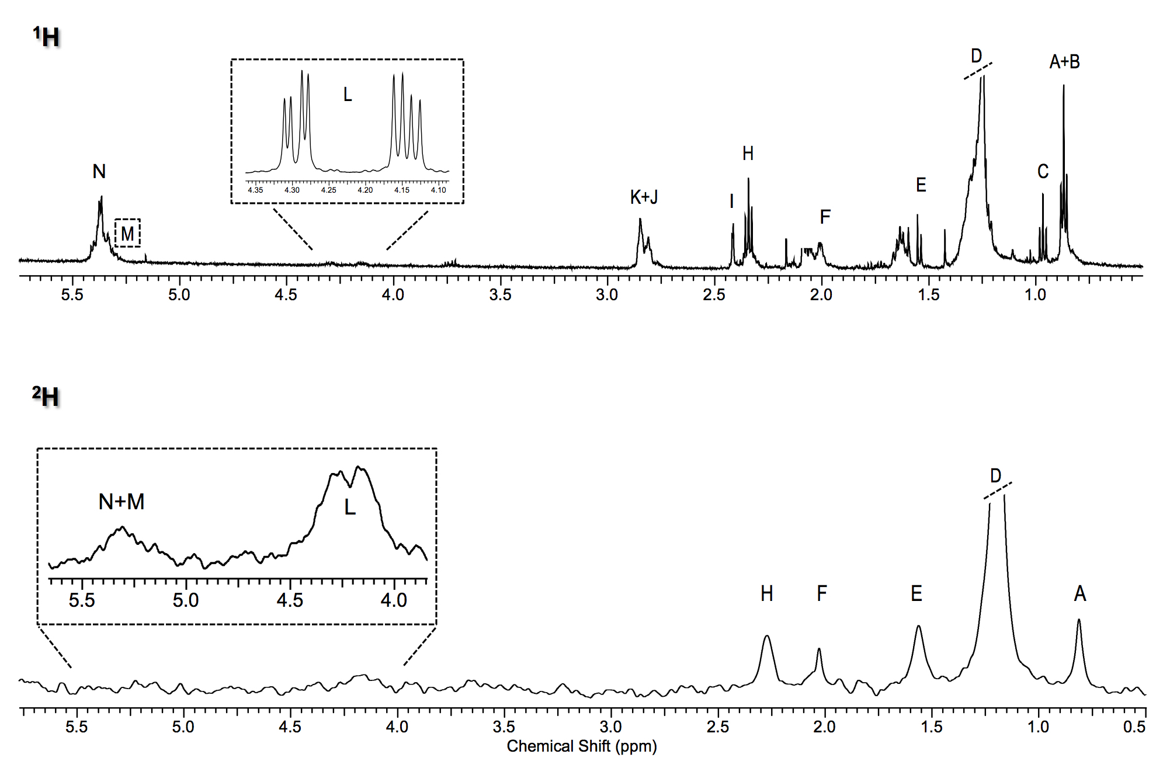
Representative ¹H (top) and ²H (bottom) NMR spectra of hepatic free fatty acids, except for inlets (dashed) of hepatic triglycerides of fed barramundi (L. calcarifer), after a 6-day residence in 3.5% ²H-enriched water. Letters on peaks indicate: A, non n-3 methyls; B, partial n-6 methyls; C, n-3 methyls; D, aliphatic chain methylenes; E, β-methylenes; F, monounsaturated allylic hydrogens; G, polyunsaturated allylic hydrogens; H, α-methylenes; I, DHA α- and β-methylenes; J, linoleic acid bisallylic hydrogens; K, other bisalylic hydrogens; L, sn-1,3 of TG-bound glycerol only in ; M, sn-2 of TG-bound glycerol; N, olefinic hydrogens. Signals from glycerol (L and M) absent in spectra of hepatic free fatty acids. Off the spectra: chloroform (solvent; singlet at 7.25 ppm) and pyrazine (internal standard; singlet at 8.60 ppm).

