Online Supporting Material
Supplemental Figure 1

A
B

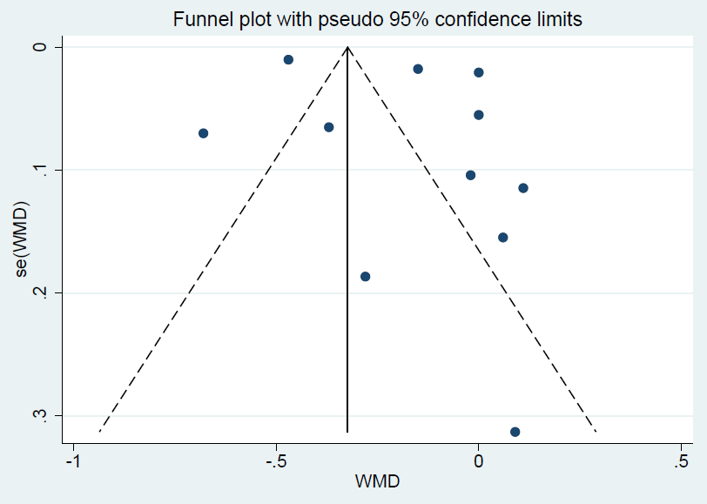
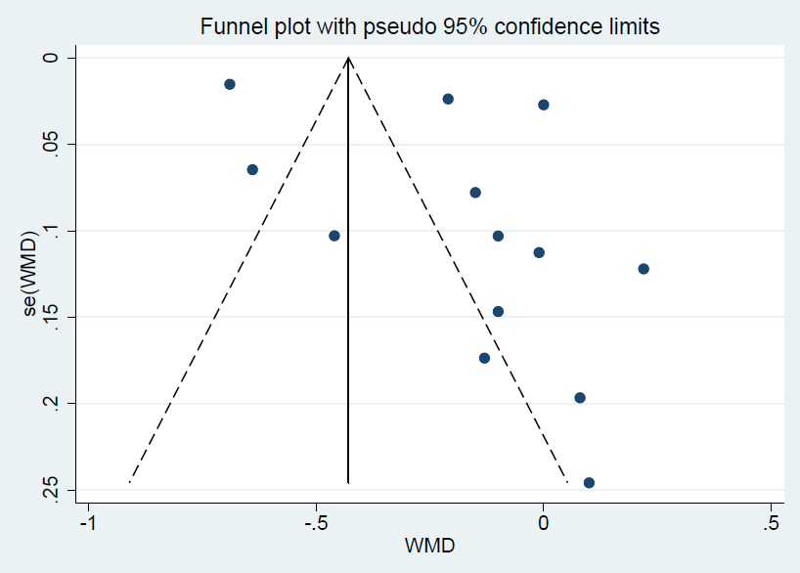

C
D
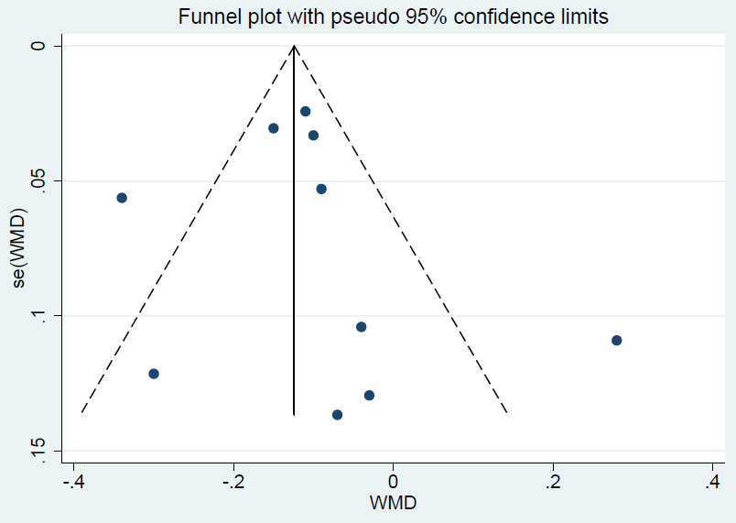
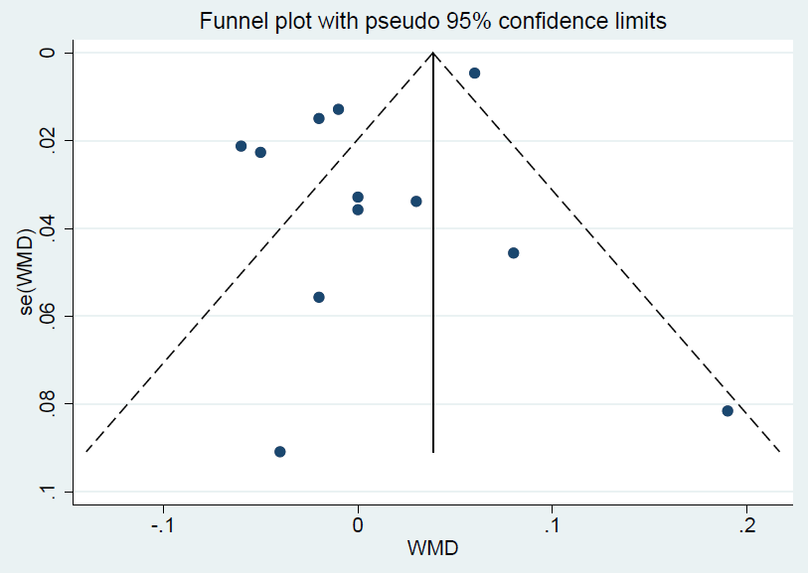

Funnel plot for the relations between GSE supplementation and serum levels of lipids (mmol/L) in (A) total cholestrol, (B) LDL-cholesterol, (C) HDL-cholesterol and (D) triglyceride. Based on visual inspection of funnel plots, we found no evidence of publication bias.

Online Supporting Material
Supplemental Figure 2

A
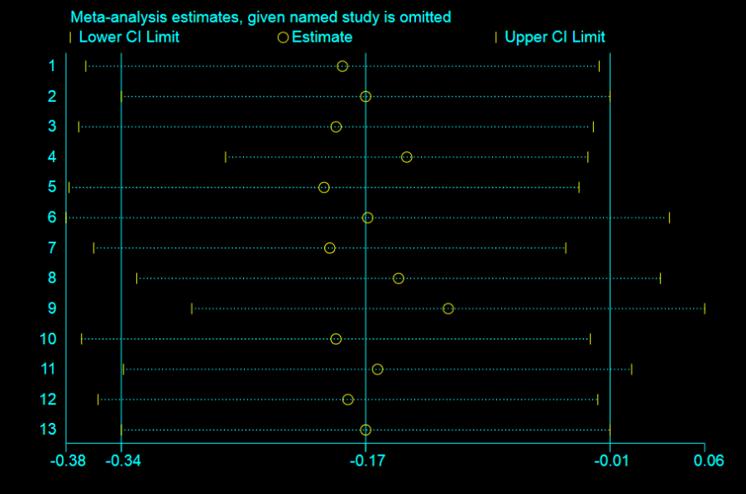
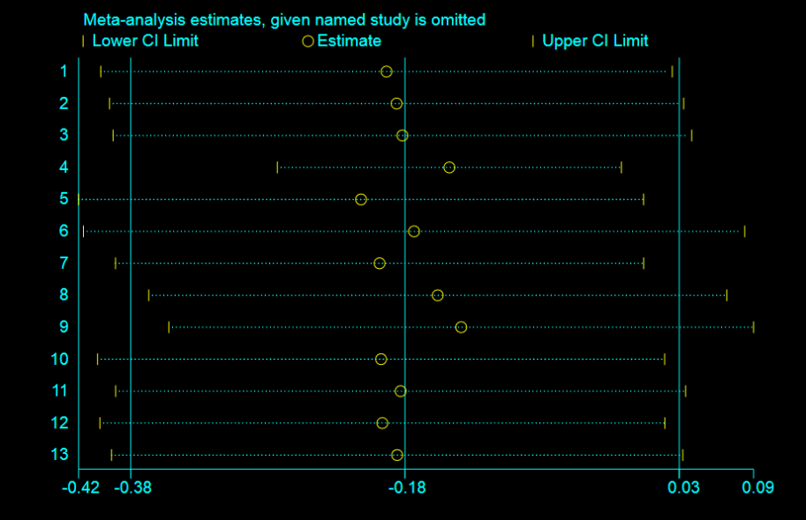
B

C
D
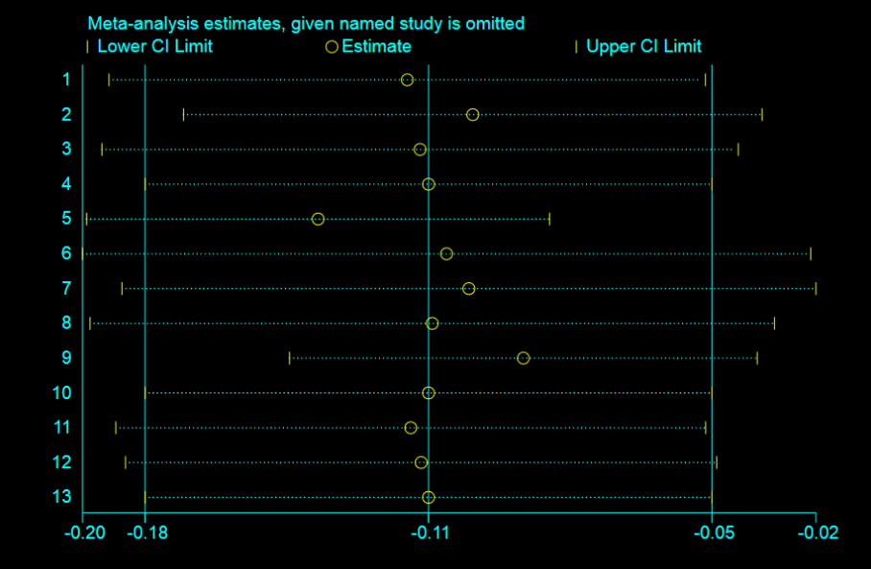
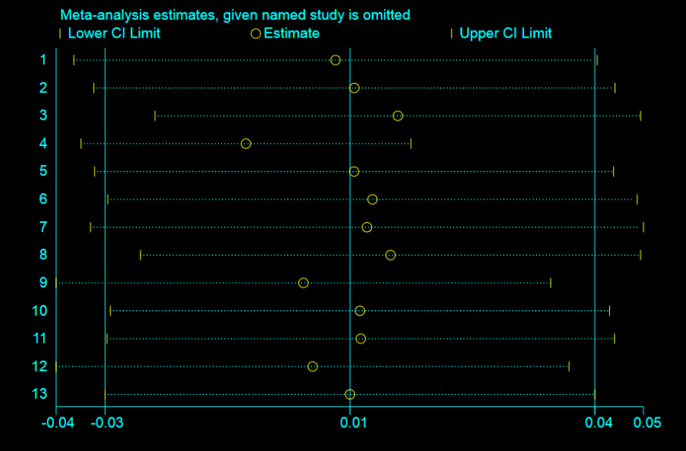

Sensitivity analysis of the relations between GSE supplementation and serum levels of lipids (mmol/L) in (A) total cholestrol, (B) LDL-cholesterol, (C) HDL-cholesterol and (D) triglyceride

