Suppl. Fig.1: Body mass index (kg/m²) of infants exposed to GDM versus not exposed

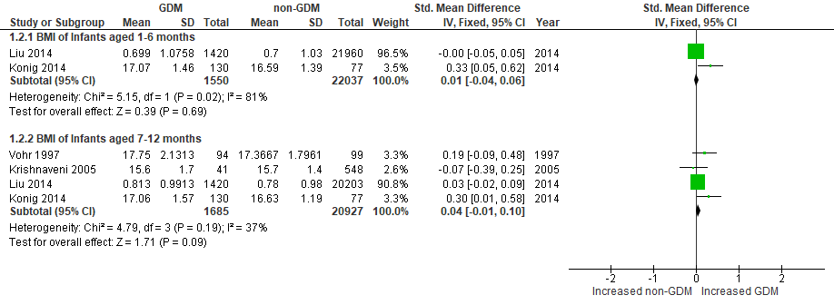

Suppl. Fig.2: Exclusive/predominant breastfeeding ≥ 5 months for infants exposed to GDM versus not exposed

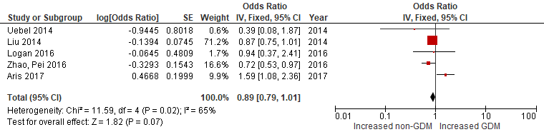

Suppl. Fig.3: No breastmilk feeding under 5 months for infants exposed to GDM versus not exposed

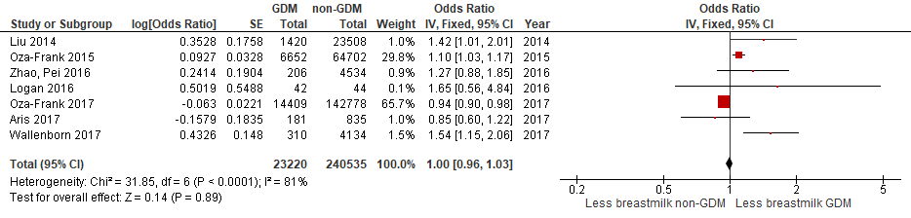

Suppl. Fig.4: Introduction of formula milk/breastmilk substitute before hospital discharge for infants exposed to GDM versus not exposed

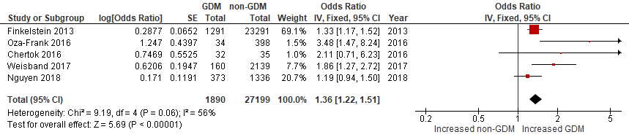
Suppl. Fig.5: Continued breastfeeding at 12 months for infants exposed to GDM versus not exposed

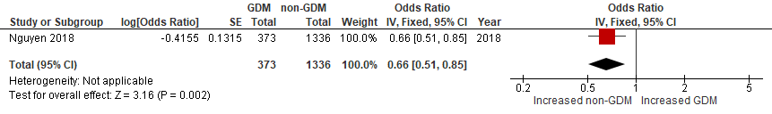

Suppl. Fig.6: Duration of breastfeeding among infants exposed to GDM versus not exposed

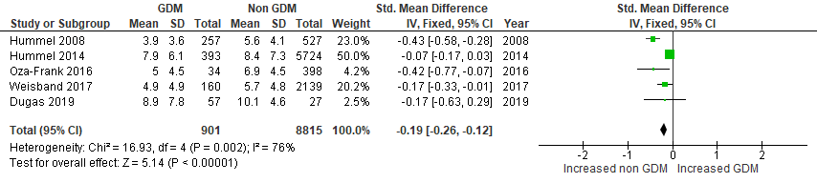

Suppl. Fig.7: Breastmilk (mature milk) composition of GDM and non-GDM mothers

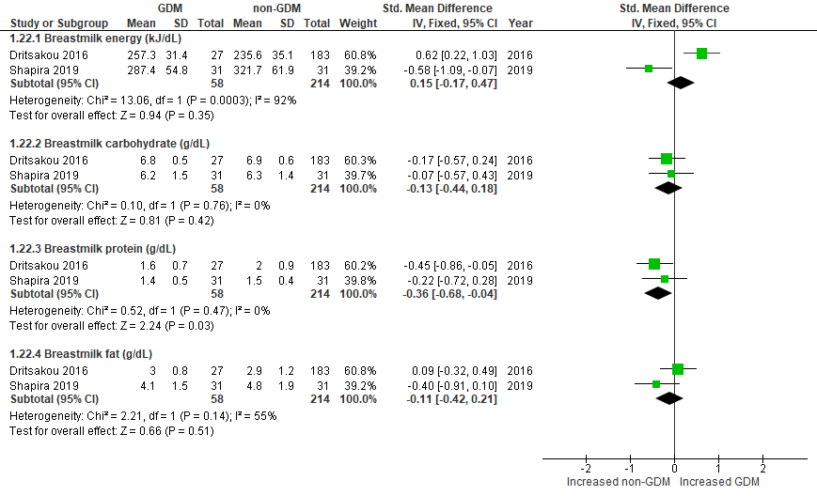

Suppl. Fig.8: Weight (kg) or weight for age z-scores of infants exposed to GDM versus not exposed
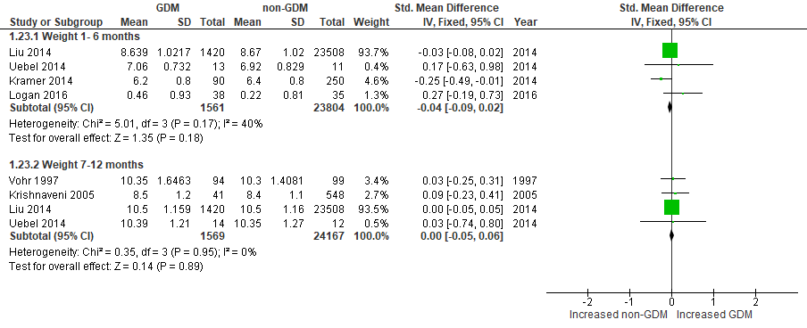

Suppl. Fig.9: Length (cm) or length for age z-scores of infants exposed to GDM versus not exposed

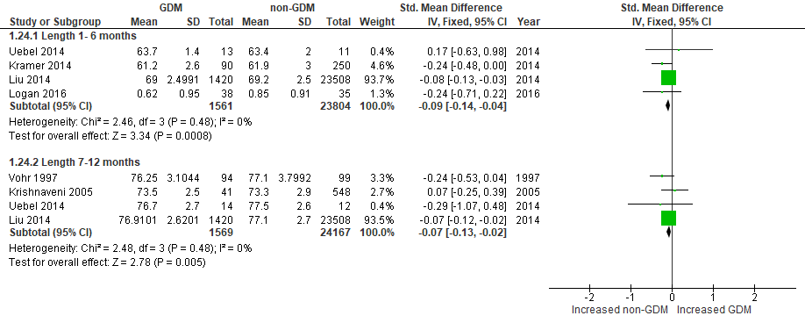

Suppl. Fig.10: Head circumference (cm) of infants exposed to GDM versus not exposed

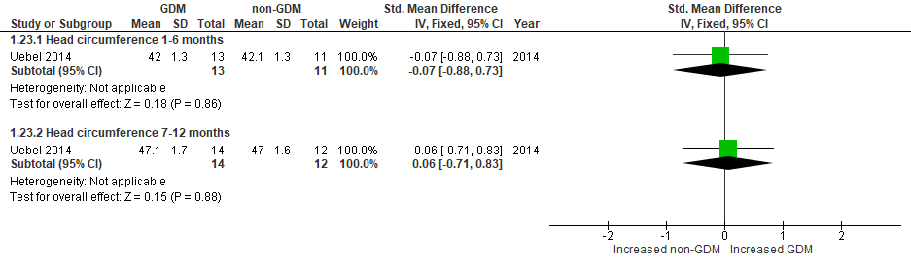

Suppl. Fig.11: Abdominal circumference (cm) of infants exposed to GDM versus not exposed

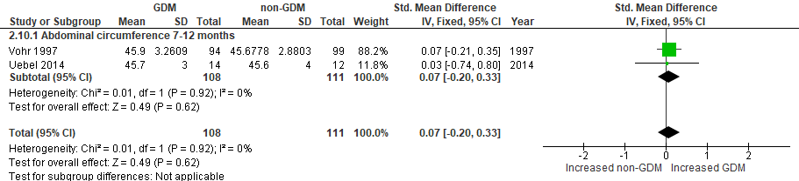

Suppl. Fig.12: Fat mass (g) of infants exposed to GDM versus not exposed

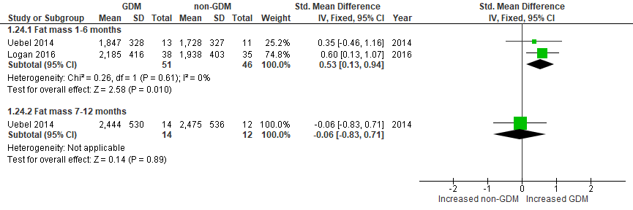

Suppl. Fig.13: Skinfold thickness (mm) of infants exposed to GDM versus not exposed
