Supplemental Table S1. Diet and nutrient composition of the experimental diet.
Item | Composition
Ingredients (g/kg DM)
Corn silage¹ | 40.3
Alfalfa haylage² | 19.3
Canola meal | 13.2
Ground corn | 12.6
Roasted soybeans | 4.6
Molasses | 3.8
Grass hay/straw³ | 3.3
Vitamin/mineral mix⁴ | 2.5
Non-protein nitrogen⁵ | 0.40
Nutrients (g/kg DM)
NDF | 32.5
ADF | 22.2
CP | 16.8
Ash | 6.9
¹Contained (g/kg DM): 6.8 CP, 36.4 NDF, 22.8 ADF.
²Contained (g/kg DM): 20.3 CP, 47.6 NDF, 41.6 ADF.
³Contained (g/kg DM): 9.2 CP, 70.9 NDF, 43.4 ADF.
⁴Contained (g/kg, as-fed basis): 36.8 Calcium carbonate; 29.0 dried corn distillers grains; 24.9 salt; 4.2 magnesium oxide (54 Mg); 2.5 organic phosphorus (15 P); 1 zinc sulfate; 0.5 mineral oil. Composition (DM-basis): 10.6% CP; 43.2% NDF; 7.0% ADF; 14.4% Ca; 0.75% P; 15.1% Cl; 0.28% K; 2.5% Mg; 0.5% S; 9.8% Na; 23.0 mg/kg Co; 651 mg/kg Cu; 796 mg/kg Fe; 54.0 mg/kg I; 1190 mg/kg Mn; 12.8 mg/kg Se; 3434 mg/kg Zn; 195,290 IU/kg vitamin A (retinyl acetate); 62,500 vitamin D (activated 7-dehydrocholesterol); 1864 IU/kg vitamin E (dl-α tocopheryl acetate).
⁵Fed as coated urea (Optigen, Alltech Inc., Lexington, KY; 259% CP, DM basis).
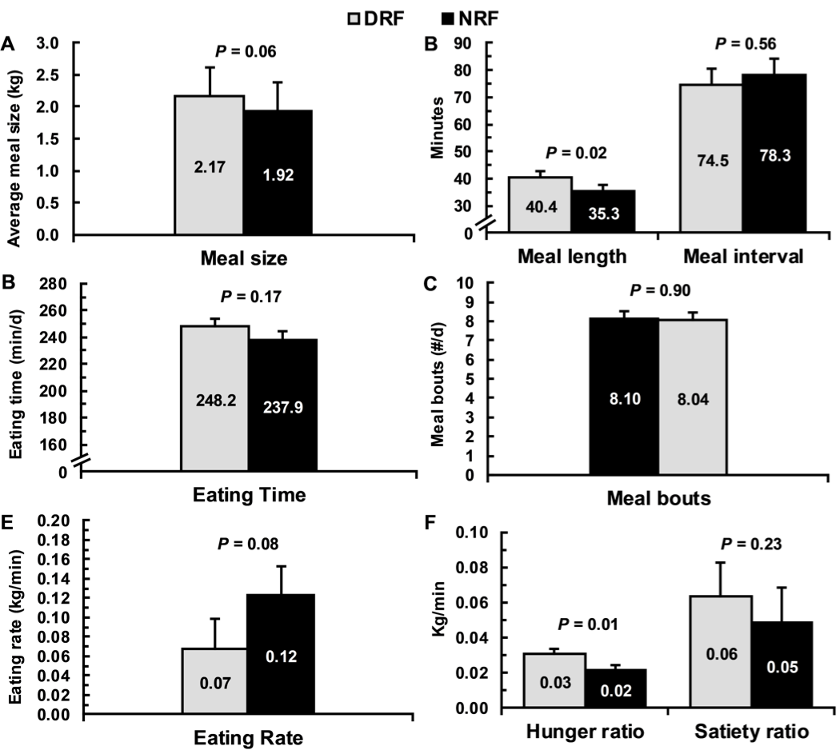

Supplemental Figure S1. Effect of day- versus night-restricted feeding on eating behavior. Treatments were feed available for 16 h during the day [day-restricted feeding (DRF); feed from 0700 to 2300] or feed available for 16 during the night [night-restricted feeding (NRF); feed from 1900 to 1100]. Data are presented as LSM with SEM bars. Panels show effect of day vs. night-restricted feeding on A. average meal size (kg), B. average meal length and intermeal interval (min), C. eating time (min/d), D. average number of meal bouts per day, E. eating rate (kg/min), and F. hunger and satiety ratios. Hunger ratio = meal size/preceding intermeal interval (kg/min). Satiety ratio = meal size/post-meal interval (kg/min).

