Table S1. Real-time PCR primer sequences ¹.
Target gene | Primer sequence Forward (5’→3’) | Primer sequence Reverse (5’→3’) | Temperature (°C) | Accession number
Hepcidin | AGCAGGAGCAGGATGAGC | GCCAGGGGATTTGTTTGT | 59.3 | JQ246442.1
LEAP-2A | TGCCTACTGCCAGAACCA | AATCGGTTGGCTGTAGGA | 59.3 | FJ390414
LEAP-2B | TGTGCCATTAGCGACTTCTGAG | ATGATTCGCCACAAAGGGG | 59.3 | KT625603
β-defensin-1 | TTGCTTGTCCTTGCCGTCT | AATCCTTTGCCACAGCCTAA | 58.4 | KT445868
Mucin2 | GAGTTCCCAACCCAACACAT | AAAGGTCTACACAATCTGCCC | 60.4 | KT625602
TGF-β1 | TTGGGACTTGTGCTCTAT | AGTTCTGCTGGGATGTTT | 55.9 | EU099588
TGF-β2 | TACATTGACAGCAAGGTGGTG | TCTTGTTGGGGATGATGTAGTT | 55.9 | KM279716
IL-4/13A | CTACTGCTCGCTTTCGCTGT | CCCAGTTTTCAGTTCTCTCAGG | 55.9 | KT445871
IL-4/13B | TGTGAACCAGACCCTACATAACC | TTCAGGACCTTTGCTGCTTG | 55.9 | KT625600
IL-10 | AATCCCTTTGATTTTGCC | GTGCCTTATCCTACAGTATGTG | 61.4 | HQ388294
IL-11 | GGTTCAAGTCTCTTCCAGCGAT | TGCGTGTTATTTTGTTCAGCCA | 57.0 | KT445870
TNF-α | CGCTGCTGTCTGCTTCAC | CCTGGTCCTGGTTCACTC | 58.4 | HQ696609
IFN-γ2 | TGTTTGATGACTTTGGGATG | TCAGGACCCGCAGGAAGAC | 60.4 | JX657682
IL-1β | AGAGTTTGGTGAAGAAGAGG | TTATTGTGGTTACGCTGGA | 57.1 | JQ692172
IL-6 | CAGCAGAATGGGGGAGTTATC | CTCGCAGAGTCTTGACATCCTT | 62.3 | KC535507.1
IL-8 | ATGAGTCTTAGAGGTCTGGGT | ACAGTGAGGGCTAGGAGGG | 60.3 | JN663841
IL-12p35 | TGGAAAAGGAGGGGAAGATG | AGACGGACGCTGTGTGAGTGTA | 55.4 | KF944667.1
IL-12p40 | ACAAAGATGAAAAACTGGAGGC | GTGTGTGGTTTAGGTAGGAGCC | 59.0 | KF944668.1
IL-15 | CCTTCCAACAATCTCGCTTC | AACACATCTTCCAGTTCTCCTT | 61.4 | KT445872
IL-17D | GTGTCCAGGAGAGCACCAAG | GCGAGAGGCTGAGGAAGTTT | 62.3 | KF245426.1
TOR | TCCCACTTTCCACCAACT | ACACCTCCACCTTCTCCA | 61.4 | JX854449
S6K1 | TGGAGGAGGTAATGGACG | ACATAAAGCAGCCTGACG | 54.0 | EF373673
4E-BP1 | GCTGGCTGAGTTTGTGGTTG | CGAGTCGTGCTAAAAAGGGTC | 60.3 | KT757305
4E-BP2 | CACTTTATTCTCCACCACCCC | TTCATTGAGGATGTTCTTGCC | 60.3 | KT757306
NF-κBp65 | GAAGAAGGATGTGGGAGATG | TGTTGTCGTAGATGGGCTGAG | 62.3 | KJ526214
NF-κBp52 | TCAGTGTAACGACAACGGGAT | ATACTTCAGCCACACCTCTCTTAG | 58.4 | KM279720
c-Rel | GCGTCTATGCTTCCAGATTTACC | ACTGCCACTGTTCTTGTTCACC | 59.3 | KT445865
IκBα | TCTTGCCATTATTCACGAGG | TGTTACCACAGTCATCCACCA | 62.3 | KJ125069
IKKα | GGCTACGCCAAAGACCTG | CGGACCTCGCCATTCATA | 60.3 | KM279718
IKKβ | GTGGCGGTGGATTATTGG | GCACGGGTTGCCAGTTTG | 60.3 | KP125491
IKKγ | AGAGGCTCGTCATAGTGG | CTGTGATTGGCTTGCTTT | 58.4 | KM079079
β-actin | GGCTGTGCTGTCCCTGTA | GGGCATAACCCTCGTAGAT | 61.4 | M25013
¹ LEAP-2, liver expressed antimicrobial peptide 2; TGF-β, transforming growth factor β; IL, interleukin; TNF-α, tumor necrosis factor α; IFN-γ2, interferon γ2; TOR, target of rapamycin; S6K1, ribosomal protein S6 kinase 1; 4E-BP, eIF4E-binding protein; NF-κB, nuclear factor kappa B; IκBα, inhibitor of κBα; IKK, IκB kinase.

Table S2. Correlation coefficient of parameters in PI, MI and DI of young grass carp.
Independent  parameters | Dependent  parameters | PI |  | MI |  | DI
 |  | Correlation  coefficients | P | Correlation  coefficients | P | Correlation  coefficients | P
p-TOR Ser 2448 protein level | TGF-β1 | + 0.903 | <0.05 | +0.923 | <0.01 | + 0.910 | <0.05
 | TGF-β2 | +0.980 | <0.01 | — | — | — | —
 | IL-4/13A | +0.958 | <0.01 | +0.876 | <0.05 | +0.921 | <0.01
 | IL-10 | +0.974 | <0.01 | +0.960 | <0.01 | +0.945 | <0.01
 | IL-11 | +0.982 | <0.01 | +0.969 | <0.01 | +0.812 | <0.05
 | S6K1 | +0.927 | <0.01 | +0.992 | <0.01 | +0.881 | <0.05
 | 4E-BP2 | -0.928 | <0.01 | -0.904 | <0.05 | -0.926 | <0.01
NF-κB p65 protein level | IFN-γ2 | +0.825 | <0.05 | +0.845 | <0.05 | +0.977 | <0.01
 | IL-1β | +0.879 | <0.05 | +0.895 | <0.05 | +0.931 | <0.01
 | IL-6 | +0.839 | <0.05 | +0.915 | <0.01 | +0.906 | <0.05
 | IL-8 | — | — | +0.888 | <0.05 | +0.938 | <0.01
 | IL-12p35 | +0.828 | <0.05 | +0.931 | <0.01 | +0.961 | <0.01
 | IL-12p40 | +0.975 | <0.01 | +0.964 | <0.01 | +0.935 | <0.01
 | IL-15 | +0.977 | <0.01 | +0.820 | <0.05 | +0.930 | <0.01
 | IL-17D | +0.930 | <0.01 | +0.955 | <0.01 | +0.970 | <0.01
c-Rel | IFN-γ2 | +0.928 | <0.01 | +0.997 | <0.01 | +0.915 | <0.05
 | IL-1β | +0.960 | <0.01 | +0.992 | <0.01 | +0.957 | <0.01
 | IL-6 | +0.912 | <0.05 | +0.970 | <0.01 | +0.985 | <0.01
 | IL-8 | — | — | +0.969 | <0.01 | +0.983 | <0.01
 | IL-12p35 | +0.906 | <0.05 | +0.970 | <0.01 | +0.894 | <0.05
 | IL-12p40 | +0.962 | <0.01 | +0.948 | <0.01 | +0.944 | <0.01
 | IL-15 | +0.974 | <0.01 | +0.979 | <0.01 | +0.899 | <0.05
 | IL-17D | +0.950 | <0.01 | +0.930 | <0.01 | +0.921 | <0.01
IκBα | NF-κBp65 protein level | -0.990 | <0.01 | -0.947 | <0.01 | -0.970 | <0.01
 | c-Rel | -0.928 | <0.01 | -0.956 | <0.01 | -0.954 | <0.01
IKKα | IκBα | -0.900 | <0.05 | -0.956 | <0.01 | -0.985 | <0.01
IKKβ | IκBα | -0.858 | <0.05 | -0.960 | <0.01 | -0.877 | <0.01
IKKγ | IκBα | -0.974 | <0.01 | -0.977 | <0.01 | -0.902 | <0.05

Fig. S1.
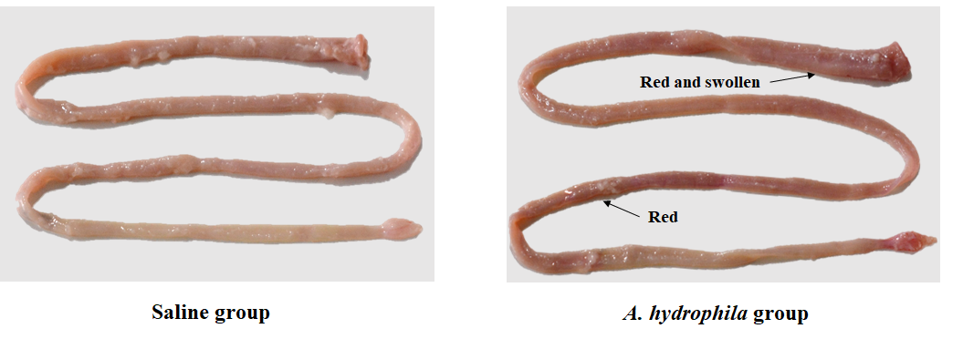
Fig. S1. The enteritis symptom in young grass carp (Ctenopharyngodon idella) after injection with physiological saline (Saline group) or A. hydrophila (A. hydrophila group, control group).

Fig. S2.
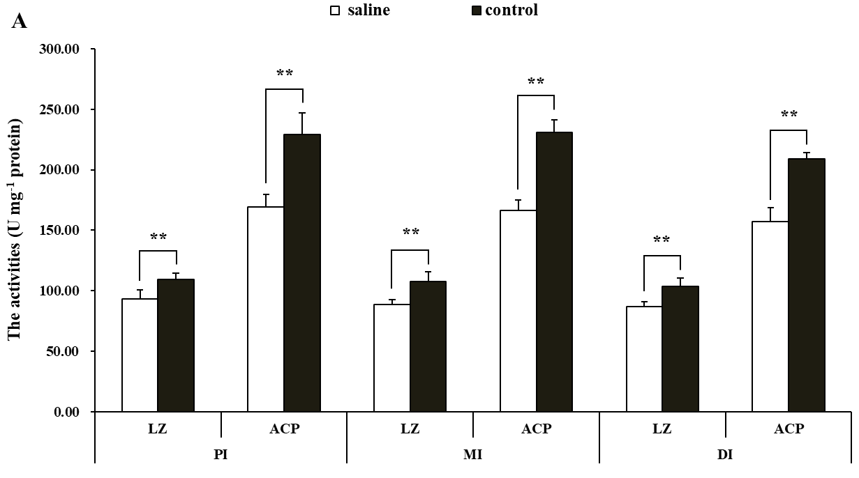

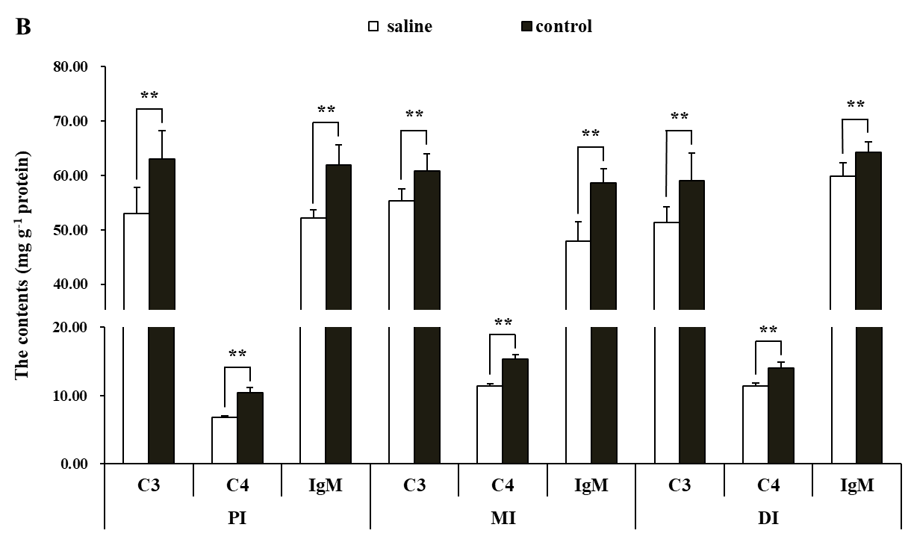
Fig. S2. The changes of immune components in the PI, MI and DI of young grass carp (Ctenopharyngodon idella) after injection with physiological saline (saline) or A. hydrophila (control). Data represent means of six fish in saline group and control group, error bars indicate SD. The data of two groups are subjected to unpaired student`s t-test to determine significant differences at P < 0.05.

