Supplementary material
Table S1. Ingredient and nutrient composition of the rations
Item | Dietary energy level, MJ/kg DM¹
 | 8.21 | 9.33 | 10.45 | 11.57
Ingredient, g/kg dry matter (DM)
Corn | 92.2 | 127.5 | 160.0 | 208.5
Corn starch | 23.5 | 70.0 | 124.0 | 161.5
Sucrose | 5.5 | 16.5 | 22.0 | 30.0
Molasses | 5.5 | 16.5 | 21.5 | 30.0
Wheat bran | 25.0 | 14.6 | 12.8 | 8.0
Soybean meal | 12.0 | 16.5 | 15.4 | 13.2
Cotton seed meal | 15.6 | 13.6 | 13.4 | 12.5
Soybean oil | 0.60 | 4.20 | 10.0 | 15.0
Calcium hydrophosphate | 6.3 | 6.6 | 6.0 | 5.3
Calcium carbonate | 1.8 | 2.0 | 2.9 | 4.0
Sodium chloride | 6.0 | 6.0 | 6.0 | 6.0
Commercial premix² | 6.0 | 6.0 | 6.0 | 6.0
Highland barley straw | 800 | 700 | 600 | 500
Chemical composition³, g/kg DM
DE, MJ/kg DM | 8.21 | 9.33 | 10.45 | 11.57
CP | 69.7 | 69.6 | 69.1 | 70.2
NDF | 684.1 | 601.5 | 519.7 | 443.7
ADF | 370.2 | 324.9 | 280.9 | 237.6
Ca | 5.21 | 5.13 | 5.20 | 4.92
P | 2.71 | 2.71 | 2.62 | 2.54

¹ Digestible energy on dry matter basis.
² The premix provided the following per kg of diets: VA 1700 IU; VD 190 IU; VE 18 IU; Co 0.30mg; Cu 17 mg; I 1.5mg; Fe 70 mg; Mn 38 mg; Se 0.28 mg; Zn 40 mg.
³ The DE were Calculated according to the Feeding Standard of Meat-producing Sheep and Goats of China, NY/T 816-2004 (Ministry of Agriculture, MOA, PRC, 2004). Others were the measured values. DM, dry matter; DE, digestible energy; CP, crude protein; NDF, neutral detergent fibre; ADF, acid detergent fibre; Ca, calcium; P, phosphorus.

Table S2. Sequences of oligonucleotide primers used for qRT-PCR.
Target gene¹ | Gene bank ID | Primer sequences²（5'→3'） | Tm³ (ºC)
FFAR2 | XM_012190178.2 | F: GTGTATGGAGTGATCGCTGCTCTG  R: CTGCTCTTGGCTGAAGTTCTCGTAG | 58
FFAR3 | XM_015099986.1 | F: CTGTTGCTCTTCCTGCCGTTCC  R: GACGTGAGATAGATGGTGGTGAAGAAG | 58
MCT1 | AJ315929.1 | F: TGGCTGTCATGTACGGTGGA  R: GCACAGTGTTACAGAAGGAAGCAG | 56.5
MCT2 | XM_004006510.3 | F: AGAAACGACCTGTAGCGAATGG  R: TGAAACTTCCCTTCCAGCCG | 58
MCT4 | XM-012186382.1 | F: TGGTGTCTGCGTCCTTCTGTG  R: ATGATGAGTGAGGGCTGGAAGT | 57
NHE1 | XM-004005085.2 | F: GCCGTCACTGTGGTCCTGTATC  R: ACACCACGAAGAAGCTCAGGAA | 56
NHE3 | XM-012097233.1 | F: GAAACAGCAGCATTCCCAACG  R: CCGCCACTCATCTCATCATCA | 58
DRA | HM010763.1 | F: CGGATTTCTCTTGGAGCCTCTAC  R: CCTTTCGCCACAATCTTCGTAT | 57
NCB1 | XM_004009897.3 | F: TCTTCTCCCAGCACGACCTCA  R: TCATTGTCACTGTCCAGACTTCCTT | 56
AE2 | XM_012100091.2 | F: GTGGTGCTGACCCGCATCTT  R: TTATACAGGCATGGGCATCTCA | 56.5
PAT1 | XM_012100091.2 | F: TCCTCATTATCATCGTCAAACTGG  R: GAGAACACGTCGGTGAACTGC | 57
vH⁺-ATPase | NM_176654.2 | F: GCGGTCACCCGAAACTACATC  R: CAATCTCAGCATACTGGGCAAAC | 58
Na⁺/K⁺-ATPase | NM-001009360.1 | F: GAGAACGGCTTCCTCCCTAATC  R: CTCTTGCCGAAGGAGGGATTAG | 56.5
ACAT1 | XM_015100759.1 | F: AGCCAGGTCATACCATCCAGC  R: TGATACATAACTTCGCTCCGCATA | 58
HMGCS2 | XM_004002390.3 | F: AGGCAACACTGACATTGAAGGC  R: AGTGCGTAGCGACCATCCCA | 58
PPAR-α | AY369138.1 | F: TAGAAGATTCCGAAACCGCAGAT  R: GGCGGATTGTTGTTGGTCTTC | 57
ACAT2 | XM_012127195.1 | F: CATTTGGTTCACTTGAGGACGG  R: TGTGGTAATTGTGGAATGCGTC | 57
HMGCS1 | XM_015101308.1 | F: CTCTAAACGACGACACTTTGGATG  R: AGGGAGCCTTGGCACTTTCTT | 58
HMGCR | XM_004010192.3 | F: AGTCCAGGTCAGGTGATGCCA  R: TCCCTCGTCCCTCTATCCAGTT | 58
SREBP-2 | AF278694.1 | F: CGAGCAGTGGAGTCCTTGGTA  R: TAATTTCAGGTACTCGAGAGCGC | 57
β-actin | U39357.1 | F: AGCCTTCCTTCCTGGGCATGGA  R: GGACAGCACCGTGTTGGCGTAGA | 58

¹ ACAT1 and ACAT2, Acetoacetyl-CoA acetyl transferase isoform 1 and 2; AE2, Anion exchanger 2; DRA, downregulated-in-adenoma; FFAR2 and FFAR3, free fatty acid receptor isoform 2 and 3; HMGCR, 3-hydroxy, 3-methylglutaryl CoA reductase; HMGCS1 and HMGCS2, 3-hydroxy, 3-methylglutaryl CoA synthase isoform 1 and 2; MCT1, MCT2 and MCT4, monocarboxylate cotransporter1 isoform 2 and 4; Na⁺/K⁺-ATPase, sodium/potassium ATPase; NBC1, Na⁺/HCO3‾ cotransporter 1; NHE1 and NHE3, sodium/hydrogen antiporter isoform 1 and 3; PAT1, putative anion transporter 1; PPAR-α, peroxisome proliferators-activated receptor α; SREBP-2, sterol regulatory element binding protein 2; νH⁺-ATPase, vacuolar-type ATPase.
² F, forward; R, reverse.
³ Tm, optimal PCR annealing temperature.

Table S3. The ammonia-N concentration of the rumen fluid in Tibetan (T) and Small-tailed Han (H) sheep offered diets of different energy levels.
Items | Breed | Dietary energy level, MJ/kg DM¹ |  |  |  | SEM | P-value²
 |  | 8.21 | 9.33 | 10.45 | 11.57 |  | Breed | E-L | E-Q | E-C
Ammonia-N mg/100mL | T | 3.06 | 2.71 | 3.15 | 3.81 | 0.369 | 0.011 | 0.026 | 0.596 | 0.837
 | H | 1.92 | 2.45 | 2.70 | 2.78 |  |  | 0.958^{x} | 0.177^{x} | 0.775^{x}

¹ Digestible energy on dry matter basis.
² E-L = Linear effect of dietary energy level; E-Q = Quadratic effect of dietary energy level; E-C = Cubic effect of dietary energy level.
^{x} P-value for the interaction of dietary energy level effect with species.

Figure S1.
Figure S1. Morphology of ruminal papillae of sheep stained by hematoxylin-eosin under 10x objective. (A) Stratum corneum thickness; (B) Epithelium thinkness; (C) Lamina propria thickness.

Figure S2.
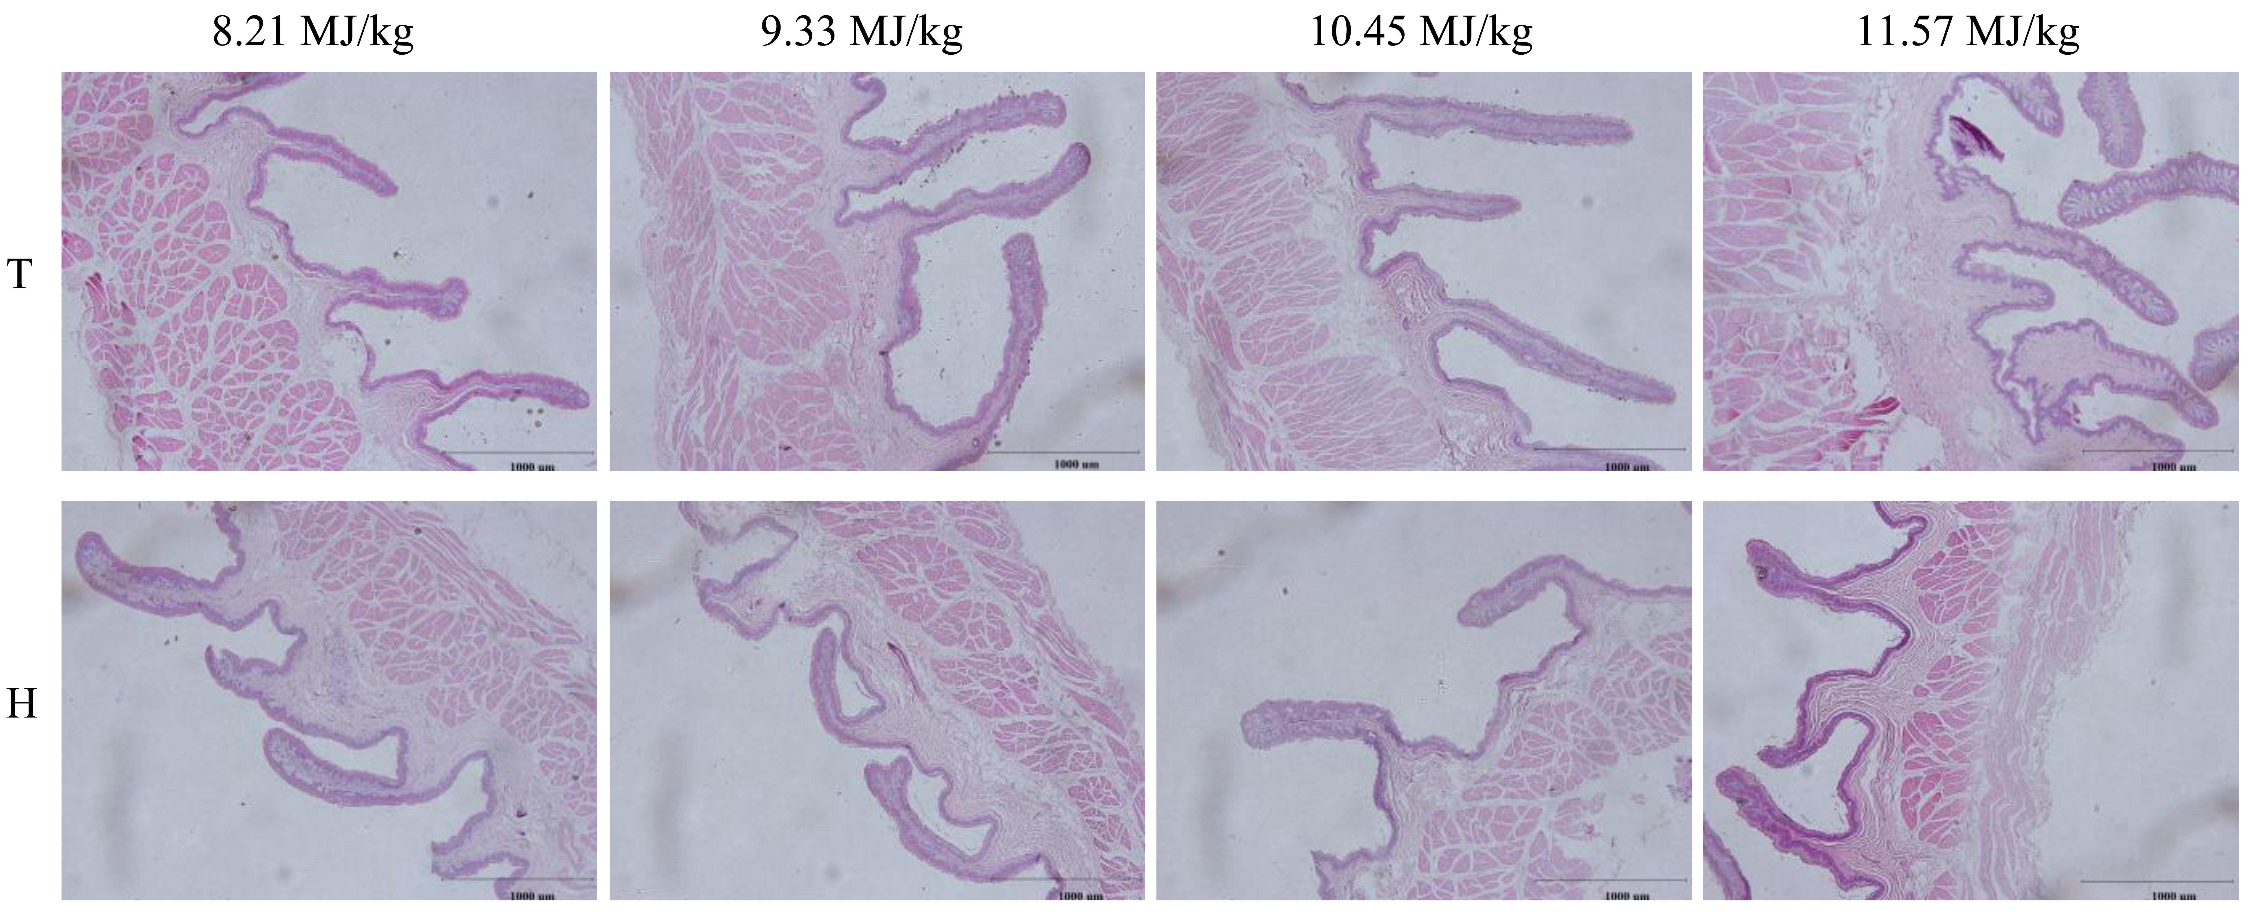
Figure S2. The representative micrographs showing morphological development in the rumen dorsal sac of Tibetan (T) and Small-tailed Han (H) sheep offered diets of different energy levels. The dietary energy levels are digestible energy on dry matter basis. Magnification 40×.

Figure S3.
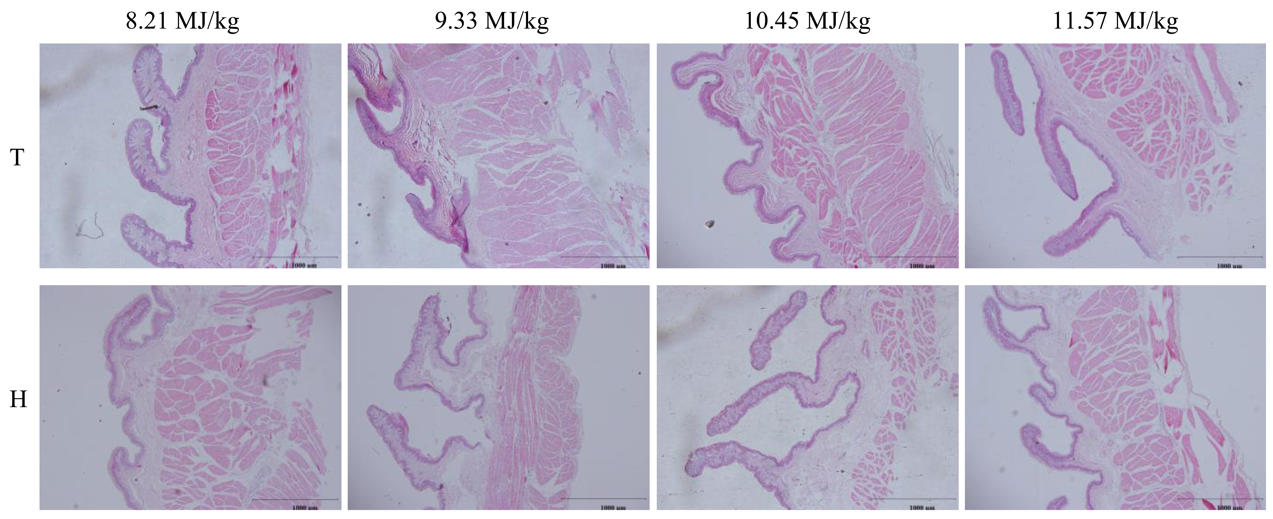
Figure S3. The representative micrographs showing morphological development in the rumen ventral sac of Tibetan (T) and Small-tailed Han (H) sheep offered diets of different energy levels. The dietary energy levels are digestible energy on dry matter basis. Magnification 40×.

Figure S4.
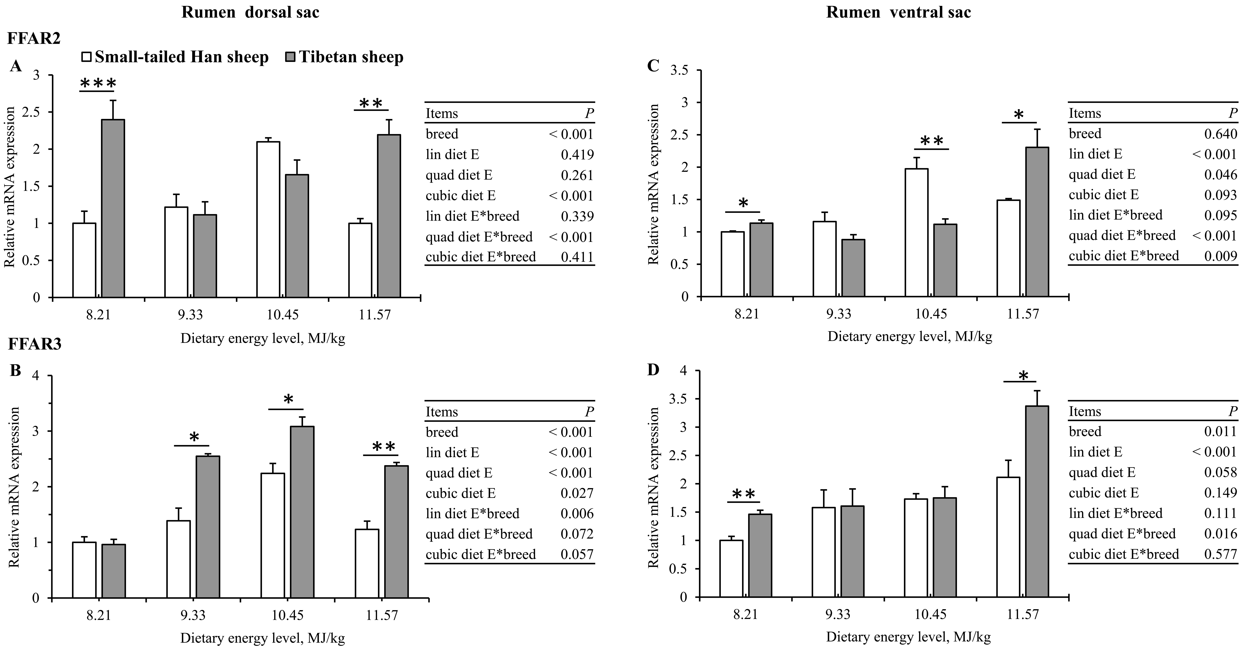
Figure S4. The expression of FFAR2 and FFAR3 mRNA in the rumen epithelium of Tibetan (T) and Small-tailed Han (H) sheep offered diets of different energy levels. FFAR2 and FFAR3, free fatty acid receptor isoform 2 and 3. The dietary energy levels are digestible energy on dry matter basis. * Means P< 0.05; ** Means P<0.01.

