768 families were eligible

467 refused to participate
301 consented
98 had body composition measurements and included in the analysis
92 had body composition measurements and included in the analysis
99 randomized to cow milk formula
101 breastfed infants
200 formula-fed infants randomized
101 randomized to goat milk formula

100 had body composition measurements and included in the analysis

Supplemental Figure 1. Participants flow chart

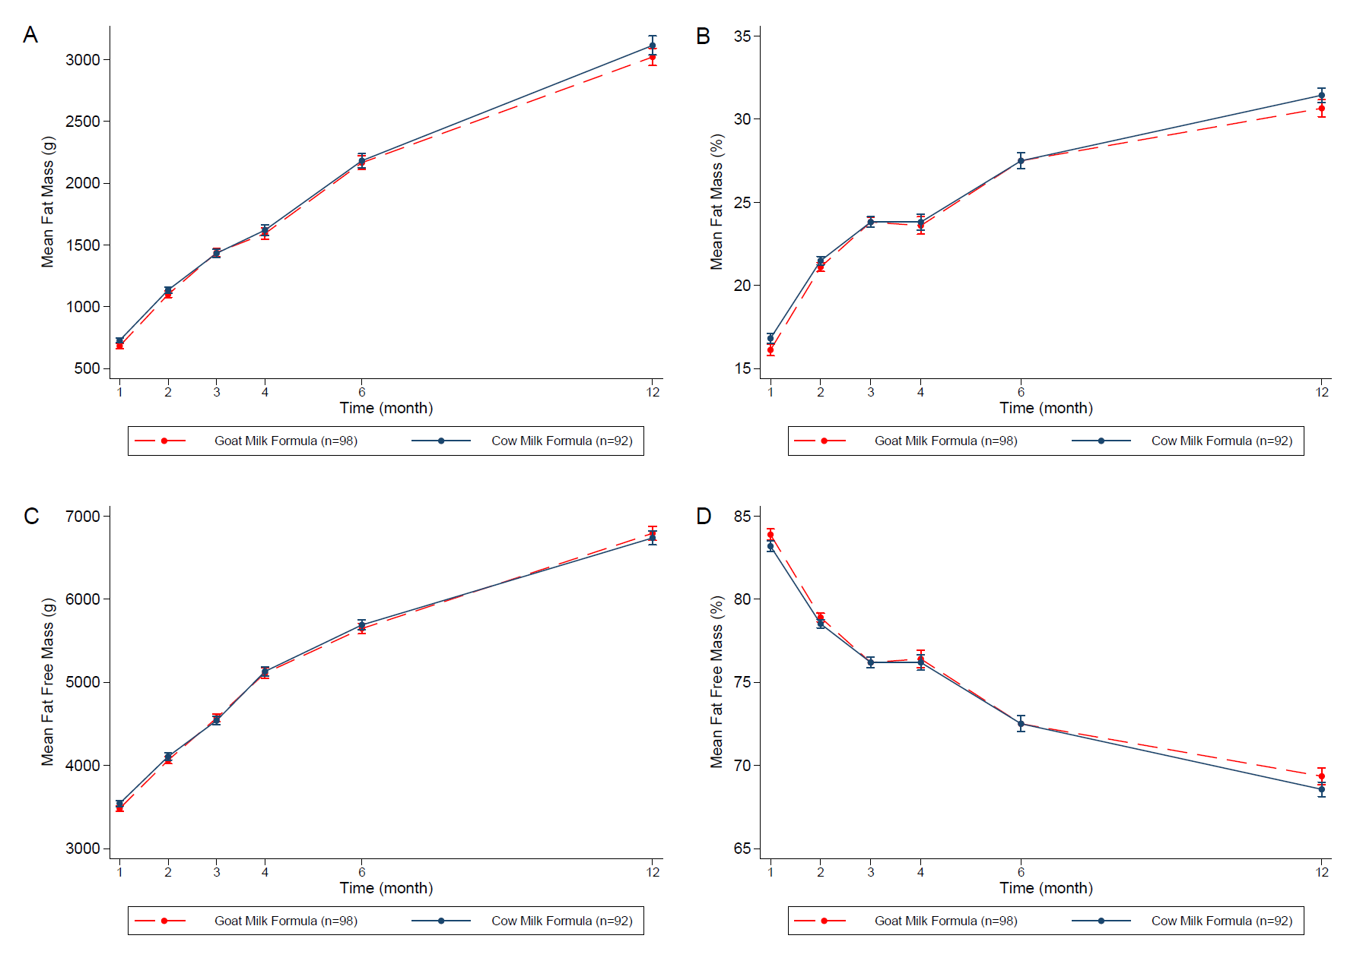
Supplemental Figure 2. Fat mass (A), fat mass percentage (B), fat free mass (C) and fat free mass percentage (D) of infants fed goat milk formula (n=98) vs. cow milk formula (n=92) in the first 12 months of age. Values are mean. A Generalised Estimating Equation with robust variance estimation was used for statistical analysis.

