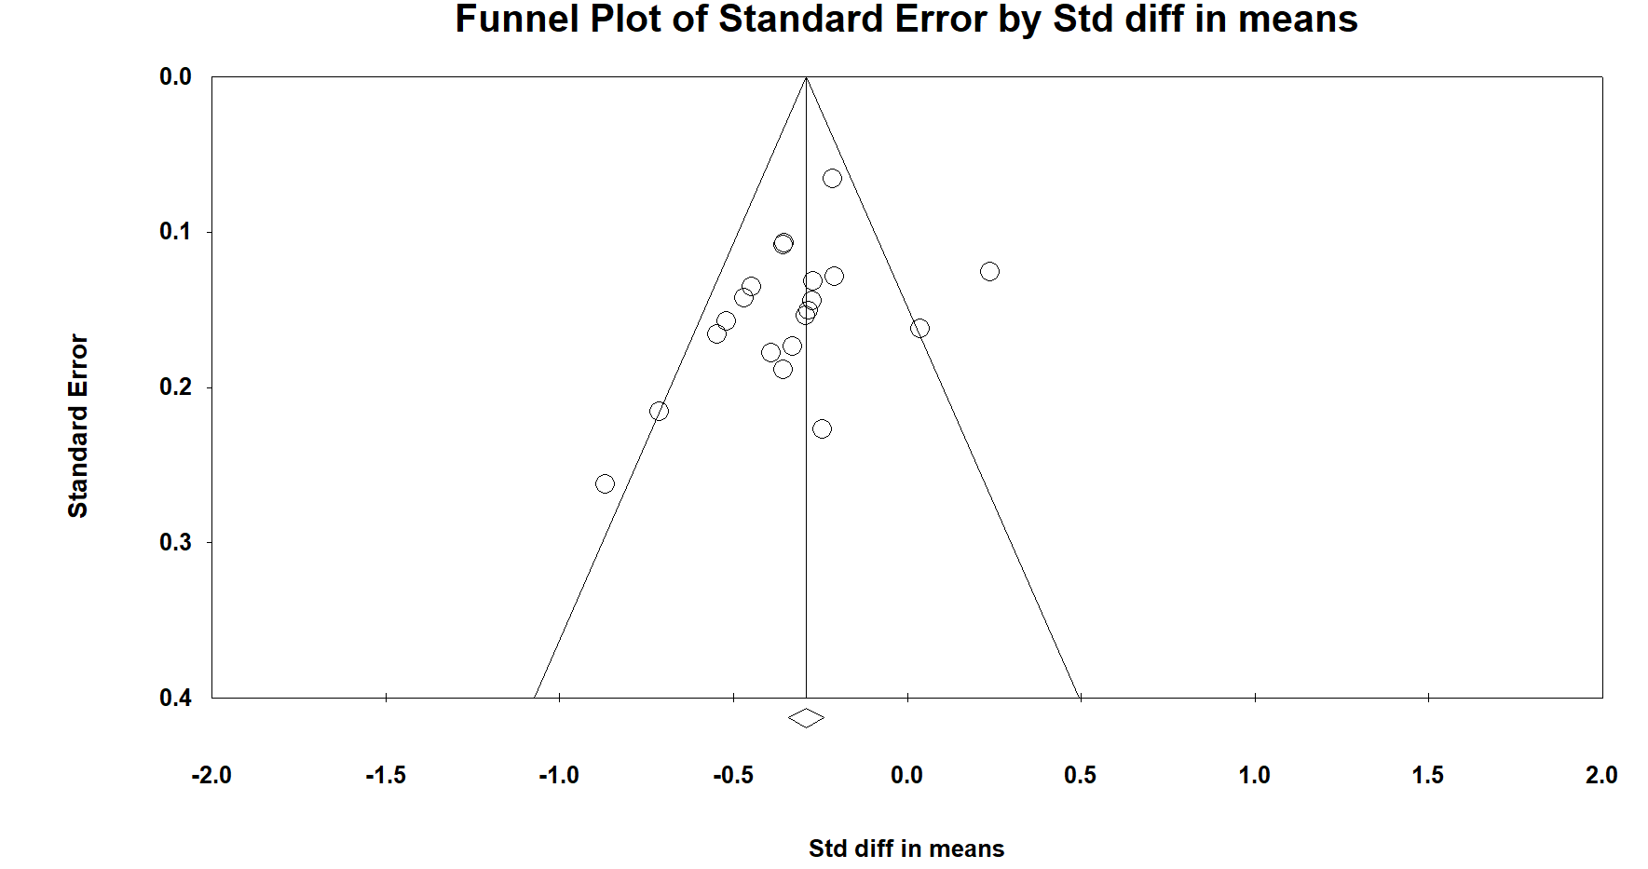

Fig. S1. Funnel plot for studies included in the meta-analysis of waist circumference.

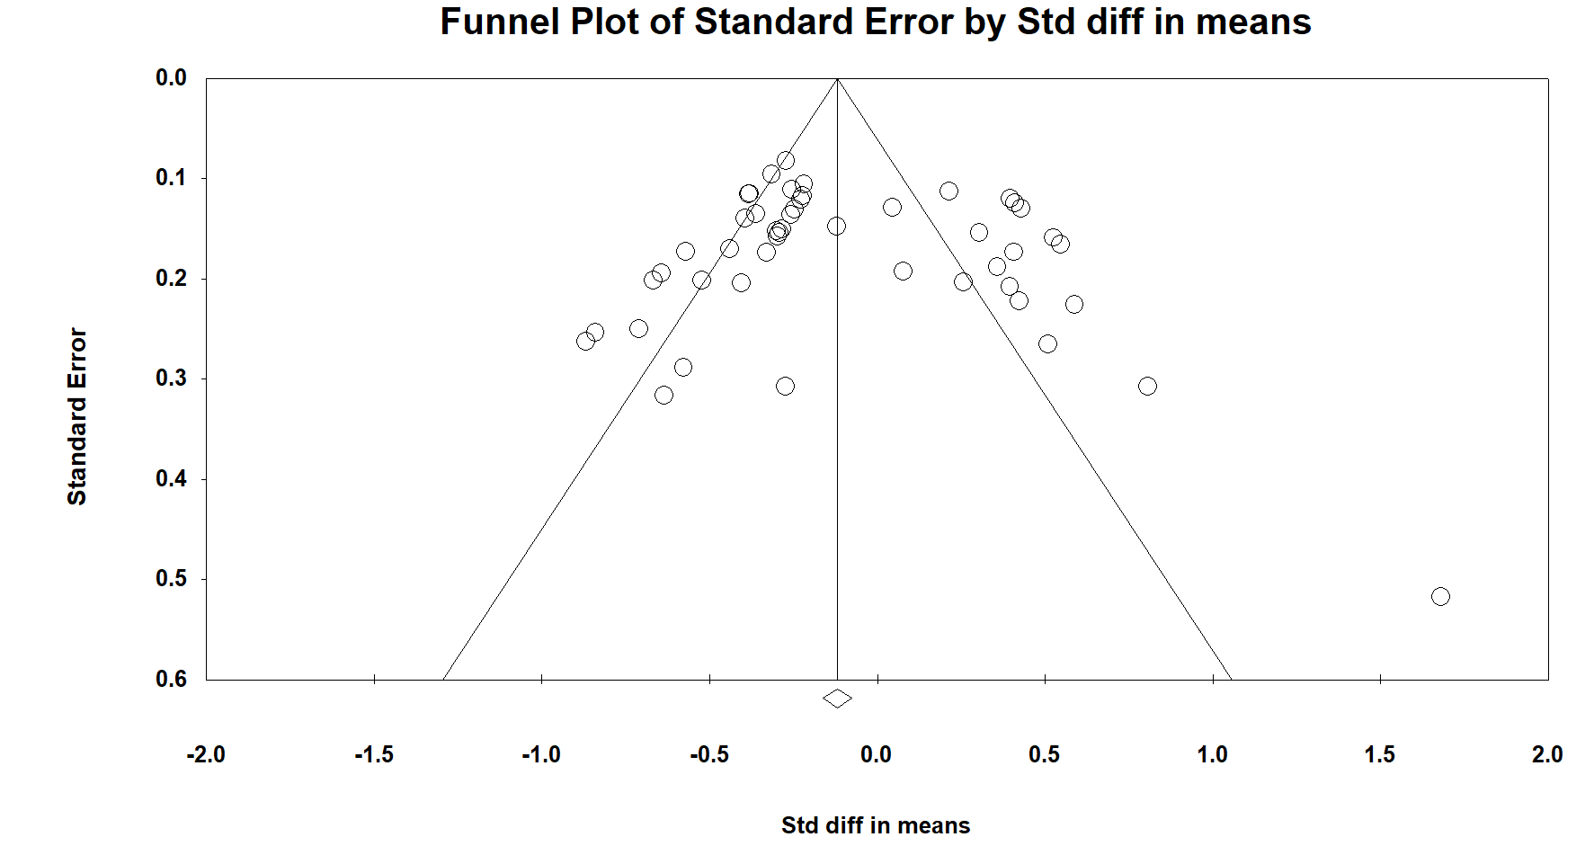
Fig. S2. Funnel plot for studies included in the meta-analysis of fasting glucose.

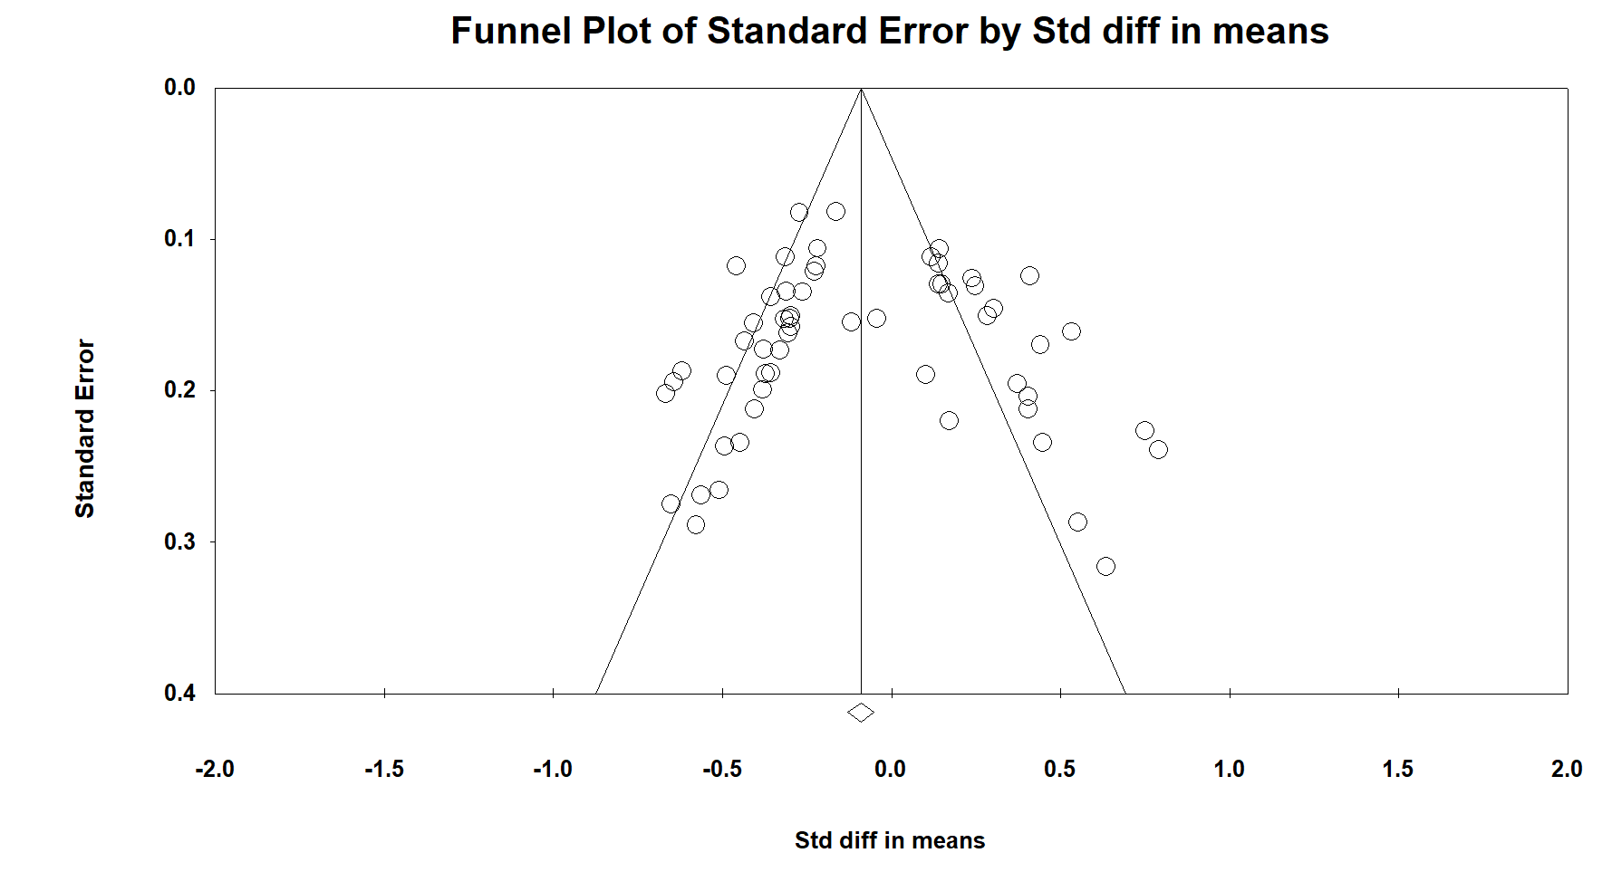
Fig. S3. Funnel plot for studies included in the meta-analysis of triglycerides.

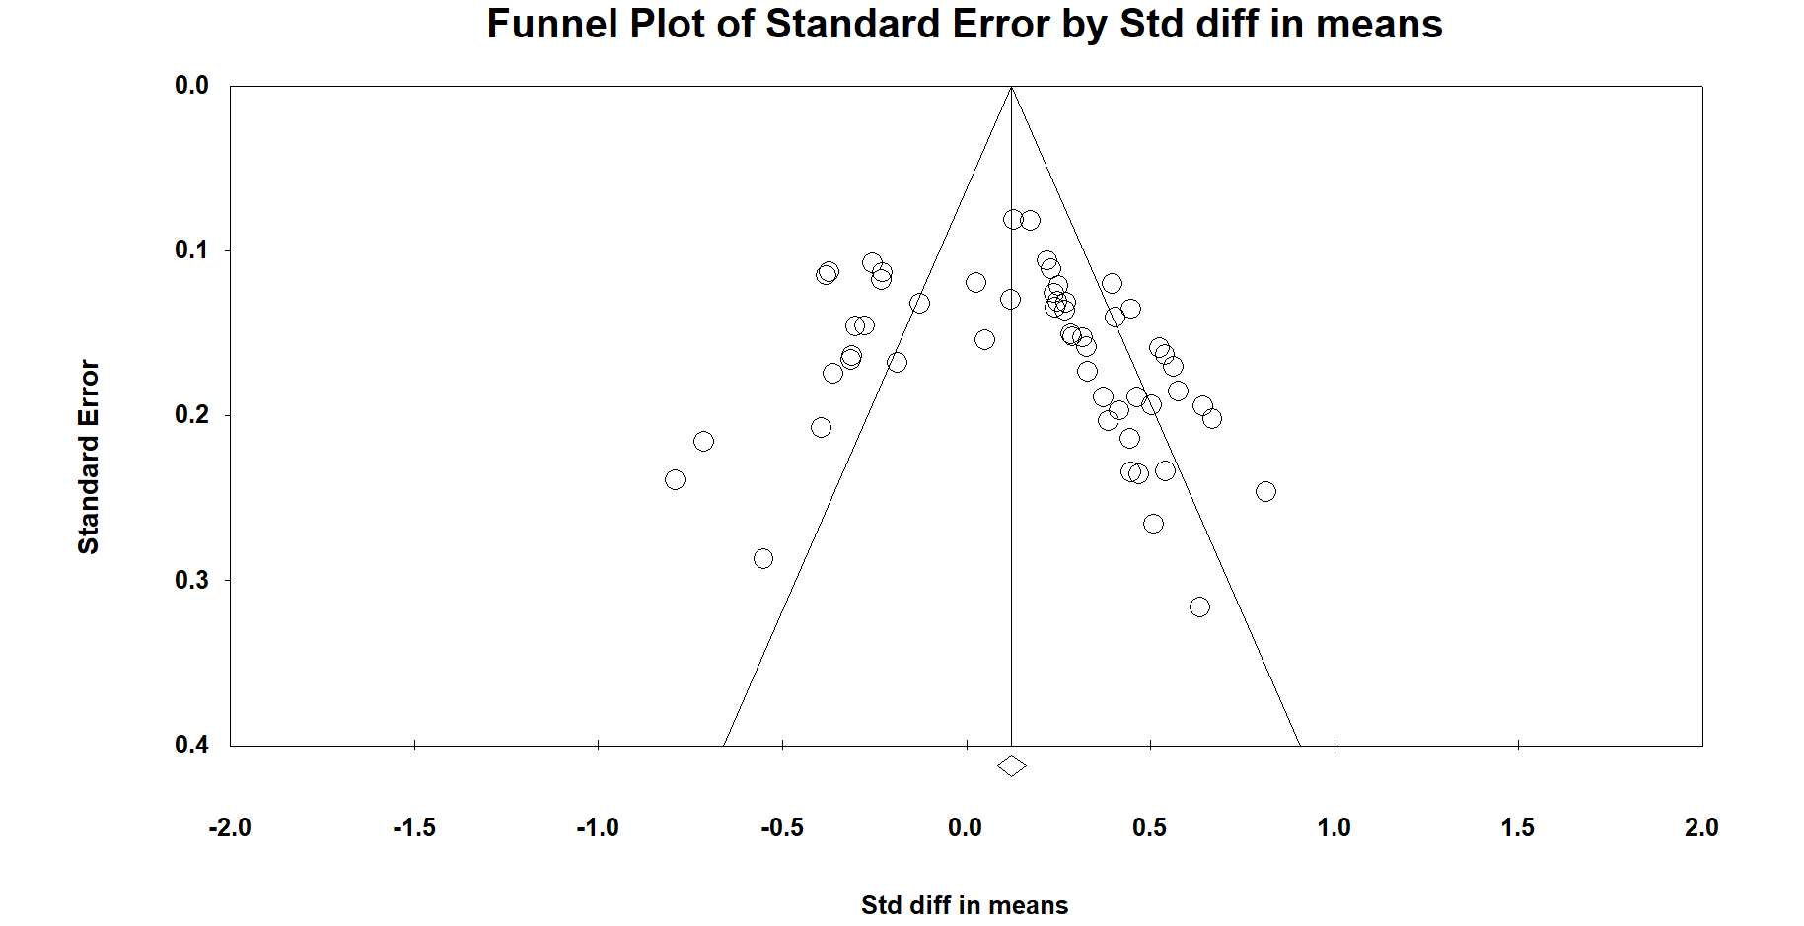

Fig. S4. Funnel plot for studies included in the meta-analysis of high-density lipoprotein cholesterol.

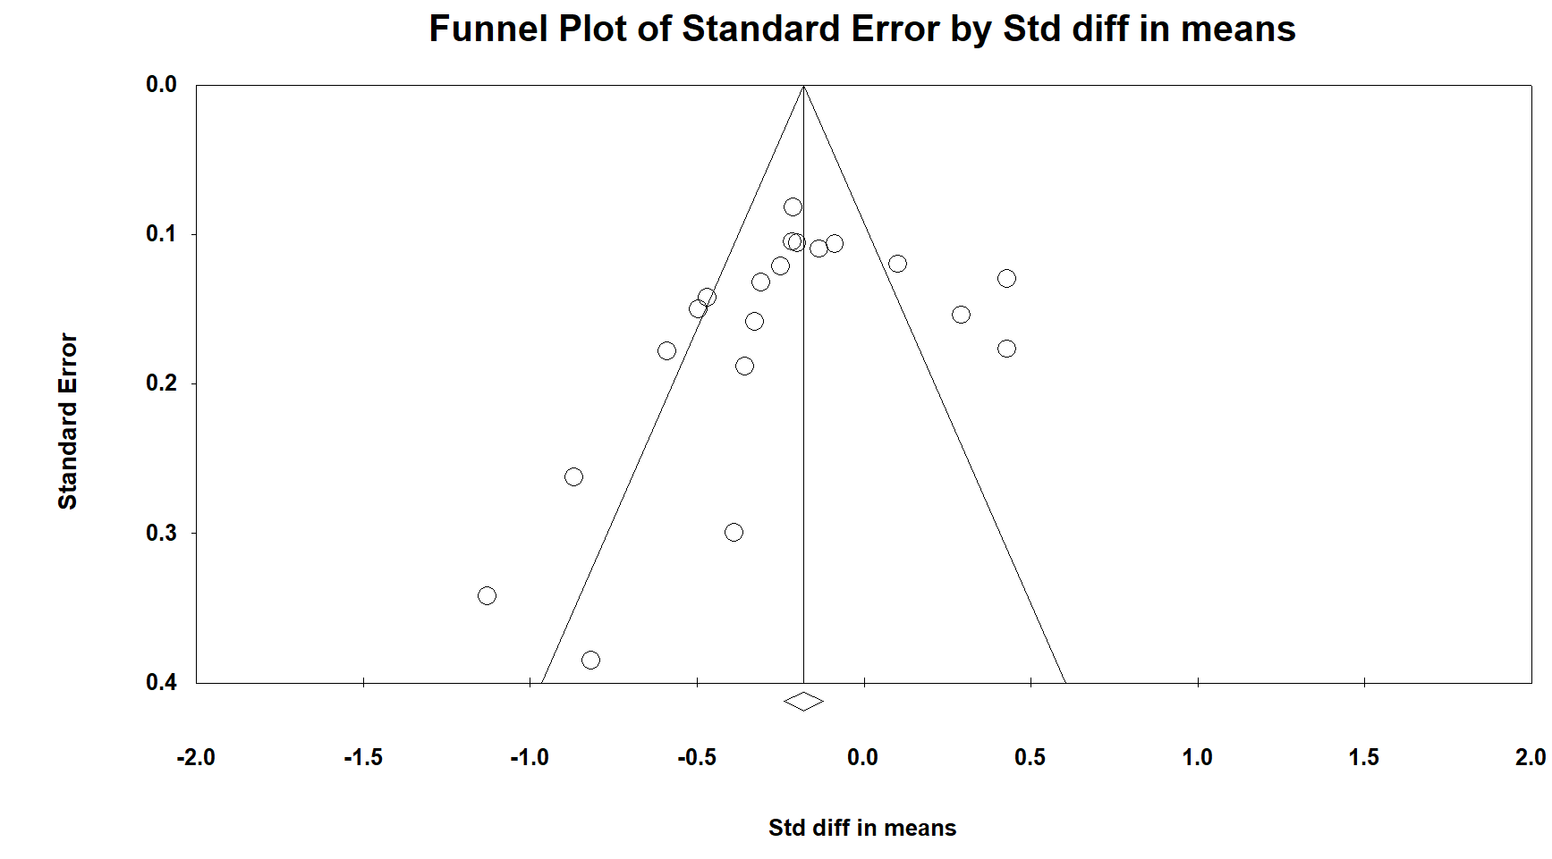
Fig. S5. Funnel plot for studies included in the meta-analysis of systolic blood pressure.

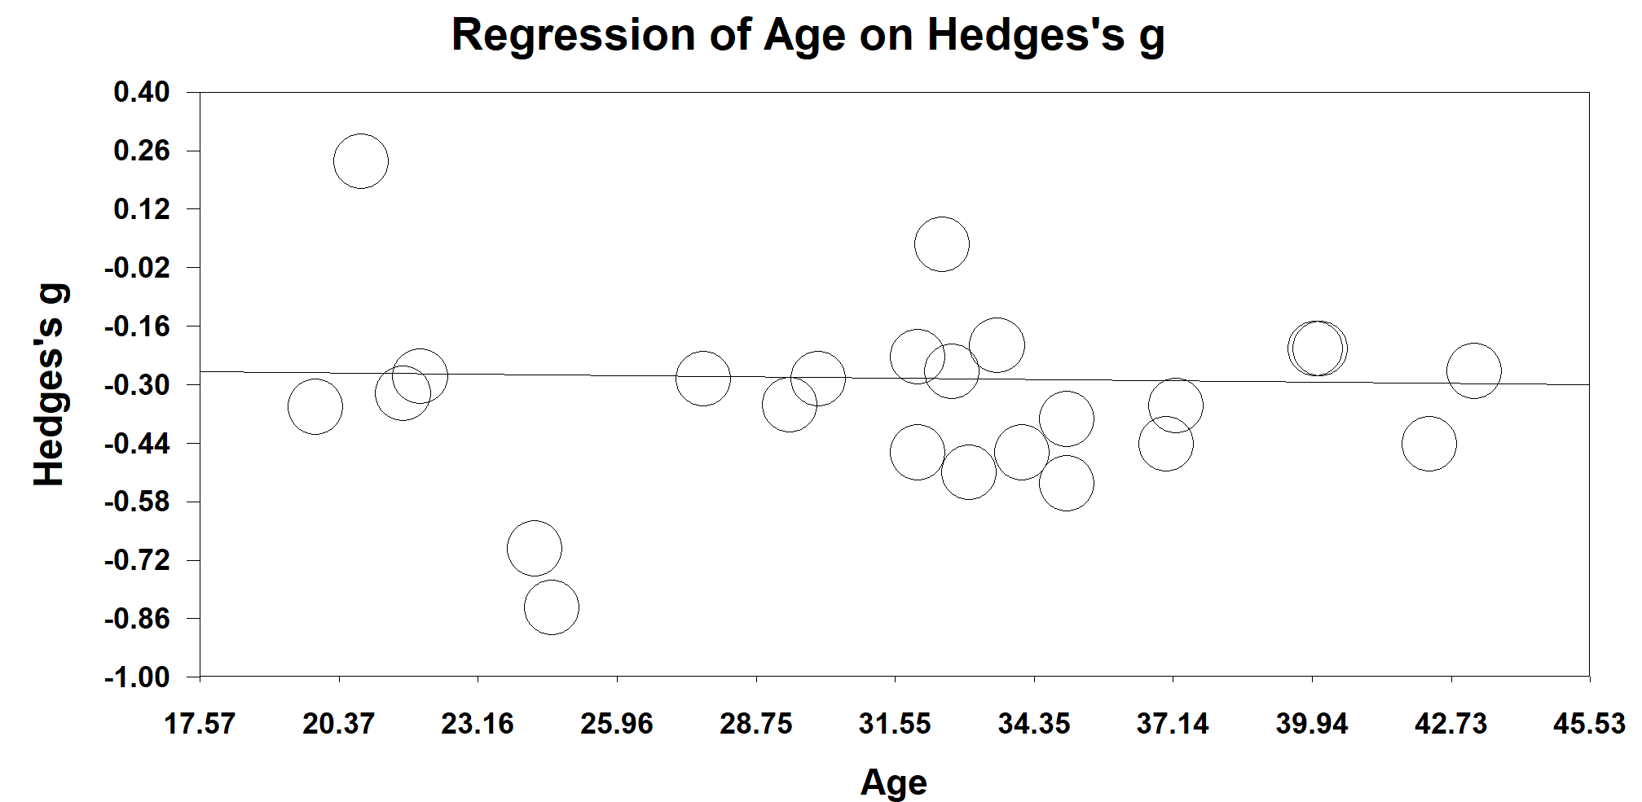
Fig. S6. Regression analysis for changes in waist circumference according to the age of fasting people and Hedges’s g values for the 24 studies (1557 subjects) included in the meta-analysis. The correlation was statistically nonsignificant (β= - 0.002, P-value=0.78).

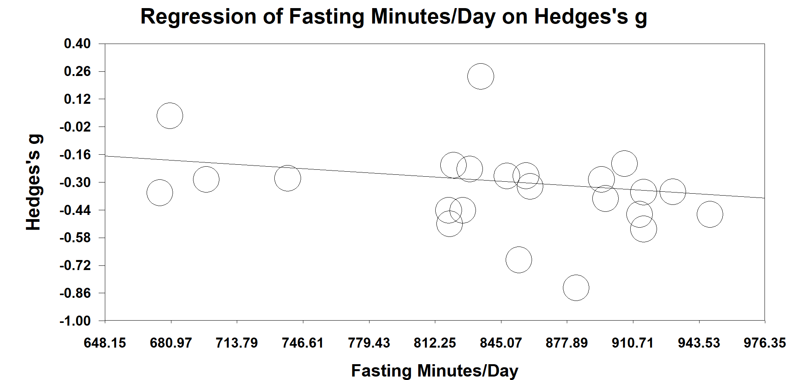
Fig. S7. Regression analysis for changes in waist circumference according to fasting minutes/day of fasting subjects and Hedges’s g values for the 24 studies (1557 subjects) included in the meta-analysis. The correlation was statistically non-significant (β=-0.001, P-value=0.08).

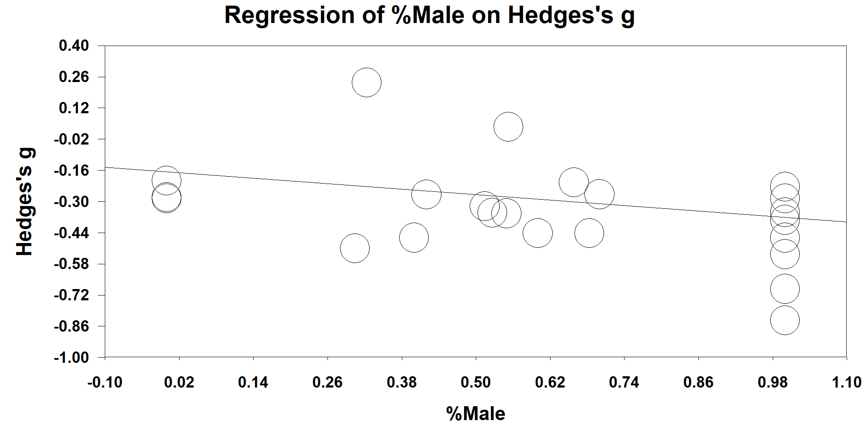
Fig. S8. Regression analysis for changes in waist circumference according to the sex of fasting subjects and Hedges’s g values for the 24 studies (1557 subjects) included in the meta-analysis. The correlation was statistically significant (β= -0.20, P-vale=0.03).

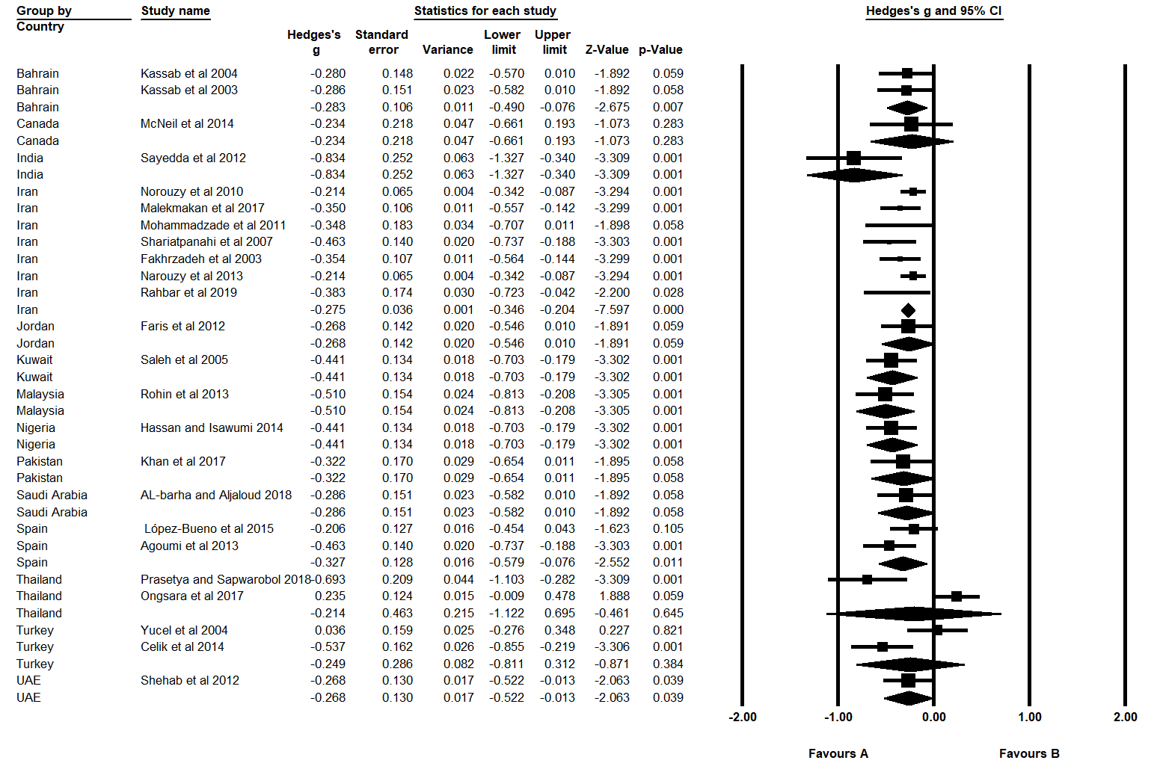
Fig. S9. Pooled Hegdes’s g values for reductions in waist circumference for fourteen countries-studies included in the meta-analysis.
Hedge’s g value is considered small when value=0.2, Medium=0.5, Large=0.8.

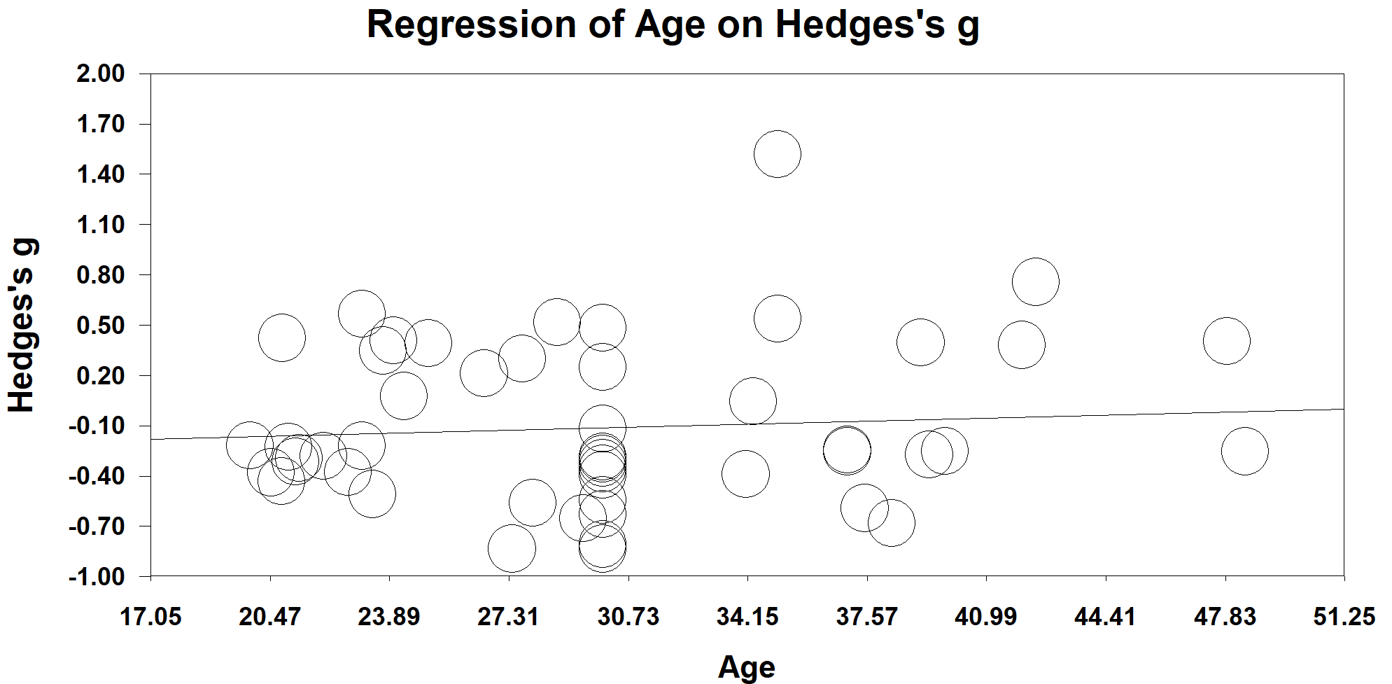

Fig. S10. Regression analysis for changes in fasting glucose according to the age of fasting subjects and Hedges’s g values for the 51 studies (2318 subjects) included in the meta-analysis. The correlation was statistically significant (β=0.005, P=0.05).

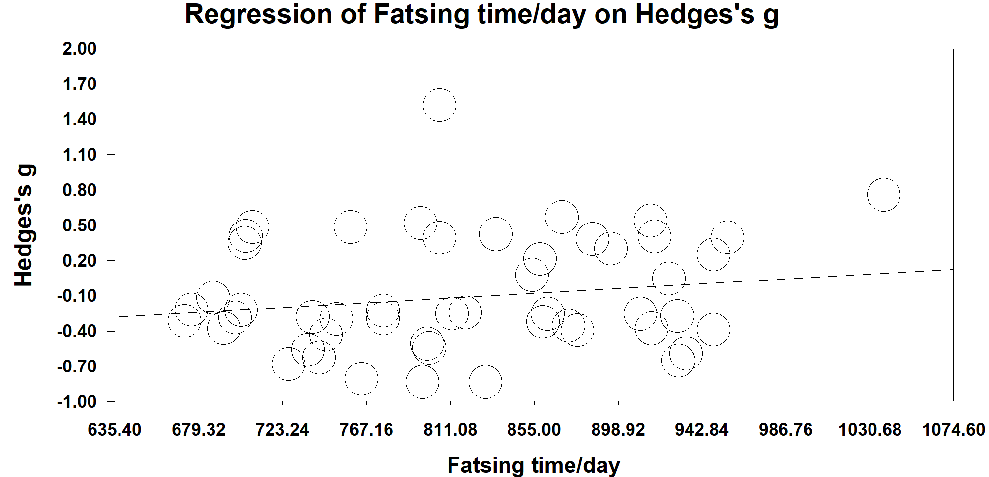
Fig. S11. Regression analysis for changes in fasting glucose according to fasting minutes/day of fasting subjects and Hedges’s g values for the 51 studies (2318 subjects) included in the meta-analysis. The correlation was statistically significant (β= - 0.001, P=0.001).

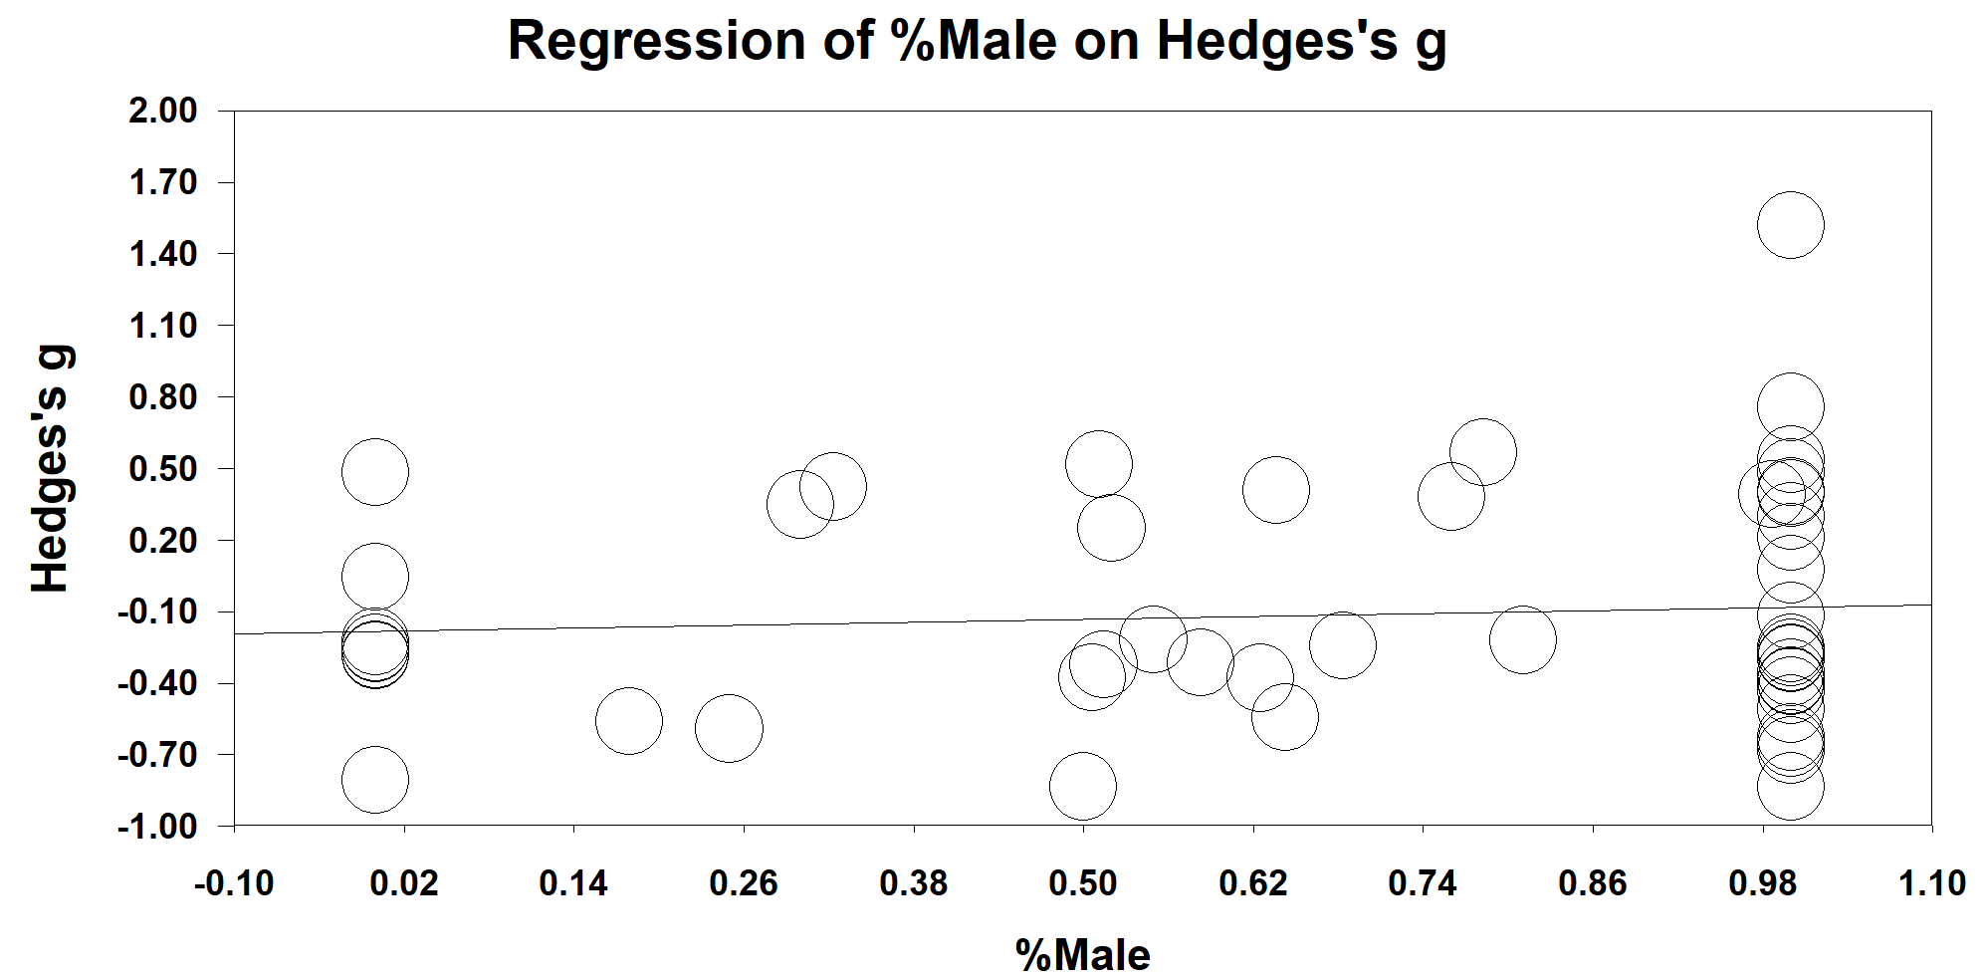
Fig. S12. Regression analysis for changes in fasting glucose according to the sex of fasting subjects and Hedges’s g values for the 51 studies (2318 subjects) included in the meta-analysis. The correlation was statistically non-significant.

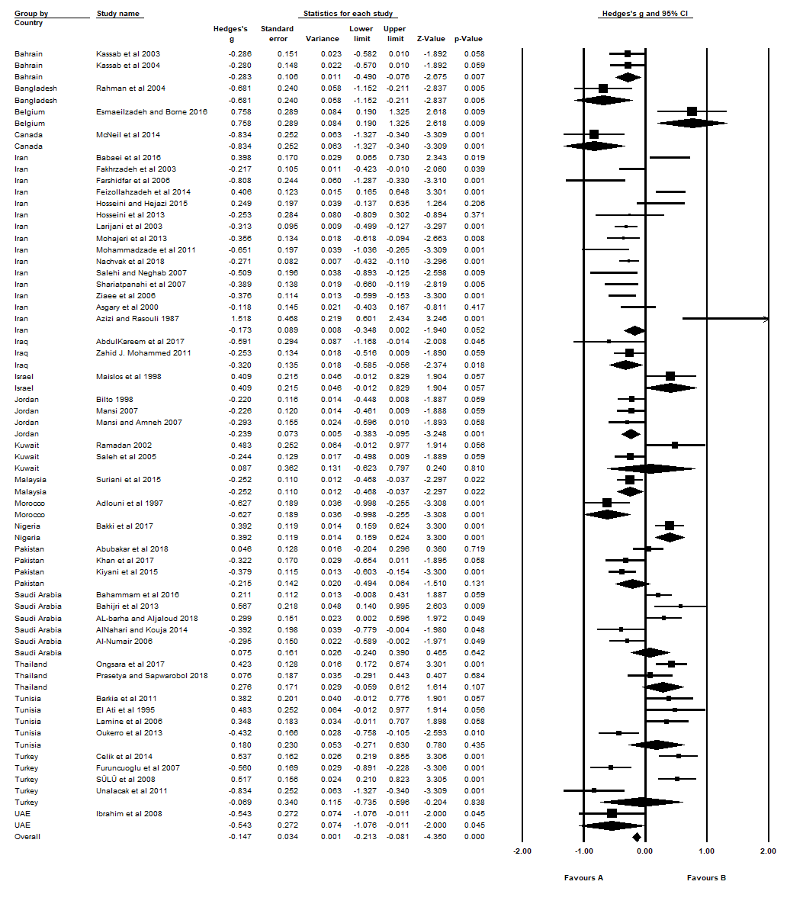
Fig. S13. Pooled Hedges’s g values for reductions in fasting glucose for nineteen countries included in the meta-analysis.
Hedge’s g value is considered small when value=0.2, Medium=0.5, Large=0.8.

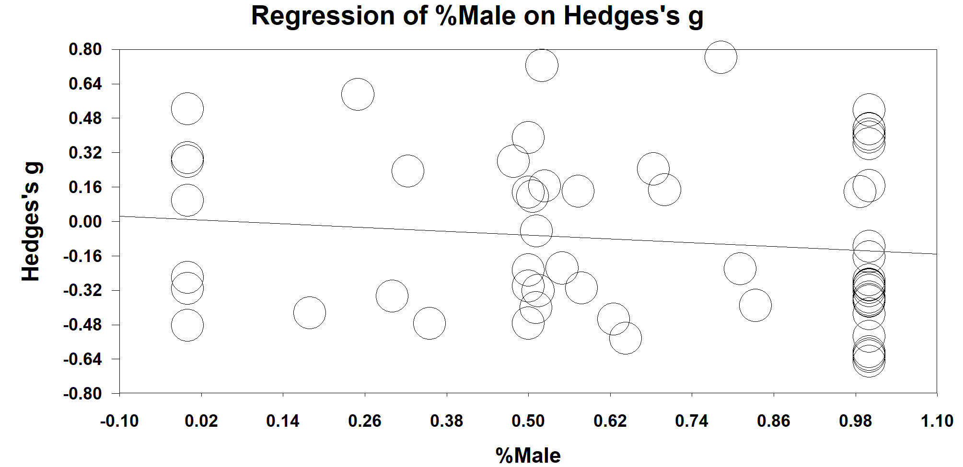
Fig. S14. Regression analysis for changes in triglycerides according to the sex of fasting subjects and Hedges’s g values for the 63 studies (2862 subjects) included in the meta-analysis. The correlation was statistically significant (β= - 0.14, P=0.01).

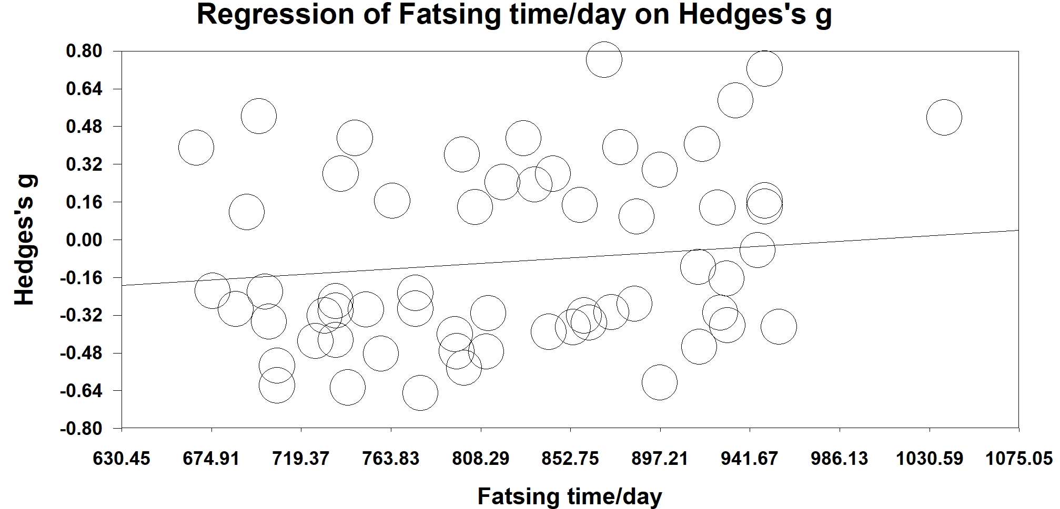
Fig. S15. Regression analysis for changes in triglycerides according to fasting minutes/day of fasting subjects and Hedges’s g values for the 63 studies (2862 subjects) included in the meta-analysis. The correlation was statistically significant (β= - 0.005, P=0.01).

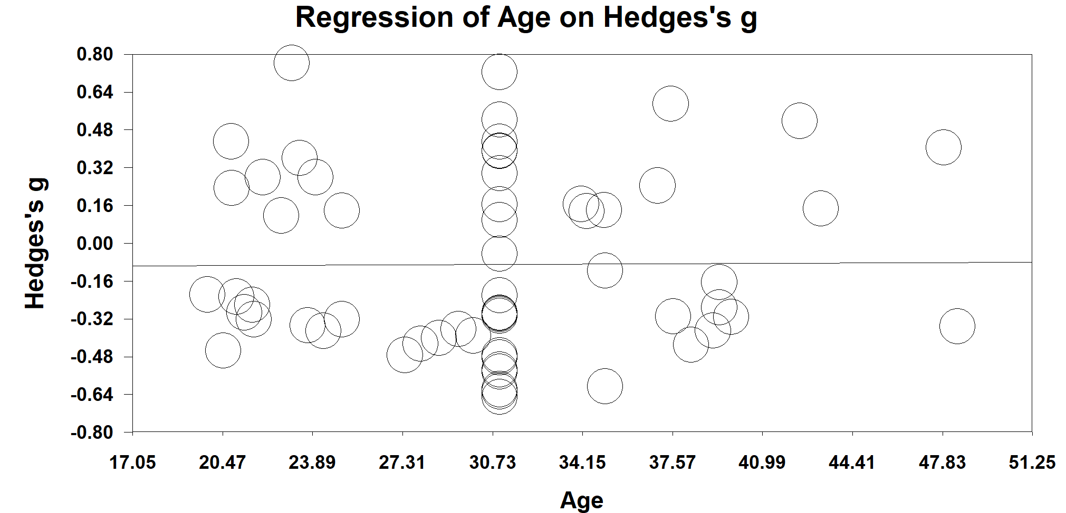

Fig. S16. Regression analysis for changes in triglycerides according to the age of fasting subjects and Hedges’s g values for the 63 studies (2862 subjects) included in the meta-analysis. The correlation was statistically non-significant.

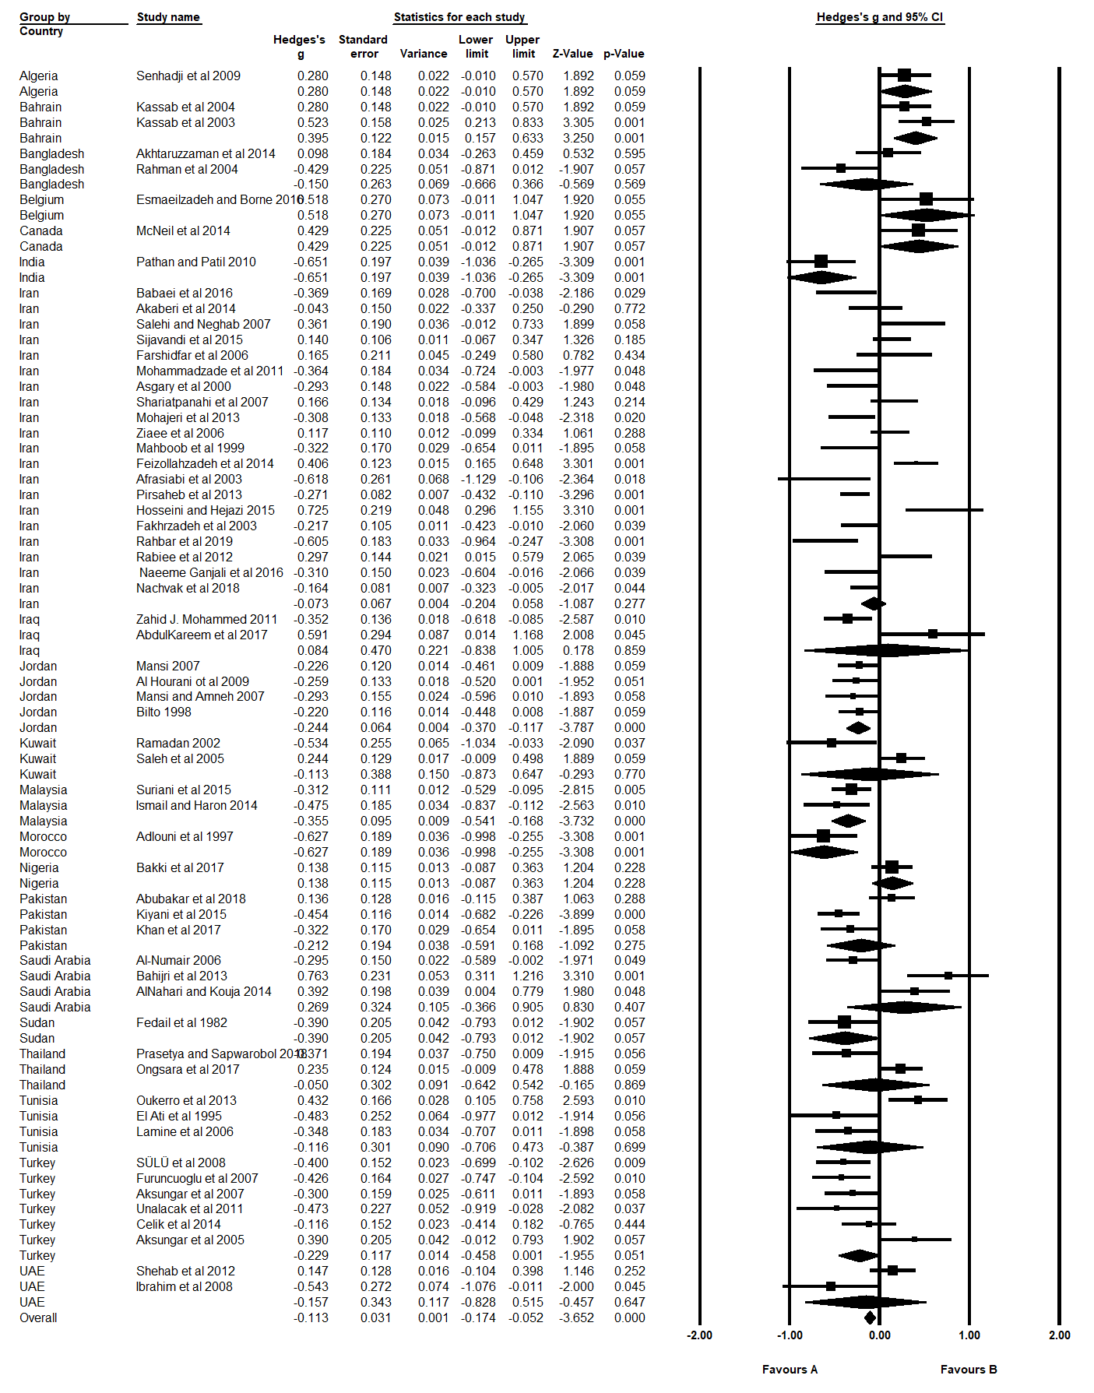
Fig. S17. Pooled Hedges’s g values for reductions in triglycerides for twenty-one countries included in the meta-analysis.
Hedge’s g value is considered small when value=0.2, Medium=0.5, Large=0.8.

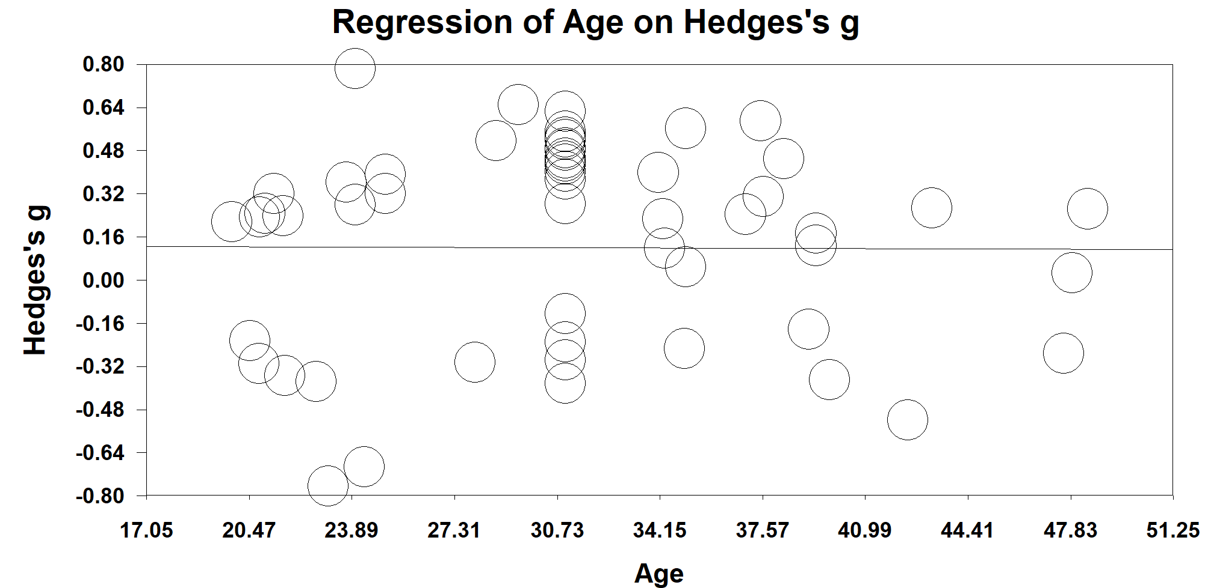

Fig. S18. Regression analysis for changes in high-density lipoprotein according to the age of fasting subjects and Hedges’s g values for the 57 studies (2771 subjects) included in the meta-analysis. The correlation was statistically non-significant.

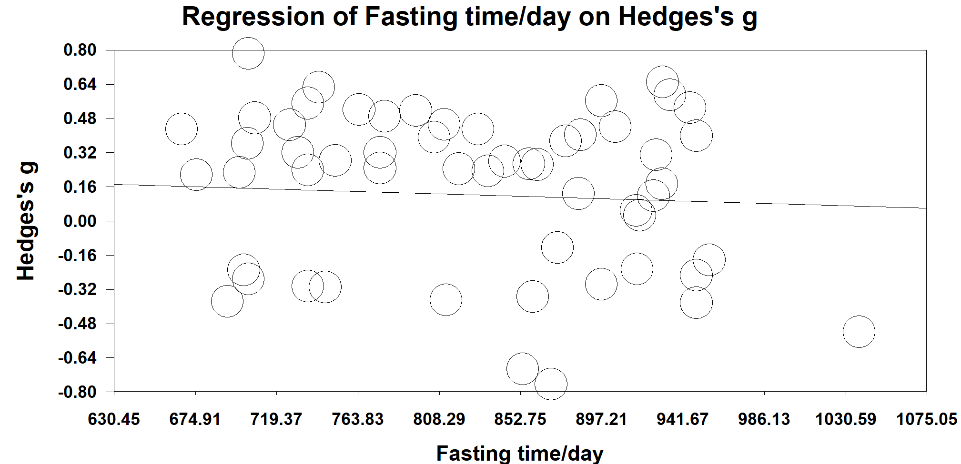
Fig. S19. Regression analysis for changes in high-density lipoprotein according to fasting minutes/day of fasting subjects and Hedges’s g values for the 57 studies (2771 subjects) studies included in the meta-analysis. The correlation was statistically non-significant.

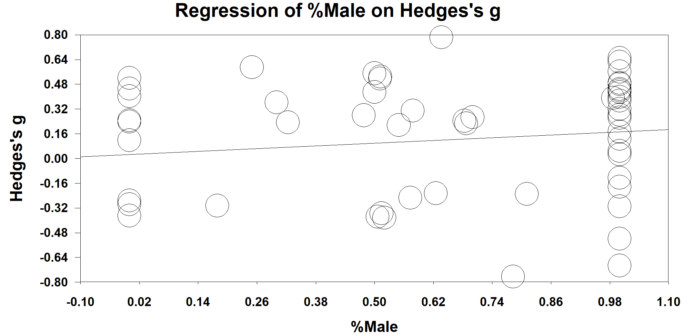

Fig. S20. Regression analysis for changes in high-density lipoprotein according to the sex of fasting subjects and Hedges’s g values for the 57 studies (2771 subjects) included in the meta-analysis. The correlation was statistically significant (β = 0.15, P = 0.005).

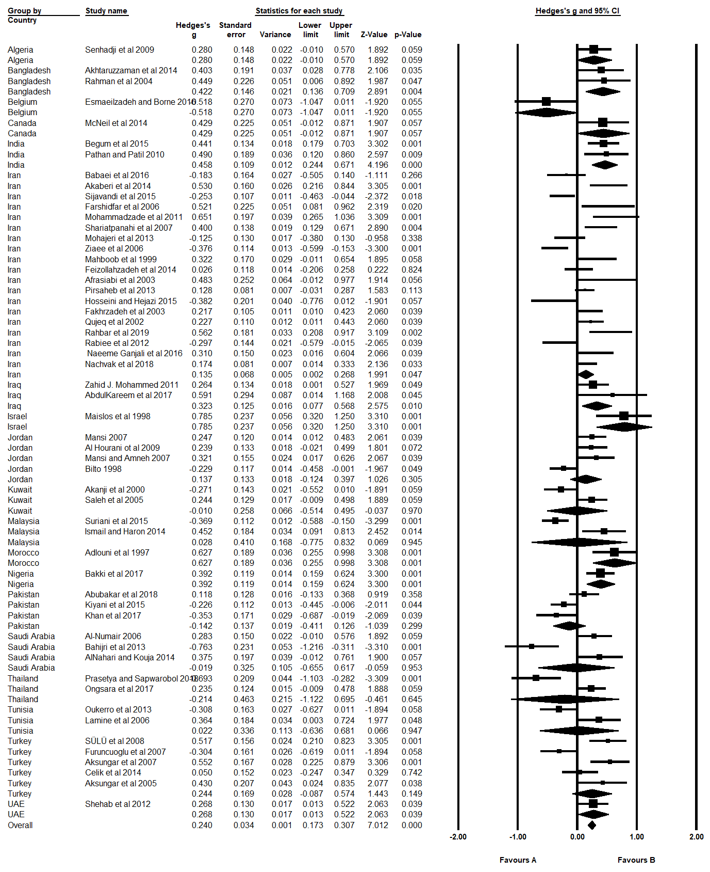
Fig. S21. Pooled Hedges’s g values for increment in high-density lipoprotein for nineteen countries included in the meta-analysis.
Hedge’s g value is considered small when value=0.2, Medium=0.5, Large=0.8.

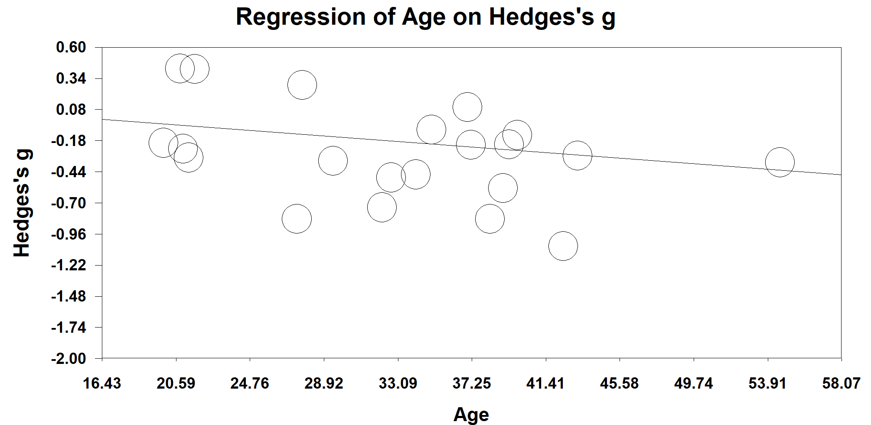
Fig. S22. Regression analysis for changes in systolic blood pressure according to the age of fasting subjects and Hedges’s g values for the 22 studies (including 1172 subjects) included in the meta-analysis. The correlation was statistically non-significant.

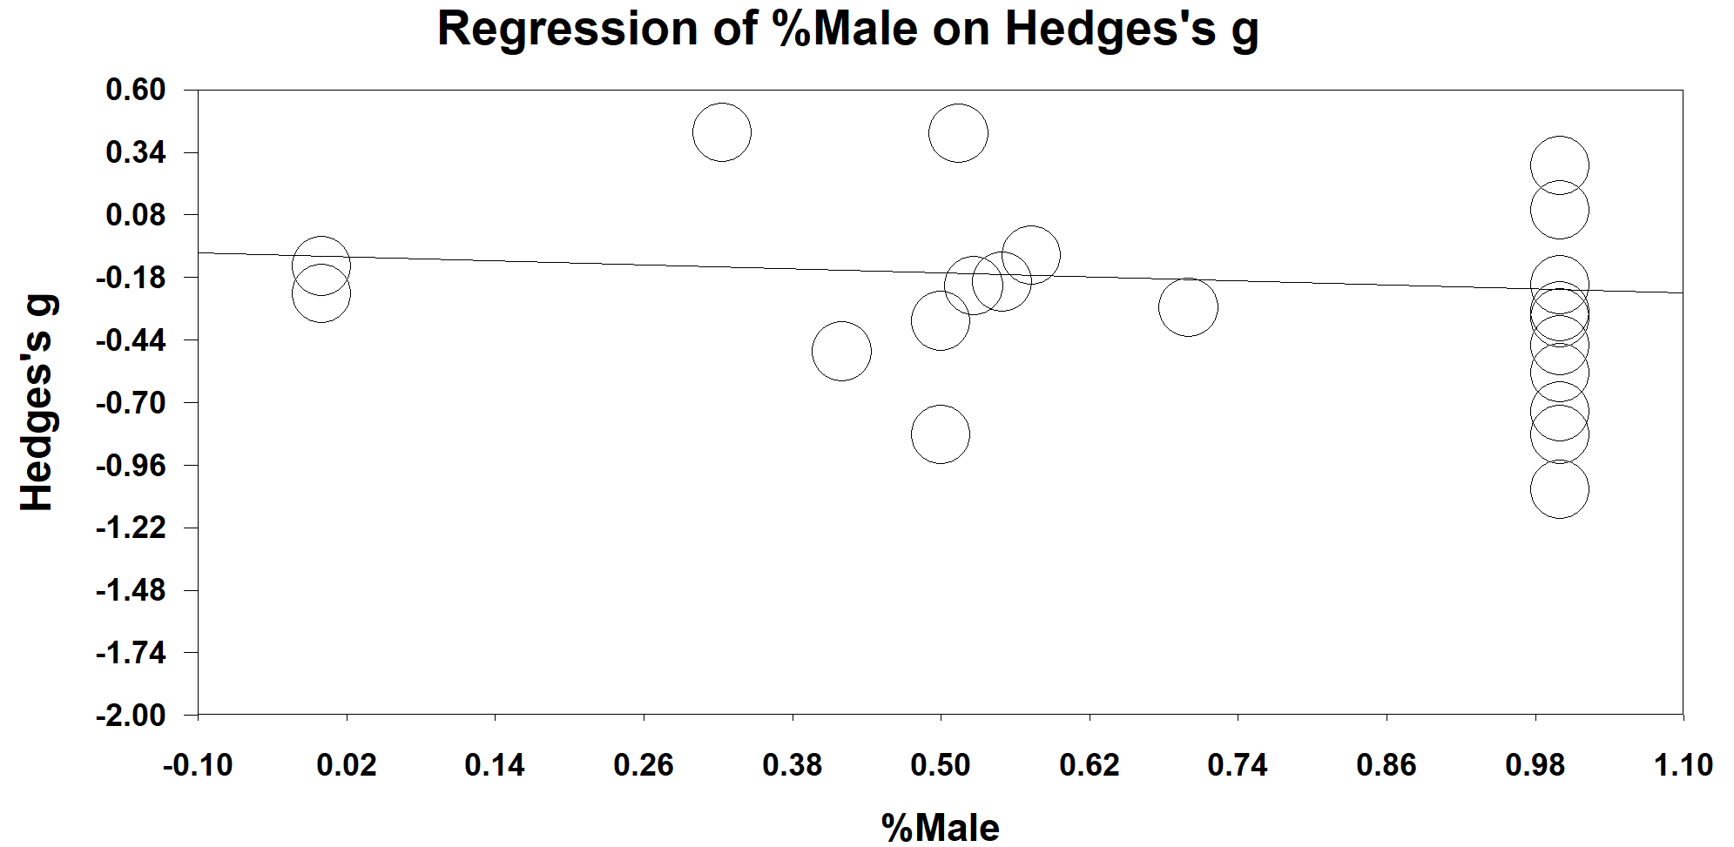
Fig. S23. Regression analysis for changes in systolic blood pressure according to the sex of fasting subjects and Hedges’s g values for the 22 studies (including 1172 subjects) included in the meta-analysis. The correlation was statistically non-significant.

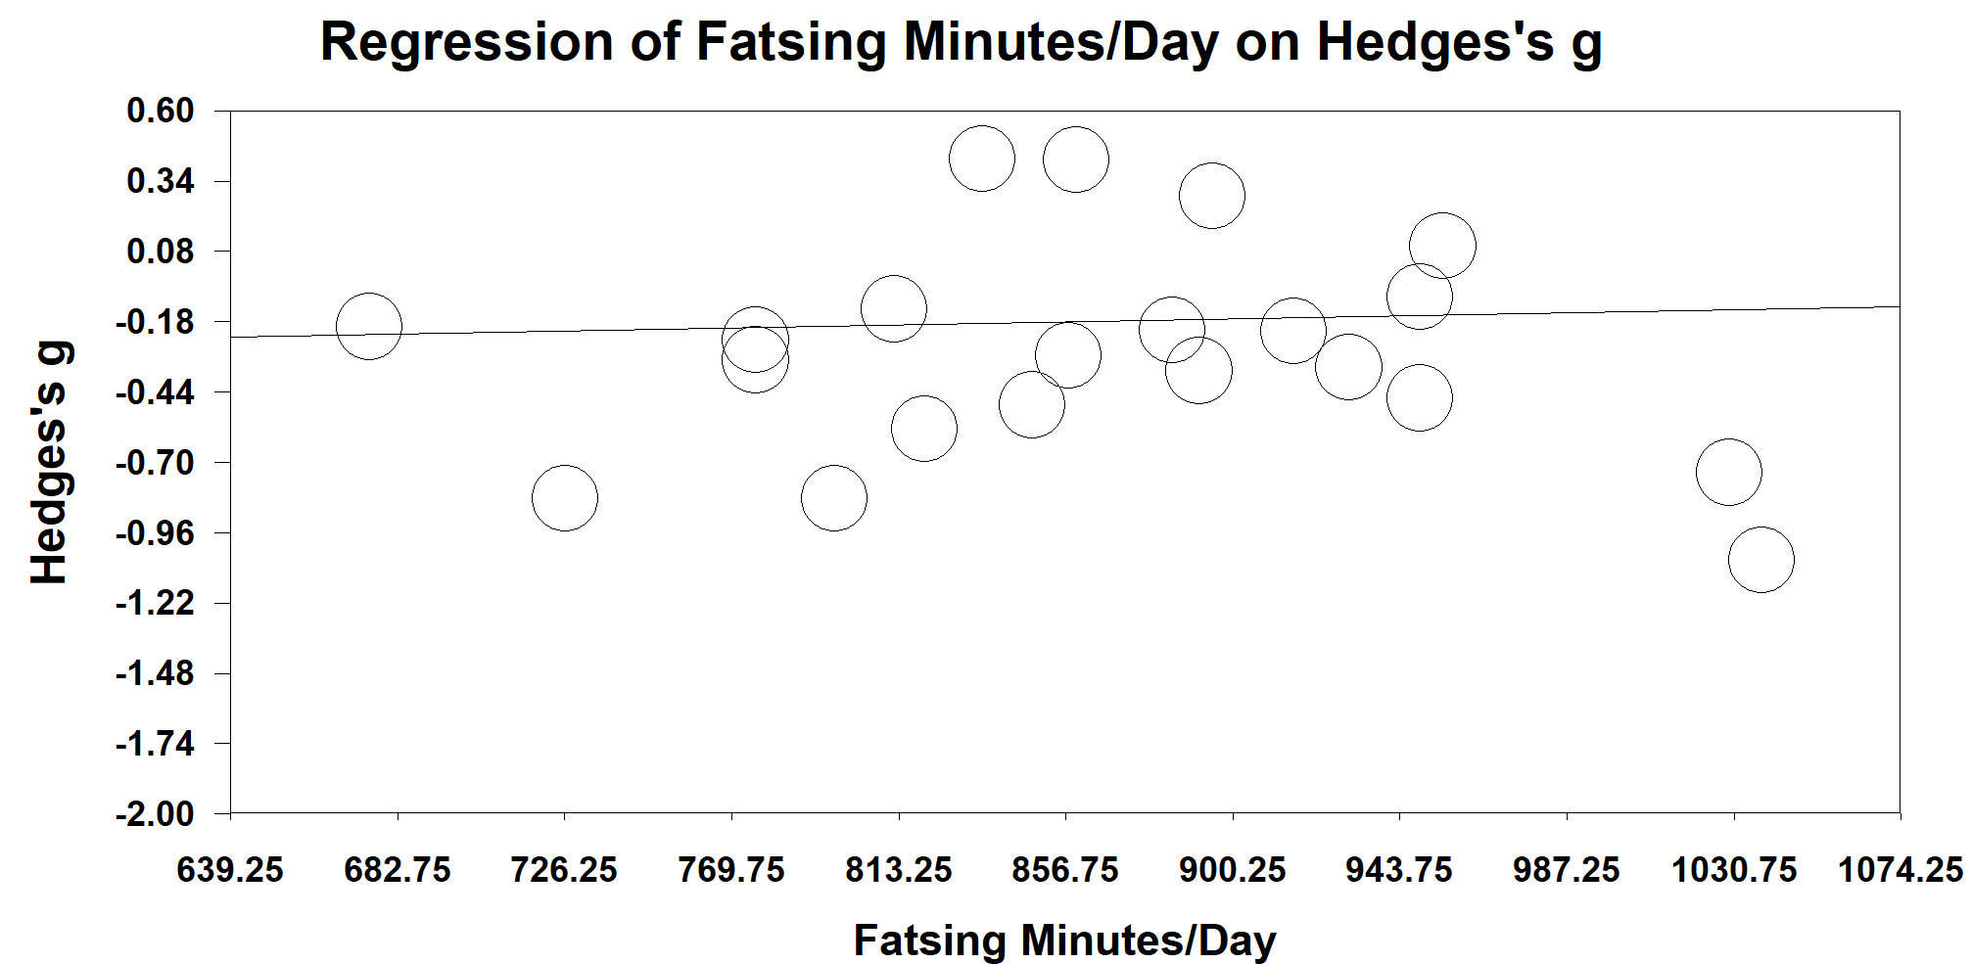
Fig. S24. Regression analysis for changes in systolic blood pressure according to fasting minutes/day of fasting subjects and Hedges’s g values for the 22 studies (including 1172 subjects) included in the meta-analysis. The correlation was statistically non-significant.

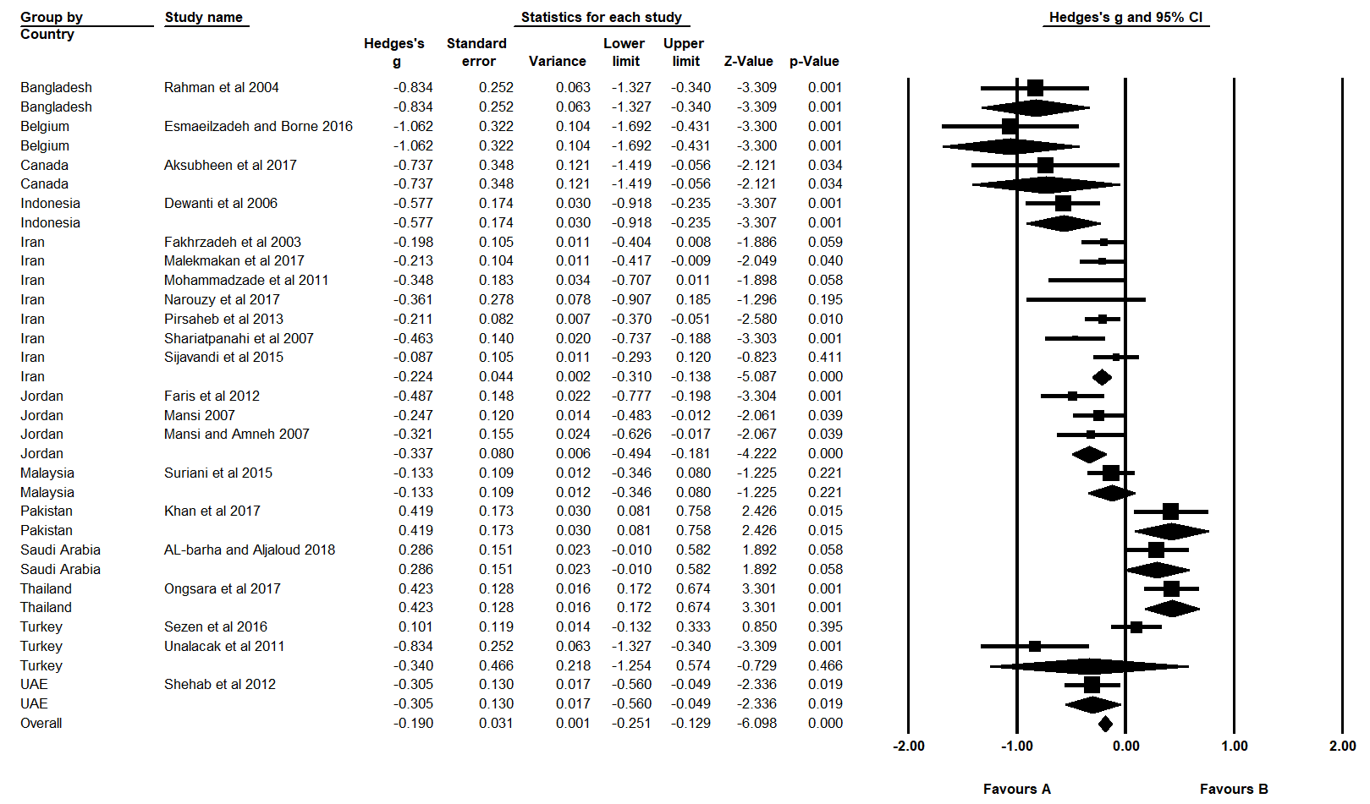
Fig. S25. Pooled Hedges’s g values for reductions in systolic blood pressure between the thirteen countries included in the meta-analysis.
Hedge’s g value is considered small when value=0.2, Medium=0.5, Large=0.8.

