Table S1. Primers used for cloning and plasmids construction
Gene | Name | Forward primer (5'-3') | Reverse primer (5'-3')
Primers for RLM-5’RACE
srebp-1 | RACE-outer | CATGGCTACATGCTGACAGCCTA | CCTCAACACTGCCGACTTATT
 | RACE-inner | CGCGGATCCACAGCCTACTGATGATCAGTCGATG | TGCGTTTCTCGCCTTTATG
accα | RACE-outer | CATGGCTACATGCTGACAGCCTA | CTCAGACGCCTTCACCATC
 | RACE-inner | CGCGGATCCACAGCCTACTGATGATCAGTCGATG | GTTGTTGTTTGTCCCTCCTG
scd1 | RACE-outer | CATGGCTACATGCTGACAGCCTA | GTTAATGGTGCTGTCGTAGGG
 | RACE-inner | CGCGGATCCACAGCCTACTGATGATCAGTCGATG | GTCAGGATGTTTACGGACCAA
fas | RACE-outer | CATGGCTACATGCTGACAGCCTA | TTGAGCACTGTGGCATAGATT
 | RACE-inner | CGCGGATCCACAGCCTACTGATGATCAGTCGATG | ACTGAGGTGTTGGGCTTGA
Promoter construct
srebp-1 | srebp1-1998 | ctatcgataggtaccgagctcGCAACAGTTCTTCTAACCCTAAT | cagtaccggaatgccaagcttACTACCTACTCGCGTTCGTT
accα | accα-2043 | ctatcgataggtaccgagctcCCAGTGCCTTGAATTTGATT | cagtaccggaatgccaagcttGTGTAGCTCCAGCCTCTTTG
scd1 | scd1-1632 | ctatcgataggtaccgagctcGGATGAGTGT GTTTCGTGTT GTG | cagtaccggaatgccaagcttGCTTATCTGATGTTCGCTTTCT
fas | fas-1889 | ctatcgataggtaccgagctcTCTCAAATGCCACTCAAACCA | cagtaccggaatgccaagcttGCAGATCCTTTGGGATAGAGTC
Primers for site-mutated construct of promoters
srebp-1 | srebp1-sre1 | aaataggaggccaacacttgCTTTCTGACTCCCAATTGGTTGC | cgagtgggactctatGACGTCACGTATGTGGCTCCG
accα | accα-sre1 | AacggtgagtgaccgcAACTGTGGTGTAGTTCATTTATAGCTTATATT | gtgttggcctcctatttcatGTATGTGGCTCCGTGATTACATCA
scd1 | scd1-sre1 | TGggtgtttCCAACATCATGTCATGTCAATATCA | GATGTTGGaaacaccCATTAAAACCTTTGCTCTTATTTCACC
 | scd1-sre2 | CGGTGaaagttgagGATTTCCAGTATAAATAAGCGAACCG | ATCctcaactttCACCGGCGAGGAGTTTCTCT
fas | fas-sre1 | TGacagagaagcagcagCAGGTGTAGGATTCCGCTCCT | ctgctgcttctctgtCATTATGAGGGGCTGGACAGC
 | fas-sre2 | GGAGaatctcaacTGTCAGGACAACGCGATGG | GACAgttgagattCTCCTAGCAACACCCTTGCATT
 | fas-sre3 | AggttaaaaggCACTGGCTGCGTCTACAGCCCA | GCCAGTGccttttaaccTTCAGAGAAAAAAAAGCGTCTGAA
 | fas-sre4 | ggtacaaggagttctatgCATCGAGGATGTCAGACATTTAAATG | atagaactccttgtacctAGTTTGGCTCTTAGGTGCAGTCC
Primers for nSREBP-1 cloning and plasmid construct
 | nSREBP-1 cloning | TGAATCTGTCTTTTGACGACCCG | CTACTTATCGTCGTCATCCTTGTAATCCAGAGCCATGCGAGAGCG
 | nSREBP-1 plasmid | ctagcgtttaaacttaagcttATGAATCTGTCTTTTGACGACCCG | tgctggatatctgcagaattcCTACTTATCGTCGTCATCCTTGTAATC
Primers for 3’UTR of srebp-1 cloning and plasmid construct
 | 3’UTR cloning | CATCAAACTAGGCAGCGGAAC | AAAATCAAATAGAAGACAATA
 | pmirGLO-srebp1 | tctagttgtttaaacgagctcCCAACTACACACAACACACACACAC | caggtcgactctagactcgagTATAGGATATACTATGTGTGCGTCTGCA
Primers for miR-29 site-mutated construct of pmirGLO-srebp1
 | pmirGLO-srebp1-miR29mut | GTCCAACGatcatgcgAATTGGACACATATTGTAGAGCATTGC | TTcgcatgatCGTTGGACCAGAATCCAGTTTAT

Table S2 Primers used for Q-PCR analysis
Gene | Forward primer (5'-3') | Reverse primer (5'-3') | Accession No.
Primers for Q-PCR genes of Homo sapiens
18s-rRNA | GTTCAGCCACCCGAGATTGA | TGTGTACAAAGGGCAGGGAC | M10098
β-actin | ACCCTGAAGTACCCCATCGA | GAGGCGTACAGGGATAGCAC | NM_001101
b2m | TGCCGCATTTGGATTGGATG | CCCCACCTCTAAGTTGCCAG | NM_004048
ef1α | CATCCAGGCCAAATAAGCGC | CTCAACACACATGGGCTTGC | M29548
gapdh | TCAGCCGCATCTTCTTTTGC | TTAAAAGCAGCCCTGGTGAC | NM_001289745
hprt | CCTGGCGTCGTGATTAGTGA | GGCCTCCCATCTCCTTCATC | NM_000194
Primers for Q-PCR genes of Ctenopharyngodon idella
18s-rRNA | GGCGCGCAAATTACCCATT | TCCCGAGATCCAACTACAAGC | EU047719
β-actin | ACCCTGAAGTACCCCATCGA | CAGAGGCATACAGGGACAGC | DQ211096
b2m | GCACTCGTCTCTTTTGCCCT | TTTCGAAGGCCAGGTCAGTC | AB128864
ef1α | CCACCGGCCATCTGATCTAC | GTGTCCAGGGGCATCAATGA | GQ266394
gapdh | GGGAAACTGTGGAGGGATGG | TGCAGCCTTGACCACTTTCT | GQ245759
nSREBP-1 | TCACCAATCCTGACCACCTC | GATGCAAGGTGACGCTACTG | KJ162572
srebp-1 | GAGTCTTGGGGTTGGATGGA | TGAGACACGTCCAGAGGTTC | KJ162572
accα | GTCCTTTGCCAGTTTCCCAG | TCCATCACCACTGCCTTCAT | GU908475
scd1 | AGCTCACATGTGGGGAATGA | TACCCTCCTGCAATCCTTGG | AJ243835
fas | TTGTGGTCTTCTCCTCGGTC | ACGACACCCACATCTCCAAT | MK111644
Primers for miR-29 of Q-PCR
miR-29 | GTGCAGGGTCCGAGGT | CGCCTAGCACCATTTGAAA
U6 | GGACACGGAAAGGATTGACAG | CGGAGTCTCGTTCGTTATCGG

Table S3. Primers used for electrophoretic mobility-shift assay
Primers |  | Forward primer (5'-3') | Reverse primer (5'-3')
srebp1-sre1 | Biotin-probe | Biotin-GTGACGTCATATCACCCCACTCG | Biotin-CGAGTGGGGTGATATGACGTCAC
 | Mutative-competitor | ATGAAATAGGAGGCCAACACTTG | CAAGTGTTGGCCTCCTATTTCAT
accα-sre1 | Biotin-probe | Biotin-GCGTCACCTCACCAT | Biotin-ATGGTGAGGTGACGC
 | Mutative-competitor | GCGGTCACTCACCGT | ACGGTGAGTGACCGC
scd1-sre1 | Biotin-probe | Biotin-ATCTCACCCAACATC | Biotin-GATGTTGGGTGAGAT
 | Mutative-competitor | GGTGTTTCCAACATC | GATGTTGGAAACACC
scd1-sre2 | Biotin-probe | Biotin-CTCGCCGGTGGGGTGAGCGGATTTC | Biotin-GAAATCCGCTCACCCCACCGGCGAG
 | Mutative-competitor | CTCGGACCGACAAACCTCTGAGTTC | GAACTCAGAGGTTTGTCGGTCCGAG
fas-sre1 | Biotin-probe | Biotin-ACATCACAGCAGCAG | Biotin-CTGCTGCTGTGATGT
 | Mutative-competitor | ACAGAGAAGCAGCAG | CTGCTGCTTCTCTGT
fas-sre2 | Biotin-probe | Biotin- CCTGACAGTTGAGATTCTCCT | Biotin- CCTGACAGTTGAGATTCTCCT
 | Mutative-competitor | CCTGACGGAATATGGGCTCCT | AGGAGCCCATATTCCGTCAGG
fas-sre3 | Biotin-probe | Biotin-GTCAGCCCATGTGGCGTGGC | Biotin-GCCACGCCACATGGGCTGAC
 | Mutative-competitor | AGTGATGGGCTGATTTCAGA | TCTGAAATCAGCCCATCACT
fas-sre4 | Biotin-probe | Biotin-AGTGATGGGCTGATTTCAGA | Biotin-TCTGAAATCAGCCCATCACT
 | Mutative-competitor | AGGTACAAGGAGTTCTATG | CATAGAACTCCTTGTACCT

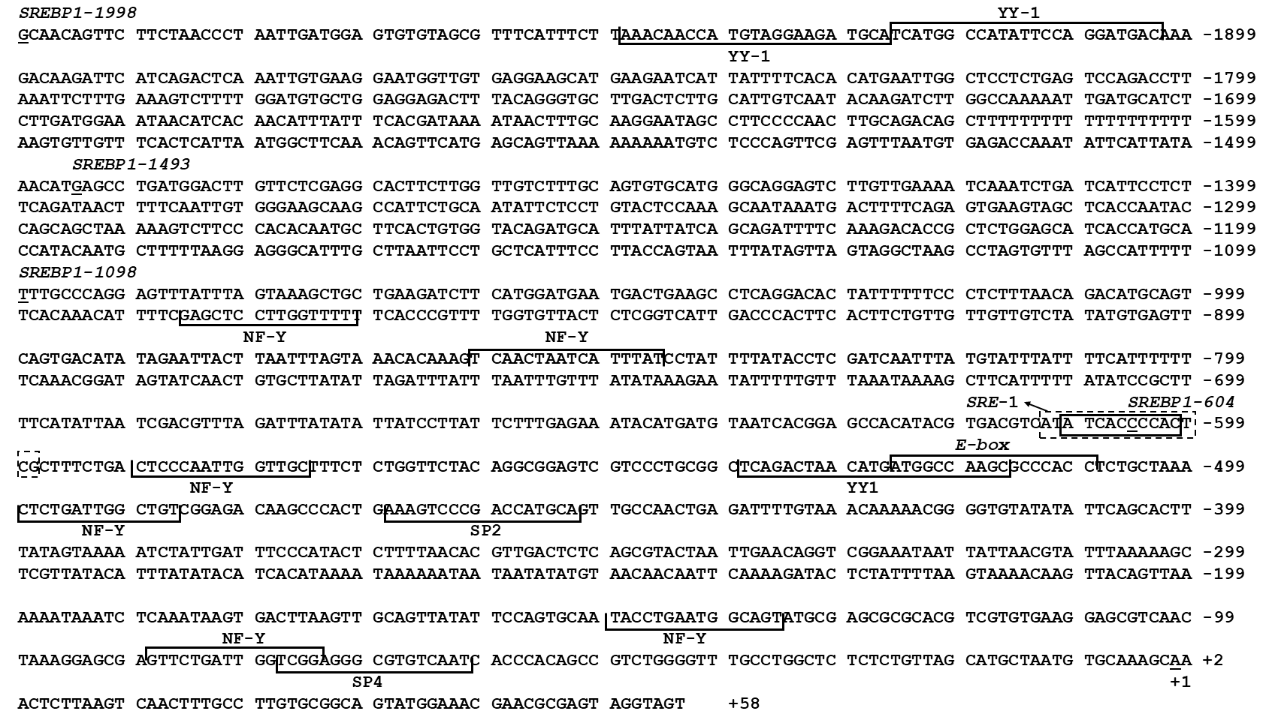
Figure S1. Nucleotide sequence of the promoter region of srebp-1 gene. +1 denotes the transcription start site (TSS) obtained from RLM-5’RACE experiment. Number on the right of the sequence means the distance to the TSS. The highlighted sequences show putative transcription factor binding sites of srebp-1 promoter region. Dotted box presents putative SRE element on MatInpspector, and solid box presents putative SRE element on JASPAR.

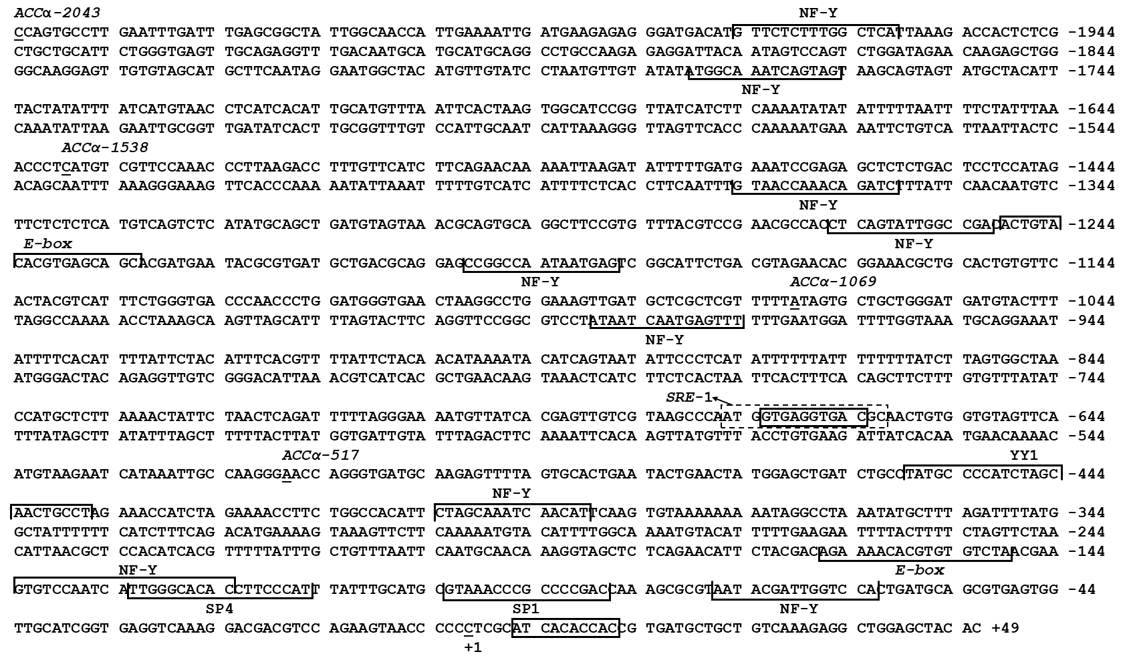
Figure S2. Nucleotide sequence of the promoter region of accα gene. +1 denotes the transcription start site (TSS) obtained from RLM-5’RACE experiment. Number on the right of the sequence means the distance to the TSS. The highlighted sequences show putative transcription factor binding sites of accα promoter region. Dotted box presents putative SRE element on MatInpspector, and solid box presents putative SRE element on JASPAR.

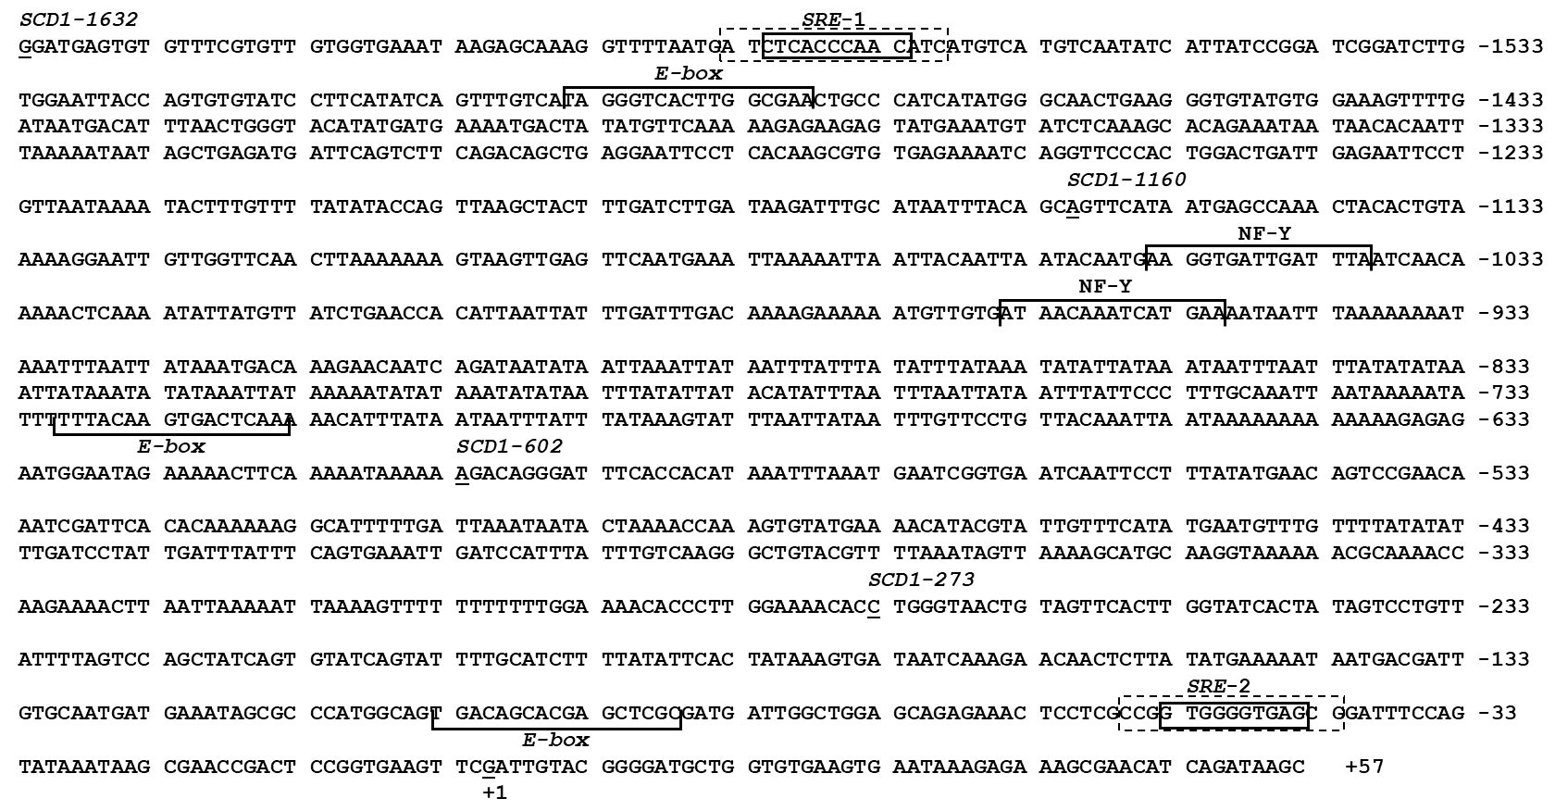
Figure S3. Nucleotide sequence of the promoter region of scd1 gene. +1 denotes the transcription start site (TSS) obtained from RLM-5’RACE experiment. Number on the right of the sequence means the distance to the TSS. The highlighted sequences show putative transcription factor binding sites of scd1 promoter region. Dotted box presents putative SRE element on MatInpspector, and solid box presents putative SRE element on JASPAR.

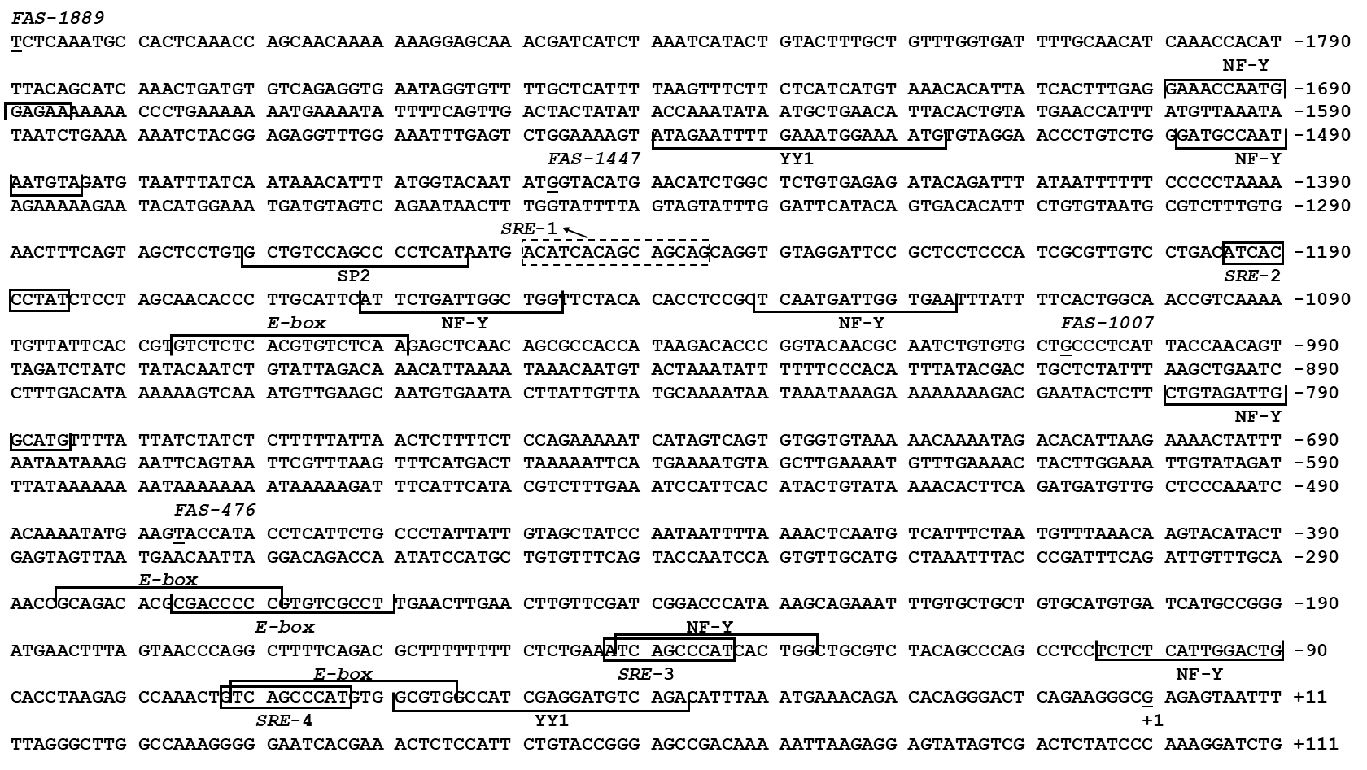
Figure S4. Nucleotide sequence of the promoter region of fas gene. +1 denotes the transcription start site (TSS) obtained from RLM-5’RACE experiment. Number on the right of the sequence means the distance to the TSS. The highlighted sequences show putative transcription factor binding sites of fas promoter region. Dotted box presents putative SRE element on MatInpspector, and solid box presents putative SRE element on JASPAR.

