Table S1. Raw data before and after standard quality control (QC) filters.
Sample ID | Reads | Bases | Paired End Reads | Post QC  Sequences | Post QC  Mean Length
L1 | 281710 | 84794710 | 140855 | 103473 | 454.64
L2 | 247116 | 74381916 | 123558 | 101931 | 454.06
L3 | 250318 | 75345718 | 125159 | 101203 | 452.04
L4 | 274438 | 82605838 | 137219 | 107348 | 453.63
L6 | 240516 | 72395316 | 120258 | 92697 | 455.23
L7 | 259144 | 78002344 | 129572 | 99681 | 450.87
L8 | 264204 | 79525404 | 132102 | 95270 | 455.08
L9 | 440768 | 132671168 | 220384 | 155654 | 456.17
L10 | 412840 | 124264840 | 206420 | 148954 | 453.07
N2 | 377040 | 113489040 | 188520 | 145534 | 453.33
N3 | 367228 | 110535628 | 183614 | 148897 | 455.45
N4 | 416144 | 125259344 | 208072 | 162650 | 454.81
N5 | 460426 | 138588226 | 230213 | 153685 | 454.61
N7 | 481376 | 144894176 | 240688 | 191280 | 455.93
N9 | 129292 | 38916892 | 64646 | 51311 | 451.75
N10 | 138594 | 41716794 | 69297 | 51881 | 456.92
N11 | 137688 | 41444088 | 68844 | 50985 | 456.47
N12 | 138142 | 41580742 | 69071 | 57901 | 453.96
N13 | 144560 | 43512560 | 72280 | 54202 | 453.13
O1 | 147820 | 44493820 | 73910 | 56389 | 456.28
O2 | 186966 | 56276766 | 93483 | 70179 | 451.33
O3 | 126816 | 38171616 | 63408 | 46403 | 455.62
O4 | 131106 | 39462906 | 65553 | 53250 | 454.64
O5 | 127140 | 38269140 | 63570 | 45012 | 455.76
O6 | 98490 | 29645490 | 49245 | 30409 | 456.06
O8 | 99438 | 29930838 | 49719 | 37916 | 454.98
O9 | 119280 | 35903280 | 59640 | 52428 | 456.35
O10 | 152976 | 46045776 | 76488 | 60209 | 455.64

Table S2. Quantification of Firmicutes and Bacteroidetes by qPCR expressed as log10 copies/g faces
 | Lean | Normal | Overweight/obesity | P-values
Firmicutes ª | 11.92±1.87 | 12.77±1.47 | 10.92±3.90 | 0.874
Bacteroidetes ª | 15.63±2.46 | 16.70±1.84 | 14.29±5.20 | 0.651
Firmicutes/Bacteroidetes ª | 0.7641±0.0323 | 0.7656±0.0408 | 0.7692±0.0374 | 0.844
a：Mean±SD

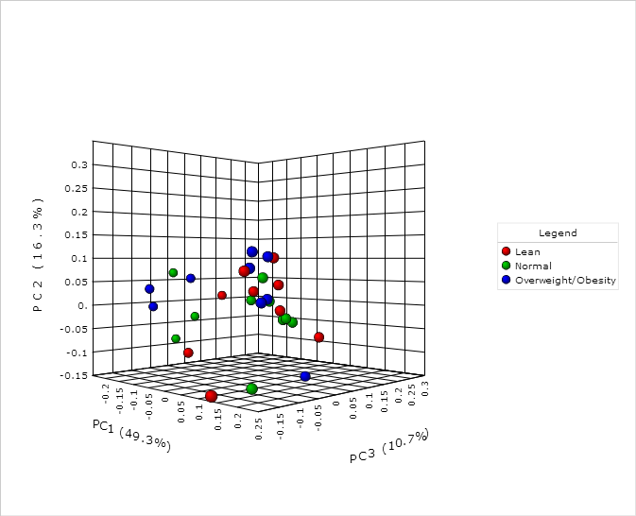
Figure S1. the weighted UniFrac principal coordinates analysis (PCOA)

