Supplementary Material 1. Characteristics of participants and non-participants

Table 4. Characteristics of participants and non-participants (n=866).
 | Total  (n=866) | Participation
 |  | No  (n=66) |  | Yes  (n=800) |  | p
 | n | n | % | n | %
District |  |  |  |  |  | 0.121
Firdavsi | 508 | 28 | 5.5 | 480 | 94.5
Shohmansour | 214 | 23 | 10.8 | 191 | 89.3
Sino | 103 | 13 | 12.6 | 90 | 87.4
Somoni | 41 | 2 | 4.9 | 39 | 95.1
Market |  |  |  |  |  | 0.229
Shohmansour | 214 | 23 | 10.8 | 191 | 89.3
Korvon | 198 | 5 | 2.5 | 193 | 97.5
Sakhovat | 153 | 15 | 9.8 | 138 | 90.2
Sultoni Kabir | 81 | 1 | 1.2 | 80 | 98.8
46th Microregion | 47 | 1 | 2.1 | 46 | 97.9
Zarafshon | 44 | 7 | 15.9 | 37 | 84.1
Varzob | 41 | 1 | 2.0 | 4.88 | 95.1
Kariyai-Bolo | 32 | 6 | 18.8 | 26 | 81.3
Yakkachinor | 29 | 6 | 20.7 | 23 | 79.3
Mirzokhuja | 27 | 0 | 0.0 | 27 | 100.0
Type of vendor |  |  |  |  |  | 0.005
Stationary | 737 | 64 | 8.7 | 673 | 91.3
Mobile | 129 | 2 | 1.6 | 127 | 98.5
Physical setup (stationary) |  |  |  |  |  | 0.658
Bench with tableboard | 194 | 19 | 9.8 | 175 | 90.2
Dukoni | 185 | 14 | 7.6 | 171 | 92.4
Stand, stall or booth | 101 | 11 | 10.9 | 90 | 89.1
Table with chairs for customers | 75 | 6 | 8.0 | 69 | 92.0
On the ground | 60 | 2 | 3.3 | 58 | 96.7
Soft ice-cream machine or freezer | 54 | 3 | 5.6 | 51 | 94.4
Truck | 45 | 5 | 11.1 | 40 | 88.9
Push cart | 23 | 4 | 17.4 | 19 | 82.6

Supplementary Material 2. Description of the homemade street foods collected in Dushanbe, Tajikistan

1. Baklava  Sweet pastry dessert made of filo layers, chopped nuts and syrup or honey. | 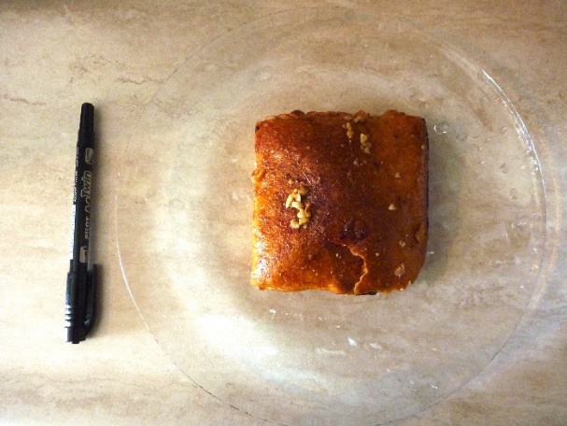
2. Belyashi  Traditional small meat pie, filled with minced meat and/or vegetables | 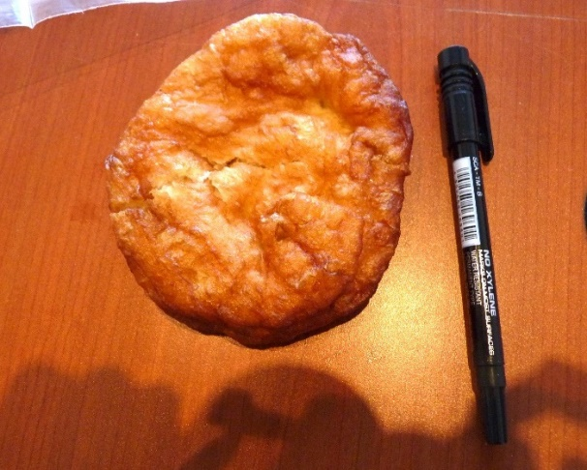
3. Bread (chapoti) | 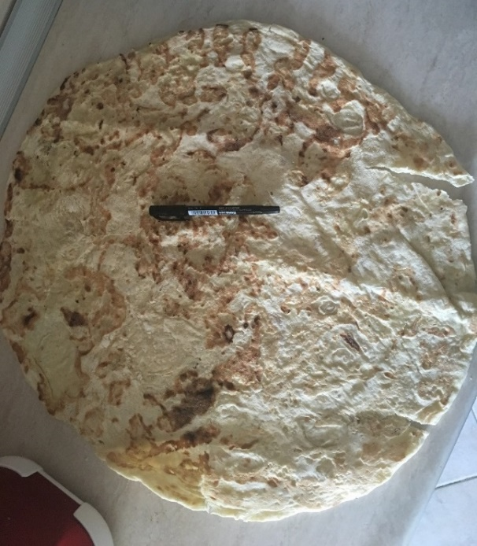
4. Bread (dark wheat) | 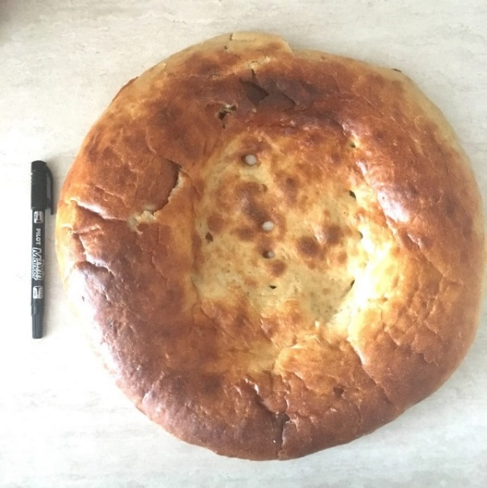
5. Bread (fatir) | 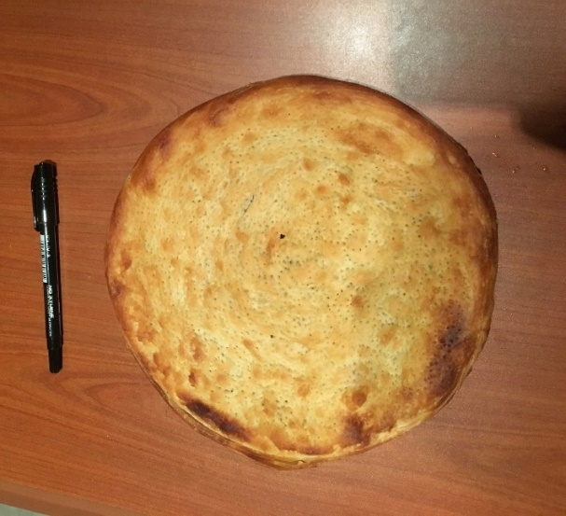
6. Bread (girdacha) | 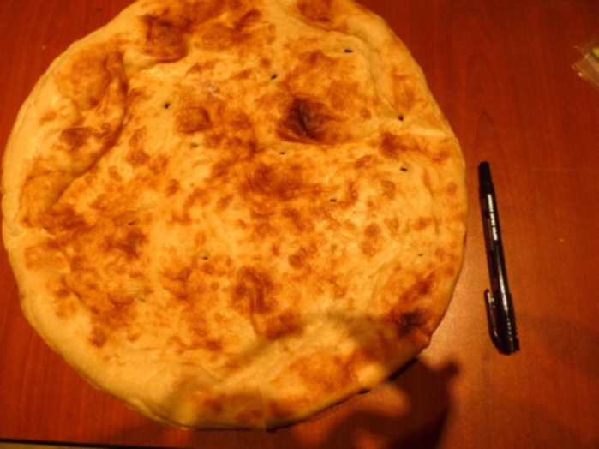
7. Bread (kulcha) | 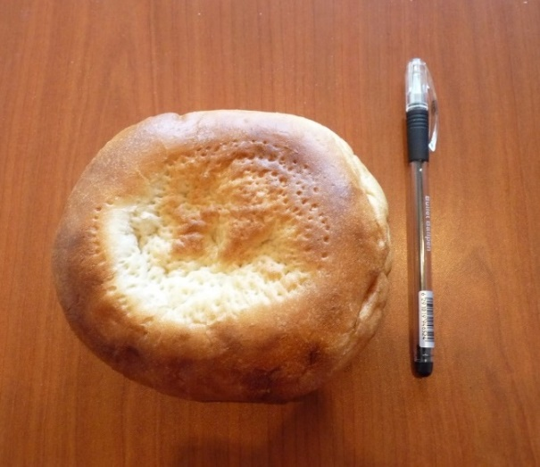
8. Bread (lepyoshka) | 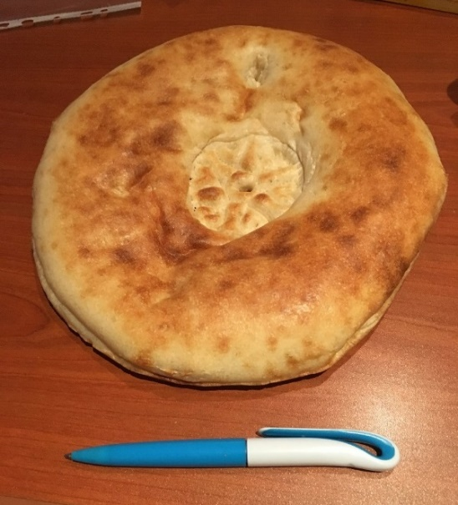
9. Bread (samarkand) | 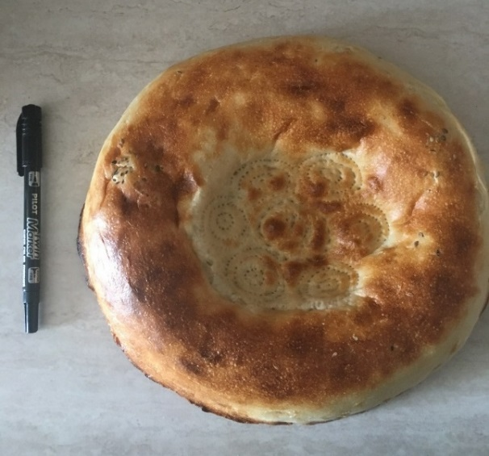
10. Bun | 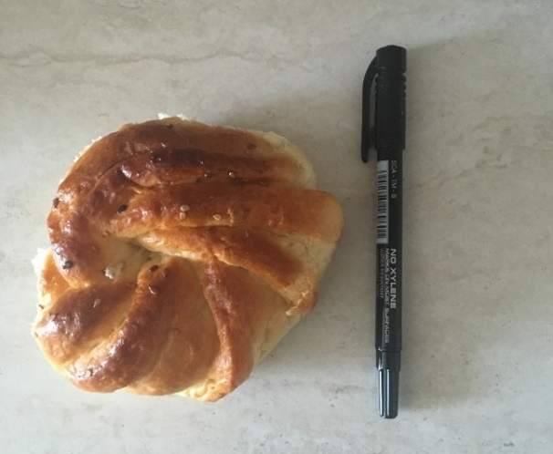
11. Cake | 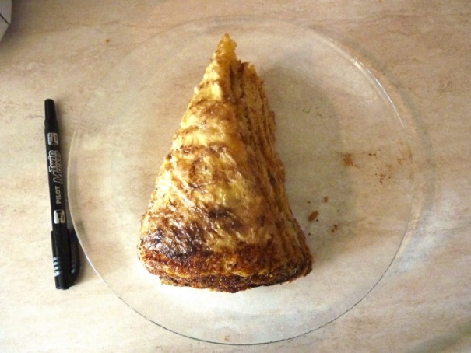
12. Chebureki  Traditional fried savoury pastry, usually filled with  ground or minced meat and onions. | 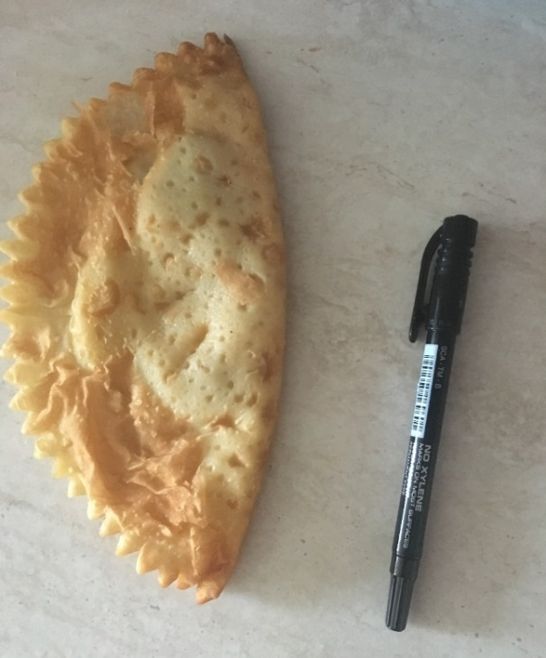
13. Fried fish | 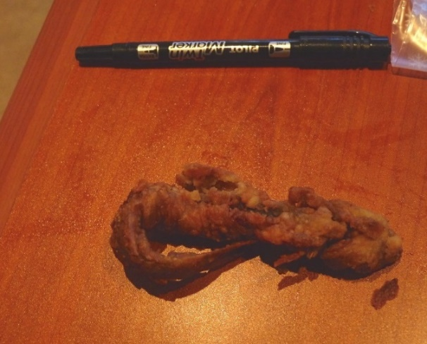
14. Fried potatoes | 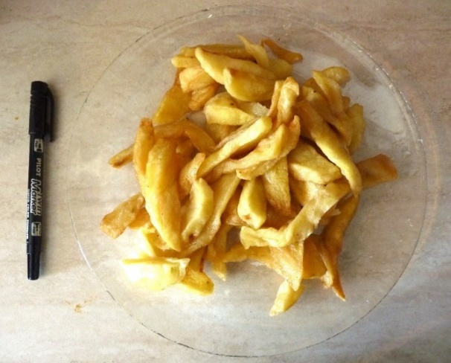
15. Hamburger | 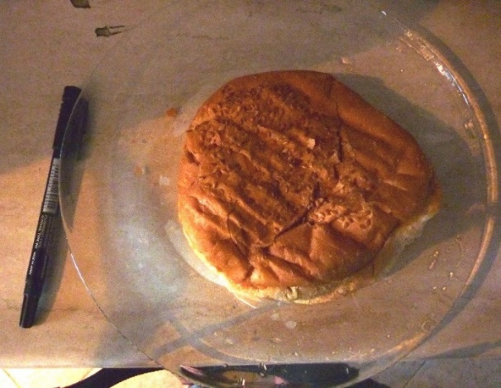
16. Hot-dog | 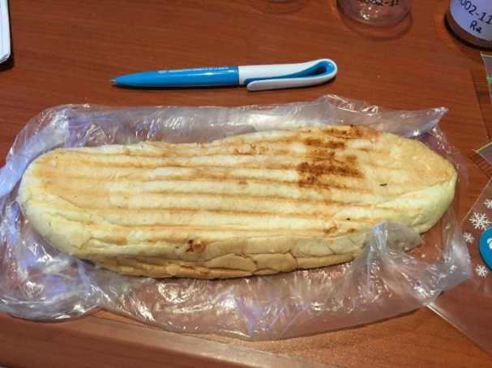
17. Ice-cream | 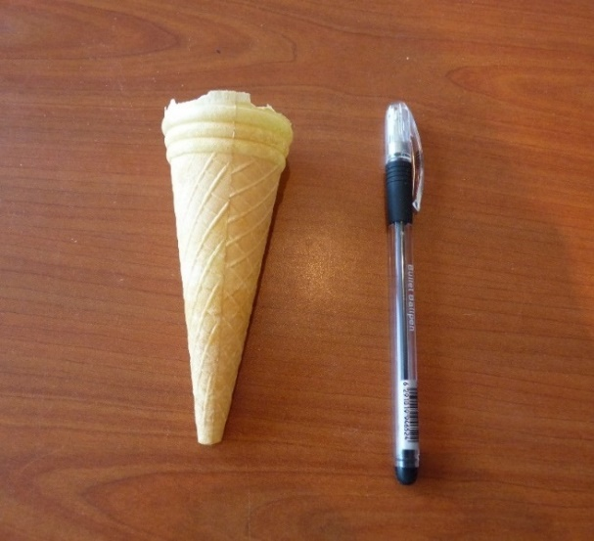
18. Kurut  Salty snack made by straining and drying sour milk or yoghurt. | 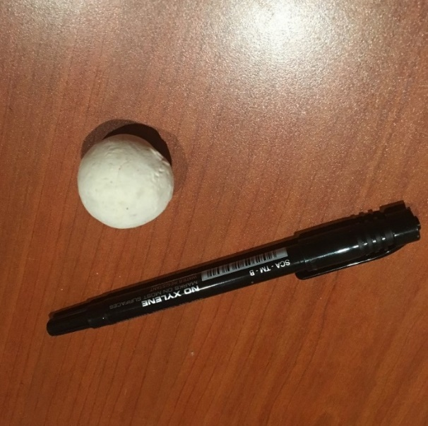
19. Piroshky  Baked pie made from yeast dough, usually stuffed with meat (typically beef) or vegetables. | 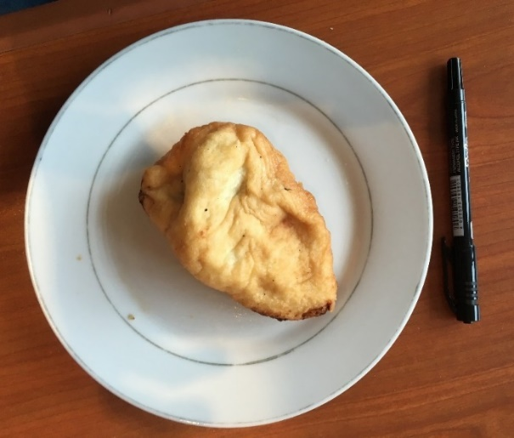
20. Plov  Rice cooked in a seasoned broth with a mixture of spices, vegetables and other ingredients, such as meat, fish and/or dried fruit. | 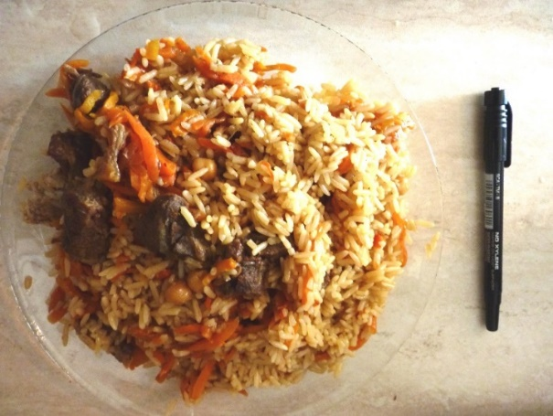
21. Sambusa  Minced meat (lamb, beef or  chicken) and vegetables  wrapped in flaky pastry or bread. | 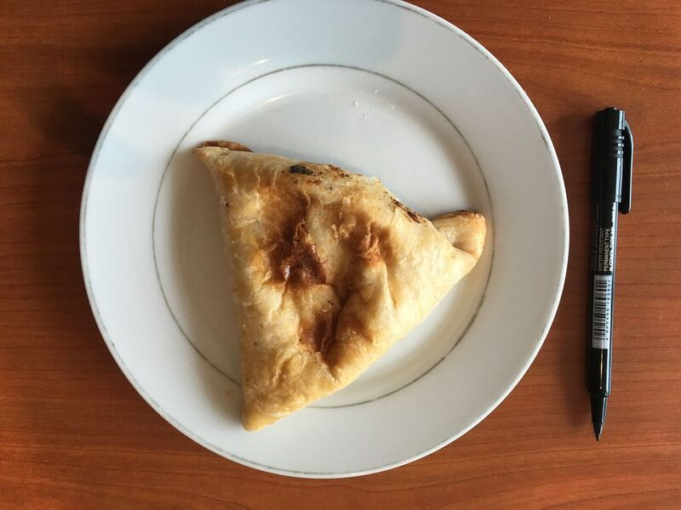
22. Sausage bun | 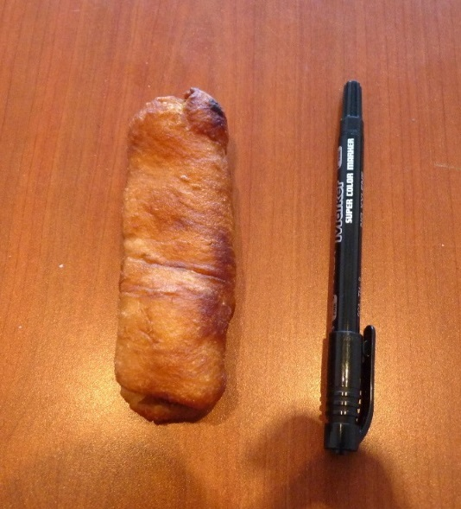
23. Shawarma | 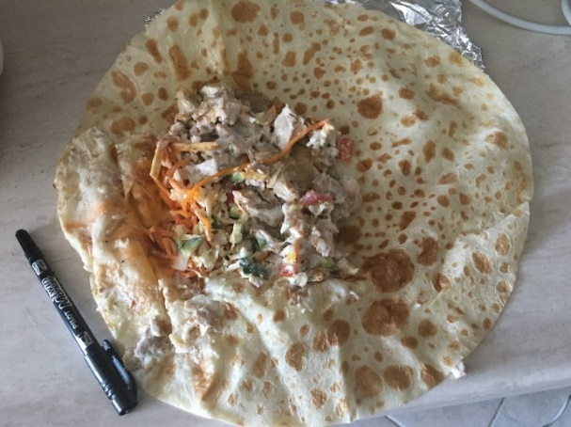
24. Soup | 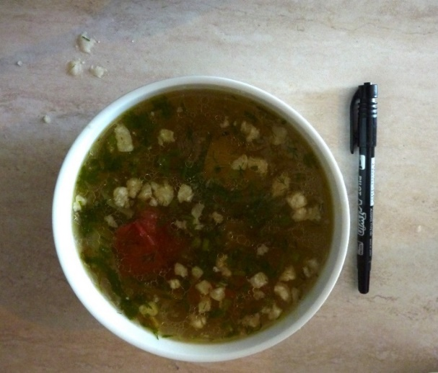
25. Sweet pastry | 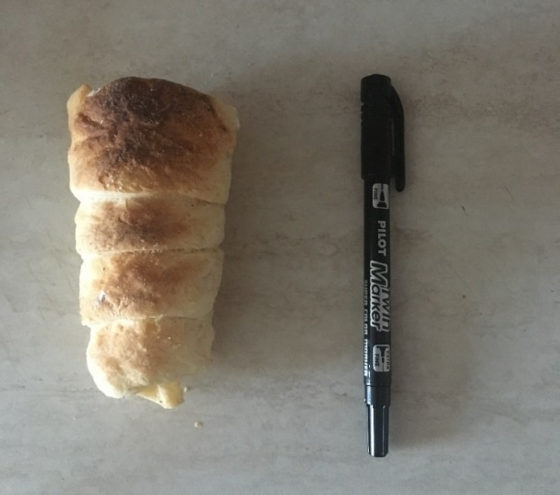

Table 5. Nutritional composition (energy and macronutrients) of the street food samples evaluated by proximate analysis, per 100g.
Industrial food | N | Mean serving size (min–max)  (g/100 g) |  |  | Mean energy (min–max)  (kcal/100 g) |  |  | Mean protein (min–max) (g/100 g) |  |  | Mean carbohydrates (min–max)  (g/100 g) |  |  | Mean total fat (min–max) (g/100 g) |  |  | Mean water (min–max) (g/100 g)
Biscuit rolls | 3 | 57 | (55 | - 61) | 384.7 | (350.0 | -449.4) | 6.4 | (4.5 | -8.3) | 68.7 | (63.2 | -71.5) | 9.4 | (4.8 | -16.2) | 14.3 | (6.5 | -19.9)
Bread | 3 | 50 | (50 | - 50) | 260.1 | (243.3 | -274.0) | 8.5 | (8.1 | -9.0) | 54.5 | (51.6 | -56.5) | 0.9 | (0.3 | -1.7) | 34.1 | (31.6 | -37.9)
Chips | 3 | 20 | (20 | - 20) | 515.0 | (503.6 | -533.6) | 5.2 | (3.8 | -7.6) | 58.3 | (55.3 | -63.6) | 29.0 | (25.9 | -31.0) | 3.3 | (1.3 | -5.0)
Chocolate | 4 | 54 | (25 | - 95) | 485.7 | (426.8 | -534.3) | 4.8 | (2.5 | -8.7) | 69.7 | (60.0 | -80.3) | 20.8 | (10.0 | -29.1) | 2.8 | (1.2 | -4.7)
Cookies | 4 | 33 | (29 | - 39) | 466.2 | (443.3 | -506.6) | 5.9 | (4.7 | -6.9) | 68.2 | (66.0 | -71.1) | 18.9 | (15.6 | -24.7) | 6.0 | (3.4 | -7.6)
Corn snacks | 4 | 38 | (38 | - 38) | 446.6 | (412.8 | -499.5) | 3.7 | (3.2 | -4.5) | 76.2 | (69.1 | -80.9) | 14.1 | (8.5 | -23.4) | 5.7 | (4.0 | -7.1)
Croutons | 3 | 39 | (37 | - 41) | 395.1 | (379.4 | -421.4) | 11.4 | (10.9 | -12.1) | 72.8 | (69.7 | -74.5) | 6.5 | (4.2 | -11.0) | 4.9 | (3.5 | -6.3)
Sunflower seeds | 4 | 53 | (50 | - 60) | 517.8 | (477.5 | -549.9) | 14.4 | (10.4 | -47.5) | 39.9 | (31.0 | -50.1) | 33.4 | (27.1 | -40.3) | 2.7 | (2.2 | -3.3)
Sweet pastries | 4 | 51 | (33 | - 61) | 440.0 | (408.3 | -509.9) | 6.9 | (5.1 | -8.4) | 60.3 | (58.6 | -63.1) | 19.0 | (16.0 | -27.2) | 12.9 | (5.8 | -18.3)
Wafers | 3 | 107 | (101 | - 111) | 525.4 | (515.1 | -543.9) | 3.9 | (3.1 | -4.3) | 66.5 | (63.3 | -68.6) | 27.1 | (25.1 | -30.4) | 1.9 | (1.3 | -2.8)
Homemade food
Baklava | 4 | 88 | (57 | - 100) | 433.1 | (421.6 | -447.5) | 12.2 | (8.7 | -13.9) | 57.1 | (54.7 | -59.3) | 17.3 | (15.2 | -18.9) | 12.3 | (11.0 | -13.3)
Belyashi | 4 | 81 | (65 | - 97) | 268.9 | (259.5 | -286.4) | 7.3 | (6.7 | -8.4) | 38.8 | (37.3 | -42.0) | 9.3 | (6.9 | -11.0) | 42.7 | (39.9 | -44.7)
Bread (chapoti) | 4 | 120 | (120 | - 120) | 287.4 | (282.8 | -298.0) | 10.1 | (9.5 | -10.9) | 61.3 | (60.3 | -63.2) | 0.2 | (0.2 | -0.2) | 26.3 | (23.3 | -27.6)
Bread (dark wheat) | 4 | 120 | (120 | - 120) | 277.1 | (267.9 | -289.5) | 12.0 | (10.6 | -12.6) | 56.7 | (55.0 | -59.2) | 0.3 | (0.2 | -0.4) | 29.1 | (26.0 | -31.3)
Bread (fatir) | 4 | 120 | (120 | - 120) | 317.5 | (303.5 | -336.0) | 9.7 | (8.9 | -10.5) | 55.5 | (50.1 | -61.2) | 6.3 | (3.1 | -8.6) | 26.9 | (23.8 | -31.4)
Bread (girdacha) | 4 | 120 | (120 | - 120) | 271.6 | (266.6 | -277.1) | 10.5 | (8.9 | -12.3) | 56.5 | (55.2 | -58.2) | 0.4 | (0.1 | -0.7) | 30.9 | (29.3 | -32.7)
Bread (kulcha) | 4 | 137 | (114 | - 185) | 309.4 | (286.2 | -325.9) | 10.1 | (9.1 | -11.0) | 58.9 | (54.8 | -62.9) | 3.7 | (2.6 | -5.0) | 25.1 | (20.7 | -29.9)
Bread (lepyoshka) | 4 | 120 | (120 | - 120) | 274.0 | (264.0 | -280.6) | 10.6 | (10.0 | -11.1) | 57.5 | (54.5 | -59.5) | 0.2 | (0.1 | -0.3) | 30.1 | (28.3 | -32.6)
Bread (samarkand) | 4 | 120 | (120 | - 120) | 283.4 | (274.3 | -302.5) | 11.0 | (10.5 | -11.5) | 56.8 | (56.2 | -57.5) | 1.4 | (0.5 | -3.9) | 28.6 | (27.0 | -29.7)
Cake | 4 | 125 | (86 | - 180) | 305.4 | (288.3 | -318.0) | 8.8 | (6.9 | -9.8) | 59.3 | (52.8 | -63.7) | 3.7 | (1.4 | -7.1) | 27.6 | (23.7 | -32.6)
Chebureki | 4 | 91 | (73 | - 104) | 406.9 | (371.1 | -466.3) | 7.0 | (6.7 | -7.7) | 54.4 | (48.2 | -63.0) | 17.9 | (15.4 | -23.3) | 19.9 | (11.8 | -27.3)
Fried fish | 4 | 96 | (60 | - 144) | 208.8 | (129.5 | -283.0) | 5.5 | (3.3 | -6.8) | 26.7 | (16.5 | -35.2) | 8.9 | (5.6 | -13.0) | 56.8 | (43.8 | -73.0)
Fried potatoes | 4 | 226 | (215 | - 234) | 337.1 | (170.7 | -491.7) | 24.8 | (21.2 | -27.7) | 10.2 | (1.2 | -16.1) | 21.9 | (7.5 | -35.2) | 35.8 | (10.7 | -62.6)
Hamburger | 4 | 204 | (188 | - 218) | 227.9 | (204.4 | -277.1) | 4.0 | (3.2 | -4.7) | 30.9 | (27.4 | -37.0) | 9.8 | (8.2 | -12.2) | 52.2 | (42.5 | -57.9)
Hot dog | 4 | 186 | (141 | - 218) | 210.3 | (168.3 | -258.3) | 8.0 | (6.7 | -9.8) | 28.3 | (26.7 | -31.1) | 7.2 | (3.0 | -12.0) | 54.9 | (48.5 | -59.9)
Ice cream | 4 | 48 | (41 | - 55) | 189.3 | (173.0 | -205.7) | 7.1 | (6.1 | -8.1) | 26.3 | (20.7 | -29.5) | 6.2 | (3.8 | -10.9) | 58.5 | (56.8 | -60.7)
Kurut | 4 | 18 | (14 | - 25) | 129.7 | (123.0 | -136.3) | 3.1 | (2.6 | -3.9) | 24.0 | (20.1 | -28.8) | 2.4 | (1.1 | -4.1) | 69.8 | (66.7 | -72.3)
Piroshky | 4 | 59 | (44 | - 73) | 329.0 | (284.2 | -443.8) | 33.1 | (15.6 | -40.3) | 20.7 | (7.6 | -50.7) | 12.6 | (2.3 | -27.7) | 23.2 | (18.9 | -31.9)
Plov | 4 | 491 | (315 | - 646) | 299.0 | (264.0 | -330.4) | 7.0 | (6.6 | -7.9) | 42.4 | (38.4 | -45.2) | 11.3 | (9.4 | -13.1) | 38.0 | (32.9 | -44.3)
Sambusa | 4 | 94 | (84 | - 102) | 173.9 | (163.3 | -182.6) | 5.1 | (4.4 | -5.5) | 25.3 | (21.5 | -27.9) | 5.8 | (4.2 | -7.1) | 62.4 | (61.1 | -65.6)
Sausage bun | 4 | 50 | (45 | - 57) | 238.4 | (207.5 | -281.6) | 8.8 | (7.6 | -9.8) | 37.4 | (34.0 | -40.1) | 6.0 | (2.4 | -11.9) | 46.0 | (42.8 | -48.9)
Shawarma /Doner Kebab | 4 | 277 | (256 | - 304) | 223.0 | (195.9 | -242.2) | 8.1 | (7.1 | -8.6) | 25.4 | (18.8 | -33.3) | 9.9 | (7.5 | -15.0) | 54.4 | (49.6 | -57.9)
Soup | 4 | 632 | (508 | - 781) | 222.6 | (161.8 | -288.0) | 11.1 | (9.2 | -14.4) | 17.8 | (15.6 | -19.5) | 11.9 | (6.9 | -17.5) | 57.3 | (48.0 | -66.0)
Sweet bun | 4 | 60 | (48 | - 73) | 77.8 | (44.2 | -111.6) | 7.1 | (2.9 | -11.4) | 3.8 | (0.5 | -7.7) | 3.8 | (1.7 | -6.5) | 83.9 | (75.2 | -89.6)
Sweet pastries | 3 | 39 | (39 | - 39) | 378.1 | (282.9 | -459.6) | 7.2 | (6.1 | -9.2) | 50.0 | (34.0 | -60.2) | 16.6 | (12.7 | -23.6) | 25.3 | (13.8 | -45.3)
Supplementary Material 3. Nutritional Composition of the street food samples evaluated by proximate analysis, per 100g.
Table 6. Nutritional composition (fatty acid profile) of the street food samples evaluated by proximate analysis, per 100g.
Industrial food | N | Mean serving size (min–max)  (g/100 g) |  |  | Mean SFA (min–max)  (g/100 g) |  |  | Mean MUFA (min–max)  (g/100 g) |  |  | Mean PUFA (min–max)  (g/100 g) |  |  | Mean n-6 (min–max)  (g/100 g) |  |  | Mean n-3 (min–max)  (g/100 g) |  |  | Mean TFA (min–max)  (g/100 g)
Biscuit rolls | 3 | 57 | (55 | - 61) | 3.7 | (0.9 | - 4.0) | 1.8 | (0.9 | - 3.4) | 1.0 | (0.8 | - 1.2) | 0.9 | (0.7 | - 1.2) | 0.1 | (0.0 | - 0.1) | 0.4 | (0.1 | - 1.0)
Bread | 3 | 50 | (50 | - 50) | 0.2 | (0.0 | - 0.2) | 0.1 | (0.0 | - 0.2) | 0.2 | (0.1 | - 0.4) | 0.2 | (0.1 | - 0.4) | 0.0 | (0.0 | - 0.0) | 0.0 | (0.0 | - 0.0)
Chips | 3 | 20 | (20 | - 20) | 5.9 | (0.7 | - 2.1) | 1.8 | (0.9 | - 3.3) | 2.7 | (0.7 | - 4.1) | 2.7 | (0.7 | - 4.1) | 0.0 | (0.0 | - 0.0) | 0.1 | (0.0 | - 0.1)
Chocolate | 4 | 54 | (25 | - 95) | 12.4 | (3.0 | - 9.6) | 4.0 | (0.1 | - 11.4) | 0.56 | (0.1 | - 1.5) | 0.5 | (0.0 | - 1.4) | 0.0 | (0.0 | - 0.1) | 0.0 | (0.0 | - 0.1)
Cookies | 4 | 33 | (29 | - 39) | 7.8 | (1.3 | - 4.1) | 2.0 | (1.2 | - 3.6) | 1.3 | (0.4 | - 1.9) | 1.2 | (0.4 | - 1.8) | 0.0 | (0.0 | - 0.1) | 0.3 | (0.0 | - 0.8)
Corn snacks | 4 | 38 | (38 | - 38) | 2.0 | (0.4 | - 1.1) | 1.0 | (0.6 | - 1.5) | 3.5 | (2.1 | - 6.2) | 3.5 | (2.1 | - 6.2) | 0.0 | (0.0 | - 0.0) | 0.0 | (0.0 | - 0.0)
Croutons | 3 | 39 | (37 | - 41) | 1.0 | (0.2 | - 0.7) | 0.6 | (0.4 | - 1.0) | 1.5 | (0.9 | - 2.8) | 1.5 | (0.9 | - 2.7) | 0.0 | (0.0 | - 0.0) | 0.0 | (0.0 | - 0.0)
Sunflower seeds | 4 | 53 | (50 | - 60) | 4.2 | (1.6 | - 2.7) | 4.3 | (3.7 | - 5.2) | 11.0 | (7.9 | - 13.6) | 10.9 | (7.9 | - 13.5) | 0.0 | (0.0 | - 0.0) | 0.0 | (0.0 | - 0.0)
Sweet pastries | 4 | 51 | (33 | - 61) | 5.9 | (1.7 | - 4.5) | 3.0 | (1.2 | - 5.2) | 3.1 | (1.0 | - 8.4) | 3.0 | (1.0 | - 8.3) | 0.0 | (0.0 | - 0.0) | 0.8 | (0.5 | - 1.4)
Wafers | 3 | 107 | (101 | - 111) | 12.1 | (9.6 | - 17.1) | 9.7 | (8.5 | - 11.8) | 3.5 | (2.2 | - 5.9) | 3.5 | (2.1 | - 5.9) | 0.0 | (0.0 | - 0.1) | 2.5 | (1.8 | - 3.4)
Homemade food
Baklava | 4 | 88 | (57 | - 100) | 5.2 | (3.4 | - 5.3) | 5.5 | (3.1 | - 6.7) | 4.7 | (2.9 | - 6.0) | 4.4 | (2.5 | - 5.7) | 0.2 | (0.1 | - 0.4) | 0.3 | (0.3 | - 0.4)
Belyashi | 4 | 81 | (65 | - 97) | 2.7 | (0.8 | - 3.3) | 2.4 | (1.7 | - 3.1) | 2.8 | (0.8 | - 4.5) | 2.7 | (0.7 | - 4.5) | 0.1 | (0.0 | - 0.4) | 0.1 | (0.1 | - 0.2)
Bread (chapoti) | 4 | 120 | (120 | - 120) | 0.0 | (0.0 | - 0.1) | 0.0 | (0.0 | - 0.0) | 0.1 | (0.1 | - 0.2) | 0.1 | (0.1 | - 0.2) | 0.0 | (0.0 | - 0.0) | 0.0 | (0.0 | - 0.0)
Bread (dark wheat) | 4 | 120 | (120 | - 120) | 0.1 | (0.1 | - 0.1) | 0.1 | (0.0 | - 0.1) | 0.2 | (0.2 | - 0.3) | 0.2 | (0.1 | - 0.2) | 0.0 | (0.0 | - 0.0) | 0.0 | (0.0 | - 0.0)
Bread (fatir) | 4 | 120 | (120 | - 120) | 1.8 | (0.9 | - 3.1) | 1.8 | (0.8 | - 2.3) | 3.4 | (1.9 | - 4.7) | 3.2 | (1.9 | - 4.4) | 0.2 | (0.0 | - 0.3) | 0.1 | (0.0 | - 0.2)
Bread (girdacha) | 4 | 120 | (120 | - 120) | 0.1 | (0.0 | - 0.2) | 0.1 | (0.0 | - 0.1) | 0.3 | (0.1 | - 0.5) | 0.3 | (0.1 | - 0.5) | 0.0 | (0.0 | - 0.0) | 0.0 | (0.0 | - 0.0)
Bread (kulcha) | 4 | 137 | (114 | - 185) | 1.2 | (0.9 | - 3.1) | 1.5 | (0.7 | - 2.7) | 1.8 | (0.8 | - 3.2) | 1.8 | (0.7 | - 3.1) | 0.0 | (0.0 | - 0.1) | 0.0 | (0.0 | - 0.0)
Bread (lepyoshka) | 4 | 120 | (120 | - 120) | 0.0 | (0.0 | - 0.1) | 0.0 | (0.0 | - 0.0) | 0.1 | (0.1 | - 0.2) | 0.1 | (0.1 | - 0.2) | 0.0 | (0.0 | - 0.0) | 0.0 | (0.0 | - 0.0)
Bread (samarkand) | 4 | 120 | (120 | - 120) | 0.3 | (0.1 | - 1.2) | 0.4 | (0.1 | - 1.1) | 0.8 | (0.3 | - 2.3) | 0.8 | (0.3 | - 2.3) | 0.0 | (0.0 | - 0.0) | 0.0 | (0.0 | - 0.0)
Cakes | 4 | 125 | (86 | - 180) | 1.6 | (3.6 | - 8.0) | 5.8 | (5.0 | - 7.0) | 6.2 | (0.1 | - 12.8) | 6.1 | (0.0 | - 12.7) | 0.1 | (0.0 | - 0.1) | 1.8 | (0.4 | - 2.7)
Chebureki | 4 | 91 | (73 | - 104) | 4.6 | (0.9 | - 6.5) | 2.3 | (0.9 | - 5.0) | 2.6 | (1.1 | - 3.6) | 2.6 | (1.0 | - 3.6) | 0.0 | (0.0 | - 0.0) | 0.1 | (0.1 | - 0.2)
Fried fish | 4 | 96 | (60 | - 144) | 3.1 | (1.5 | - 5.6) | 4.8 | (2.0 | - 6.7) | 7.8 | (6.6 | - 9.0) | 6.6 | (5.6 | - 7.8) | 0.3 | (0.0 | - 0.7) | 0.2 | (0.0 | - 0.3)
Fried potatoes | 4 | 226 | (215 | - 234) | 5.6 | (2.9 | - 8.6) | 5.5 | (4.0 | - 7.8) | 11.3 | (2.0 | - 18.6) | 11.1 | (1.9 | - 18.4) | 0.1 | (0.1 | - 0.1) | 0.2 | (0.1 | - 0.4)
Hamburger | 4 | 204 | (188 | - 218) | 2.2 | (1.4 | - 6.2) | 3.9 | (1.8 | - 6.8) | 6.6 | (3.1 | - 9.0) | 6.4 | (3.0 | - 8.7) | 0.1 | (0.1 | - 0.2) | 0.1 | (0.1 | - 0.3)
Hot dog | 4 | 186 | (141 | - 218) | 1.7 | (1.4 | - 3.9) | 3.0 | (1.8 | - 5.3) | 6.5 | (2.7 | - 14.5) | 6.3 | (2.5 | - 14.3) | 0.1 | (0.1 | - 0.2) | 0.1 | (0.0 | - 0.2)
Ice cream | 4 | 48 | (41 | - 55) | 1.2 | (0.3 | - 1.2) | 0.3 | (0.1 | - 0.6) | 0.1 | (0.0 | - 0.2) | 0.1 | (0.0 | - 0.2) | 0.0 | (0.0 | - 0.0) | 0.0 | (0.0 | - 0.1)
Kurut | 4 | 18 | (14 | - 25) | 1.4 | (0.2 | - 2.1) | 0.6 | (0.1 | - 1.2) | 0.1 | (0.1 | - 0.2) | 0.0 | (0.0 | - 0.1) | 0.0 | (0.0 | - 0.1) | 0.1 | (0.0 | - 0.1)
Piroshky | 4 | 59 | (44 | - 73) | 7.1 | (1.4 | - 2.7) | 1.7 | (1.0 | - 2.3) | 3.0 | (0.6 | - 6.2) | 2.9 | (0.6 | - 6.1) | 0.0 | (0.0 | - 0.0) | 0.1 | (0.0 | - 0.1)
Plov | 4 | 491 | (315 | - 646) | 3.2 | (4.7 | - 22.0) | 7.8 | (4.7 | - 15.3) | 9.5 | (6.5 | - 13.0) | 7.6 | (4.6 | - 11.0) | 1.8 | (0.5 | - 2.8) | 0.4 | (0.1 | - 0.8)
Sambusa | 4 | 94 | (84 | - 102) | 2.1 | (1.2 | - 3.6) | 1.4 | (0.7 | - 2.6) | 1.5 | (0.4 | - 3.4) | 1.5 | (0.3 | - 3.3) | 0.0 | (0.0 | - 0.0) | 0.1 | (0.1 | - 0.2)
Sausage bun | 4 | 50 | (45 | - 57) | 2.4 | (0.7 | - 1.1) | 1.3 | (1.0 | - 1.7) | 2.5 | (1.9 | - 3.9) | 2.5 | (1.8 | - 3.9) | 0.0 | (0.0 | - 0.1) | 0.0 | (0.0 | - 0.1)
Shawarma/Doner Kebab | 4 | 277 | (256 | - 304) | 1.9 | (6.3 | - 8.9) | 10.8 | (9.3 | - 13.1) | 13.9 | (4.3 | - 24.2) | 13.6 | (4.1 | - 23.9) | 0.2 | (0.2 | - 0.2) | 0.1 | (0.1 | - 0.2)
Soup | 4 | 632 | (508 | - 781) | 2.7 | (4.8 | - 24.3) | 8.6 | (4.0 | - 19.4) | 2.7 | (0.9 | - 7.4) | 2.6 | (0.7 | - 7.3) | 0.1 | (0.1 | - 0.2) | 1.2 | (0.4 | - 2.6)
Sweet bun | 4 | 60 | (48 | - 73) | 1.6 | (0.2 | - 2.2) | 0.7 | (0.2 | - 1.5) | 0.5 | (0.4 | - 0.5) | 0.4 | (0.4 | - 0.5) | 0.0 | (0.0 | - 0.0) | 0.0 | (0.0 | - 0.1)
Sweet pastries | 3 | 39 | (39 | - 39) | 6.3 | (1.4 | - 3.8) | 1.7 | (1.0 | - 2.5) | 1.9 | (0.6 | - 2.8) | 1.8 | (0.6 | - 2.6) | 0.1 | (0.0 | - 0.2) | 0.4 | (0.1 | - 0.6)
SFA, saturated fatty acids. MUFA, monounsaturated fatty acids. PUFA, polyunsaturated fatty acids. TFA, trans fatty acids.

Supplementary Material 4. Characteristics of street food vendors, vending sites and food availability in Dushanbe, Tajikistan

Table 7. Characteristics of street food vendors, vending sites and food availability, by type of vending site in Dushanbe, Tajikistan.
 | Total (n=800) |  | Stationary (n=673) |  | Mobile (n=127) |  | p
Food Vendor characteristics | n | % | n | % | n | %
Sex (women) | 493 | 61.6 | 416 | 61.8 | 77 | 60.6 | 0.799
Owner (yes) | 539 | 67.4 | 436 | 64.8 | 103 | 81.1 | 0.050
Vending sites characteristics
Access to drinking water | 787 | 98.4 | 664 | 98.7 | 123 | 96.9 | 0.047
Access to toilet facility | 776 | 97.0 | 659 | 97.9 | 117 | 92.1 | 0.007
Food Availability
Fruit | 36 | 4.5 | 36 | 5.4 | 0 | 0.0 | 0.294
Food other than fruit | 699 | 87.4 | 583 | 86.6 | 116 | 91.3 | 0.018
Industrialª | 135 | 19.4 | 122 | 20.9 | 13 | 11.4 | 0.001
Homemade and Industrial ª | 119 | 17.1 | 115 | 19.7 | 4 | 3.5
Homemadeª | 443 | 63.6 | 346 | 59.4 | 97 | 85.1
Cooked^{b} | 460 | 81.9 | 373 | 80.9 | 87 | 86.1 | 0.031
Prepared but uncooked ^{b} | 111 | 19.8 | 98 | 21.3 | 13 | 12.9 | 0.035
Unprepared and uncooked ^{b} | 35 | 6.2 | 31 | 6.7 | 4 | 4.0 | 0.138
Beverages | 324 | 40.5 | 308 | 45.8 | 16 | 12.6 | <0.001
ª For this variable, sample size is lower (n= 697)
^{b} The sum of the values for this variable is higher than the total number of homemade foods, as each vendor could have available foods prepared in different ways.

Table 8. Characteristics of the stationary street food vending sites by physical setups in Dushanbe, Tajikistan (n=673).
 | Total |  | Physical Setupª
 |  |  | Informal  (n=303) |  | Formal  (n=370) |  | p
Food vendor characteristics | n | % | n | % | n | %
Sex (women) | 416 | 61.8 | 206 | 68.0 | 210 | 56.8 | 0.064
Owner (yes) | 436 | 64.8 | 238 | 78.6 | 198 | 53.5 | <0.001
Business characteristics
Operating the whole week | 615 | 91.4 | 271 | 89.4 | 344 | 93.0 | 0.140
Operating the whole year | 477 | 70.9 | 219 | 77.3 | 258 | 69.7 | 0.613
Operating under every type of weather | 473 | 70.3 | 192 | 63.4 | 281 | 76.0 | 0.028
Hygiene and Food Safety
Access to electricity | 429 | 63.7 | 124 | 40.9 | 305 | 82.4 | <0.001
Access to drinking water | 664 | 98.7 | 294 | 97.0 | 370 | 100.0 | <0.001
Access to toilet facility | 659 | 97.9 | 293 | 96.7 | 366 | 98.9 | 0.035
ª Informal physical setups: bench with table board (n= 175); displaying foods on the floor (n=58); push cart (n=19) and other sites (n=51) as freezer (n=22); soda water machine (n=16); soft ice-cream machine (n=8); pop-corn machine (n=1); car trunk (n=1) and unspecified (n=3). Formal physical setups: dukoni (n=171); stand, stall or booth (n= 90); tables with chairs for customers (n=69); and truck (n=40).

