Supplementary material

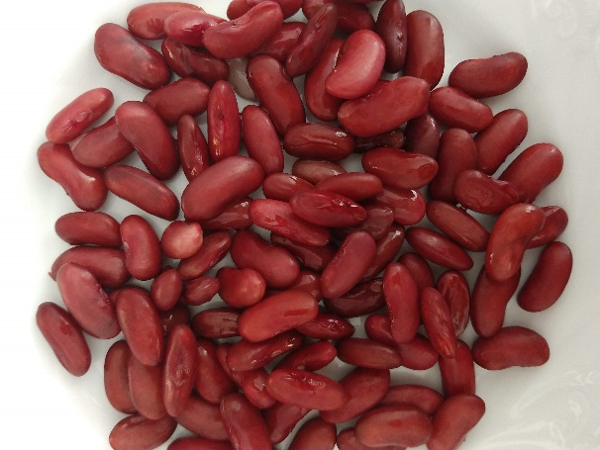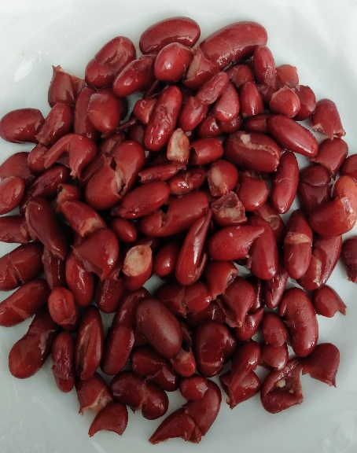

Figure S1. Representative macroscopic pictures of processed common beans after application of a thermal treatment (95 °C) with a duration of 20 min (left) and 120 min (right).

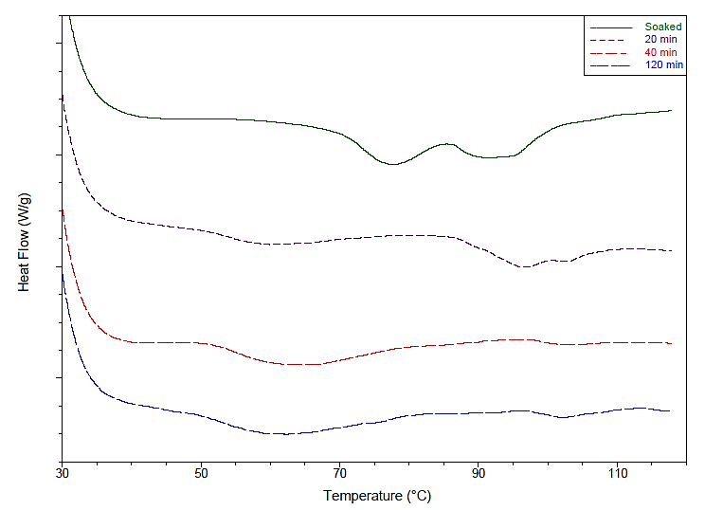

Figure S2. Representative DSC thermograms of thermally processed common beans with different process-induced hardness levels. In the legend of the figure, associated cooking times are shown. The correspondence with hardness is as follows: 20min – 10 179 g; 40min – 6 713 g; 120min – 3 697 g.
A representative thermogram of soaked common beans (no thermal treatment applied), exhibiting the peak corresponding to residual gelatinisation enthalpy (Tp ≈ 78 °C), is shown for comparison purposes.

Figure S3. Average number of mastication cycles as a function of process-induced hardness level. Error bars represent the standard deviation of n = 16 participants in the mastication study.

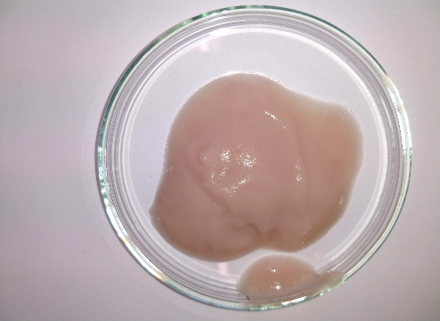
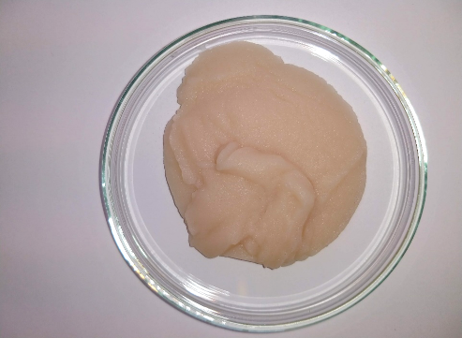
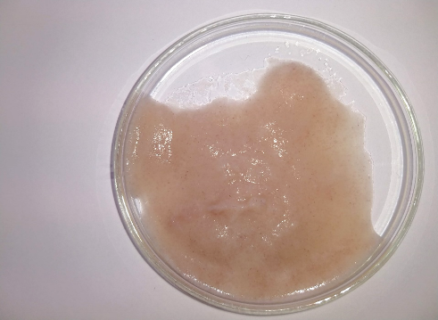
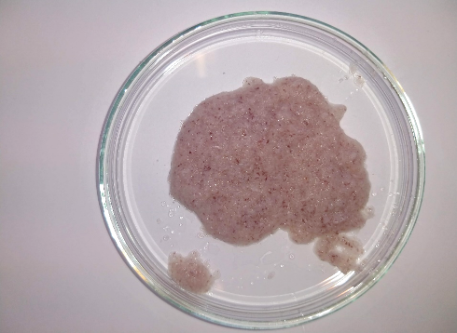
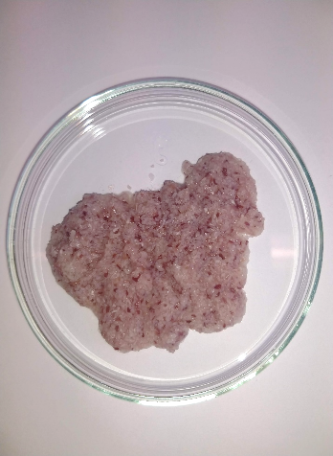
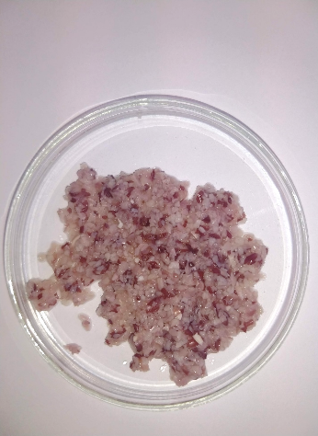
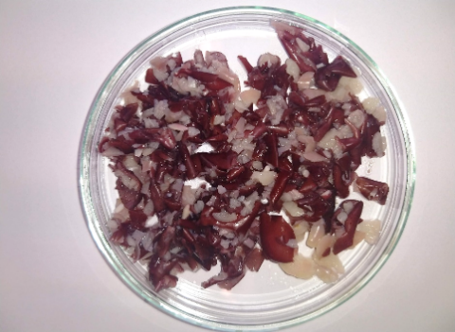
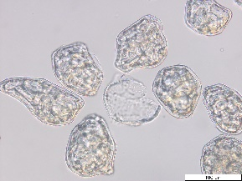
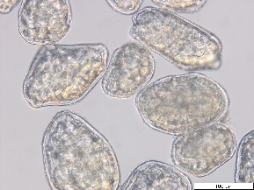
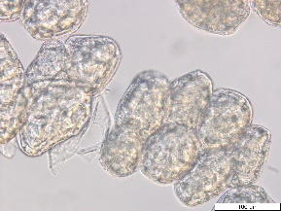
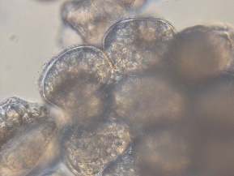
40 – 80 µm
80 – 125 µm
125 – 250 µm
250 – 500 µm
500 – 1000 µm
1000 – 2000 µm
> 2000 µm
Individual cells
Small cell clusters
Big cell clusters

Figure S4. Photographic characterisation (top) of the representative particle size fractions present in an oral bolus generated after human mastication of thermally processed common beans. Representative micrographs of the fractions (<500 µm) as observed under the light microscope are also shown (bottom pictures).

