SUPPLEMENTARY MATERIAL

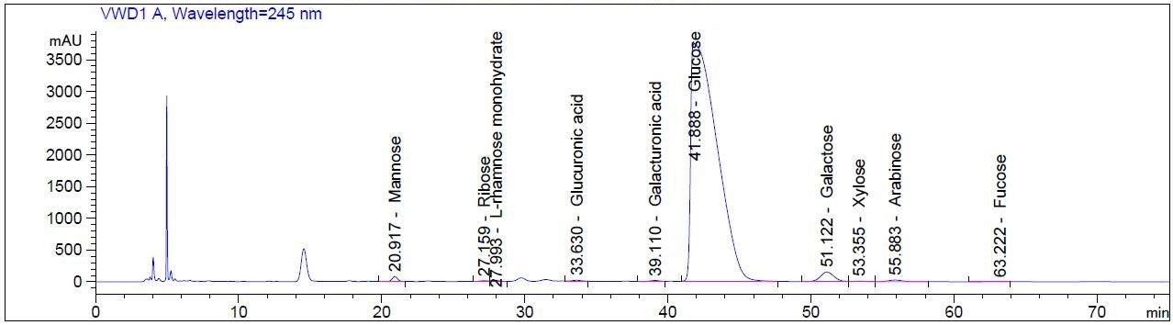
Supplemental Figure 1. Monosaccharide composition of Acanthopanax senticosus polysaccharides by high performance Liquid chromatography method.

Supplementary Table 1. Sequences for real-time PCR Primers
Genes | Description | Accession No. | Forward (5'->3') | Reverse (5'->3') | Product length(bp)
TNF-α | Tumor necrosis factor alpha | NM_214022 | CGCCCACGTTGTAGCCAATGT | CAGATAGTCGGGCAGGTTGATCTC | 388
HIF-1α | Hypoxia inducible factor-1 alpha | NM_001123124 | TCACCTGAGCCTAACAGTCC | TGCCTCTGTGTCTTCAGCAAA | 111
iNOS | Inducible nitric oxide synthase | NM_001143690 | AGGAGCAAGGCCACCTCTAT | GCTTCTGGCTCTTAAGCTGGA | 144
GAPDH | Glyceraldehyde-3-phosphate dehydrogenase | NM_001206359 | ACTCACTCTTCTACCTTTGATGCT | TGTTGCTGTAGCCAAATTCA | 100

