Supplementary Figure 1. Flow diagram of subject recruitment for this study.

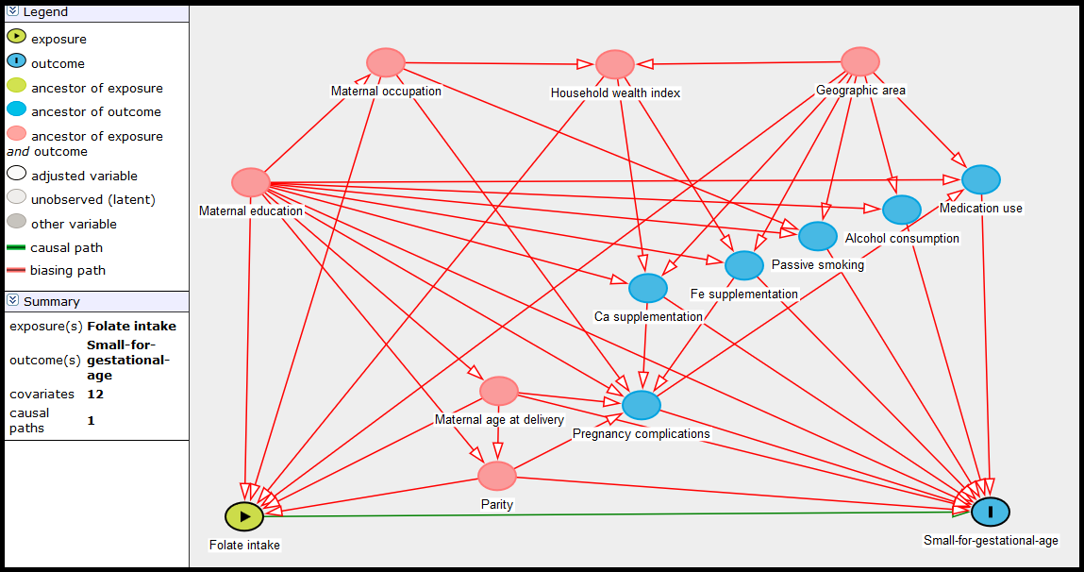
Supplementary Figure 2. Directed acyclic graph drawn in the DAGitty programme to identify the minimum set of confounders (depicted in red) to enter the adjusted model to examine the association between folate intake and small-for-gestational-age births.

Supplementary Table 1. Association between folate (dietary folate, supplemental folic acid and total folate) intake during pregnancy and birth weight Z score in Shaanxi Province, Northwest China*
 | Crude β coefficient (95% CI) | Adjusted β coefficient (95% CI)†
Dietary folate intake‡ | 0.058 (0.009, 0.108) | 0.058 (0.007, 0.108)
Folic acid supplementation
Before conception or during pregnancy§ | 0.006 (0.002, 0.010) | 0.006 (0.001, 0.010)
Before conception§ | 0.009 (0.001, 0.018) | 0.008 (-0.001, 0.017)
During the first trimester§ | 0.008 (0.002, 0.015) | 0.008 (0.001, 0.014)
During the second or third trimester§ | 0.006 (-0.002, 0.014) | 0.005 (-0.003, 0.013)
Total folate intake|| | 0.107 (0.056, 0.157) | 0.104 (0.053, 0.156)
* Two-level linear regression models were used to estimate OR and 95% CI. The total folate intake equals the dietary folate intake throughout pregnancy plus 1.7 × the average supplemented folic acid consumed during the first, second and third trimesters.
† Adjusted for geographic area, maternal age at delivery (continuous), maternal education, maternal occupation, household wealth index (continuous) and parity.
‡ Per one-unit increase in the log-transformed value of dietary folate intake.
§ Per 10-day increase in the duration of folic acid supplementation.
|| Per one-unit increase in the log-transformed value of total folate intake.

