Supplementary Material

Supplemental Figure 1. Intake of ALA and the risk of incident PAD. The analyses were conducted using Cox proportional hazard regression including adjustment for age and gender (model 1A) with the median intake of ALA as reference. The 20th, 40th, 60th and 80th percentiles of ALA intake are shown with dotted lines. The shaded grey area indicates the 95% CIs of hazard ratios of PAD (solid black line). The spline plot is shown for the 2.5-97.5 percentiles of ALA intake.
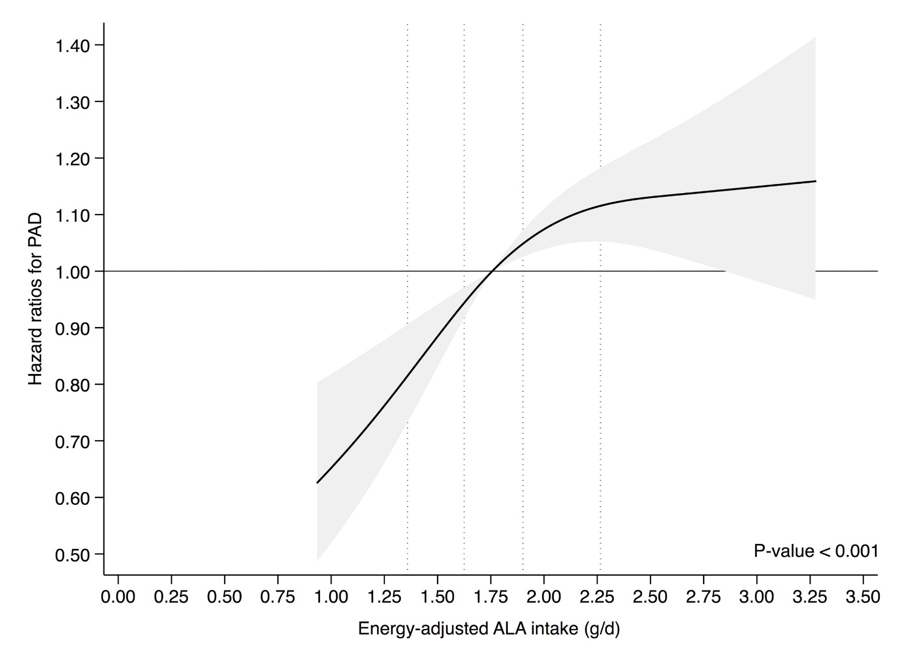

Supplemental Figure 2. Intake of ALA and the risk of incident PAD. The multivariable analyses were conducted using Cox proportional hazard regression including adjustment for established PAD risk factors and co-morbidities (model 2) with the median intake of ALA as reference. The 20th, 40th, 60th and 80th percentiles of ALA intake are shown with dotted lines. The shaded grey area indicates the 95% CIs of hazard ratios of PAD (solid black line). The spline plot is shown for the 2.5-97.5 percentiles of ALA intake.

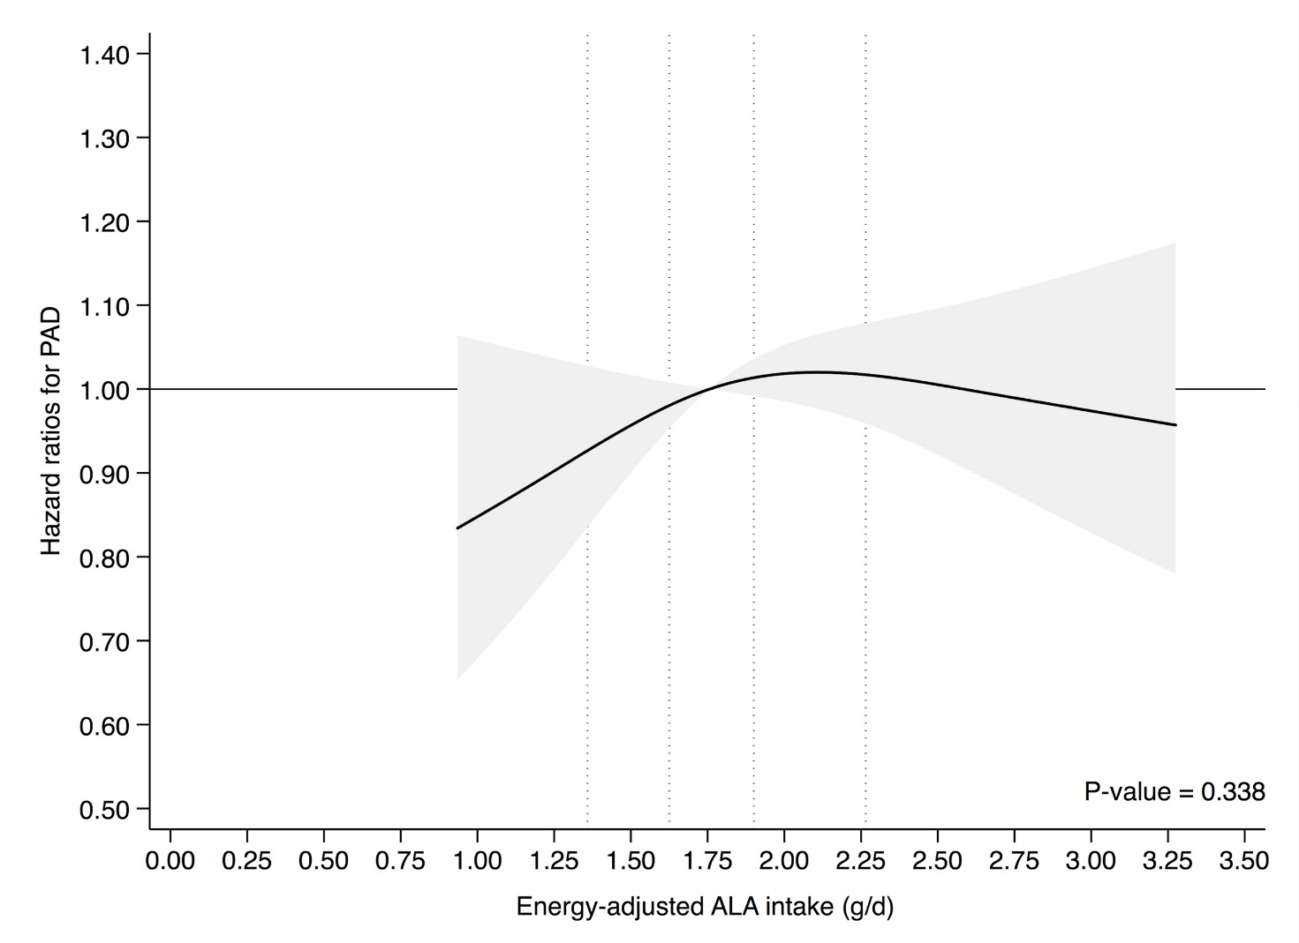

Supplemental Figure 3. Intake of ALA and the risk of incident PAD. The multivariable analyses were conducted using Cox proportional hazard regression including adjustment for established PAD risk factors and potential dietary risk factors (model 3) with the median intake of ALA as reference. The 20th, 40th, 60th and 80th percentiles of ALA intake are shown with dotted lines. The shaded grey area indicates the 95% CIs of hazard ratios of PAD (solid black line). The spline plot is shown for the 2.5-97.5 percentiles of ALA intake.

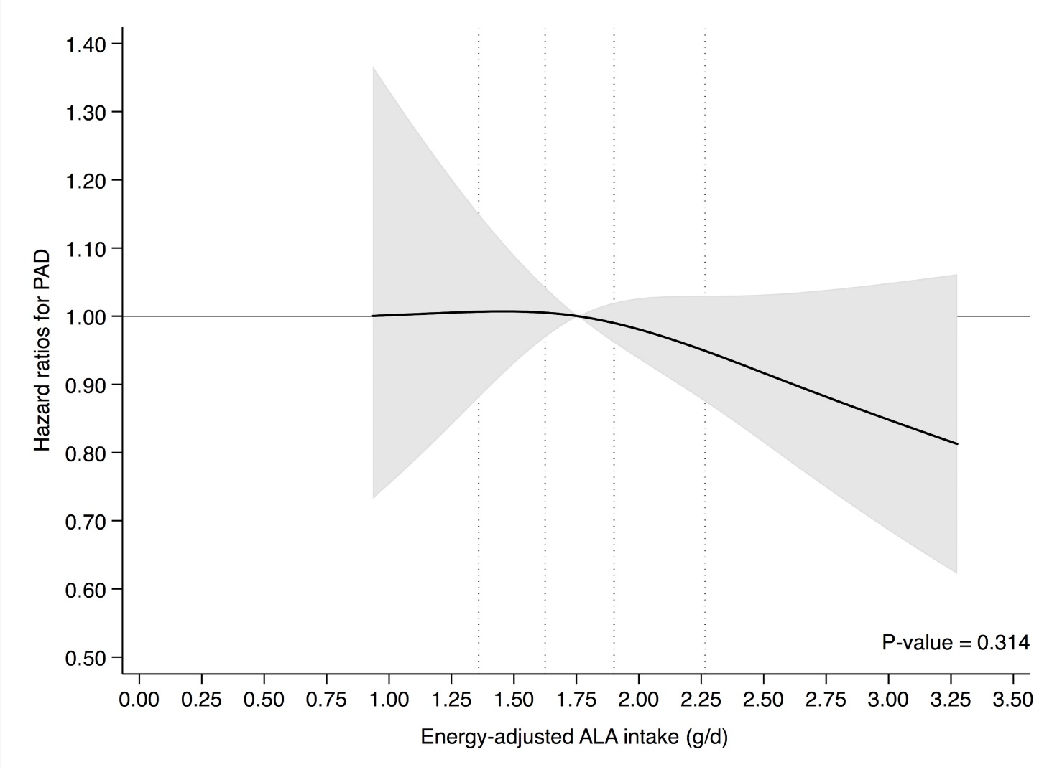

Supplemental Table 1. Sex-specific analyses of quintiles of energy-adjusted ALA intake and hazard ratios for peripheral artery disease
Men (n = 26.332) |  |  |  |  |  | Women (n = 28.916)
Quintiles of ALA intake | Cases | Model 1A* | Model 1B† | Model 2‡ |  | Quintiles of ALA intake | Cases | Model 1A* | Model 1B† | Model 2‡
 | (n) | HR (95% CI) | HR (95% CI) | HR (95% CI) |  |  | (n) | HR (95% CI) | HR (95% CI) | HR (95% CI)
<1.67 g/d | 99 | 1 (reference) | 1 (reference) | 1 (reference) |  | < 1.24 g/d | 50 | 1 (reference) | 1 (reference) | 1 (reference)
1.67-1.94 g/d | 120 | 1.18 (0.91; 1.55) | 1.12 (0.86; 1.46) | 1.18 (0.91; 1.55) |  | 1.24-1.43 g/d | 58 | 1.14 (0.78; 1.66) | 1.02 (0.70; 1.49) | 1.02 (0.70; 1.49)
1.94-2.19 g/d | 121 | 1.19 (0.91; 1.55) | 1.07 (0.82; 1.39) | 1.11 (0.85; 1.45) |  | 1.43-1.62 g/d | 75 | 1.48 (1.03; 2.11) | 1.15 (0.80; 1.64) | 1.21 (0.84; 1.73)
2.19-2.54 g/d | 117 | 1.17 (0.90; 1.53) | 0.94 (0.72; 1.24) | 1.00 (0.77; 1.32) |  | 1.62-1.88 g/d | 80 | 1.55 (1.09; 2.21) | 1.06 (0.74; 1.52) | 1.08 (0.76; 1.55)
>2.54 g/d | 133 | 1.34 (1.03; 1.74) | 1.03 (0.79; 1.34) | 1.12 (0.86; 1.45) |  | > 1.88 g/d | 97 | 1.88 (1.33; 2.64) | 1.15 (0.81; 1.63) | 1.18 (0.84; 1.68)
Abbreviations: ALA, alpha-linolenic acid; HR, hazard ratio
Statistical analyses were conducted using Cox proportional hazard regression. All models were adjusted for gender by allowing baseline hazards among men and women to differ.

* Model 1A included baseline age
† Model 1B included the variables of model 1A and the following risk factors for PAD: length of schooling, smoking, physical activity, waist circumference, body mass index and alcohol intake.
‡ Model 2 included the variables of model 1B and the following potential intermediate variables: self-reported history of hypercholesterolemia and/or use of lipid-lowering medication, hypertension and/or use of antihypertensive medication and diabetes mellitus and/or use of insulin.

