Supplemental Table 1: Between-group difference in changes in intervention outcomes between white rice (WR) and brown rice (BR) diets by sex, age, baseline weight status and baseline physical activity level
 | Mean (SE) BR vs. WR | n | p value | Mean (SE) BR vs. WR | n | p value | p for heterogeneity
Sex
 | Women |  |  | Men
Body weight (kg) | 0.04 (0.31) | 49 | 0.81 | 0.40 (0.40) | 58 | 0.40 | 0.60
BMI (kg/m²) | 0.17 (0.17) | 49 | 0.28 | 0.06 (0.17) | 58 | 0.82 | 0.55
Body fat % | 1.53 (0.78) | 49 | 0.10 | -0.01 (0.82) | 58 | 0.72 | 0.34
Waist circumference (cm) | -0.82 (0.88) | 49 | 0.27 | 0.68 (0.69) | 58 | 0.24 | 0.12
Fasting blood glucose (mg/dL) | 0.40 (2.4) | 50 | 0.84 | -0.43 (2.37) | 58 | 0.55 | 0.83
Fasting insulin (µ IU/mL) | 0.04 (1.39) | 50 | 0.89 | 0.33 (1.15) | 58 | 0.57 | 0.29
HbA1c mmol/mol | 0.02 (0.66) | 50 | 0.59 | -0.87 (0.77) | 58 | 0.17 | 0.15
HbA1c % | 0.002 (0.06) | 50 | 0.59 | -0.08 (0.07) | 58 | 0.17 | 0.15
Insulin resistance (HOMA-IR) | 0.12 (0.38) | 50 | 0.84 | -0.04 (0.29) | 58 | 0.92 | 0.49
Triglycerides (mg/dL) | 9.26 (7.15) | 50 | 0.39 | -8.97 (14.54) | 58 | 0.83 | 0.47
Cholesterol (mg/dL) | -8.36 (4.44) | 50 | 0.04 | 1.03 (6.26) | 58 | 0.77 | 0.21
HDL cholesterol (mg/dL) | -0.30 (0.93) | 50 | 0.90 | 0.09 (0.89) | 58 | 0.70 | 0.81
LDL cholesterol (mg/dL) | -9.84 (4.42) | 50 | 0.02 | 2.09 (5.88) | 54 | 0.81 | 0.16
HS-CRP (mg/L) | -0.22 (0.45) | 50 | 0.31 | -0.66 (0.37) | 58 | 0.06 | 0.38
Weight Status
 | BMI ≥ 25 |  |  | BMI < 25
Body weight (kg) | 0.19 (0.31) | 83 | 0.74 | 0.40 (0.45) | 24 | 0.21 | 0.36
BMI (kg/m²) | 0.10 (0.14) | 83 | 0.62 | 0.15 (0.23) | 24 | 0.36 | 0.57
Body fat % | 0.67 (0.69) | 83 | 0.34 | 0.79 (0.97) | 24 | 0.28 | 0.64
Waist circumference (cm) | -0.02 (0.65) | 83 | 0.96 | 0.05 (1.0) | 24 | 0.93 | 0.91
Fasting blood glucose (mg/dL) | -1.49 (1.85) | 84 | 0.20 | 4.07 (4.0) | 28 | 0.35 | 0.17
Fasting insulin (µ IU/mL) | 0.16 (1.12) | 84 | 0.87 | -2.91 (3.13) | 28 | 0.35 | 0.34
HbA1c mmol/mol | -1.09 (0.55) | 84 | 0.10 | 1.64 (0.87) | 28 | 0.09 | 0.02
HbA1c % | -0.10 (0.05) | 84 | 0.10 | 0.15 (0.08) | 28 | 0.09 | 0.02
Insulin resistance (HOMA-IR) | 0.01 (0.29) | 84 | 0.99 | -0.83 (0.97) | 28 | 0.39 | 0.40
Triglycerides (mg/dL) | -3.27 (9.38) | 84 | 0.87 | 1.50 (19.22) | 28 | 0.99 | 0.93
Cholesterol (mg/dL) | -6.71 (4.62) | 84 | 0.13 | 9.46 (6.4) | 28 | 0.16 | 0.04
HDL cholesterol (mg/dL) | -0.61 (4.62) | 84 | 0.87 | 1.54 (1.19) | 28 | 0.15 | 0.14
LDL cholesterol (mg/dL) | -6.07 (4.39) | 81 | 0.09 | 7.63 (6.48) | 27 | 0.17 | 0.04
HS-CRP (mg/L) | -0.62 (0.34) | 84 | 0.02 | 0.03 (0.52) | 28 | 0.96 | 0.26
Age
 | ≥ 40 years |  |  | < 40 years
Body weight (kg) | 0.46 (0.43) | 41 | 0.35 | 0.10 (0.33) | 66 | 0.73 | 0.59
BMI (kg/m²) | 0.17 (0.17) | 41 | 0.39 | 0.08 (0.16) | 66 | 0.62 | 0.78
Body fat % | 0.71 (0.82) | 41 | 0.29 | 0.69 (0.78) | 66 | 0.36 | 0.89
Waist circumference (cm) | -0.67 (0.93) | 41 | 0.47 | -0.84 (2.13) | 69 | 0.62 | 0.34
Fasting blood glucose (mg/dL) | 1.09 (2.91) | 43 | 0.80 | -0.84 (2.13) | 69 | 0.62 | 0.94
Fasting insulin (µ IU/mL) | 0.69 (0.86) | 43 | 0.36 | -1.42 (1.78) | 69 | 0.40 | 0.24
HbA1c mmol/mol | -0.11 (0.98) | 43 | 0.84 | -0.55 (0.55) | 69 | 0.43 | 0.79
HbA1c % | -0.01 (0.09) | 43 | 0.84 | -0.05 (0.05) | 69 | 0.43 | 0.79
Insulin resistance (HOMA-IR) | 0.17 (0.23) | 43 | 0.49 | -0.43 (0.51) | 69 | 0.39 | 0.28
Triglycerides (mg/dL) | -16.42 (17.97) | 43 | 0.53 | 6.86 (7.93) | 69 | 0.47 | 0.38
Cholesterol (mg/dL) | -11.91 (6.62) | 43 | 0.07 | 3.09 (4.62) | 69 | 0.60 | 0.08
HDL cholesterol (mg/dL) | -1.33 (1.13) | 43 | 0.25 | 0.71 (0.71) | 69 | 0.17 | 0.08
LDL cholesterol (mg/dL) | -8.68 (7.08) | 41 | 0.14 | 1.04 (4.07) | 67 | 0.83 | 0.17
HS-CRP (mg/L) | -0.56 (0.47) | 43 | 0.09 | -0.40 (0.36) | 69 | 0.22 | 0.48
Physical Activity
 | Moderate to vigorous physical activity |  |  | Sedentary
Body weight (kg) | -0.39 (0.43) | 12 | 0.53 | 0.32 (0.29) | 92 | 0.39 | 0.95
BMI (kg/m²) | -0.12 (0.44) | 12 | 0.69 | 0.14 (0.13) | 92 | 0.35 | 0.98
Body fat % | 1.13 (3.03) | 12 | 0.56 | 0.67 (0.55) | 92 | 0.17 | 0.78
Waist circumference (cm) | -0.37 (1.21) | 12 | 0.91 | 0.24 (0.61) | 92 | 0.79 | 0.92
Fasting blood glucose (mg/dL) | 4.31 (3.68) | 13 | 0.23 | -1.02 (1.91) | 96 | 0.30 | 0.11
Fasting insulin (µ IU/mL) | 4.73 (4.45) | 13 | 0.26 | -1.32 (1.19) | 96 | 0.29 | 0.16
HbA1c mmol/mol | -0.55 (1.42) | 13 | 0.46 | -0.66 (0.55) | 96 | 0.34 | 0.75
HbA1c % | -0.05 (0.13) | 13 | 0.46 | -0.06 (0.05) | 96 | 0.34 | 0.75
Insulin resistance (HOMA-IR) | 1.39 (1.28) | 13 | 0.26 | -0.42 (0.34) | 96 | 0.21 | 0.15
Triglycerides (mg/dL) | -4.62 (21.61) | 13 | 0.72 | -2.68 (9.38) | 96 | 0.92 | 0.79
Cholesterol (mg/dL) | -2.85 (9.75) | 13 | 0.48 | -2.25 (4.28) | 96 | 0.65 | 0.64
HDL cholesterol (mg/dL) | -0.23 (2.36) | 13 | 0.70 | -0.01 (0.65) | 96 | 0.57 | 0.61
LDL cholesterol (mg/dL) | -1.85 (10.32) | 13 | 0.63 | -2.21 (4.04) | 92 | 0.53 | 0.84
HS-CRP (mg/L) | 0.25 (0.80) | 13 | 0.63 | -0.58 (0.31) | 96 | 0.02 | 0.15
Prediabetes status
 | HbA1c ≥ 5.6% |  |  | HbA1c < 5.6%
Body weight (kg) | 0 (0.35) | 36 | 0.63 | 0.35 (0.35) | 71 | 0.23 | 0.23
BMI (kg/m²) | 0.09 (0.15) | 36 | 0.87 | 0.12 (0.16) | 71 | 0.36 | 0.55
Body fat % | 1.43 (1.17) | 36 | 0.31 | 0.33 (0.63) | 71 | 0.38 | 0.65
Waist circumference (cm) | 0.22 (0.98) | 36 | 0.75 | -0.12 (0.67) | 71 | 0.88 | 0.77
Fasting blood glucose (mg/dL) | -3.24 (3.55) | 38 | 0.12 | 1.51 (1.84) | 74 | 0.43 | 0.09
Fasting insulin (µ IU/mL) | -0.15 (2.88) | 38 | 0.93 | -0.85 (0.93) | 74 | 0.32 | 0.69
HbA1c mmol/mol | -1.42 (0.98) | 38 | 0.17 | 0.11 (0.55) | 74 | 0.82 | 0.20
HbA1c % | -0.13 (0.09) | 38 | 0.17 | 0.01 (0.05) | 74 | 0.82 | 0.20
Insulin resistance (HOMA-IR) | -0.22 (0.88) | 38 | 0.84 | -0.19 (0.21) | 74 | 0.35 | 0.97
Triglycerides (mg/dL) | -2.29 (15.9) | 38 | 0.86 | -1.97 (9.96) | 74 | 0.81 | 0.81
Cholesterol (mg/dL) | -9.71 (6.58) | 38 | 0.20 | 0.95 (4.75) | 74 | 0.99 | 0.30
HDL cholesterol (mg/dL) | -1.92 (1.17) | 38 | 0.16 | 0.88 (0.70) | 74 | 0.12 | 0.04
LDL cholesterol (mg/dL) | -7.81 (6.99) | 36 | 0.29 | -0.07 (4.31) | 72 | 0.76 | 0.46
HS-CRP (mg/L) | -0.20 (0.40) | 38 | 0.34 | -0.59 (0.38) | 74 | 0.07 | 0.58
HbA1c, glycated hemoglobin; HOMA-IR, homeostasis model assessment of insulin resistance; HS-CRP, high-sensitivity C- reactive protein.

Supplemental Figure 1: Between group difference in changes in select intervention outcomes by opinion about brown rice
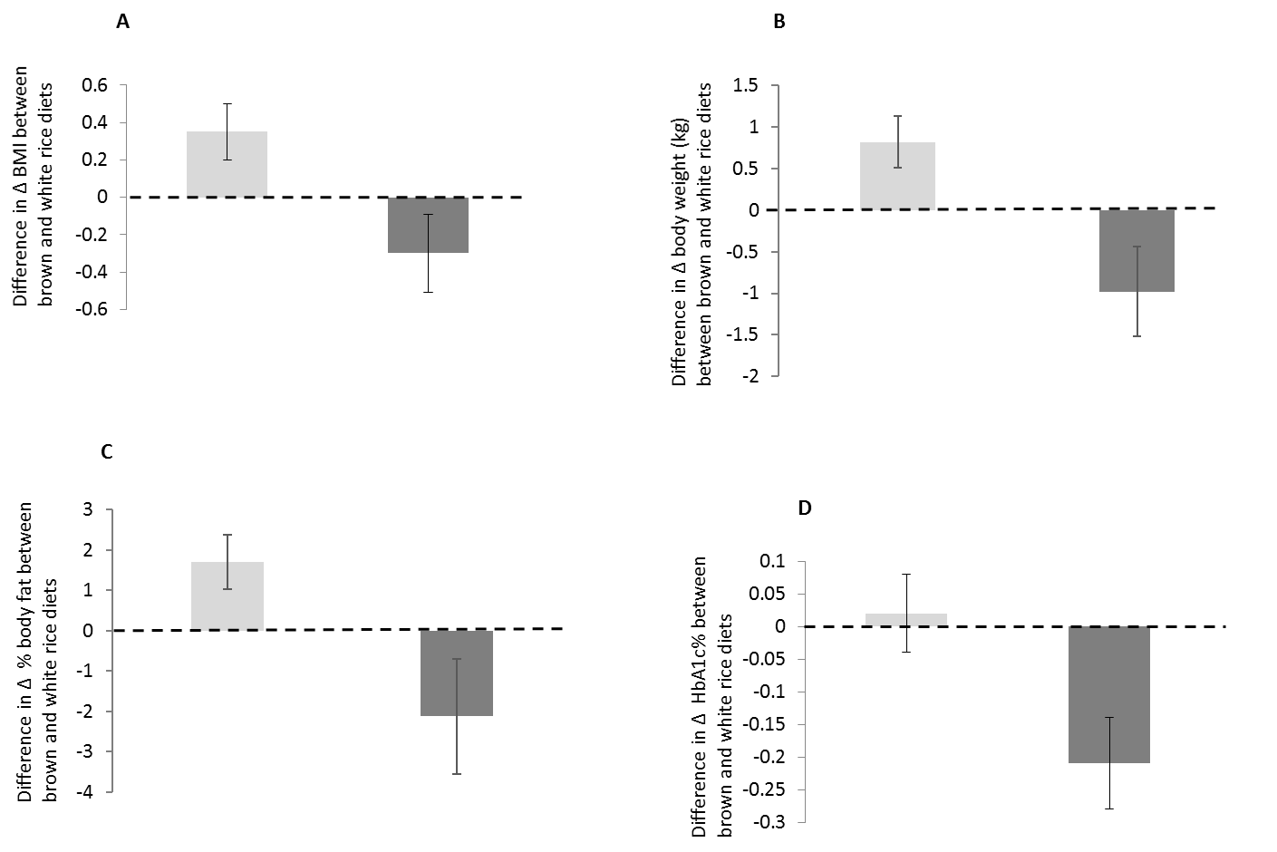
Light grey bars, participants think that brown rice is healthy; dark grey bars, participants do not think that brown rice is healthy. A, illustrates difference in changes in BMI between brown rice and white rice groups by whether participants thought brown rice was healthy (p=0.02) or if they did not think that brown rice was healthy (p=0.10). B, illustrates difference in changes in body weight (kg) between brown rice and white rice groups by whether participants thought brown rice was healthy (p=0.01) or if they did not think that brown rice was healthy (p=0.05). C, illustrates difference in changes in % body fat between brown rice and white rice groups by whether participants thought brown rice was healthy (p=0.01) or if they did not think that brown rice was healthy (p=0.13). D illustrates difference in changes in HbA1c % between brown rice and white rice groups by whether participants thought brown rice was healthy (p=0.58) or if they did not think that brown rice was healthy (p=0.004). All p for heterogeneity <0.05. HbA1c, glycated hemoglobin.

Supplemental Table 2: Mean satiety according to brown rice and white rice diet throughout the study

 | Baseline |  |  | Mid study |  |  | End of study
 | Brown rice | White rice | p value* | Brown rice | White rice | p value* | Brown rice | White rice | p value*
N | 107 | 101 | 85 | 111 | 111 | 99 | 107 | 105 | 92
Mean (SD) | 2.99 (1.52) | 3.52 (1.52) | 0.17 | 3.13 (1.27) | 3.60 (1.45) | 0.04 | 3.21 (1.35) | 3.37 (1.39) | 0.45

*p-value for Wilcoxon signed rank test for differences in satiety (brown rice vs. white rice). Satiety based on the following values from a Likert scale: 1=extremely full; 2=satisfied; 3=semi-satisfied; 4=no particular feeling; 5=semi-hungry; 6=hungry; 7=extremely hungry.

