Supplemental Table 1 Characteristics of gene-specific primers used for qPCR analysis of gene expression in the liver of 19 mo-old mice
Gene symbol | Forward primer (3′-5)  Reverse primer (5′-3) | Product size (bp) | NCBI Genbank accession no.
Reference genes
Actb | AGTGTGACGTTGACATCCGT  AGCTCAGTAACAGTCCGCCTA | 296 | NM_007393
Atb5b | GCCAGAGACTATGCGGCGCA  CCCCCAAATGCTGGGCCACC | 187 | NM_016774
Canx | GTCCCCGGGAGGCTCGAGATAGA  ACCTCCCCTGTTGGAACTGGAGC | 234 | NM_007597
Cyc1 | GCTTCGCCGGACGGTACTGG  CGCAATGGAAGCTGCCGGGA | 99 | NM_025567
Eif4a2 | ACATGGCGGCCCAGAGGGAA  TGGTGGGGGCCAATACTAGTGCT | 299 | NM_013506
Rpl13a | GTGGTCGTACGCTGTGAAGGCATC  GGCCTCGGGAGGGGTTGGTATT | 109 | NM_009438
Target Genes
Acaca | ATGTGGCCTGGGTAGATCCT  CGGACAAGGTAAGCCCCAAT | 295 | NM_133360
Acadm | AGGTTTCAAGATCGCAATGG  CTCCTTGGTGCTCCACTAGC | 152 | NM_007382
Aldh9a1 | AGCTGAAGACGGTGTGTGTG  CTAATGACCCAAAGCCTGGA | 154 | NM_019993
Atf4 | TTCCTCGAATCCAGCAAAGCCC  CTCCAACATCCAATCTGTCCGG | 286 | NM_009716
Bbox1 | CCTAAAGGCAGAAGCAGTGG  TCCGGTCAAATGTCAAATCA | 200 | NM_130452
Ddit3 | AGCCAGAATAACAGCCGGAACC  GGGACTCAGCTGCCATGACTG | 117 | NM_007837
Dnajc3 | CTGCATGGACACAGGTCCCAG  AGGCTGGACACCCCTACCTC | 217 | NM_008929
Fasn | AGATGGAAGGCTGGGCTCTA  GAAGCGTCTCGGGATCTCTG | 268 | NM_007988
Gpam | AGGAAAGAGCCAGCATCAGG  CAAAGGTATCAGCAACAGGGACT | 150 | NM_008149
Gpx1 | CTCTTTACCTTCCTGCGGAA  GGACAGCAGGGTTTCTATGT | 219 | NM_008160
Herpud1 | CGCAGTTGGAGTGTGAGTCGC  ACCCTTTGTGCTGGTTTCTGGC | 213 | NM_022331
Hmox1 | GATTTGTCTGAGGCCTTGAAG  CTTAAAGCCTTCTCTGGACAC | 111 | NM_010442
Hp | GCAATGGGTGAACAGAGTCG  GAAGAGGTTTTTGGCCGTCG | 213 | NM_017370
Hsp90b1 | CCTGCTGACCTTCGGGTTCG  CTGTCCTTGAGCCTTCTCGGC | 98 | NM_011631
Hspa5 | TCATCGGACGCACTTGGAATGAC  CGCTGGGCATCATTGAAGTAAGC | 250 | NM_001163434
Icam1 | GATGCTCAGGTATCCATCCA  CCACAGTTCTCAAAGCACAG | 212 | NM_010493
Lbp | TCGTGGGCAGTACGAGTTTC  AAGAGATTCAGCAGCCACCC | 327 | NM_008489
Nqo1 | ACGTCATTCTCTGGCCGATTCAG  AGGTCAAACAGGCTGCTTGGAG | 196 | NM_008706
Pdia4 | CCGTTGACTATGATGGCTCCAGG  GGTCTGTCTGTTCGGTGGCG | 285 | NM_009787
Ppp1r15a | GCGGCTCAGATTGTTCAAAGCC  AGATGGGTTTCTAAGGCGTGCC | 271 | NM_008654
Saa1 | CCAGGATGAAGCTACTCACCA  TGTCTGTTGGCTTCCTGGTC | 313 | NM_009117
Scd1 | CGTGGCTTCTTCTTCTCTCA  CTTCTCGGCTTTCAGGTCAG | 105 | NM_009127
Slc22a5/Octn2 | CTTGTCCCTCACACCGTGAA  CCTAGCTCAGAGAAGTTGGC | 137 | NM_011396
Slc25a20/Cact | GGAGTCACCCCTATGTTCGC  ATCCGTTCTCCAGGGGTCAT | 161 | NM_020520
Slc27a1/Fatp1 | AAGGGCCAGGGATCTCTCTCTCCA  TGTCGTCGCAGCTCTAGCCGA | 319 | NM_011977
Sod1 | GATGACTTGGGCAAAGGTGG  CTGCGCAATCCCAATCACTC | 90 | NM_011434
Tnf | CCAAGTGGAGGAGCAGCT  GCAAATCGGCTGACGGTGACGGTGT | 189 | NM_013693

Supplemental Table 2 Characteristics of gene-specific primers used for qPCR validation of microarray data for selected differentially expressed transcripts in skeletal muscle of 19 mo-old mice
Gene symbol | Forward primer (3′-5)  Reverse primer (5′-3) | Product size (bp) | NCBI Genbank accession no.
Reference genes
Actb | AGTGTGACGTTGACATCCGT  AGCTCAGTAACAGTCCGCCTA | 296 | NM_007393
Atb5b | GCCAGAGACTATGCGGCGCA  CCCCCAAATGCTGGGCCACC | 187 | NM_016774
Canx | GTCCCCGGGAGGCTCGAGATAGA  ACCTCCCCTGTTGGAACTGGAGC | 234 | NM_007597
Cyc1 | GCTTCGCCGGACGGTACTGG  CGCAATGGAAGCTGCCGGGA | 99 | NM_025567
Eif4a2 | ACATGGCGGCCCAGAGGGAA  TGGTGGGGGCCAATACTAGTGCT | 299 | NM_013506
Rpl13a | GTGGTCGTACGCTGTGAAGGCATC  GGCCTCGGGAGGGGTTGGTATT | 109 | NM_009438
Target genes
Ankrd2 | CGACACCAACGTGAGAGACA  ACTGGGCTGGTATAGGCTGA | 365 | XM_006527234
B4glant2 | GAGGTGGGGATCATTCCAGG  TTGTTCCGTGTGAGCCAAGA | 91 | NM_008081
Gamt | GCTCTCTTCCCATGGTCCTAG  TCATCTGAGGGAAGGCATAGT | 275 | XM_011243370
Olfr1052 | CACTGGGTCAGTCATAGGTGG  TCGTCCAGAAGCTGAGCGTA | 268 | NM_147010
Olfr1356 | CGGGCTGCATCACACAGATA  TGATCCAAGAGCCAGCATCG | 161 | NM_146308
Olfr142 | ACCCCTATGCTGAACCCCAT  CAGCTGTCCTTTTGCTTCCAG | 89 | NM_146984
Olfr427 | GGCTCTTATGTACCTGCGCT  CAGCTCCCAGAGACAGTGAG | 186 | NM_207158
Olfr618 | TTGGTTTCAAGCTGGAGGCA  GCAGTATGGCAGACTCGGTT | 92 | NM_147047
Ostn | GCTTCAACTGTGTCAGAAGGC  TCACCCCTAGGCTGGTAGAA | 181 | NM_198112
Perp | CTGAGGTTAAGCCGCTGTCA  TCCGGTCTACGCTGGTTCTA | 141 | NM_022032
Pld5 | GGCAGGAAGATCTCATCGCA  GCCTTGGAAGAGCGGTAAGT | 239 | NM_001195816
Tppp3 | ATCTGCCACCAAGAGCTTCC  GGCAAAAGCAGGCAAGAGTC | 171 | XM_006531324

Supplemental Table 3 Relative mRNA concentrations of genes involved in lipid metabolism in the liver of 19 mo-old mice fed a control diet or a diet supplemented with 1000 mg/kg diet L-carnitine from 3 wk to 19 mo of age
 | Control |  | Carnitine
Gene symbol | Mean | SD | Mean | SD | P
 | Relative mRNA level (fold of Control = 1.00)
Lipid catabolism
Acadm | 1.00 | 0.30 | 1.18 | 0.48 | 0.36
Aldh9a1 | 1.00 | 0.56 | 1.73 | 0.81 | 0.04
Bbox1 | 1.00 | 0.51 | 1.53 | 0.80 | 0.10
Slc22a5/Octn2 | 1.00 | 0.32 | 1.36 | 0.73 | 0.22
Slc25a20/Cact | 1.00 | 0.35 | 1.33 | 0.59 | 0.16
Slc27a1/Fatp1 | 1.00 | 0.38 | 1.24 | 0.48 | 0.25
Lipid synthesis
Acaca | 1.00 | 0.33 | 0.90 | 0.31 | 0.52
Fasn | 1.00 | 0.36 | 0.95 | 0.45 | 0.79
Gpam | 1.00 | 0.48 | 1.27 | 0.74 | 0.37
Scd1 | 1.00 | 0.61 | 1.37 | 1.23 | 0.40
n = 10 mice/group.
Acaca, acetyl-CoA carboxylase alpha; Acadm, acyl-CoA dehydrogenase medium chain; Aldh9a1, aldehyde dehydrogenase 9 family member A1; Bbox1, gamma-butyrobetaine hydroxylase 1; Fasn, fatty acid synthase; Gpam, glycerol-3-phosphate acyltransferase, mitochondrial; Scd1, stearoyl-CoA desaturase; Slc22a5/Octn2, solute carrier family 22 member 5/organic cation transporter 2; Slc25a20/Cact, solute carrier family 25 member 20/carnitine/acylcarnitine translocase; Slc27a1/Fatp1, solute carrier family 27 member 1/fatty acid transporter 1.
Supplemental Table 4 Relative mRNA concentrations of genes involved in stress signalling and stress adaptation in the liver of 19 mo-old mice fed a control diet or a diet supplemented with 1000 mg/kg diet L-carnitine from 3 wk to 19 mo of age
 | Control |  |  |  | Carnitine
Gene symbol | Mean |  | SD |  | Mean |  | SD | P
 | Relative mRNA level (fold of Control = 1.00)
ER stress/UPR
Atf4 | 1.00 |  | 0.52 |  | 1.32 |  | 0.41 | 0.17
Ddit3 | 1.00 |  | 0.43 |  | 1.08 |  | 0.37 | 0.71
Dnajc3 | 1.00 |  | 0.43 |  | 1.19 |  | 0.26 | 0.28
Herpud1 | 1.00 |  | 0.41 |  | 1.13 |  | 0.30 | 0.47
Hsp90b1 | 1.00 |  | 0.41 |  | 1.13 |  | 0.20 | 0.44
Hspa5 | 1.00 |  | 0.40 |  | 1.31 |  | 0.38 | 0.07
Pdia4 | 1.00 |  | 0.43 |  | 1.25 |  | 0.29 | 0.18
Ppp1r15a | 1.00 |  | 0.25 |  | 1.04 |  | 0.29 | 0.81
NF-κB
Hp | 1.00 |  | 0.43 |  | 0.83 |  | 0.42 | 0.45
Icam1 | 1.00 |  | 0.54 |  | 0.96 |  | 0.75 | 0.88
Lbp | 1.00 |  | 0.39 |  | 0.80 |  | 0.59 | 0.32
Saa1 | 1.00 |  | 0.63 |  | 0.58 |  | 0.38 | 0.13
Tnf | 1.00 |  | 0.38 |  | 1.14 |  | 0.48 | 0.50
Nrf2
Gpx1 | 1.00 |  | 0.36 |  | 1.40 |  | 0.83 | 0.54
Hmox1 | 1.00 |  | 0.52 |  | 1.25 |  | 1.07 | 0.52
Nqo1 | 1.00 |  | 0.56 |  | 1.08 |  | 0.66 | 0.76
Sod1 | 1.00 |  | 0.33 |  | 1.18 |  | 0.41 | 0.34
n = 10 mice/group.
Atf4, activating transcription factor 4; Ddit3, DNA damage inducible transcript 3; Dnajc3, DnaJ heat shock protein family (Hsp40) member C3; ER stress/UPR, endoplasmic reticulum stress/unfolded protein response; Gpx1, glutathione peroxidase 1; Herpud1, homocysteine inducible ER protein with ubiquitin like domain 1; Hmox1, heme oxygenase 1; Hp, haptoglobin; Hspa5, heat shock protein family A (Hsp70) member 5; Hsp90b1, heat shock protein 90 beta family member 1; Icam1, intercellular adhesion molecule 1; Lbp, lipopolysaccharide binding protein; NF-κB, nuclear factor-kappa B; Nqo1, NAD(P)H quinone dehydrogenase 1; Nrf2, nuclear factor, erythroid 2 like 2; Pdia4, protein disulfide isomerase family A member 4; Ppp1r15a, protein phosphatase 1 regulatory subunit 15A; Saa1, serum amyloid A1; Sod1, superoxide dismutase 1; Tnf, tumor necrosis factor.

Supplemental Table 5 Up-regulated genes in skeletal muscle of 19 mo-old mice fed a control diet or a diet supplemented with 1000 mg/kg diet carnitine from 3 wk to 19 mo of age*
 |  | Carnitine vs. Control
Gene symbol | Gene description | FC | P-value
B4galnt2 | beta-1,4-N-acetyl-galactosaminyl transferase 2 | 3.11 | 0.002
Perp | PERP, TP53 apoptosis effector | 2.16 | 0.015
Pld5 | phospholipase D family, member 5 | 2.16 | 0.040
Ostn | osteocrin | 2.09 | 0.016
Gm3594//Gm3269 | predicted gene 3594 // predicted gene 3269 | 1.69 | 0.016
Gm3696 | predicted gene 3696 | 1.65 | 0.026
Gm14412 | predicted gene 14412 | 1.64 | 0.015
Gm17430 | predicted gene, 17430 | 1.54 | 0.004
Gamt | guanidinoacetate methyltransferase | 1.53 | 0.020
Gm4963 | predicted gene 4963 | 1.52 | 0.003
Tppp3 | tubulin polymerization-promoting protein family member 3 | 1.48 | 0.001
Gm6445 | predicted gene 6445 | 1.45 | 0.044
Desi2 | desumoylating isopeptidase 2 | 1.45 | 0.011
LOC101056648 | tubulin alpha-1C chain-like | 1.44 | 0.013
Ociad2 | OCIA domain containing 2 | 1.43 | 0.027
Gm3173 | predicted gene 3173 | 1.41 | 0.033
Cmbl | carboxymethylenebutenolidase-like (Pseudomonas) | 1.41 | 0.031
Thbs1 | thrombospondin 1 | 1.40 | 0.038
Sar1b | SAR1 gene homolog B (S. cerevisiae) | 1.39 | 0.041
Sar1b | SAR1 gene homolog B (S. cerevisiae) | 1.39 | 0.041
Pcdh7 | protocadherin 7 | 1.39 | 0.004
n-R5s67 | nuclear encoded rRNA 5S 67 | 1.39 | 0.007
Cd97 | CD97 antigen | 1.38 | 0.019
Plcd4 | phospholipase C, delta 4 | 1.38 | 0.023
Gnai3 | guanine nucleotide binding protein (G protein), alpha inhibiting 3 | 1.38 | 0.004
Olfr467 | olfactory receptor 467 | 1.38 | 0.040
Klk1 | kallikrein 1 | 1.38 | 0.003
Gm3373 | predicted gene 3373 | 1.37 | 0.031
3000002C10Rik | glyceraldehyde-3-phosphate dehydrogenase pseudogene | 1.37 | 0.044
LOC101056658 | adenosylhomocysteinase-like | 1.37 | 0.003
Ephx1 | epoxide hydrolase 1, microsomal | 1.36 | 0.016
Gm5796 | predicted gene 5796 | 1.36 | 0.026
Gm15337 | predicted gene 15337 | 1.36 | 0.024
Cyp20a1 | cytochrome P450, family 20, subfamily a, polypeptide 1 | 1.34 | 0.007
Rexo2 | REX2, RNA exonuclease 2 homolog (S. cerevisiae) | 1.34 | 0.015
Snap29 | synaptosomal-associated protein 29 | 1.33 | 0.022
Gm9234 | predicted pseudogene 9234 | 1.33 | 0.044
Rfc2 | replication factor C (activator 1) 2 | 1.33 | 0.008
Spcs2 | signal peptidase complex subunit 2 homolog (S. cerevisiae) | 1.33 | 0.048
Gm2046 | predicted gene 2046 | 1.32 | 0.010
Cst3 | cystatin C | 1.32 | 0.017
Lgals1 | lectin, galactose binding, soluble 1 | 1.32 | 0.044
Gm15934 | predicted gene 15934 | 1.32 | 0.027
LOC101056547 | proteasome assembly chaperone 2-like | 1.32 | 0.017
Ccnyl1 | cyclin Y-like 1 | 1.32 | 0.041
Yae1d1 | Yae1 domain containing 1 | 1.32 | 0.012
Gm5481 | predicted gene 5481 | 1.32 | 0.008
Mrpl49 | mitochondrial ribosomal protein L49 | 1.31 | 0.013
Mrpl16 | mitochondrial ribosomal protein L16 | 1.30 | 0.020
Gm21082 | predicted gene, 21082 | 1.30 | 0.028
Parm1 | prostate androgen-regulated mucin-like protein 1 | 1.30 | 0.020
Slc2a1 | solute carrier family 2 (facilitated glucose transporter), member 1 | 1.30 | 0.029
BC031181 | cDNA sequence BC031181 | 1.30 | 0.038
Spcs2 | signal peptidase complex subunit 2 homolog (S. cerevisiae) | 1.30 | 0.005
Gm3591 | predicted gene 3591 | 1.30 | 0.034
Cuta | cutA divalent cation tolerance homolog (E. coli) | 1.29 | 0.002
Ccnd1 | cyclin D1 | 1.29 | 0.001
Mall | mal, T cell differentiation protein-like | 1.29 | 0.036
9630033F20Rik | RIKEN cDNA 9630033F20 gene | 1.28 | 0.008
Olfr221 | olfactory receptor 221 | 1.28 | 0.005
Usp37 | ubiquitin specific peptidase 37 | 1.28 | 0.026
Erlin1 | ER lipid raft associated 1 | 1.28 | 0.009
Vim | vimentin | 1.28 | 0.015
Tnp2 | transition protein 2 | 1.28 | 0.044
Hspe1 | heat shock protein 1 (chaperonin 10) | 1.27 | 0.012
Hdac1 | histone deacetylase 1 | 1.27 | 0.015
Gm9855 | thymine DNA glycosylase pseudogene | 1.27 | 0.026
C1qtnf2 | C1q and tumor necrosis factor related protein 2 | 1.27 | 0.036
Pcdhb12 | protocadherin beta 12 | 1.26 | 0.046
Gm12739 | predicted gene 12739 | 1.26 | 0.026
Mfsd1 | major facilitator superfamily domain containing 1 | 1.26 | 0.049
Atp8b1 | ATPase, class I, type 8B, member 1 | 1.26 | 0.035
Ndufaf5 | NADH dehydrogenase (ubiquinone) complex I, assembly factor 5 | 1.26 | 0.034
Angpt2 | angiopoietin 2 | 1.26 | 0.003
Gm10228 | predicted gene 10228 | 1.26 | 0.015
Prl8a1 | prolactin family 8, subfamily a, member 1 | 1.26 | 0.002
Prps1 | phosphoribosyl pyrophosphate synthetase 1 | 1.26 | 0.005
Vti1a | vesicle transport through interaction with t-SNAREs 1A | 1.26 | 0.037
Vmn2r41 | vomeronasal 2, receptor 41 | 1.26 | 0.035
Vmn1r79 | vomeronasal 1 receptor 79 | 1.26 | 0.037
Mxra8 | matrix-remodelling associated 8 | 1.26 | 0.014
Nedd8 | neural precursor cell expressed, developmentally down-regulated gene 8 | 1.26 | 0.049
Tmem42 | transmembrane protein 42 | 1.26 | 0.016
Rragc | Ras-related GTP binding C | 1.26 | 0.013
Fads3 | fatty acid desaturase 3 | 1.26 | 0.004
Fnta | farnesyltransferase, CAAX box, alpha | 1.26 | 0.020
Clcn6 | chloride channel 6 | 1.26 | 0.012
Tma7-ps | translational machinery associated 7 homolog (S. cerevisiae), pseudogene | 1.26 | 0.035
Pgap1 | post-GPI attachment to proteins 1 | 1.26 | 0.030
Gstm2 | glutathione S-transferase, mu 2 | 1.26 | 0.034
Olfr895 | olfactory receptor 895 | 1.26 | 0.008
Slc25a33 | solute carrier family 25, member 33 | 1.26 | 0.013
Tbx3 | T-box 3 | 1.26 | 0.026
Cdan1 | congenital dyserythropoietic anemia, type I (human) | 1.25 | 0.011
Rab30 | RAB30, member RAS oncogene family | 1.25 | 0.026
Nt5c3 | 5'-nucleotidase, cytosolic III | 1.25 | 0.037
Rpl7l1 | ribosomal protein L7-like 1 | 1.25 | 0.023
Rpl10 | ribosomal protein L10 | 1.25 | 0.011
LOC637657 | ragulator complex protein LAMTOR3-like | 1.25 | 0.021
Vps72 | vacuolar protein sorting 72 (yeast) | 1.25 | 0.030
Smpd4 | sphingomyelin phosphodiesterase 4 | 1.25 | 0.008
Gm7634 | predicted gene 7634 | 1.25 | 0.004
Hist2h4 | histone cluster 2, H4 | 1.25 | 0.018
Anapc4 | anaphase promoting complex subunit 4 | 1.25 | 0.019
Npl | N-acetylneuraminate pyruvate lyase | 1.25 | 0.028
Olfr23 | olfactory receptor 23 | 1.25 | 0.040
Ky | kyphoscoliosis peptidase | 1.25 | 0.023
Pitpna | phosphatidylinositol transfer protein, alpha | 1.24 | 0.016
Usp14 | ubiquitin specific peptidase 14 | 1.24 | 0.021
Lama4 | laminin, alpha 4 | 1.24 | 0.048
LOC101056420 | uncharacterized LOC101056420 | 1.24 | 0.026
Txndc17 | thioredoxin domain containing 17 | 1.24 | 0.012
Naa60 | N(alpha)-acetyltransferase 60, NatF catalytic subunit | 1.24 | 0.003
Map2k1 | mitogen-activated protein kinase kinase 1 | 1.24 | 0.008
Necap1 | NECAP endocytosis associated 1 | 1.24 | 0.025
Elac2 | elaC homolog 2 (E. coli) | 1.24 | 0.032
Olfr26 | olfactory receptor 26 | 1.24 | 0.010
0610031J06Rik | RIKEN cDNA 0610031J06 gene | 1.24 | 0.040
Casr | calcium-sensing receptor | 1.24 | 0.050
Rxrg | retinoid X receptor gamma | 1.24 | 0.030
Sharpin | SHANK-associated RH domain interacting protein | 1.24 | 0.030
Gm21560 | predicted gene, 21560 | 1.24 | 0.002
Smco1 | single-pass membrane protein with coiled-coil domains 1 | 1.24 | 0.004
Psmd6 | proteasome (prosome, macropain) 26S subunit, non-ATPase, 6 | 1.24 | 0.007
Rab6a | RAB6A, member RAS oncogene family | 1.24 | 0.011
Mapk9 | mitogen-activated protein kinase 9 | 1.23 | 0.046
Gabarapl2 | gamma-aminobutyric acid (GABA) A receptor-associated protein-like 2 | 1.23 | 0.009
Cnih | cornichon homolog (Drosophila) | 1.23 | 0.041
Mmp28 | matrix metallopeptidase 28 (epilysin) | 1.23 | 0.016
Ryr3 | ryanodine receptor 3 | 1.23 | 0.046
Alg3 | asparagine-linked glycosylation 3 (alpha-1,3-mannosyltransferase) | 1.23 | 0.031
Mpp1 | membrane protein, palmitoylated | 1.23 | 0.044
Pold2 | polymerase (DNA directed), delta 2, regulatory subunit | 1.23 | 0.047
1700020N15Rik | RIKEN cDNA 1700020N15 gene | 1.23 | 0.048
n-R5s30 | nuclear encoded rRNA 5S 30 | 1.23 | 0.012
Gm5068 | predicted gene 5068 | 1.23 | 0.009
Pid1 | phosphotyrosine interaction domain containing 1 | 1.23 | 0.026
Ube2cbp | ubiquitin-conjugating enzyme E2C binding protein | 1.23 | 0.041
Gm2446 | predicted gene 2446 | 1.23 | 0.001
Hist1h3f | histone cluster 1, H3f | 1.23 | 0.026
Crip1 | cysteine-rich protein 1 (intestinal) | 1.23 | 0.046
Slc8a3 | solute carrier family 8 (sodium/calcium exchanger), member 3 | 1.23 | 0.045
Gm8526 | predicted gene 8526 | 1.23 | 0.003
n-R5s179 | nuclear encoded rRNA 5S 179 | 1.23 | 0.040
Rap1gap2 | RAP1 GTPase activating protein 2 | 1.23 | 0.026
Flna | filamin, alpha | 1.23 | 0.042
Aasdhppt | aminoadipate-semialdehyde dehydrogenase-phosphopantetheinyl transferase | 1.22 | 0.018
Csrp1 | cysteine and glycine-rich protein 1 | 1.22 | 0.009
Fam175b | family with sequence similarity 175, member B | 1.22 | 0.042
Ids | iduronate 2-sulfatase | 1.22 | 0.042
Hgsnat | heparan-alpha-glucosaminide N-acetyltransferase | 1.22 | 0.030
Vps25 | vacuolar protein sorting 25 (yeast) | 1.22 | 0.017
Psma1 | proteasome (prosome, macropain) subunit, alpha type 1 | 1.22 | 0.045
Pi4k2a | phosphatidylinositol 4-kinase type 2 alpha | 1.22 | 0.034
Ccdc101 | coiled-coil domain containing 101 | 1.22 | 0.023
Rpap2 | RNA polymerase II associated protein 2 | 1.22 | 0.045
Qars | glutaminyl-tRNA synthetase | 1.22 | 0.024
Usp38 | ubiquitin specific peptidase 38 | 1.22 | 0.021
Tbc1d7 | TBC1 domain family, member 7 | 1.22 | 0.044
Gm5592 | predicted gene 5592 | 1.22 | 0.010
Commd9 | COMM domain containing 9 | 1.22 | 0.018
BC056474 | cDNA sequence BC056474 | 1.22 | 0.040
Eri3 | exoribonuclease 3 | 1.22 | 0.025
Fads1 | fatty acid desaturase 1 | 1.22 | 0.016
Dhps | deoxyhypusine synthase | 1.22 | 0.028
Arl8a | ADP-ribosylation factor-like 8A | 1.22 | 0.026
Cops5 | COP9 (constitutive photomorphogenic) homolog, subunit 5 (Arabidopsis thaliana) | 1.22 | 0.003
Mir5124 | microRNA 5124 | 1.21 | 0.036
Zfp60 | zinc finger protein 60 | 1.21 | 0.040
Myadm | myeloid-associated differentiation marker | 1.21 | 0.040
Gm20267 | predicted gene, 20267 | 1.21 | 0.014
Mocs2 | molybdenum cofactor synthesis 2 | 1.21 | 0.046
Kctd21 | potassium channel tetramerisation domain containing 21 | 1.21 | 0.005
Ufsp2 | UFM1-specific peptidase 2 | 1.21 | 0.035
Ube2f | ubiquitin-conjugating enzyme E2F (putative) | 1.21 | 0.002
Gtf3c6 | general transcription factor IIIC, polypeptide 6, alpha | 1.21 | 0.045
Hamp2 | hepcidin antimicrobial peptide 2 | 1.21 | 0.011
Metap1 | methionyl aminopeptidase 1 | 1.21 | 0.049
Tatdn3 | TatD DNase domain containing 3 | 1.21 | 0.030
Hmox2 | heme oxygenase (decycling) 2 | 1.21 | 0.022
Gnpda2 | glucosamine-6-phosphate deaminase 2 | 1.21 | 0.035
Eif3m | eukaryotic translation initiation factor 3, subunit M | 1.21 | 0.006
Zfp82 | zinc finger protein 82 | 1.21 | 0.048
Gm11368 | predicted gene 11368 | 1.21 | 0.008
Ptges3l | prostaglandin E synthase 3 (cytosolic)-like | 1.21 | 0.025
Gm14989 | predicted gene 14989 | 1.21 | 0.047
Mphosph10 | M-phase phosphoprotein 10 (U3 small nucleolar ribonucleoprotein) | 1.21 | 0.043
Cpe | carboxypeptidase E | 1.21 | 0.034
*Filter criteria: FC > 1.2 and P < 0.05 between carnitine group vs. control group. FCs were calculated from the signal log ratios, which were calculated from n = 5 microarrays per group. FC, fold change.
Supplemental Table 6 Down-regulated genes in skeletal muscle of 19 mo-old mice fed a control diet or a diet supplemented with 1000 mg/kg diet carnitine from 3 wk to 19 mo of age*
 |  | Carnitine vs. Control
Gene symbol | Gene description | FC | P-value
Ankrd2 | ankyrin repeat domain 2 (stretch responsive muscle) | -2.52 | 0.046
Gimap1 | GTPase, IMAP family member 1 | -1.72 | 0.000
Fggy | FGGY carbohydrate kinase domain containing | -1.60 | 0.046
Vmn1r20 | vomeronasal 1 receptor 20 | -1.58 | 0.030
Olfr142 | olfactory receptor 142 | -1.53 | 0.008
Gm13369 | heterogeneous nuclear ribonucleoprotein A3-like | -1.52 | 0.007
Olfr618 | olfactory receptor 618 | -1.46 | 0.022
Olfr735 | olfactory receptor 735 | -1.46 | 0.024
Olfr437 | olfactory receptor 437 | -1.46 | 0.024
Traj25 | T cell receptor alpha joining 25 | -1.45 | 0.012
Snhg3 | small nucleolar RNA host gene (non-protein coding) 3 | -1.45 | 0.037
Gm11546 | predicted gene 11546 | -1.44 | 0.005
Npr3 | natriuretic peptide receptor 3 | -1.43 | 0.043
Olfr1052 | olfactory receptor 1052 | -1.43 | 0.005
Gm2444 | predicted gene 2444 | -1.43 | 0.009
Cyp4a31 | cytochrome P450, family 4, subfamily a, polypeptide 31 | -1.42 | 0.000
Gm1078 | predicted gene 1078 | -1.42 | 0.010
1700010D01Rik | RIKEN cDNA 1700010D01 gene | -1.42 | 0.012
Klk1b9 | kallikrein 1-related peptidase b9 | -1.42 | 0.009
Gm9705 | predicted gene 9705 | -1.41 | 0.009
Gm16105 | predicted gene 16105 | -1.41 | 0.034
Obox1 | oocyte specific homeobox 1 | -1.40 | 0.045
4921509C19Rik | RIKEN cDNA 4921509C19 gene | -1.40 | 0.005
Olfr1356 | olfactory receptor 1356 | -1.40 | 0.023
Olfr741 | olfactory receptor 741 | -1.40 | 0.003
Reg2 | regenerating islet-derived 2 | -1.40 | 0.000
Nxpe5 | neurexophilin and PC-esterase domain family, member 5 | -1.40 | 0.001
Gm2790 | predicted gene 2790 | -1.39 | 0.023
Olfr427 | olfactory receptor 427 | -1.38 | 0.006
Vmn2r101 | vomeronasal 2, receptor 101 | -1.38 | 0.003
Spink14 | serine peptidase inhibitor, Kazal type 14 | -1.38 | 0.008
Lmod2 | leiomodin 2 (cardiac) | -1.38 | 0.044
Cabp7 | calcium binding protein 7 | -1.38 | 0.005
Gm8324 | predicted gene 8324 | -1.38 | 0.006
Vmn1r26 | vomeronasal 1 receptor 26 | -1.38 | 0.036
Vmn1r40 | vomeronasal 1 receptor 40 | -1.37 | 0.013
Ctrb1 | chymotrypsinogen B1 | -1.37 | 0.048
Olfr449 | olfactory receptor 449 | -1.37 | 0.014
Gm5634 | predicted gene 5634 | -1.37 | 0.024
Vmn2r26 | vomeronasal 2, receptor 26 | -1.37 | 0.031
Hsd3b5 | hydroxy-delta-5-steroid dehydrogenase, 3 beta- and steroid delta-isomerase 5 | -1.36 | 0.018
Olfr799 | olfactory receptor 799 | -1.36 | 0.009
n-R5s45 | nuclear encoded rRNA 5S 45 | -1.36 | 0.035
Olfr338 | olfactory receptor 338 | -1.36 | 0.019
Olfr630 | olfactory receptor 630 | -1.36 | 0.038
Olfr679 | olfactory receptor 679 | -1.36 | 0.018
Klk1b8 | kallikrein 1-related peptidase b8 | -1.36 | 0.001
Myl6b | myosin, light polypeptide 6B | -1.36 | 0.011
n-R5s62 | nuclear encoded rRNA 5S 62 | -1.36 | 0.026
Gm5218 | predicted gene 5218 | -1.36 | 0.044
Olfr418-ps1 | olfactory receptor 418, pseudogene 1 | -1.36 | 0.037
Slc28a2 | solute carrier family 28 (sodium-coupled nucleoside transporter), member 2 | -1.36 | 0.035
Gm17268 | predicted gene, 17268 | -1.36 | 0.030
Vmn2r60 | vomeronasal 2, receptor 60 | -1.36 | 0.006
Tcrb-J | T cell receptor beta, joining region | -1.35 | 0.002
Stfa2l1 | stefin A2 like 1 | -1.35 | 0.005
Olfr267 | olfactory receptor 267 | -1.35 | 0.012
Gm6976 | predicted gene 6976 | -1.35 | 0.040
Traj23 | T cell receptor alpha joining 23 | -1.35 | 0.002
7530422B04Rik | RIKEN cDNA 7530422B04 gene | -1.35 | 0.006
Gm6713 | predicted gene 6713 | -1.35 | 0.024
Hps1 | Hermansky-Pudlak syndrome 1 homolog (human) | -1.35 | 0.014
Skint4 | selection and upkeep of intraepithelial T cells 4 | -1.35 | 0.002
Cfd | complement factor D (adipsin) | -1.35 | 0.022
Olfr1298 | olfactory receptor 1298 | -1.34 | 0.008
Btbd17 | BTB (POZ) domain containing 17 | -1.34 | 0.026
Gm17059 | predicted gene 17059 | -1.34 | 0.002
Klk1b3 | kallikrein 1-related peptidase b3 | -1.34 | 0.010
Krtap4-9 | keratin associated protein 4-9 | -1.33 | 0.038
Gzmd | granzyme D | -1.33 | 0.003
Vmn1r36 | vomeronasal 1 receptor 36 | -1.33 | 0.014
Mafb | v-maf musculoaponeurotic fibrosarcoma oncogene family, protein B (avian) | -1.33 | 0.044
Gm11415 | predicted gene 11415 | -1.33 | 0.041
Gzmf | granzyme F | -1.33 | 0.037
Taar7a | trace amine-associated receptor 7A | -1.32 | 0.026
Olfr1501 | olfactory receptor 1501 | -1.32 | 0.024
Gm8777 | predicted gene 8777 | -1.32 | 0.044
Reg3a | regenerating islet-derived 3 alpha | -1.32 | 0.009
Speer4f | spermatogenesis associated glutamate (E)-rich protein 4f | -1.32 | 0.035
Ms4a18 | membrane-spanning 4-domains, subfamily A, member 18 | -1.32 | 0.033
Epgn | epithelial mitogen | -1.32 | 0.010
Olfr495 | olfactory receptor 495 | -1.32 | 0.040
Mycs | myc-like oncogene, s-myc protein | -1.32 | 0.001
Olfr899 | olfactory receptor 899 | -1.32 | 0.002
Hoxc8 | homeobox C8 | -1.31 | 0.030
Tspan10 | tetraspanin 10 | -1.31 | 0.000
Defb33 | defensin beta 33 | -1.31 | 0.019
Gm9268 | predicted gene 9268 | -1.31 | 0.007
Prg2 | proteoglycan 2, bone marrow | -1.31 | 0.003
Crxos1 | Crx opposite strand transcript 1 | -1.31 | 0.018
Gm14199 | predicted gene 14199 | -1.31 | 0.012
Gm10914 | predicted gene 10914 | -1.30 | 0.016
Igkv1-115 | immunoglobulin kappa variable 1-115 | -1.30 | 0.029
Cts7 | cathepsin 7 | -1.30 | 0.016
Prss46 | protease, serine, 46 | -1.30 | 0.039
Gm13746 | predicted gene 13746 | -1.30 | 0.012
Gm17193 | predicted gene 17193 | -1.30 | 0.034
Slc22a21 | solute carrier family 22 (organic cation transporter), member 21 | -1.30 | 0.005
Ipo4 | importin 4 | -1.30 | 0.032
Gm2042 | predicted gene 2042 | -1.30 | 0.013
Tubb4a | tubulin, beta 4A class IVA | -1.30 | 0.006
Tcstv3 | 2-cell-stage, variable group, member 3 | -1.30 | 0.014
Gm17677 | predicted gene, 17677 | -1.30 | 0.036
Olfr1219 | olfactory receptor 1219 | -1.29 | 0.037
Olfr487 | olfactory receptor 487 | -1.29 | 0.005
4930430J20Rik | RIKEN cDNA 4930430J20 gene | -1.29 | 0.014
2410012M07Rik | RIKEN cDNA 2410012M07 gene | -1.29 | 0.006
Abcb1b | ATP-binding cassette, sub-family B (MDR/TAP), member 1B | -1.29 | 0.050
Olfr367-ps | olfactory receptor 367, pseudogene | -1.29 | 0.018
Olfr550 | olfactory receptor 550 | -1.29 | 0.004
Trem3 | triggering receptor expressed on myeloid cells 3 | -1.29 | 0.041
Vmn1r170 | vomeronasal 1 receptor 170 | -1.29 | 0.029
Ctsll3 | cathepsin L-like 3 | -1.29 | 0.041
H2-M10.1 | histocompatibility 2, M region locus 10.1 | -1.29 | 0.014
Olfr531 | olfactory receptor 531 | -1.28 | 0.035
Ces1f | carboxylesterase 1F | -1.28 | 0.003
Gm11493 | predicted gene 11493 | -1.28 | 0.043
Edar | ectodysplasin-A receptor | -1.28 | 0.012
Zfp503 | zinc finger protein 503 | -1.28 | 0.043
Zfp503 | zinc finger protein 503 | -1.28 | 0.043
Gm9848 | predicted gene 9848 | -1.28 | 0.022
Slc10a4 | solute carrier family 10 (sodium/bile acid cotransporter family), member 4 | -1.28 | 0.048
Sult2a1 | sulfotransferase family 2A, dehydroepiandrosterone (DHEA)-preferring, member 1 | -1.28 | 0.041
Vmn1r169 | vomeronasal 1 receptor 169 | -1.28 | 0.006
Rab15 | RAB15, member RAS oncogene family | -1.28 | 0.039
Olfr281 | olfactory receptor 281 | -1.28 | 0.010
Olfr218 | olfactory receptor 218 | -1.28 | 0.003
Vmn1r184 | vomeronasal 1 receptor, 184 | -1.28 | 0.011
Gyltl1b | glycosyltransferase-like 1B | -1.28 | 0.033
Vmn1r172 | vomeronasal 1 receptor 172 | -1.28 | 0.023
Cldn26 | claudin 26 | -1.27 | 0.041
Olfr656 | olfactory receptor 656 | -1.27 | 0.036
Zfy2 | zinc finger protein 2, Y linked | -1.27 | 0.016
Gm10024 | predicted gene 10024 | -1.27 | 0.002
Klra6 | killer cell lectin-like receptor, subfamily A, member 6 | -1.27 | 0.005
Olfr1026 | olfactory receptor 1026 | -1.27 | 0.037
Padi2 | peptidyl arginine deiminase, type II | -1.27 | 0.040
mmu-let-7e | mmu-let-7e | -1.27 | 0.019
Gm12410 | predicted gene 12410 | -1.27 | 0.014
Zc3h10 | zinc finger CCCH type containing 10 | -1.27 | 0.003
4932431P20Rik | RIKEN cDNA 4932431P20 gene | -1.27 | 0.027
Cd7 | CD7 antigen | -1.27 | 0.016
Obp1a | odorant binding protein IA | -1.27 | 0.050
Gm14459 | predicted gene 14459 | -1.27 | 0.023
Olfr1106 | olfactory receptor 1106 | -1.27 | 0.037
Zfp459 | zinc finger protein 459 | -1.27 | 0.026
LOC101056457 | uncharacterized LOC101056457 | -1.27 | 0.037
9230009I02Rik | RIKEN cDNA 9230009I02 gene | -1.27 | 0.011
H2-M1 | histocompatibility 2, M region locus 1 | -1.27 | 0.044
Zp3r | zona pellucida 3 receptor | -1.27 | 0.007
B630019K06Rik | novel protein similar to F-box and leucine-rich repeat protein 17 (Fbxl17) | -1.27 | 0.024
Fbxw20 | F-box and WD-40 domain protein 20 | -1.27 | 0.005
Sox11 | SRY-box containing gene 11 | -1.27 | 0.016
Gm5849 | predicted gene 5849 | -1.26 | 0.023
Bcl2l10 | Bcl2-like 10 | -1.26 | 0.003
Krt36 | keratin 36 | -1.26 | 0.016
Snhg11 | small nucleolar RNA host gene 11 | -1.26 | 0.004
Gm11011 | predicted gene 11011 | -1.26 | 0.024
Mul1 | mitochondrial ubiquitin ligase activator of NFKB 1 | -1.26 | 0.005
Olfr1100 | olfactory receptor 1100 | -1.26 | 0.026
Krt6a | keratin 6A | -1.26 | 0.041
Tmem130 | transmembrane protein 130 | -1.26 | 0.013
Ropn1l | ropporin 1-like | -1.26 | 0.026
Olfr131 | olfactory receptor 131 | -1.26 | 0.036
Krtap9-3 | keratin associated protein 9-3 | -1.26 | 0.010
Olfr108 | olfactory receptor 108 | -1.26 | 0.043
Mrgpra3 | MAS-related GPR, member A3 | -1.26 | 0.048
Gm10360 | predicted gene 10360 | -1.26 | 0.000
Olfr958 | olfactory receptor 958 | -1.26 | 0.016
Gm12148 | predicted gene 12148 | -1.26 | 0.005
Gm17384 | predicted gene, 17384 | -1.26 | 0.047
Gm12248 | predicted gene 12248 | -1.26 | 0.013
Gm14179 | predicted gene 14179 | -1.26 | 0.016
Mppe1 | metallophosphoesterase 1 | -1.26 | 0.033
Gm13782 | predicted gene 13782 | -1.25 | 0.038
Olfm3 | olfactomedin 3 | -1.25 | 0.014
Olfr481 | olfactory receptor 481 | -1.25 | 0.040
Hoxc5 | homeobox C5 | -1.25 | 0.023
Vmn1r185 | vomeronasal 1 receptor 185 | -1.25 | 0.011
LOC100044625 | disks large homolog 5-like | -1.25 | 0.031
Olfr628 | olfactory receptor 628 | -1.25 | 0.010
BC061194 | cDNA sequence BC061194 | -1.25 | 0.006
AF357428 | snoRNA AF357428 | -1.25 | 0.047
5730460C07Rik | RIKEN cDNA 5730460C07 gene | -1.25 | 0.039
Gm10782 | predicted gene 10782 | -1.25 | 0.016
Gm12657 | predicted gene 12657 | -1.25 | 0.028
Olfr1012 | olfactory receptor 1012 | -1.25 | 0.014
Ly6f | lymphocyte antigen 6 complex, locus F | -1.25 | 0.040
Gm17244 | predicted gene, 17244 | -1.25 | 0.012
Kap | kidney androgen regulated protein | -1.25 | 0.027
Treml4 | triggering receptor expressed on myeloid cells-like 4 | -1.25 | 0.034
Olfr448 | olfactory receptor 448 | -1.25 | 0.020
Tac2 | tachykinin 2 | -1.25 | 0.038
Gm19585 | predicted gene, 19585 | -1.25 | 0.031
n-R5s157 | nuclear encoded rRNA 5S 157 | -1.25 | 0.008
Vmn2r81 | vomeronasal 2, receptor 81 | -1.25 | 0.036
Olfr132 | olfactory receptor 132 | -1.24 | 0.015
Hist1h2bm | histone cluster 1, H2bm | -1.24 | 0.019
Crp | C-reactive protein, pentraxin-related | -1.24 | 0.026
Fbxw23 | F-box and WD-40 domain protein 23 | -1.24 | 0.042
Gm10663 | predicted gene 10663 | -1.24 | 0.046
Olfr850 | olfactory receptor 850 | -1.24 | 0.036
Acot4 | acyl-CoA thioesterase 4 | -1.24 | 0.021
Upk3bl | uroplakin 3B-like | -1.24 | 0.042
Begain | brain-enriched guanylate kinase-associated | -1.24 | 0.004
5830411N06Rik | RIKEN cDNA 5830411N06 gene | -1.24 | 0.008
Calml3 | calmodulin-like 3 | -1.24 | 0.041
Vmn1r203 | vomeronasal 1 receptor 203 | -1.24 | 0.036
Slc24a5 | solute carrier family 24, member 5 | -1.24 | 0.048
Arxes1 | adipocyte-related X-chromosome expressed sequence 1 | -1.24 | 0.016
A930002I21Rik | RIKEN cDNA A930002I21 gene | -1.24 | 0.039
Gm12259 | predicted gene 12259 | -1.24 | 0.016
Klra5 | killer cell lectin-like receptor, subfamily A, member 5 | -1.24 | 0.025
Olfr576 | olfactory receptor 576 | -1.24 | 0.033
Gm5901 | predicted gene 5901 | -1.24 | 0.037
Gm15458 | predicted gene 15458 | -1.24 | 0.044
Gm2036 | predicted gene 2036 | -1.24 | 0.039
Tcl1b1 | T cell leukemia/lymphoma 1B, 1 | -1.24 | 0.043
Gm12714 | predicted gene 12714 | -1.24 | 0.001
Gm5144 | predicted gene 5144 | -1.24 | 0.017
Gm10685 | predicted gene 10685 | -1.24 | 0.025
Olfr898 | olfactory receptor 898 | -1.24 | 0.012
Atp5j2 | ATP synthase, H+ transporting, mitochondrial F0 complex, subunit F2 | -1.24 | 0.045
Gm10860 | predicted gene 10860 | -1.23 | 0.008
Olfr31 | olfactory receptor 31 | -1.23 | 0.048
Rs1 | retinoschisis (X-linked, juvenile) 1 (human) | -1.23 | 0.015
Ceacam2 | carcinoembryonic antigen-related cell adhesion molecule 2 | -1.23 | 0.009
Zbtbd6 | kelch repeat and BTB (POZ) domain containing 6 | -1.23 | 0.011
Odam | odontogenic, ameloblast asssociated | -1.23 | 0.006
9530002B09Rik | RIKEN cDNA 9530002B09 gene | -1.23 | 0.002
Fancg | Fanconi anemia, complementation group G | -1.23 | 0.041
Gm7367 | 1110014K08Rik pseudogene | -1.23 | 0.047
Ly6k | lymphocyte antigen 6 complex, locus K | -1.23 | 0.006
Arl13a | ADP-ribosylation factor-like 13A | -1.23 | 0.020
Gm2240 | predicted gene 2240 | -1.23 | 0.022
Gm16191 | predicted gene 16191 | -1.23 | 0.045
Prop1 | paired like homeodomain factor 1 | -1.23 | 0.016
Sprr3 | small proline-rich protein 3 | -1.23 | 0.035
Fabp1 | fatty acid binding protein 1, liver | -1.23 | 0.048
Gm11937 | predicted gene 11937 // keratin associated protein 2-4 | -1.23 | 0.013
Mip | major intrinsic protein of eye lens fiber | -1.23 | 0.016
Olfr169 | olfactory receptor 169 | -1.23 | 0.030
Asic3 | acid-sensing (proton-gated) ion channel 3 | -1.23 | 0.011
Gm14920 | predicted pseudogene 14920 | -1.23 | 0.010
Iapp | islet amyloid polypeptide | -1.23 | 0.005
Gm11656 | predicted gene 11656 | -1.23 | 0.013
Kcnh5 | potassium voltage-gated channel, subfamily H (eag-related), member 5 | -1.23 | 0.031
Pnliprp1 | pancreatic lipase related protein 1 | -1.23 | 0.000
2300002M23Rik | RIKEN cDNA 2300002M23 gene | -1.23 | 0.039
Igsf10 | immunoglobulin superfamily, member 10 | -1.23 | 0.029
Keg1 | kidney expressed gene 1 | -1.23 | 0.014
Gm14329 | predicted gene 14329 | -1.23 | 0.030
Lyg2 | lysozyme G-like 2 | -1.23 | 0.007
Gm16336 | predicted gene 16336 | -1.22 | 0.018
Rp1l1 | retinitis pigmentosa 1 homolog (human)-like 1 | -1.22 | 0.044
Ifna1 | interferon alpha 1 | -1.22 | 0.034
mmu-mir-9-1 | mmu-mir-9-1 | -1.22 | 0.022
Olfr466 | olfactory receptor 466 | -1.22 | 0.049
Gm15341 | predicted gene 15341 | -1.22 | 0.009
Igkv4-55 | immunoglobulin kappa variable 4-55 | -1.22 | 0.033
Xkr9 | X Kell blood group precursor related family member 9 homolog | -1.22 | 0.000
Gm19281 | predicted gene, 19281 | -1.22 | 0.001
Vpreb3 | pre-B lymphocyte gene 3 | -1.22 | 0.022
Mroh5 | maestro heat-like repeat family member 5 | -1.22 | 0.042
Gm11567 | predicted gene 11567 | -1.22 | 0.016
Ncapg2 | non-SMC condensin II complex, subunit G2 | -1.22 | 0.017
Gm14286 | predicted gene 14286 | -1.22 | 0.027
Prlr | prolactin receptor | -1.22 | 0.030
Gm14097 | predicted gene 14097 | -1.22 | 0.018
Kif11 | kinesin family member 11 | -1.22 | 0.002
Olfr516 | olfactory receptor 516 | -1.22 | 0.033
Ctla4 | cytotoxic T-lymphocyte-associated protein 4 | -1.22 | 0.007
Selenbp1 | selenium binding protein 1 | -1.22 | 0.040
Rnf212 | ring finger protein 212 | -1.22 | 0.004
Gm15872 | predicted gene 15872 | -1.22 | 0.043
Olfr1002 | olfactory receptor 1002 | -1.22 | 0.037
Gm15561 | predicted gene 15561 | -1.22 | 0.018
Nutm1 | NUT midline carcinoma, family member 1 | -1.21 | 0.006
Syt5 | synaptotagmin V | -1.21 | 0.049
Syk | spleen tyrosine kinase | -1.21 | 0.045
Gm5538 | predicted gene 5538 | -1.21 | 0.035
Wnt8b | wingless related MMTV integration site 8b | -1.21 | 0.028
Traj59 | T cell receptor alpha joining 59 | -1.21 | 0.006
Slc5a8 | solute carrier family 5 (iodide transporter), member 8 | -1.21 | 0.040
Zfp947 | zinc finger protein 947 | -1.21 | 0.032
Chaf1b | chromatin assembly factor 1, subunit B (p60) | -1.21 | 0.013
Rgs17 | regulator of G-protein signaling 17 | -1.21 | 0.045
Gm13708 | predicted gene 13708 | -1.21 | 0.016
Gm17359 | predicted gene, 17359 | -1.21 | 0.012
Spink8 | serine peptidase inhibitor, Kazal type 8 | -1.21 | 0.030
Prrxl1 | paired related homeobox protein-like 1 | -1.21 | 0.041
Defb1 | defensin beta 1 | -1.21 | 0.027
Gm16275 | predicted gene 16275 | -1.21 | 0.032
Krtap31-2 | keratin associated protein 31-2 | -1.21 | 0.043
Kif2b | kinesin family member 2B | -1.21 | 0.035
Fam72a | family with sequence similarity 72, member A | -1.21 | 0.010
Pxt1 | peroxisomal, testis specific 1 | -1.21 | 0.043
Tmem81 | transmembrane protein 81 | -1.21 | 0.018
Rps8 | ribosomal protein S8 | -1.21 | 0.044
Gm4988 | predicted gene 4988 | -1.21 | 0.005
Gm5097 | predicted gene 5097 | -1.21 | 0.014
Sh3tc1 | SH3 domain and tetratricopeptide repeats 1 | -1.21 | 0.038
Shank1 | SH3/ankyrin domain gene 1 | -1.21 | 0.039
Flrt2 | fibronectin leucine rich transmembrane protein 2 | -1.21 | 0.046
Flrt2 | fibronectin leucine rich transmembrane protein 2 | -1.21 | 0.046
Olfr461 | olfactory receptor 461 | -1.21 | 0.006
Gm7972 | predicted gene 7972 | -1.21 | 0.014
Satl1 | spermidine/spermine N1-acetyl transferase-like 1 | -1.21 | 0.019
D17Ertd648e | DNA segment, Chr 17, ERATO Doi 648, expressed | -1.21 | 0.037
Krtap19-5 | keratin associated protein 19-5 | -1.21 | 0.048
Sowaha | sosondowah ankyrin repeat domain family member A | -1.21 | 0.006
Fli1 | Friend leukemia integration 1 | -1.21 | 0.010
Tmem120a | transmembrane protein 120A | -1.21 | 0.020
Gm16567 | predicted gene 16567 | -1.21 | 0.034
A230083G16Rik | RIKEN cDNA A230083G16 gene | -1.21 | 0.014
Vip | vasoactive intestinal polypeptide | -1.21 | 0.042
Serpinf2 | serine (or cysteine) peptidase inhibitor, clade F, member 2 | -1.21 | 0.044
Gm10436 | predicted gene 10436 | -1.21 | 0.001
*Filter criteria: FC < -1.2 and P < 0.05 between carnitine group vs. control group. FCs were calculated from the signal log ratios, which were calculated from n = 5 microarrays per group. FC, fold change.

Supplemental Table 7 The most enriched GO biological process and molecular function terms assigned to the up-regulated genes in skeletal muscle of 19 mo-old mice fed a control diet or a diet supplemented with 1000 mg/kg diet L-carnitine from 3 wk to 19 mo of age
GO category | GO term*
Biological process
 | macromolecular complex assembly
 | homotypic cell-cell adhesion
 | cellular component biogenesis
 | proteolysis
 | protein complex assembly
 | protein complex biogenesis
 | protein oligomerisation
 | response to organic cyclic compound
 | protein complex subunit organisation
 | organonitrogen compound biosynthetic process
 | protein deubiquitination
 | peptide metabolic process
 | response to magnesium ion
Molecular function
 | peptidase activity
 | ubiquitin-like protein-specific protease activity
 | enzyme binding
*GO terms are sorted by their enrichment P-value in increasing order. Only GO terms with enrichment P-value < 0.01 are shown.
GO, gene ontology.

Supplemental Table 8 The most enriched GO biological process and molecular function terms assigned to the down-regulated genes in skeletal muscle of 19 mo-old mice fed a control diet or a diet supplemented with 1000 mg/kg diet L-carnitine from 3 wk to 19 mo of age
GO category | GO term*
Biological process
 | sensory perception of smell
 | sensory perception of chemical stimulus
 | sensory perception
 | G-protein coupled receptor signalling pathway
 | neurological system process
 | system process
 | detection of chemical stimulus
 | detection of chemical stimulus involved in sensory perception
 | detection of stimulus
 | detection of stimulus involved in sensory perception
 | response to pheromone
Molecular function
 | G-protein coupled receptor activity
 | olfactory receptor activity
 | transmembrane receptor activity
 | transmembrane signalling receptor activity
 | signalling receptor activity
 | receptor activity
 | molecular transducer activity
 | signal transducer activity
 | odorant binding
 | pheromone receptor activity
 | serine-type endopeptidase activity
*GO terms are sorted by their enrichment P-value in increasing order. Only GO terms with enrichment P-value < 0.01 are shown.
GO, gene ontology.

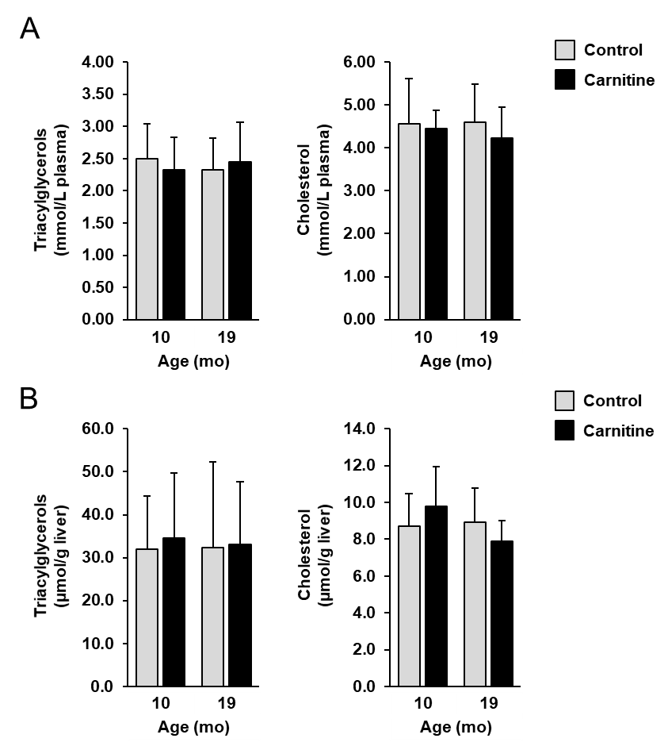

Supplemental Fig. 1
Concentrations triacylglycerols and cholesterol in plasma (A) and liver (B) of mice at 10 and 19 mo of age fed a control diet or a diet supplemented with 1000 mg/kg diet L-carnitine from 3 wk to 19 mo of age. Bars represent means and SD for n = 10 mice/group.

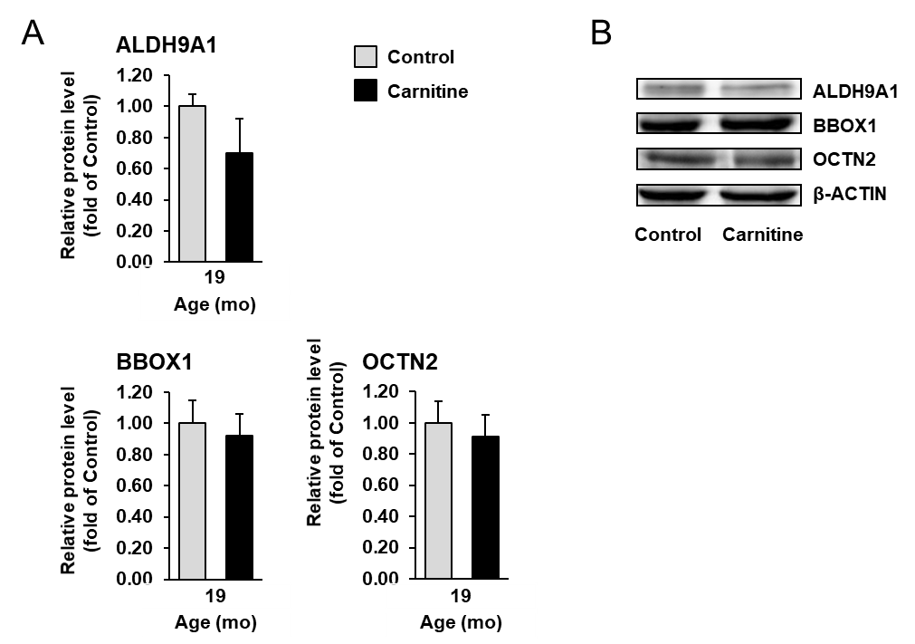

Supplemental Fig. 2
A, Relative protein levels of ALDH9A1, BBOX1 and OCTN2 in the liver of 19 mo-old mice fed a control diet or a diet supplemented with 1000 mg/kg diet L-carnitine from 3 wk to 19 mo of age. Bars represent means and SD for n = 6 mice/group and are expressed as fold of control group (= 1.0). B, Representative immunoblots of ALDH9A1, BBOX1, OCTN2 and β-ACTIN for normalisation are shown.
ALDH9A1, aldehyde dehydrogenase 9 family member A1; BBOX1, gamma-butyrobetaine hydroxylase 1; OCTN2; organic cation transporter 2.
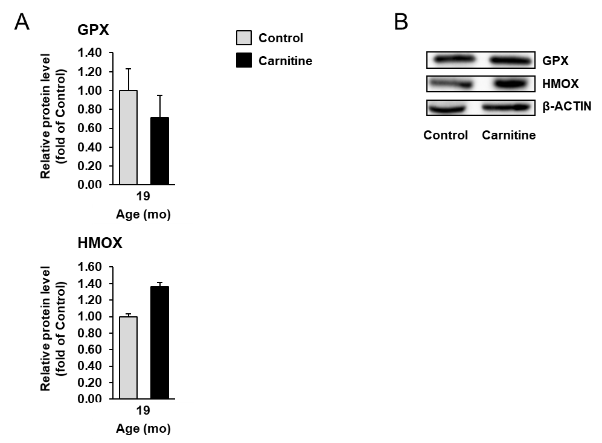

Supplemental Fig. 3
A, Relative protein levels of GPX and HMOX in the liver of 19 mo-old mice fed a control diet or a diet supplemented with 1000 mg/kg diet L-carnitine from 3 wk to 19 mo of age. Bars represent means and SD for n = 6 mice/group and are expressed as fold of control group (= 1.0). B, Representative immunoblots of GPX, HMOX and β-ACTIN for normalisation are shown.
GPX, glutathione peroxidase; HMOX, heme oxygenase.

