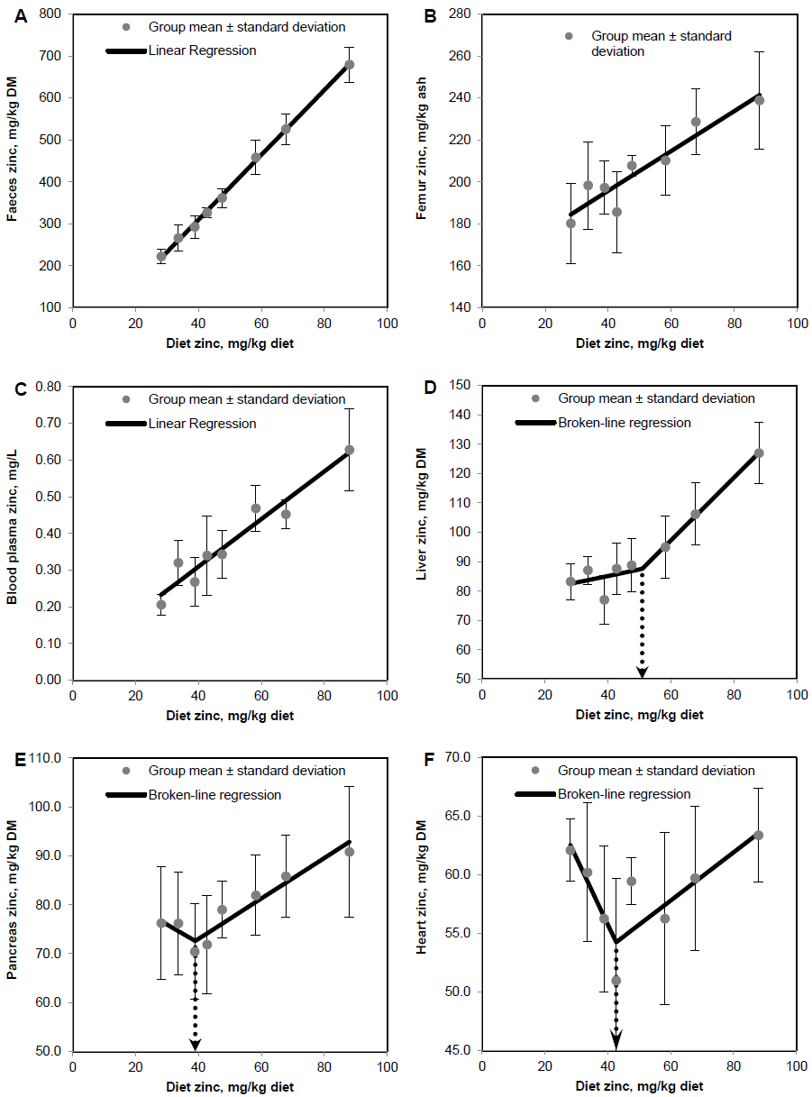
Supplementary Figure 1. Response of zinc concentrations in faeces (A), femur (B), blood plasma (C), liver (D), pancreas (E) and heart muscle (F) in weaned piglets fed diets with different zinc concentrations for 8d (see Supplementary Table 1 for detailed information on the statistical measures of the respective regression curves) ^{(8, 9, 10, 12)}. Notes: d, days; DM, dry matter; Values are arithmetic means ± SDs, n = 6; reference numbers (8, 9, 10, 12) at the end of the title refer to the reference list of the published manuscript.
Supplementary Table 1. Linear and Broken-line regression analysis of zinc concentrations in faeces, femur, blood plasma, liver, pancreas and heart muscle in weaned piglets fed diets with different zinc concentrations¹ for 8d† ^{(8, 9, 10, 12)}.
 |  | ²Regression model | ³Parameter estimate | ⁴p-value | R²
Faeces | mg/kg DM | y = 0.88 + bx | b 7.72 ± 0.12 | < 0.0001 | 1.00
Femur | mg/kg ash | y = 179 + bx | b 0.55 ± 0.13 | 0.005 | 0.75
Blood plasma | mg/L | y = 0.05 + bx | b 0.007 ± 0.0007 | < 0.0001 | 0.94
Liver | mg/kg DM | y = 76.3 + b₁x for x ≤ X_{B} | X_{B} 50.9 ± 5.53 | < 0.0001 | 0.94
 |  | y = 33.2 + b₂x for x > X_{B} | Y_{B} 87.5 ± 3.94 | < 0.0001
 |  |  | b₁ 0.22 ± 0.21 | 0.33
 |  |  | b₂ 1.07 ± 0.15 | < 0.0001
Pancreas | mg/kg DM | y = 87.2 + b₁x for x ≤ X_{B} | X_{B} 39.0 ± 5.09 | < 0.0001 | 0.92
 |  | y = 56.5 + b₂x for x > X_{B} | Y_{B} 72.6 ± 1.39 | < 0.0001
 |  |  | b₁ -0.38 ± 0.41 | 0.39
 |  |  | b₂ 0.41 ± 0.06 | < 0.0001
Heart | mg/kg DM | y = 78.5 + b₁x for x ≤ X_{B} | X_{B} 42.7 ± 0.006 | < 0.0001 | 0.72
 |  | y = 45.5 + b₂x for x > X_{B} | Y_{B} 54.2 ± 1.2 | < 0.0001
 |  |  | b₁ -0.57 ± 0.2 | 0.006
 |  |  | b₂ 0.21 ± 0.05 | 0.004
Notes: b, slope of parameter response of linear regression curves; b₁, slope of broken-line regression curves over dietary Zn doses ≤ X_{B}; b₂; slope of broken-line regression curves over dietary Zn doses > X_{B}; DM, tissue dry matter; R², coefficient of determination of the respective regression model; X_{B}, X intercept of the breakpoint in parameter response; Y_{B}, Y intercept of the breakpoint in parameter response; Zn, zinc. †Applied dietary Zn concentrations: 28.1, 33.6, 38.8, 42.7, 47.5, 58.2, 67.8 and 88.0 mg Zn/kg diet. Linear and broken line regression models were estimated on base of independent arithmetic group means relative to dietary Zn concentration (N = 8; except for Colon where the two lowest supplied groups were excluded from the analyses N_{Colon} = 6). Parameter estimates are presented ± standard error as indicator of the precision of estimation. P ≤ 0.05 was considered as indicator of statistical significance; reference numbers (8, 9, 10, 12) at the end of the title refer to the reference list of the published manuscript.

