Supplementary figure 8: Forest plot for standardised mean difference effect size in quality of life when nutrition therapy is compared to usual care: subgroup analysis of intervention duration.
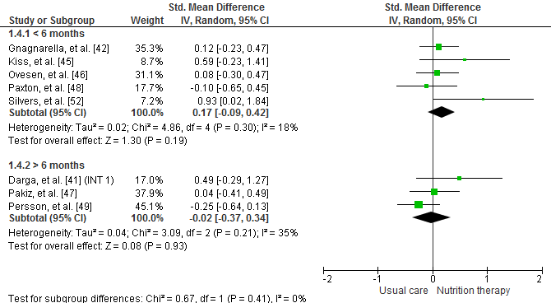
NOTE: The squares represent the pooled standardized mean difference effect size for each study, with the total pooled effect shown in the black diamond. All analysis are based on a random effects model. INT = intervention group 1.

Supplementary figure 9: Forest plot for standardised mean difference effect size in quality of life when nutrition therapy is compared to usual care: subgroup analysis of frequency of nutrition consults.
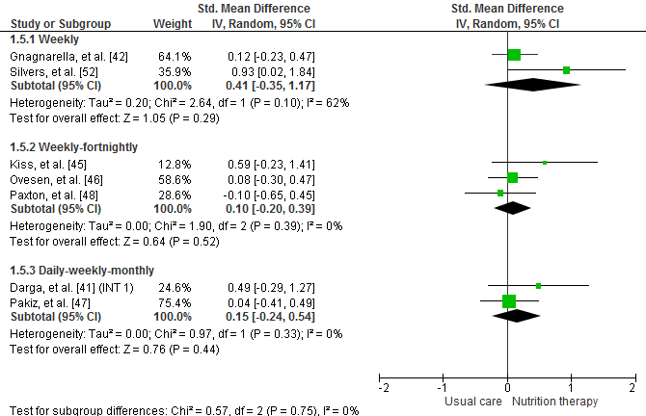
NOTE: The squares represent the pooled standardized mean difference effect size for each study, with the total pooled effect shown in the black diamond. All analysis are based on a random effects model. INT = intervention group 1.

Supplementary figure 10: Forest plot for standardised mean difference effect size in quality of life when nutrition therapy is compared to usual care: subgroup analysis of mode of nutrition consults.
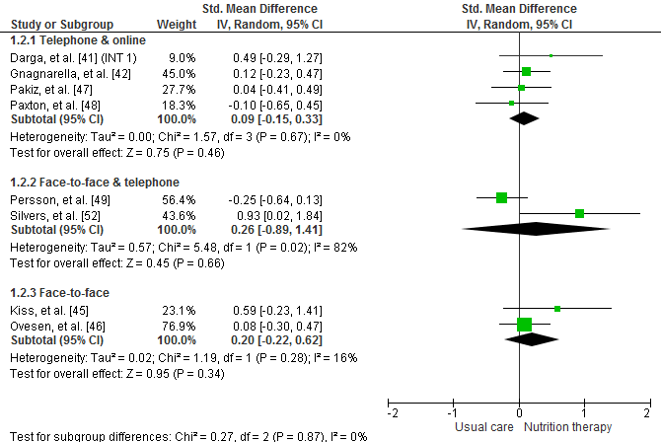
NOTE: The squares represent the pooled standardized mean difference effect size for each study, with the total pooled effect shown in the black diamond. All analysis are based on a random effects model. INT = intervention group 1.

Supplementary figure 11: Forest plot for standardised mean difference effect size in quality of life when nutrition therapy is compared to usual care: subgroup analysis of nutrition therapies.
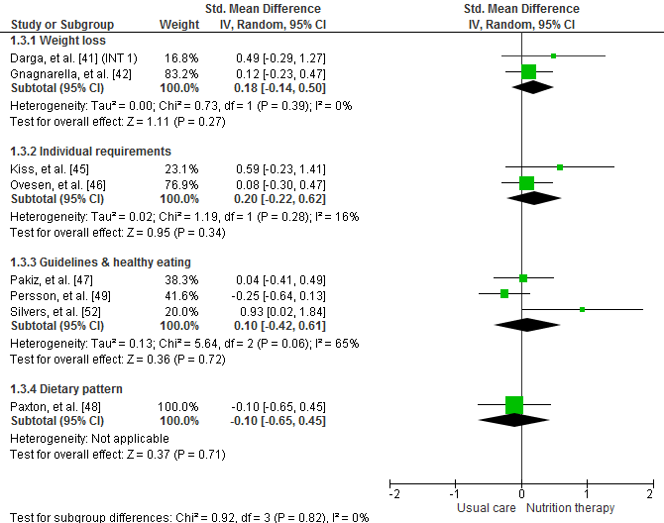
NOTE: The squares represent the pooled standardized mean difference effect size for each study, with the total pooled effect shown in the black diamond. All analysis are based on a random effects model. INT = intervention group 1.

