**Supplementary data**

**Figure S1a: Mean and standard deviation (SD) of neonatal 25(OH)D3 by month of birth among a random sample of infants born between 1993 and 2002 in Denmark**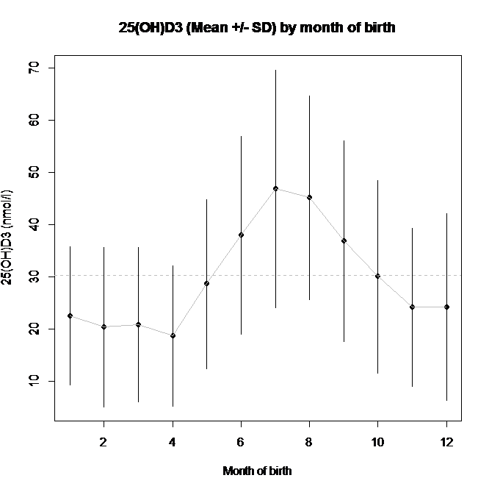

**Figure S1b: Residual plot of neonatal 25(OH)D3 by month of birth among a random sample of infants born between 1993 and 2002 in Denmark**

