**Table S1. GenBank accession numbers of human ELOVLx mRNA (NM) used for transfection studies. Protein coding sequences (NP) of vertebrate ELOVL6 used for phylogenetic analysis.** AA, amino acids; NM, mRNA; NP, protein.

|  |  |  |
| --- | --- | --- |
|  | **Name** | **NCBI Reference Sequence** |
| **Human mRNA** | *Homo sapiens* ELOVL1 | NM_022821.3 |
| *Homo sapiens* ELOVL3 | NM_152310.2 |
| *Homo sapiens* ELOVL6 | NM_024090.2 |
| *Homo sapiens* ELOVL7 | NM_024930.2 |
| **Vertebrate AA** | *Homo sapiens* (human) ELOVL6 | NP_076995.1 |
| *Mus musculus* (house mouse) ELOVL6 | NP_569717.1 |
| *Rattus norvegicus* (Norway rat) ELOVL6 | NP_599210.1 |
| *Macaca mulatta* (Rhesus monkey) ELOVL6 | NP_001253850.1 |
| *Bos Taurus* (cattle) ELOVL6 | NP_001095625.1 |
| *Gallus gallus* (chicken) ELOVL6 | NP_001026710.1 |
| *Xenopus tropicalis* (tropical clawed frog) ELOVL6 | NP_001017257.2 |
| *Ictalurus punctatus* (channel catfish) ELOVL6 | NP_001187477.1 |
| *Danio rerio* (zebrafish) ELOVL6 | NP_955826.1 |

**Table S2. Primer sequences and annealing temperatures used for testing ELOVLx transfection efficiency by RT-PCR.**

|  |  |  |  |
| --- | --- | --- | --- |
| **Primer** | **F/R** | **Sequence** | **Annealing Temperature** |
| **GAPDH** | Forward | 5’-AAC GGA TTT GGT CGT ATT GGG C-3’ | 61 |
| Reverse | 5’-TTG ACG GTG CCA TGG AAT TTG C-3’ |
| **ELOVL1** | Forward | 5’-TAC CAA GAG GTG ATG AAG CAC GCA-3’ | 67 |
| Reverse | 5'-AAC GAA GTA CAC GTA GGT CAG GAG-3’ |
| **ELOVL2** | Forward | 5’-GGA CAA TAT GTT TGG ACC GCG A-3’ | 61 |
| Reverse | 5’-ACC CAG CCA TAT TGA GAG CAG A-3’ |
| **ELOVL3** | Forward | 5’-TTA TTC ACT GGT ACC ACC ACA G-3’ | 59 |
| Reverse | 5’-GAA CAC CAA AGT TCA TGG TGA C-3’ |
| **ELOVL4** | Forward | 5’-AAA CGT AGT GTC CAC GGC ACT CAA-3’ | 67 |
| Reverse | 5’-ACC CAG CCA CAC AAA CAG GAG ATA-3’ |
| **ELOVL5** | Forward | 5’-ACT ATG GTT TGT CGT CAG TCC CTT-3’ | 66 |
| Reverse | 5'-ACA ACC AAC CAA GAG GGA ATG TGC-3’ |
| **ELOVL6** | Forward | 5’-TGA GGA AGC CAT TAG TGC TCT GGT-3’ | 67 |
| Reverse | 5’-AAA CTG ACT GCT TCA GGC CTT TGG-3’ |
| **ELOVL7** | Forward | 5’-GTG ATC TTA CAT CGA GGA CTG TGC-3’ | 65 |
| Reverse | 5'-TGA GCT TTG GTC CCA AGG AAG TGA-3’ |

A

cDNA → WT C+n13 E1+n13 E3+n13 E6+n13 E7+n13 Blank

Primers

↓

GAPDH

E1

E2

E3

E4

E5

E6

E7

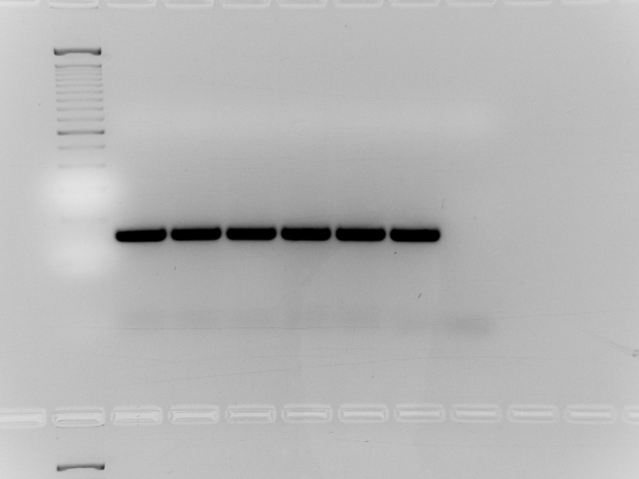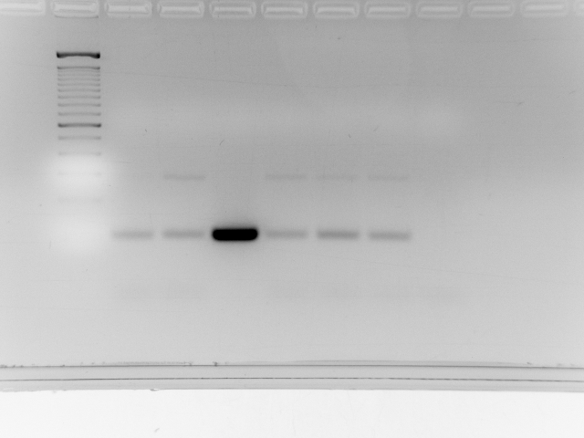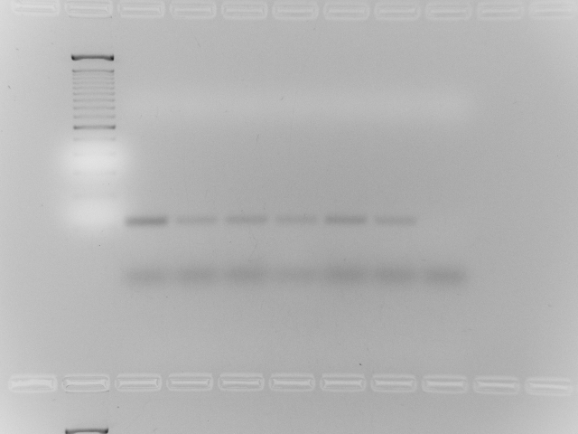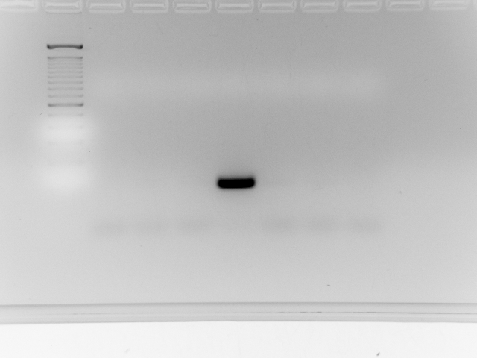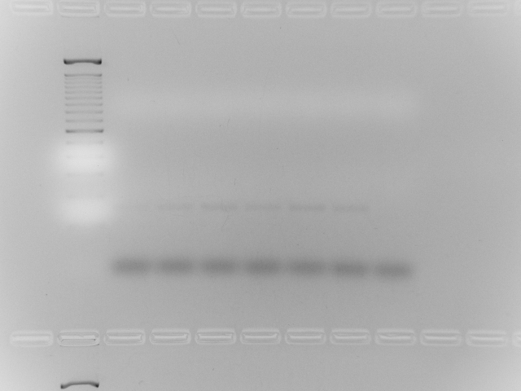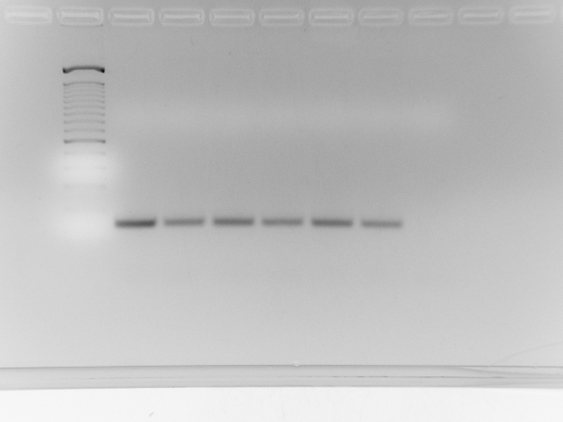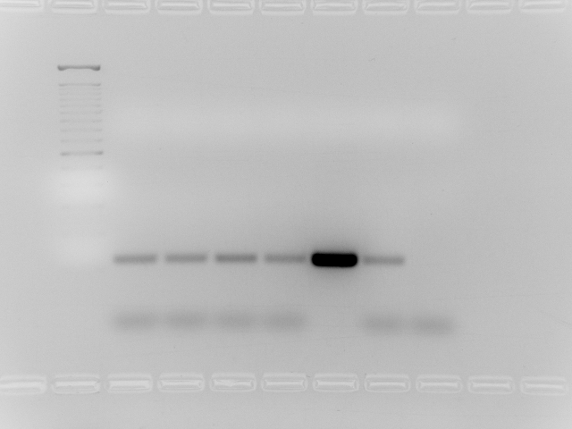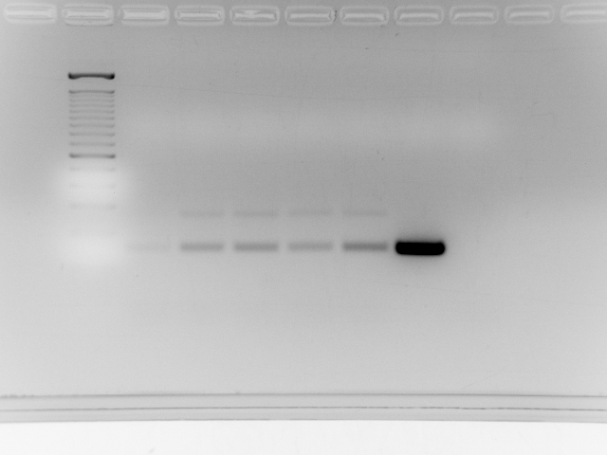

Primers

↓

GAPDH

E1

E2

E3

E4

E5

E6

E7

B

cDNA → WT C+n15 E1+n15 E3+n15 E6+n15 E7+n15 Blank

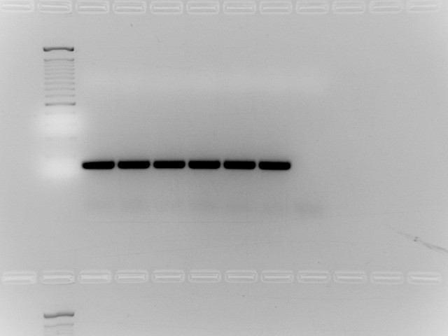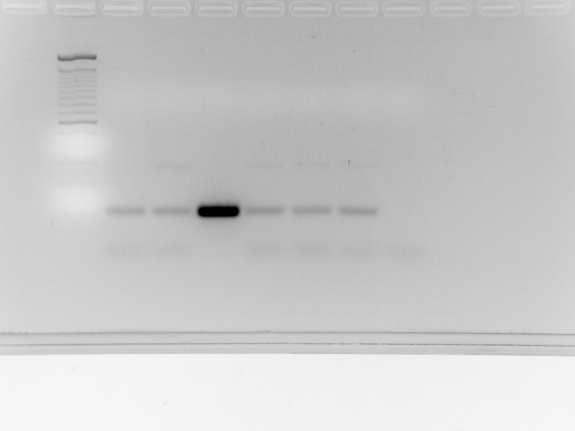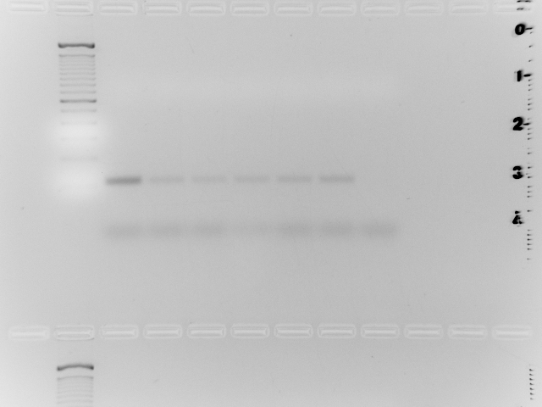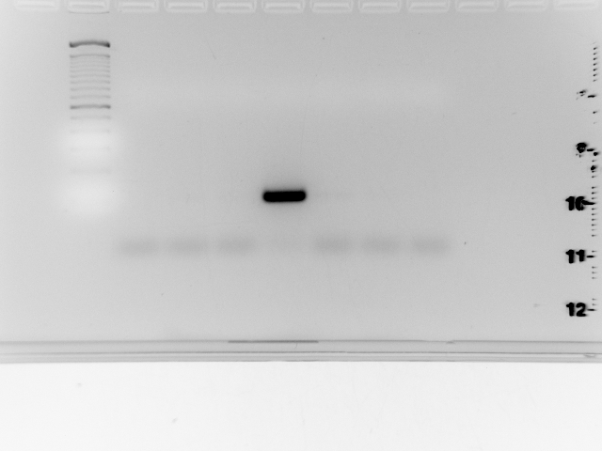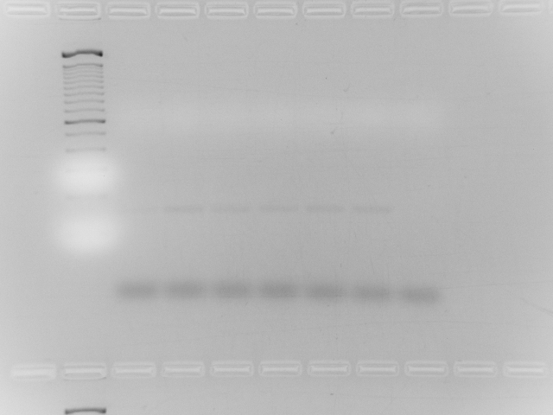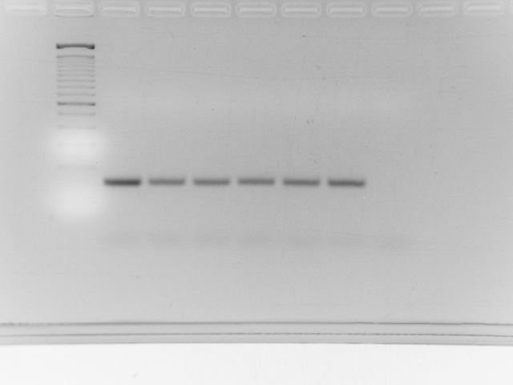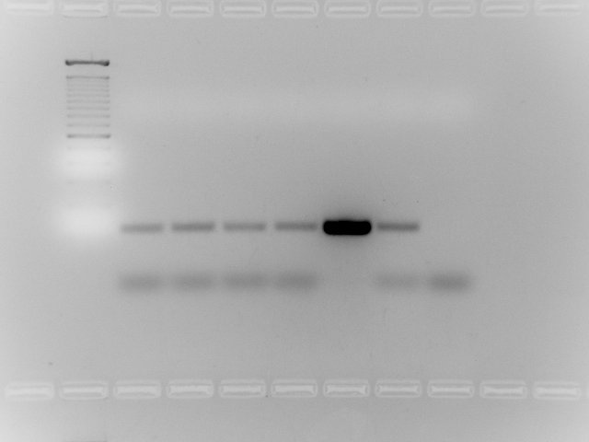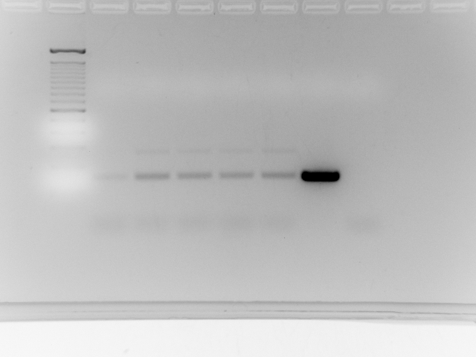

C

Primers

↓

GAPDH

E1

E2

E3

E4

E5

E6

E7

cDNA → WT C+n17 E1+n17 E3+n17 E6+n17 E7+n17 Blank

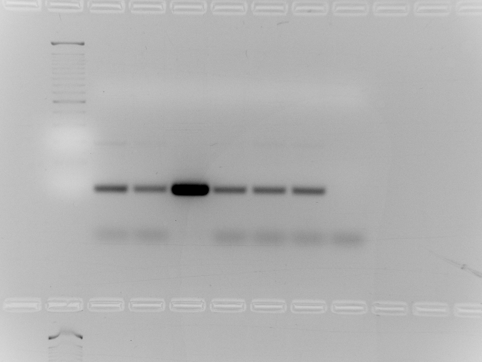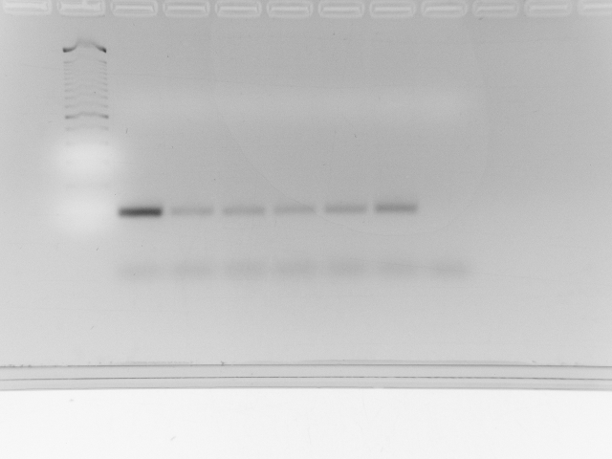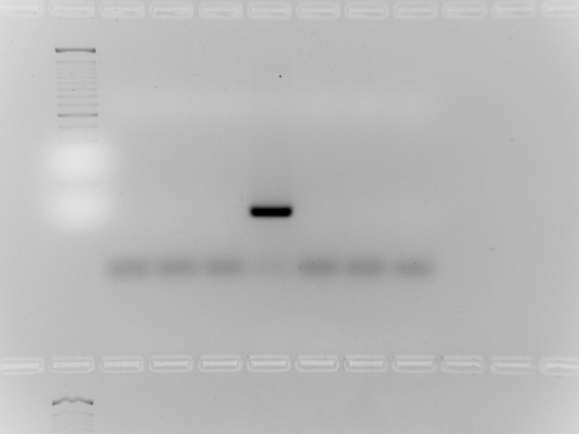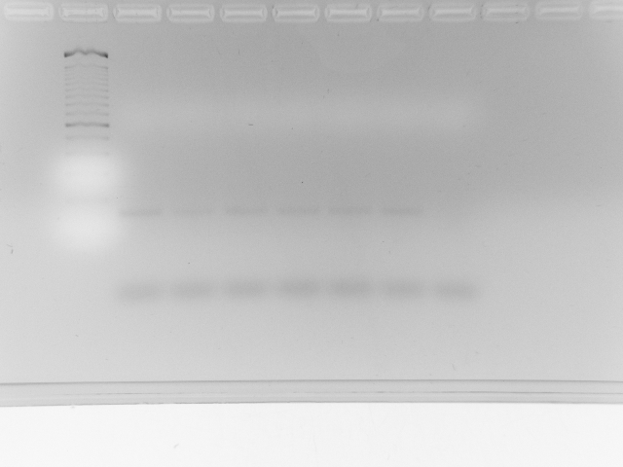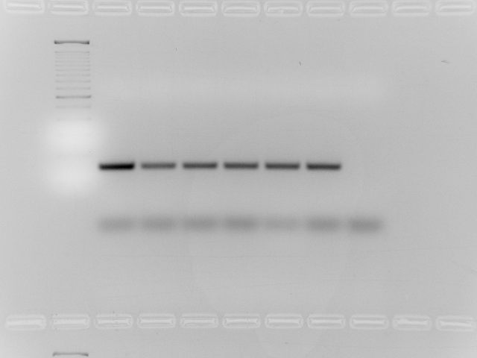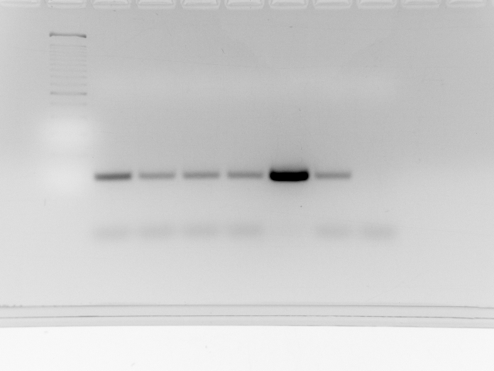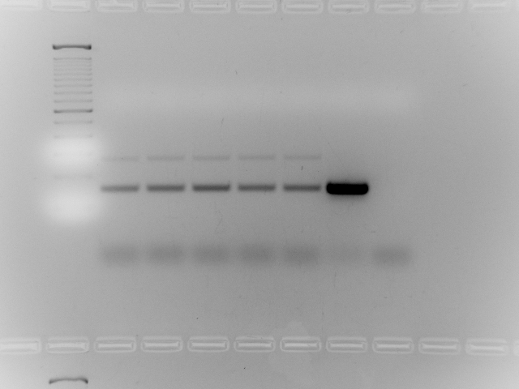

**Figure S1: ELOVL1-ELOVL7 gene expression of Wild Type, control and ELOVLx cells incubated with A) 80µM n-13:0; B) 80µM n-15:0; C) 80µM n-17:0.** PCR was performed for 28 cycles. GAPDH is used as housekeeping control.Alltransfections were found to be successful as the expression levels of transfected ELOVLx are higher in all treatment groups.E1, ELOVL1; E2, ELOVL2; E3, ELOVL3; E4, ELOVL4; E5, ELOVL5; E6, ELOVL6; E7, ELOVL7; WT, Wild Type; C, Control; n13= n-13:0; n15= n-15:0; n17= n-17:0; Blank, was water only as template.

Overall design of the experiment (in the order of occurrence)

(a) The open reading frame of ELOVL transcripts (ELOVL1, ELOVL3, ELOVL6 and ELOVL7) were cloned into a pcDNA3.1(+) expression vector. We cultured bacteria from single colony and then extracted plasmid DNA, which was used for transfection assays. The extracted DNA was verified by DNA sequencing and stored at -20°C before use.

(b) OCSFA are treated to cells as BSA bound substrates. n-13:0, n-15:0 and n-17:0 dissolved in absolute ethanol to make 100mM FA stock. FA stock (200μl) was then mixed with FA free BSA in 1× PBS (4.4% w/w) and incubated overnight at 37°C. BSA bound OCSFA were filtered using 0.22 μm syringe, and diluted to 80 μM with non-FBS MCF7 media when added to cells.

(c) MCF7 cells were seeded at 1x106 cell density into 60mm cell culture dishes. Usually after 48h growth, cell are 60-80% confluent and are used for transfection. 4µg of Vector (control) or ELOVL DNA was transfected into cells along with 200µl jetPRIME buffer, 8µl jetPRIME reagent, and 5ml growth media. After 24h incubation, BSA bound OCSFA substrates were treated at 80 μM, diluted with non-FBS MCF7 media. After additional 24h, cells were collected by trypsinization. 90% of cell samples were used for lipid extraction and to make fatty acid methyl esters (FAME). FAME samples are used to do structural identification by GC-EI-MS/MS and quantified by GC-FID. 10% of cell samples were used for testing ELOVLx transfection efficiency. RNA was extracted and reverse-transcribed to cDNA. cDNA then was used as template in PCR reactions.

(d) Once we found ELOVL6 is the major one catalyzing elongations of n-13:0 → n-15:0 → n-17:0, we did the amino acid sequence and phylogenetic analysis of ELOVL6 in order to have a better understanding on this gene.

Validation Studies

(a) Validation of transfection efficiency confirmed by RT-PCR analysis.

(b) Validation of gain of function carried out by transfecting ELOVLx and FAME analysis.