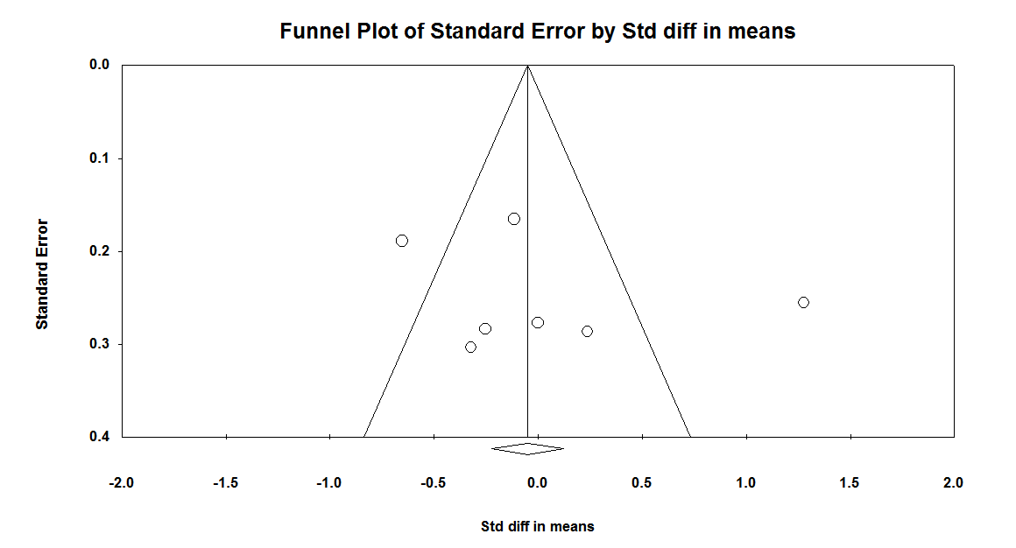
Supplementary Fig 5. Funnel plot (with 95 % confidence intervals) of Standardized mean differences C-reactive protein (CRP) concentration with anthocyanins. The vertical line (——) shows the combined mean differences calculated with the random-effects model.

