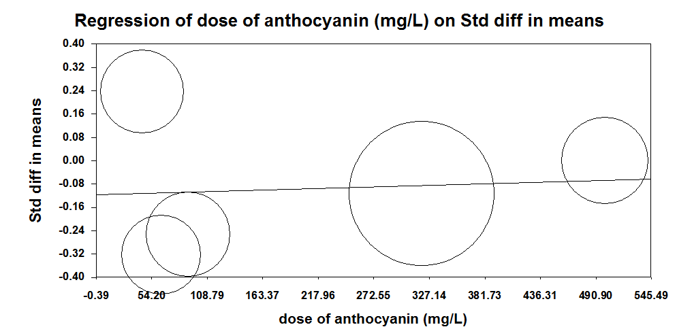
Supplementary Fig 4. Meta-regression plots of the association between Standardized mean difference in plasma C-reactive protein (CRP) concentrations values after anthocyanins supplementation with dose of anthocyanins. The size of each circle is inversely proportional to the variance of change.

