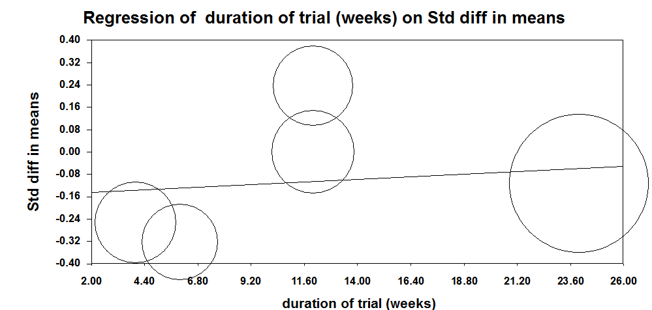
Supplementary Fig 3. Meta-regression plots of the association between Standardized mean difference in plasma C-reactive protein (CRP) concentrations values after anthocyanins supplementation with duration of trail. The size of each circle is inversely proportional to the variance of change.

