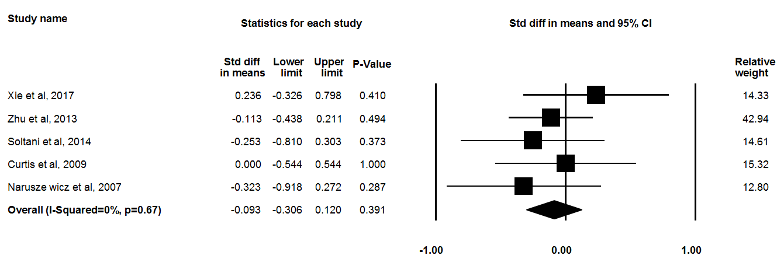
Supplementary Fig 2. Forest plot illustrates Standardized mean difference (represented by the black square) and 95 % confidence interval (CI) (represented by horizontal line) for C-reactive protein (CRP) concentration and anthocyanins. Weights are from random effects analysis. The area of the black square is proportional to the specific- study weight to the overall meta-analysis. The center of the diamond displays the pool Standardized mean differences and its width shows the pooled 95 % CI.

