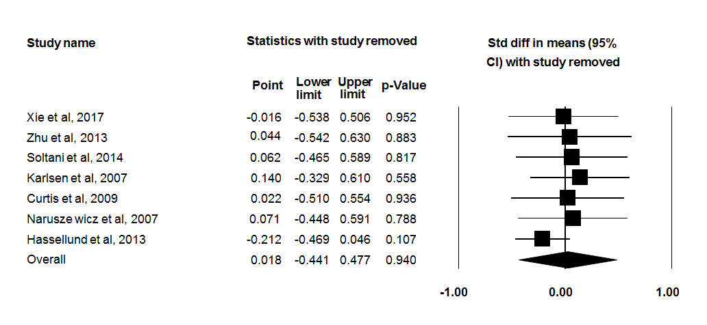
Supplementary Fig 1. Sensitivity analysis was performed using a random-effect model for impact of anthocyanins and C-reactive protein (CRP) concentration.

