Appendix 1. Association between dietary protein density as assessed in FFQ2 and birth weight

(a) Analysis with isocaloric replacement of protein with carbohydrate
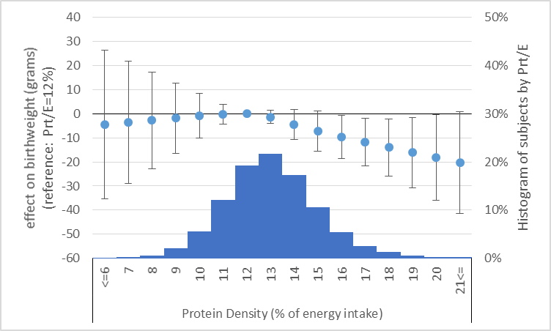

(b) Analysis with isocaloric replacement of protein with fat
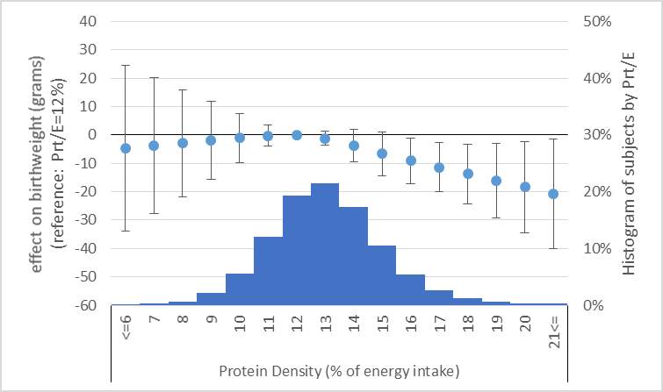
Figure legends:
Prt/E: protein energy percentage
Histogram displays number of subjects by dietary protein density as assessed in FFQ2.
Estimated difference in birthweight compared to women who had highest birthweight is shown in circle, with associated 95% confidence intervals shown as whiskers.
Appendix 2. Association between dietary fat and carbohydrate density as assessed in FFQ2 and birth weight

(a) Analysis with isocaloric replacement of fat with carbohydate
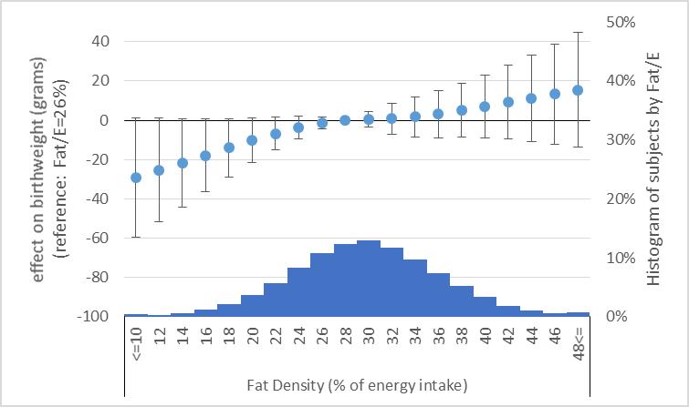

(b) Analysis with isocaloric replacement of carbohydrate with fat
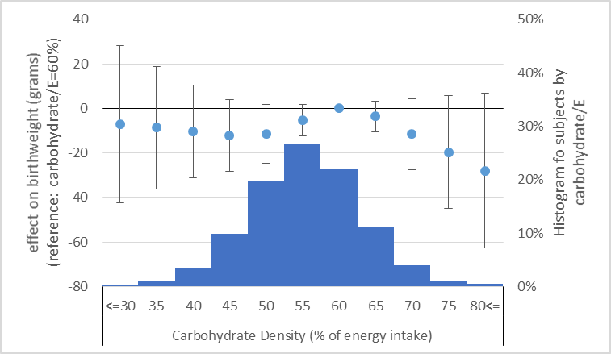

Figure legends:
Fat/E: fat energy percentage; carbohydrate/E: carbohydrate energy percentage
Histogram displays number of subjects by dietary protein density as assessed in FFQ2.
Estimated difference in birthweight compared to women who had highest birthweight is shown in circle, with associated 95% confidence intervals shown as whiskers.

