Supplemental Figure 3. UK Ofcom Score among NNPS PASS/FAIL/Out-of-scope food items in the different NNPS categories in France and in the US.
France
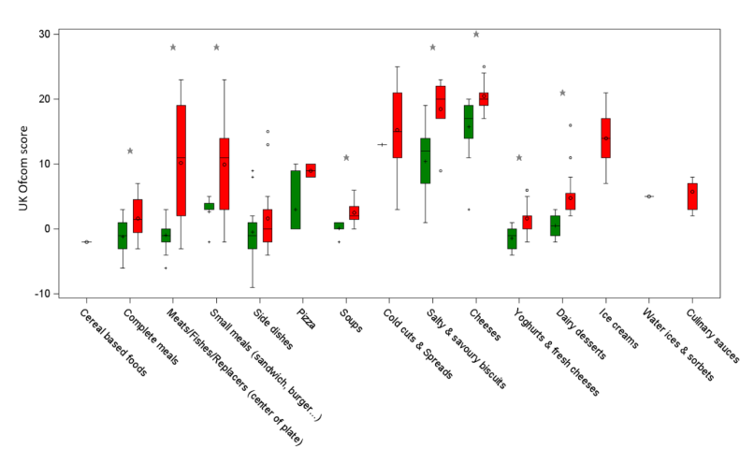
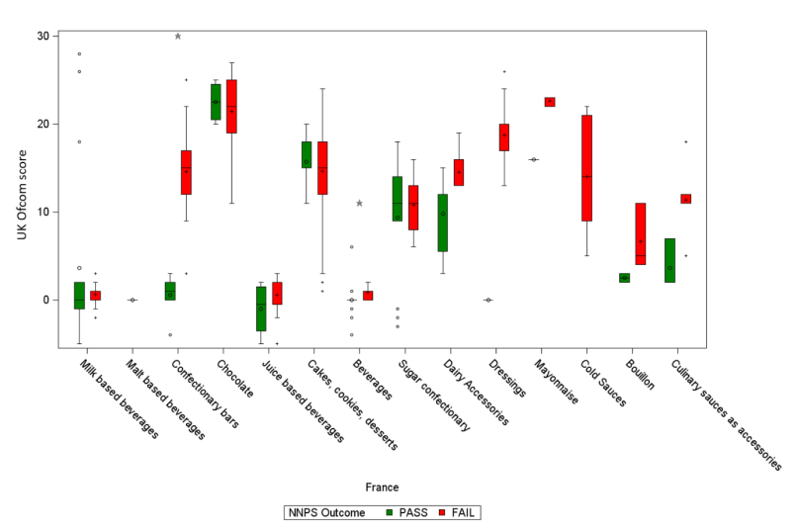
No boxplot could be drawn for categories with no food items
United states
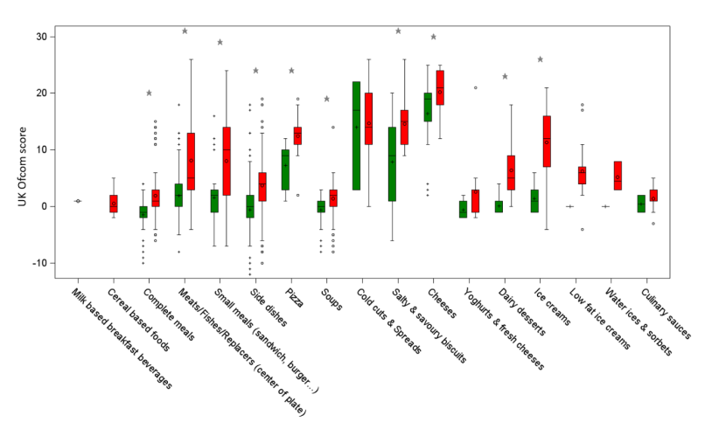
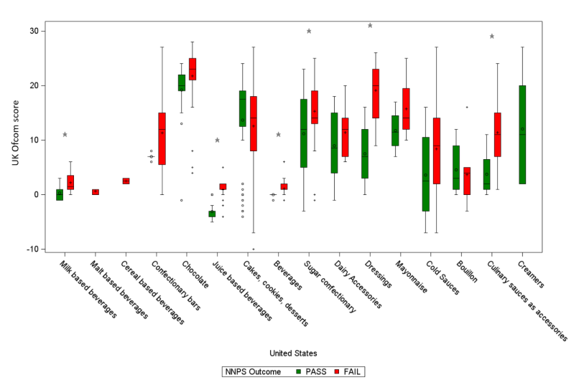
No boxplot could be drawn for categories with no food items

