**Supplementary Table S1.** Odds ratio (OR) for weak grip strength (<22kg) and slow timed-up-and-go (>10.2 s) by vegetable and fruit serve intake1.

|  |  |  |  |  |  |  |  |  |  |  |  |  |  |  |  |  |  |  |  |
| --- | --- | --- | --- | --- | --- | --- | --- | --- | --- | --- | --- | --- | --- | --- | --- | --- | --- | --- | --- |
|  | |  | |  | | **OR per serve 2** | |  | |  | **Serve Intake Categories** | | | | | |  | | |
|  | |  | | ***p* Value** | | **<2 Serves/d** | | | **2 to <3 Serves/d** | | **≥3 Serves/d** | | | **p for trend 3** | | |
| Vegetables | Weak Grip Strength | | Number | | 1421 | |  | | 408 | | | 564 | | 449 | | - | | |
| <22 kg, n (%) | | 867 (61.0) | |  | | 261 (64.0) | | | 361 (64.0) | | 245 (54.6) | | - | | |
| Age-adjusted | | 0.87 (0.78-0.96) | | 0.006 | | 1.00 (Referent) | | | 1.00 (0.77-1.31) | | 0.69 (0.52-0.91) | | 0.005 | | |
| Multivariable-adjusted | | 0.87 (0.77-0.97) | | 0.014 | | 1.00 (Referent) | | | 1.00 (0.76-1.31) | | 0.69 (0.51-0.94) | | 0.015 | | |
| Slow Timed-Up-and-Go | | Number | | 1426 | |  | | 410 | | | 566 | | 450 | | - | | |
| >10.2 s, *n* (%) | | 527 (37.0) | |  | | 169 (41.2) | | | 200 (35.3) | | 158 (35.1) | | - | | |
| Age-adjusted | | 0.93 (0.84-1.03) | | 0.169 | | 1.00 (Referent) | | | 0.78 (0.60-1.02) | | 0.79 (0.60-1.05) | | 0.121 | | |
| Multivariable-adjusted | | 0.88 (0.78-0.99) | | 0.032 | | 1.00 (Referent) | | | 0.73 (0.55-0.97) | | 0.69 (0.50-0.94) | | 0.024 | | |
|  |  | |  | |  | |  | | **<1 Serves/d** | | | **1 to <2 Serves/d** | | **≥2 Serves/d** | |  | | |
| Fruits | Weak Grip Strength | | Number | | 1421 | |  | | 407 | | | 542 | | 472 | | - | | |
| <22 kg, n (%) | | 867 (61.0) | |  | | 263 (64.6) | | | 334 (61.6) | | 270 (57.2) | | - | | |
| Age-adjusted | | 0.81 (0.72-0.92) | | 0.001 | | 1.00 (Referent) | | | 0.86 (0.65-1.12) | | 0.70 (0.53-0.93) | | 0.011 | | |
| Multivariable-adjusted | | 0.84 (0.73-0.96) | | 0.010 | | 1.00 (Referent) | | | 0.87 (0.66-1.15) | | 0.76 (0.57-1.01) | | 0.056 | | |
| Slow Timed-Up-and-Go | | Number | | 1426 | |  | | 408 | | | 543 | | 475 | | - | | |
| >10.2 s, *n* (%) | | 527 (37.0) | |  | | 157 (38.5) | | | 197 (36.3) | | 173 (36.4) | | - | | |
| Age-adjusted | | 0.95 (0.84-1.08) | | 0.430 | | 1.00 (Referent) | | | 0.88 (0.67-1.15) | | 0.88 (0.66-1.15) | | 0.370 | | |
| Multivariable-adjusted | | 0.91 (0.79-1.05) | | 0.187 | | 1.00 (Referent) | | | 0.83 (0.62-1.10) | | 0.81 (0.90-1.10) | | 0.181 | | |

1Odds ratios (95% CI) for weak grip strength and slow timed-up-and-go by vegetable and fruit serve intake analyzed using logistic regression. 2Vegetable and fruit serves were calculated based on the 2013 Australian Dietary Guidelines of a vegetable and fruit serve equal to 75 g/d and 150g/d, respectively; 3Test for trend conducted using median value for each vegetable (1.6, 2.5, and 3.6 serves/d) and fruit serve category (0.7, 1.5 and 2.5 serves/d); Multivariable-adjusted model included age, BMI, treatment code, prevalent diabetes mellitus, socioeconomic status, physical activity, smoking history, and energy, protein, calcium and alcohol intake.

**Supplementary Table 2.** Baseline characteristics in all participants and by fruit serve intake categories 1.

|  |  |  |  |  |  |
| --- | --- | --- | --- | --- | --- |
|  | **All Participants** | **Fruit Serve Intake 2** | | | |
| **<1 Serves/d** | **1 to <2 Serves/d** | **≥2 Serves/d** | ***p* Value 3** |
| Number | 1429 | 409 | 544 | 476 | - |
|  | **Demographics** | | | |  |
| Age, years | 75.2 ± 2.7 | 75.0 ± 2.7 | 75.2 ± 2.7 | 75.3 ± 2.7 | 0.173 |
| Treatment (calcium) 4 | 716 (50.1) | 202 (49.4) | 263 (48.4) | 251 (52.7) | 0.367 |
| Body mass index (BMI) 5, kg/m2 | 27.2 ± 4.8 | 26.8 ± 4.6 | 27.3 ± 4.7 | 27.4 ± 4.9 | 0.161 |
| Appendicular lean mass, kg 6 | 15.0 ± 2.2 | 14.6 ± 2.2 | 15.2 ± 2.0 | 15.0 ± 2.3 | 0.056 |
| Smoked ever 7 | 531 (37.4) | 176 (43.2) | 169 (31.3) | 186 (39.2) | <0.001 |
| Prevalent diabetes mellitus | 90 (6.3) | 19 (4.6) | 32 (5.9) | 39 (8.2) | 0.084 |
|  | **Socioeconomic status 8** | | | |  |
| Top 10% most highly disadvantaged | 63 (4.4) | 18 (4.4) | 24 (4.4) | 21 (4.4) | 0.999 |
| Highly disadvantaged | 171 (12.1) | 53 (13.1) | 64 (11.9) | 54 (11.4) | - |
| Moderate-highly disadvantaged | 229 (16.2) | 68 (16.8) | 87 (16.1) | 74 (15.7) | - |
| Low-moderately disadvantaged | 216 (15.2) | 62 (15.3) | 80 (14.8) | 74 (15.7) | - |
| Low disadvantaged | 298 (21.0) | 82 (20.2) | 118 (21.9) | 98 (20.8) | - |
| Top 10% least disadvantaged | 440 (31.1) | 122 (30.1) | 167 (30.9) | 151 (32.0) | - |
|  | **Dietary intakes** | | | |  |
| Energy, kJ/day | 7102.3 ± 2078.1 | 6830.9 ± 1955.2 | 6813.9 ± 1999.9 | 7665.0 ± 2156.5 | <0.001 |
| Protein, g/day | 79.5 ± 26.6 | 75.5 ± 25.1 | 76.2 ± 24.5 | 86.8 ± 28.6 | <0.001 |
| Calcium, mg/day | 954.0 ± 346.8 | 855.7 ± 307.4 | 952.4 ± 340.9 | 1040.4 ± 362.9 | <0.001 |
| Alcohol, g/day | 1.8 (0.3-9.8) | 2.6 (0.3-11.9) | 1.9 (0.4-9.3) | 1.2 (0.0-7.8) | 0.067 |
|  | **Physical function** | | | |  |
| Physical activity 5, kJ/day | 470.6 (109.1-855.4) | 401.5 (0.0-817.7) | 451.8 (106.3-802.6) | 538.7 (211.6-926.8) | 0.002 |
| Grip strength, kg 8 | 20.5 ± 4.7 | 20.1 ± 4.7 | 20.6 ± 4.6 | 20.8 ± 4.8 | 0.114 |
| Timed-up-and-go, sec9 | 10.0 ± 3.0 | 10.0 ± 2.8 | 10.0 ± 3.2 | 9.9 ± 2.9 | 0.755 |
| Prevalent falls 10 | 166 (11.8) | 50 (12.4) | 58 (10.8) | 58 (12.4) | 0.672 |

1Data presented as mean ± SD, median (interquartile range) or number *n* and (%); 2 Fruit serves were calculated based on the 2013 Australian Dietary Guidelines of a fruit serve equal to 150 g/d; 3 *p* values are a comparison between groups using ANOVA, Kruskal-Wallis test, and Chi-square test where appropriate; 4 *n* =1428; 5 *n* =1427; 6 *n* = 484; 7 *n* = 1421; 8 *n* =1417; 9 n=1426; 10 n=1407

**Supplementary Table 3.** Spearman’s correlation coefficient (ρ) between the vegetable classes and total vegetable intake.

|  |  |  |  |  |  |
| --- | --- | --- | --- | --- | --- |
|  | Cruciferous | Allium | Yellow/Orange/Red | Leafy Green | Legumes |
| Cruciferous1 | - | 0.12*** | 0.21*** | 0.17*** | 0.24*** |
| Allium2 | 0.12*** | - | 0.39*** | 0.17*** | 0.17*** |
| Yellow/Orange/Red1 | 0.21*** | 0.39*** | - | 0.31*** | 0.21*** |
| Leafy Green1 | 0.17*** | 0.17*** | 0.31*** | - | 0.06* |
| Legumes1 | 0.24*** | 0.17*** | 0.21*** | 0.06* | - |
| Total Vegetable Intake3 | 0.53*** | 0.43*** | 0.72*** | 0.37*** | 0.48*** |

1 per 20 g serve; 2 per 10 g serve; 3 per 75 g serve.*p<0.05 and ***p<0.001

**Supplementary Table 4.** Multivariable-adjusted hazard ratios for falls-related hospitalisation by fruit type.

|  |  |  |  |
| --- | --- | --- | --- |
|  |  | All Participants | *p* Value |
| Falls-Related Hospitalisations |  |  |  |
| Apples & Pears (per 20 g serve/d) |  | 0.99 (0.96-1.02) | 0.411 |
| Oranges & Other Citrus Fruits (per 20 g serve/d) |  | 1.01 (0.99-1.04) | 0.345 |
| Bananas (per 20 g serve/d) |  | 1.03 (0.99-1.07) | 0.158 |
| Other Fruits (per 20 g serve/d) |  | 1.00 (0.98-1.03) | 0.797 |

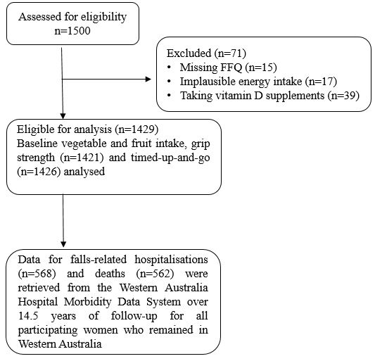

**Supplementary Figure 1:** Diagrammatic representation of the overall study design.

**C**

**Falls-Related Hospitalisations**

**Grip Strength/**

**Timed-Up-And-Go**

**Vegetable/ Fruit Consumption**

**Physical Activity**

**U**

**Health Conscious Personality**

**Supplementary Figure 2:** Hypothesised causal pathways in the relationship between vegetable /fruit consumption and the risk of falls-related hospitalisations. Variables in boxes were included in a multivariable Cox regression model for the risk of falls-related hospitalizations. C=confounders (other than physical activity) that were included in the multivariable-adjusted model. U=unmeasured confounder which is associated with both diet (vegetable/fruit consumption) and physical activity. Grip strength and timed-up-and-go were added separately to this model (additional analysis section) in order to assess the extent to which each of these variables directly or indirectly affected the relationship between vegetable consumption and the risk of hospitalised falls.

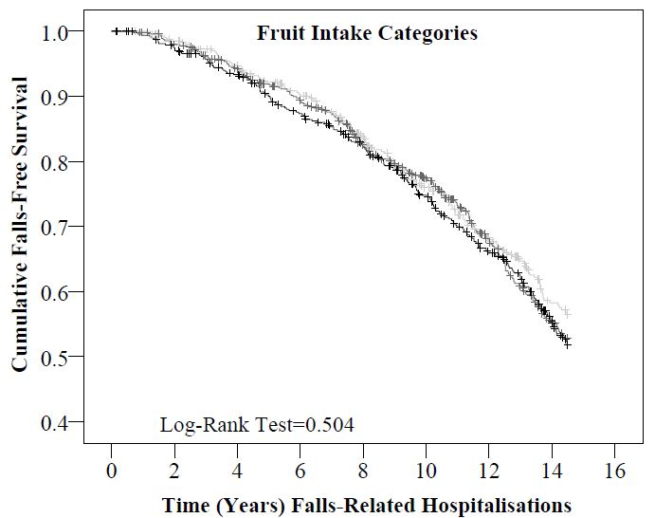

**Supplementary Figure 3**: Kaplan-Meier survival curve for fruit intake categories on falls-related hospitalisations. Low: <1 serves/d, moderate: 1 to <2 serves/d and high: ≥ 2 serves/d intake categories are represented by the light grey, grey and black lines respectively.